Insert Employee Name:
New Employee’s First Year – Roadmap to Success

Days 31-60

Connect:
Continue periodic check-ins with manager
Connect
Learn
Build
Do
Days 61-90
Connect:
Continue periodic check-ins with manager
Continue to build strong working relationships internally and across the system
Encourage collaborative partnerships

Learn:
Complete functional/on-the-job training Continue organizational learning & acclimation Identify any additional learning areas/needs

Demonstrate Progress:
Own responsibility of actions and become accountable for your work
Begin working independently on projects Demonstrate autonomous decision-making Self-evaluation progress on initial SMART goals

Next Steps:
Prepare for performance conversation with manager Identify future SMARTER goals
Days 1-30
Connect:
Meet your manager
Introductions with team, internal partners, peers, and customers
Meet your assigned UWSA Ambassador Tour the building(s)

Learn:
Understand role & performance expectations Participate in functional and on-the-job training Attend new employee welcome session Review policies, procedures, protocols
Ask about unspoken norms Be curious and ask questions

Logistics & Compliance:
Access to building, parking, equipment, systems Complete new hire tasks (complete I-9, obtain WisCARD, submit W-4 and direct deposit)
Participate in benefits info session and enroll Complete mandated training (Open Records, Info Security, Title IX, Child Neglect Prevention) Review Code of Ethics & reporting

Next Steps:
Setup periodic check-ins with manager Set initial SMARTER goals
Setup regular meetings with team members and internal partners
Begin to network internally and build strong working relationships

Learn:
Review organizational charts and continue organizational learning
Participate in functional and on-the-job training Ask about department short and long-term goals Understand how your role connects to the greater
mission
Attend new employee sessions on safety and legal topics

Demonstrate Progress:
Begin exercising autonomy in job duties
Identify any additional needs for training, tools, and access
Understand your role in team success
Self-evaluate progress on initial SMART goals

Next Steps:
Ask your team, partners, and customers for feedback Setup performance conversation with manager

Employee Signature and date: Supervisor Signature and date: By signing this form is not necessarily that you agree, but it is acknowledged and discussed.

PERFORMANCE MANAGEMENT
SMART GOALS & CORE VALUES
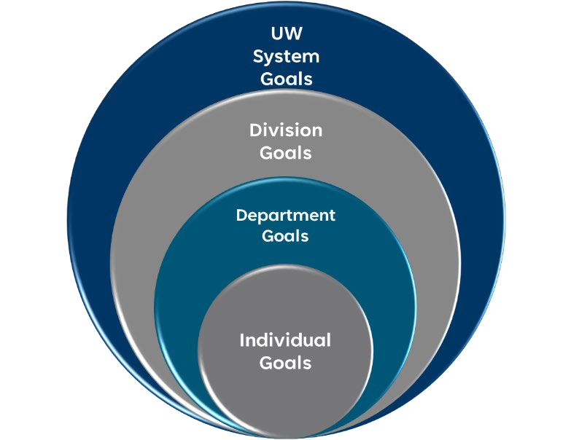
Employees should be able to see their goals reflected in the accomplishment of department, division, and system goals.
Engagement is created when I can see how my work and my efforts contribute to the greater whole.

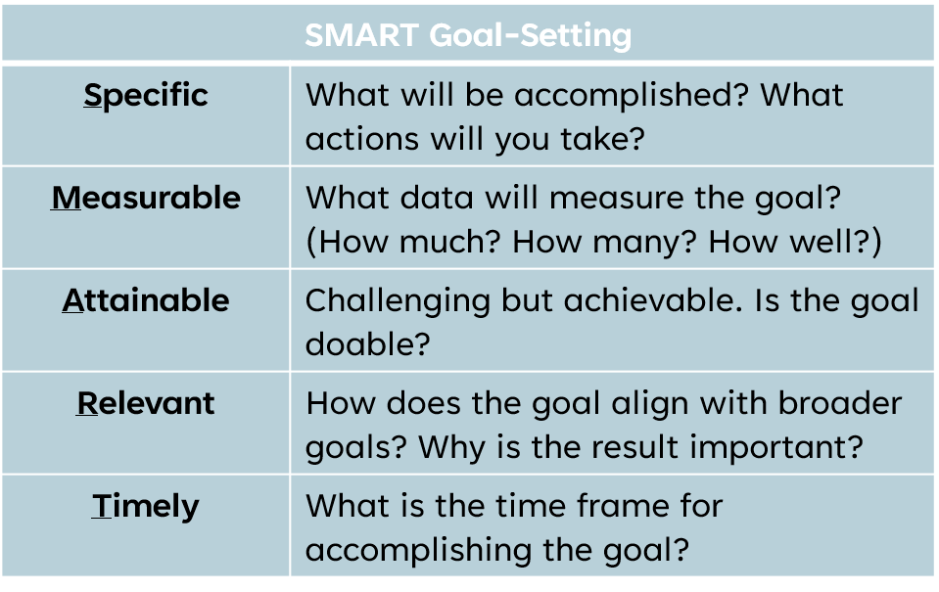

Using Core Values to Drive Performance
- Purpose-driven
  - Our purpose drives all that we do
- People-focused
  - We value and promote all who work, live, and learn in the UW System, as well as those in the communities we serve across the state
- Commitment to Stewardship
  - We are accountable to each other, to the UW System, and to the Wisconsin Idea. The decisions we make are focused on the best interests of those who work and learn at the universities in the System and the state of Wisconsin.

When developing your SMART goals, it is important to refer to the UW Systems Core Values and think through how these Core Values can be incorporated into your goals.

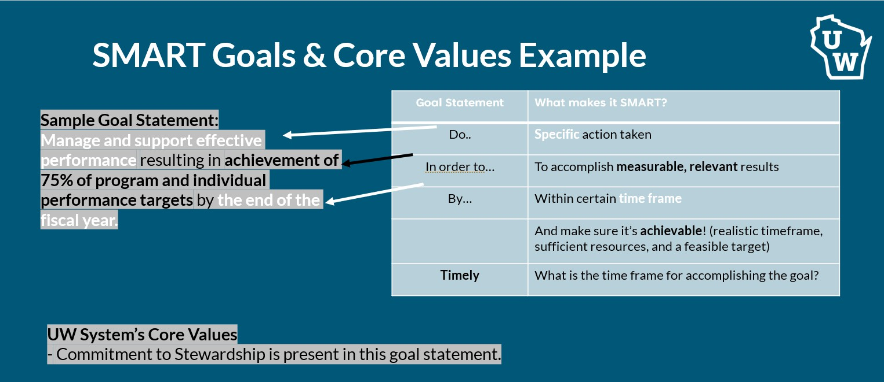

Specific
SMARTER Goal-Setting
What will be accomplished? What actions will you take?

Measureable Attainable Relevant
Timely Evaluate Revise
What data will measure the goal? (How much? How many? How well?)
Challenging but achievable. Is the goal doable?
How does the goal align with broader goals? Why is the result important?
What is the time frame for accomplishing the goal? Evaluate progress towards goals
Revise as needed

- Help ensure clarity of expectations around desired accomplishments
- Contribute to better calibration in performance assessment between you and your supervisor
- Contribute to greater consistency in performance assessment across the organization

DEVELOP SMART GOALS THAT ADDRESS BOTH PERFORMANCE AND DEVELOPMENT

Performance Goals
- Job-related and role-driven;
- Connected to key responsibilities and deliverables
- Aligned to division and organization
- Usually 3-5 goals

Development Goals
- Learning-oriented
- Future-focused
- Support higher level performance and career advancement

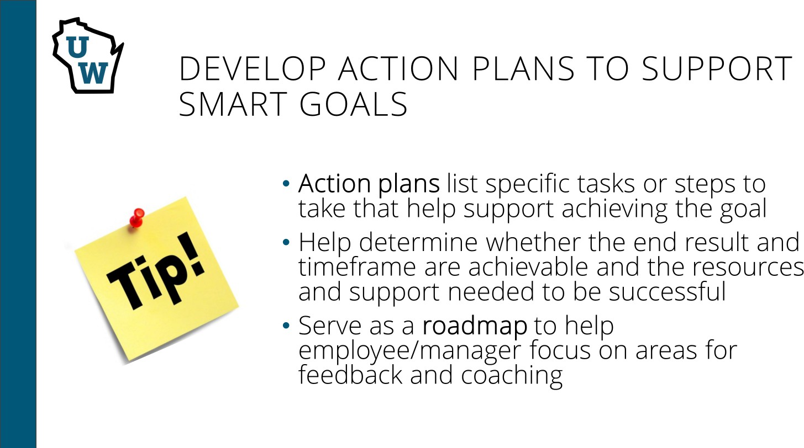

Video: Performance Management - Employee

Flowcharts: Electronic Performance Management in HRS

Insert Employee Name:
New Employee’s First Year – Roadmap to Success

Develop SMARTER Goals

Align individual goals with the mission & vision of your department, the Mission of the University of Wisconsin System, and the Mission of the UW System Administration. Note: This sheet is optional and intended for use during the introductory period or until SMARTER Goals are defined and documented in the ePerformance Management system in your portal.

Specific  Specific position duties, goals, or expectations |  | Measurable  How will this be measured? | Achievable/Attainable What tools and resources do you need to achieve the goal? | Reasonable/Relevant How does this support our departmental and/or organizational mission & vision? | Time Sensitive/ Time Bound When do we want to accomplish this goal? | Evaluate Progress  For use at evaluation.  Has there been progress? Is this work completed? Are revisions  needed? | Revise  Identify any revisions to previously established goals.
1
2
3
4
5
6
7
8

Employee Signature and date: Supervisor Signature and date: By signing this form is not necessarily that you agree, but it is acknowledged and discussed.

