Notes for EARS
Happy New Year!
Agenda:
- Expense Report (UW) has been updated, which has caused issues in the W2 reporting
  - We are working with Mary to confirm the updated workbook is functional and then we will send out to this group
  - We are also looking into a way to filter out non employees from the search going forward (HR doesn’t need any non-employee information)

- Cash Advances reconciliation and reminders and changes to Spend Authorization workflow that have happened and will happen estimated in March
  - Completed: Central Grant Accountant to get any Cash Advances requested on Grant funding, or any Gift Card business purpose requests on grant funding
  - Adding a new Spend Authorization Reviewer UW role (expected to go live in January for Milwaukee)
    - This is optional for each campus
    - This role can review (edit/approve) Spend Authorizations and can be mapped at the Cost Center or Cost Center Hierarchy level
  - Adding a new Research Participant Cash Advance Specialist role for Research Participant Cash Advances, campuses will have to map this role and likely will map to Central Grant Accountant or EARS
  - Same general rules apply, should be reconciled within 30 days of expected end date of research
- New optional workflow for campuses to add Expense Report Reviewer UW
  - Up to each campus if they want to use this role
  - Can be mapped at the Cost Center or Cost Center Hierarchy level
  - Not sure which campuses will be using this role
- Reminder on to complete Mass Close Spend Authorizations monthly
- The “To Do” step was not consistently working correctly when the cash sale/employee repayment with the Bursars have collected repayment – this issue has been resolved. Be sure to run Find Journal Lines- Flattened (UW) report to make sure all repayments have been processed.
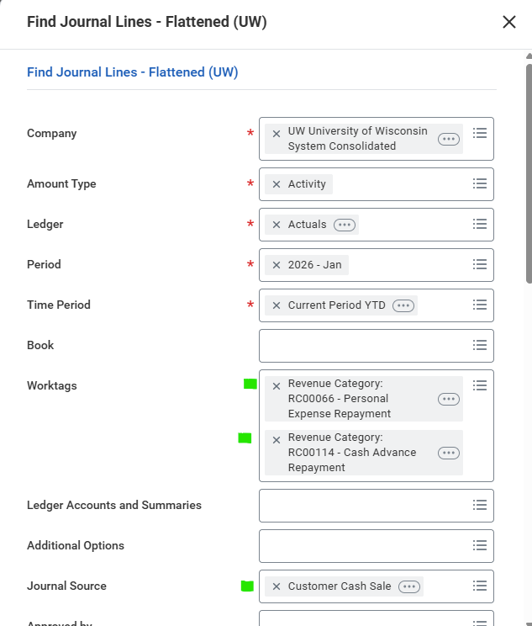

- Grants repayments – Grants team is requiring that in most repayment scenarios, the funding first be taking off Grant funding first before repayments can be processed
- Grants will be allowing Cash Advance repayments – should be completed in January
- Working on updating Job Aids for both employees and EARS and new RPCAS
  - Cash Advances and Spend Authorizations
- Reminder to be looking at outstanding cash advances and following up with employees. As of 1/8 we have 22 cash advances are overdue for reconciliation systemwide
- While we don’t have any hard rules on cash advances, in general, should be used for student led trips/expenses and not individual employee travel
- The EARS are the role to question if the Cash Advance is reasonable
No Spend Authorization Mass Close Requests have been processed. Each month campuses should be completing a “Spend Authorization” clean up to close Spend Authorizations that are either no longer needed (I didn’t take the trip) or used and the employee didn’t mark as the final expense report for that Spend Authorization.
You may want to remind employees they can close Spend Authorizations that they no longer need by navigating:
Personal – Expenses Hub – Spend Authorizations
Then next to actions if there is a drop down, then select “Cancel” from the drop down if this Spend Authorization is no longer need
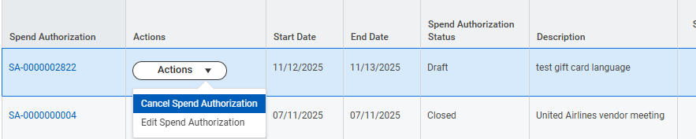

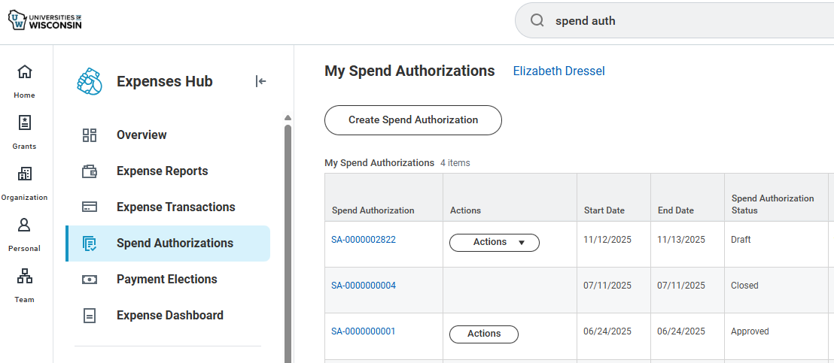

If the Spend Authorization has already been applied to an Expense Report
Click Actions
It Opens up to “Confirm Spend Authorization Close”
Click “OK” then “Done”
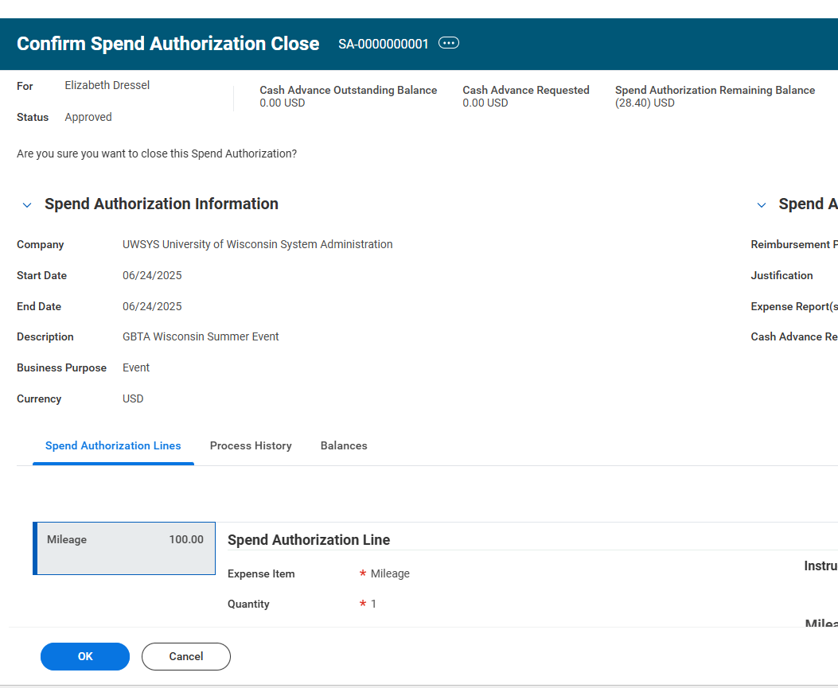

You will notice the Spend Authorization Status now shows “Closed”
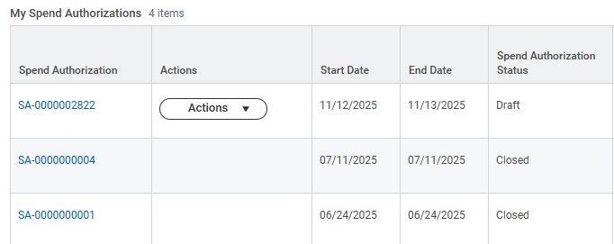

Feel free to use these screenshots if helpful. We have seen employees are not always marking the “final expense report” and also forgetting to attach Spend Authorizations to Expense Reports.
Reminder to run and clean up open Spend Authorizations.
Here is the list of Spend Authorizations Spend Start Date on or on/after 6/1/24 and spend end date on before 11/1/25 by campus as of 1/7/26:
UWEAU: 20
UWGBY: 41
UWLAC: 35
UWMIL: 561
UWMSN: 32
UWOSH: 10
UWPKS: 56
UWPLT: 11
UWRVF: 9
UWSTO: 11
UWSTP: 21
UWSUP:10
UWSYS: 6
UWWTW: 51

Mass Close Spend Authorizations is the report you want to use to close Spend Authorizations (if you know it is no longer needed)
It didn’t look like any campus had used the “Mass Close” process, wanted to check in on how you are tracking these?
Repayments from ECMs
We had a questions on what to do with the open receivable for an ECM (Expense Receivable Repayments can only be done for workers). The best, cleanest way is an additional expense report to clear the receivable for the ECM, since paying back with cash or check will create an accounting entry that will need to be cleared.
Notes for if a cash/check is need: Credit the Expense account (6000 account) and debit the employee receivable 1307
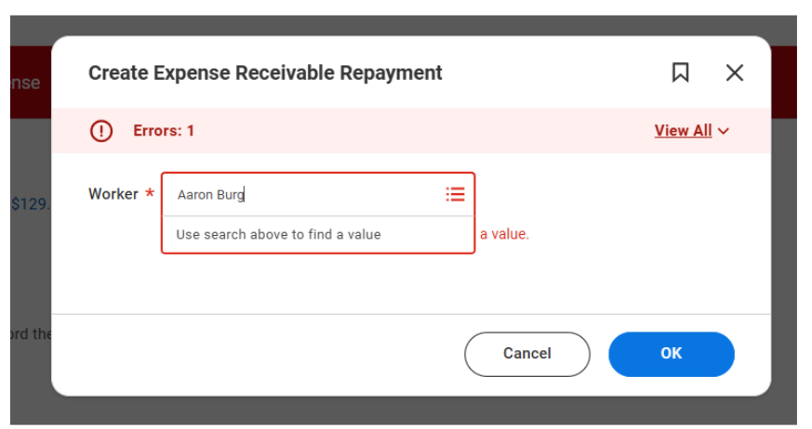

We also migrated a fix last week to this validation message, so that it will now show any expense payee, including ECM's, contingent workers, and employees. This was another concern of Allie's since it wasn't clear to an EDES entering an expense report where the amount due would come from:
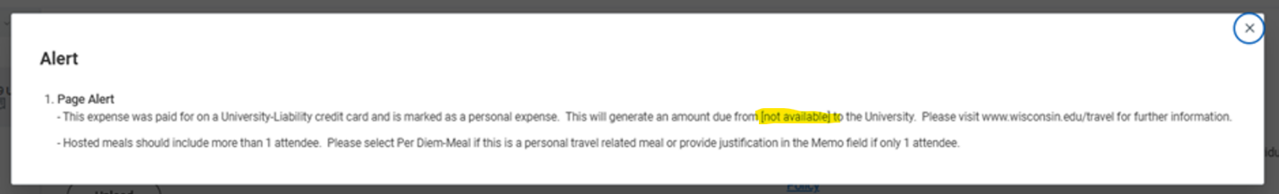
Grant Repayments
The Grants team confirmed last week that any of these Revenue Categories highlighted in pink when paying back the UW from Expenses will be blocked.

Revenue Category Used:
- RC00066 – Personal Expense Receivable recorded in Expense (1307)
  - We don’t allow Personal checkbox to be used on Grant funding so paying back on a grant should not be an issue
- RC00114 – Cash Advance Repayment (1307)
  - This had been blocked by Grants team, but is being opened on Wednesday, Jan 14.
- RC88912 – Post pay or other miscellaneous refund. Payment is made by the recipient
  - Accounting Adjustment off the Grants
  - First have to work with Cost Center Accounting Specialist (or Accountant, Award Billing Specialist) – to do Accounting Adjustment, once complete and the funds are moved off grant, then payback can be processed
- PC88909 – Refund of prior year GPR expense
- Revenue RC – Refund from a third party
  - First have to work with Cost Center Accounting Specialist (or Accountant, Award Billing Specialist) – to do Accounting Adjustment, once complete and the funds are moved off grant, then payback can be processed
  - Grant closed – move to Project, Program or Gift and once off the grant, do Accounting Adjustment
We have created this draft form and believe requesting this form or email version to be completed will be helpful
DRAFT UW Payback of Workday Expenses:
UW Payback of Money Owed from Workday Expenses (Cash Advance or Overpayment by UW /duplicate payments or personal or unallowable charges on a UW Purchasing Card)
Employee to Complete:
Employees Name:
Employee ID:
The Expense Report or Spend Authorization (Cash Advances only) that you are paying money back from:
Total amount paid back to UW:
Amount | Program/Grant/Project/Gift | Cost Center | Fund | Function

If funding was originally on a Grant, work with your Expense Advance Repayment Specialist
How paid back – Cash or Check. If Check include Check #

Bursars office or Central Finance office to complete (Cash Sale Deposit Specialist and Cash Sale Payment Specialist):
Date payment received:
Amount:
Cash/Check – if check list check number:
Revenue Category Used: Select one:
- PC00066 – Personal Expense Receivable recorded in Expense
- RC00114 – Cash Advance Repayment
- RC88912 – Post pay or other miscellaneous refund. Payment is made by the recipient
- PC88909 – Refund of prior year GPR expense
- Revenue RC – Refund from a third party
Please attach this document to the Expense Report
(END OF DRAFT FORM)
Questions for this group:
How to communicate this requirement to the employee on getting these grant adjustments completed before repayment can be processed?
- Is Job Aid sufficient? Should we list the EARS as resources to help?
- Any scenarios you are not sure how to handle we should add to job aids?
- Any more notes from us needed?

Questions for us

