New Non-Employee Request Form Process

Log into SFS
Choose Expenses Tile from Homepage
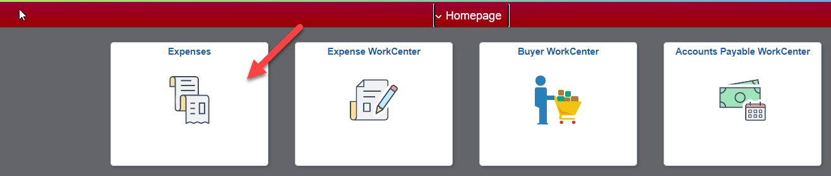
Choose Request Non-Employee Emplid tile
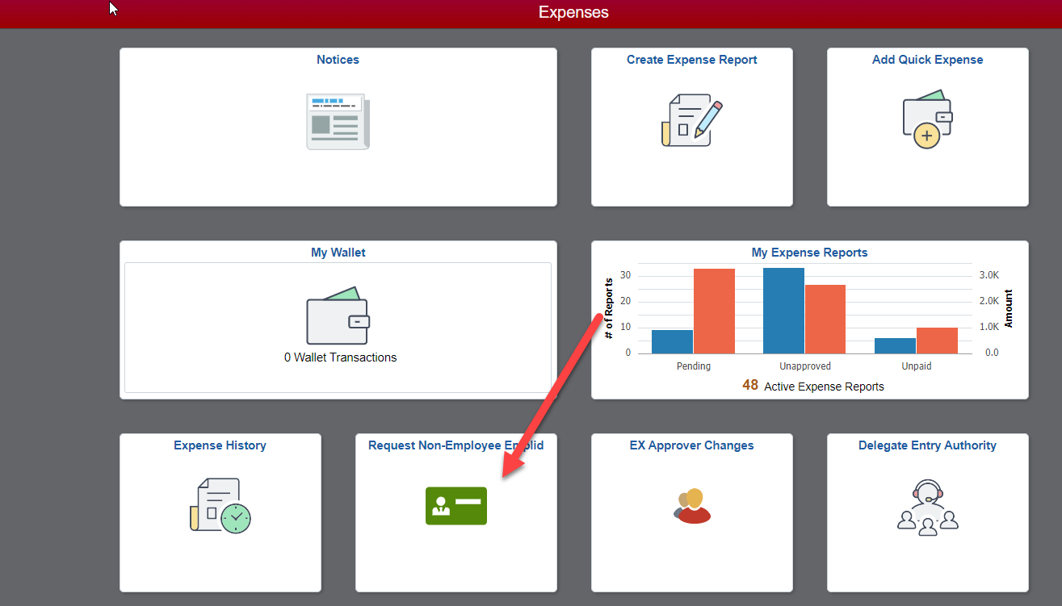

Choose Request Non-Employee Emplid
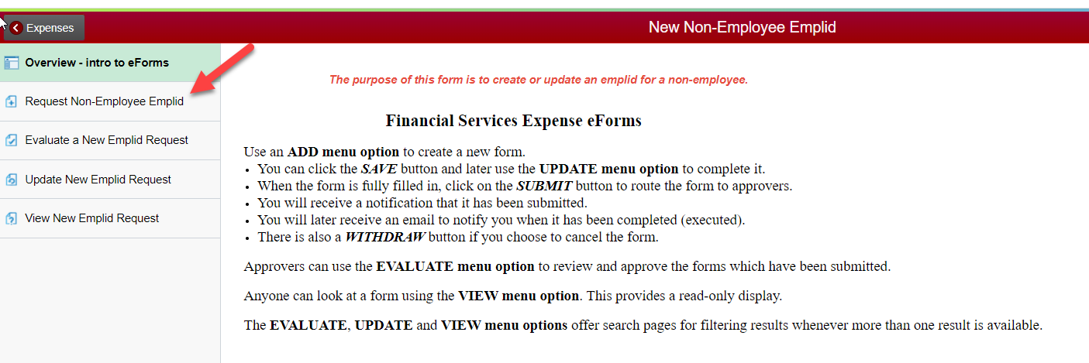
Choose either Add a New Non-Employee or Update an Existing Emplid and fill in all the required fields (have an asterisk).
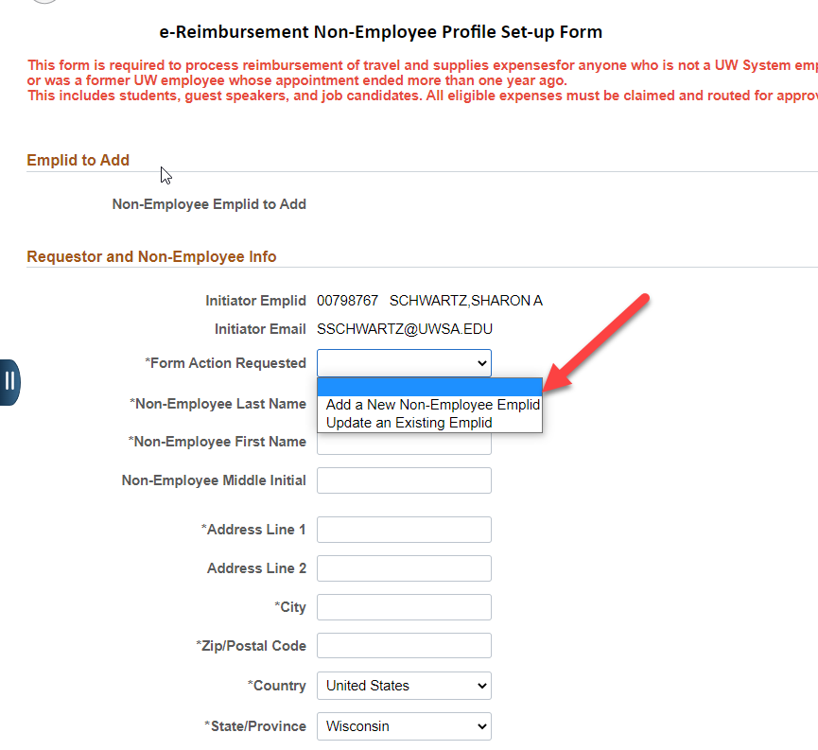
Once completed submit the form. You will receive an email saying the form has been submitted. Once the Non-Employee ID has been created or updated you will receive another email stating that it has been approved.

