Expensing UATP Purchased Airline Tickets – Best Practices

Travel Incorporated Invoice Sample:
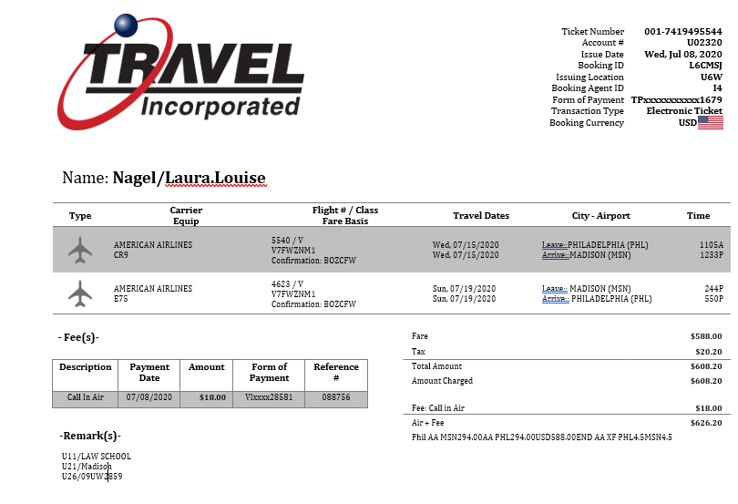
To ensure that the correct funding string is charged for your ticket (purchased with a UATP card), best practice is to complete an expense report that includes both the airfare and Travel Incorporated service fee.

How do I know if a UATP card was used to purchase my ticket?
All Delta, United, American, and Southwest airline tickets will be purchased using the University’s UATP cards until all the funds have been used. To verify that the UATP card was used, look for the Form of Payment line in the upper right-hand corner of the invoice. If the form of payment card shows TP, your airline ticket has been paid for with one of the University’s UAPT cards.
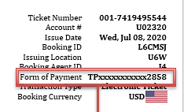

UATP Transactions – Important information
- Airfare and service fees will always be charged to 2 different credit cards – see Travel Inc Invoice Sample on page 1.
- Only airfare can be paid for with a UATP card.
- All campuses, except for UW Eau Claire, will have Travel Incorporated Service Fees charged at the time of ticketing and will require a credit card at the time of booking.
  - Agencies service fees must be paid for with either a University Purchasing card, a US Bank Corporate card, or a personal credit card.
Note: Some campuses do not allow personal credit cards to be used for travel. Please reach out to your campus travel manager with any questions.
- If your Concur profile does not have a credit card designated to ‘airfare’ you will need to provide a credit card at the time of booking to cover the cost of the agency service fee.
- UW Eau Claire service fees will continue to be paid for at the campus level and not passed on to travelers at the time of ticketing.
- Best Practice – include both the service fee and the UATP ticket in your expense report

Expensing UATP transactions
- Review your invoice carefully.
- Locate the Form of Payment field at the top right-hand corner of your Travel Incorporated invoice.
- If UATP card was used for payment, select UATP (UW Prepaid Air Card) as the Reimbursement Method in the Airfare Payment details section of the Expense Report.

Note - Since your credit card has not been charged for this airline ticket, you will not receive reimbursement for it. This information should be added to help ensure that the correct funding string is charged for your ticket. If this information is not added, your default funding may be charged.
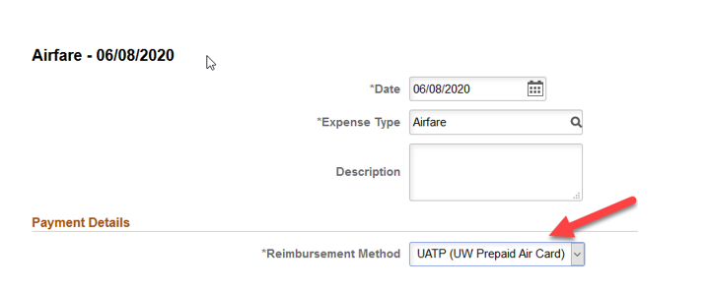
- Add an expense entry for the service fee (other than UW Eau Claire). Do not select UATP (UW Prepaid Air Card) for the service fee. Review your Travel Inc. invoice ‘Fees’ section (see screenshot on page 1) to determine which credit card was used to pay the agency service fee.

