


Counseling Impact Assessment Report
2024-2025

TABLE OF CONTENTS
Acknowledgments 3
Foreword 5
Introduction & Methods 6
2024-2025 Highlights 8
Clinical Services 13
Other Center Services 14
Personnel & Staffing 16
Staff Retention 19
Supplemental Telemental Health & Well-Being Services 23
Conclusion 28
References 29
Appendices 30
Appendix 1: Counseling Use…………………………………………………………………………………………..………….30
Appendix 2: Client Demographic Data………………………………………………………………………………………31
Appendix 3: Client Presenting Concerns and Academic Stress………………………………………………….36
Appendix 4: Mental Health and Alcohol/Drug Use History………………………………………………………..39
Appendix 5: Mental Health and Academic Outcomes……………………………………………………………….41
Appendix 6: Client Satisfaction………………………………………………………………………………………………….46




Acknowledgments

Assessment of the impact of mental health counseling has been occurring for 14 years across the Universities of Wisconsin and is considered a priority for all counseling center professionals who use the data and information to inform and improve their practices and advocate for resources. This comprehensive report would not be possible without the commitment of time and effort from UW universities counseling centers (for providing data), the UW Counseling Impact Assessment Committee (for organizing and writing this report), Universities of Wisconsin Administration (for annual funding of the project) and Catalyst at UW-Stout (for coordinating data aggregation and analysis).
Gratitude is extended to all counseling center staff who work tirelessly to provide effective mental health services in support of student well-being and success.

COUNSELING IMPACT ASSESSMENT COMMITTEE

Crystal Champion, Ph.D., UW-La Crosse
Director, Counseling Services
Chasidy Faith, Ph.D., UW-Stout
Director, Student Counseling Center
Committee Co-Chair
Michelle Gauger, M.S., UW-Green Bay
Executive Director, University Wellness and Student Counseling Services
Stacey Gerken, Ph.D., UW-Stevens Point
Director, Counseling Center
Bjorn Hanson, Ph.D., UW-Madison
Coordinator of Data, Quality, and Informatics
Riley McGrath, Ph.D., ABPP, UW-Eau Claire
Director, Counseling Services
Committee Co-Chair

Data Analyst:
Justin Sullivan, M.S., UW-Stout
Project Manager, Catalyst

Universities of Wisconsin Liaison:
John Achter, Ph.D., UW Administration
Sr. Director of Student Success & Wellbeing
Office of Enrollment and Student Success

COUNSELING CENTER DIRECTORS
Riley McGrath, Ph.D., ABPP, LP, UW-Eau Claire
Director, Counseling Services
Michelle Gauger, M.S., LPC, UW-Green Bay
Executive Director, University Wellness and Student Counseling Services
Crystal Champion, Ph.D., LP, UW-La Crosse
Director, Counseling & Testing
Ellen Marks, Ph.D., LP, UW-Madison
Director, Mental Health Services
Carrie Fleider, MSW, LCSW, UW-Milwaukee
Director, University Counseling Services
Angela Hawley, MSN, UW-Oshkosh
Director, Student Health and Wellness
Renee’ Sartin Kirby, Ph.D., UW-Parkside
Director, Student Health & Counseling Center
Teresa Miller, MSW, LCSW, UW-Platteville
Interim Director, Counseling Services
Mark Huttemier, M.A., LPC, UW-River Falls
Director, Student Health & Counseling
Stacey Gerken. Ph.D., LP, UW-Stevens Point
Director, Student Counseling Center
Chasidy Faith, Ph.D., LP, UW-Stout
Director, Student Counseling Center
Randy Barker, MSE, LPC, UW-Superior
Director for Health, Counseling & Well-Being
Stacey Weber, Ph.D., LP, UW-Whitewater
Director, Counseling Services

Foreword

This annual report presents findings from the fourteenth year of data collection by the Universities of Wisconsin Counseling Impact Assessment Project (UWCIAP). The project tracks a core set of shared data elements across counseling centers, providing benchmark data for each university and allowing for system-level analyses of counseling use and impact.
The UWCIAP, initiated by UW counseling center directors in 2010, was designed to systematically track trends, assess services, and support continuous quality improvement. The data in this report highlight both the effectiveness of counseling and the value students place on these services. Consistent with national research, the findings show that students who improve through counseling are more likely to persist in their education.
Beyond usage data, this report emphasizes key challenges that, if left unaddressed, could undermine the excellent work of our counseling centers. In particular, staffing and salary data demonstrate the need for more equitable staffing levels and market-based compensation for licensed professional staff. Addressing the consistently strong demand for mental health services requires strong institutional support and funding to minimize the impact of mental health concerns on academic performance and student retention.
The report also includes information on the use of extended mental health and well-being resources made available through the Universities of Wisconsin’s partnership with Mantra Health.

Riley McGrath, Ph.D. ABPP, UW-Eau Claire Chasidy Faith, Ph.D., UW-Stout
Committee Co-Chair Committee Co-Chair

Introduction & Methods

INTRODUCTION

Counseling services on university campuses play a vital role in student success, particularly as mental health concerns have become more widely recognized and students continue to seek services at a high rate. Annual data from the Universities of Wisconsin align with national findings showing that more students are entering college with a history of mental health concerns and prior service use.
As previous reports have demonstrated, UW counseling centers make a measurable difference in student outcomes, improving academic performance while fostering essential life skills for managing current and future challenges. Students consistently affirm the value of core services such as individual and group counseling, as well as crisis intervention, prevention education, skills workshops, and campus consultation. Counseling professionals remain responsive to the evolving mental health and well-being needs of their communities. While most students continue to access services in person, expanded telehealth options have further increased accessibility and flexibility.
Note: The data presented in this report represent students who engaged in counseling at UW counseling centers. These findings should not be interpreted as representative of the entire student population.

METHODS

The current report summarizes data collected across all 13 Universities of Wisconsin. The report uses two primary data collection sources summarized in Table 1 below. In addition to these two primary sources of data, counseling center directors responded to survey questions to provide information on service use and staffing.

Table 1: Measures
Client Information Form (CIF)
- A standard intake form created by the Counseling Impact Assessment Committee and first implemented in 2012-2013 | - Uses standardized data set (SDS) items from the Center for Collegiate Mental Health (CCMH), which allows for national comparisons
- Gathers information at counseling intake about presenting concerns, mental health background, and academic functioning | - Consists of varying response scales, depending on type of item; items are reviewed and updated each year to remain consistent with CCMH items
Learning Outcomes and Satisfaction (LOS) Survey
- A survey created by the committee and administered at the end of each semester to students who use counseling services | - Includes an overall measure of satisfaction with services and perceptions of impact of counseling on academic and other areas of life functioning
- Assesses the extent to which counseling was helpful in addressing specific concerns, increasing coping skills, and improving overall well-being | - Consists of the response scales Disagree (1) to Strongly Agree (5) and Poor (1) to Excellent (5)

Universities collect Client Information Form (CIF) data as part of routine clinical practice when student clients first request services. CIF data included in this report are from clients who gave consent to share their data for this purpose. These data are deidentified before sharing with UW-Stout’s Catalyst office at the end of the academic year and then aggregated for reporting purposes. Learning Outcomes and Satisfaction (LOS) surveys are administered at the end of each semester and aggregated at the end of the academic year. Students consent to having their data shared for this report before completing the survey. Table 2 shows the total number of student clients whose data was submitted for each measure, and the number and percentage of total participants from each UW university.

Table 2: Participation in each Measure by UW University
UW University | CIF – Intake  n = 5,385 | LOS - End of Semester  n = 1,128
Eau Claire | 15% (802) | 20% (221)
Green Bay | 4% (211) | 8% (87)
La Crosse | 8% (442) | 9% (98)
Madison | 12% (659) | 6% (61)
Milwaukee | 14% (726) | 3% (30)
Oshkosh | 6% (304) | 8% (94)
Parkside | 1% (32) | 1% (8)
Platteville | 6% (308) | 10% (110)
River Falls | 6% (336) | 2% (21)
Stevens Point | 6% (346) | 3% (33)
Stout | 10% (520) | 18% (202)
Superior | 3% (148) | 2% (25)
Whitewater | 10% (551) | 12% (138)

2024-2025 Highlights

COUNSELING Usage
Student usage of counseling services continues to occur in high numbers, with 13,920 UW students accessing mental health services through UW counseling centers during the 2024-2025 academic year, representing 9.2% of the student population (compared to 9.5% last year). Students attended an average of 5.1 sessions with their counselors this year, similar to recent years. (See Appendix 1, p. 30.)

DEMOGRAPHICS
Female students (58%) attend counseling at a higher rate than male students (33%), but this gap has been narrowing in the past few years. Students who identify as transgender or other nonbinary gender category accounted for 8% of students attending counseling this year, matching the highest percentage since data collection began. Of the students seeking help, 81% identified as White and 19% identified as Students of Color. This is the highest percentage of Students of Color in 13 years and reflects increased racial/ethnic diversity in the student population across UWs in the past several years. Finally, 15% of clients identified with a disability and 40% identified as Lesbian, Gay, Bisexual, or Queer (LGBQ), both higher than national averages. (See Appendix 2, pp. 31-35.)

PRESENTING CONCERNS & ACADEMIC Stress
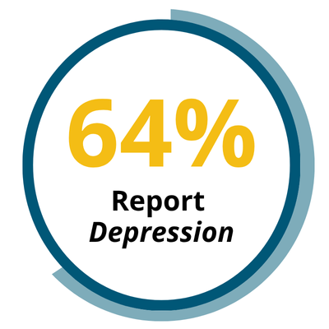
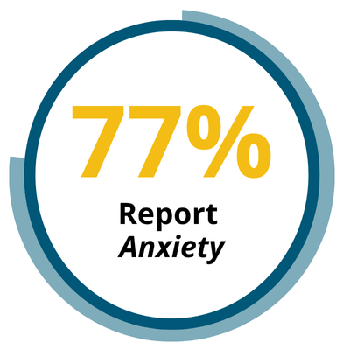
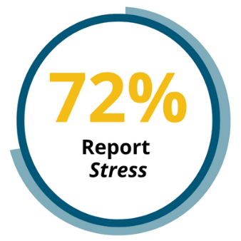
Anxiety (77% of counseling clients), stress (72%), and depression (64%) were the top three reasons students seek counseling, remaining consistent over the past several years. Additional concerns that impact academic performance—procrastination/motivation (52%), low self-esteem/confidence (47%), attention/concentration (44%), and problems related to school or grades (36%)—are all in the top 10 concerns identified by students. (See Appendix 3, pp. 36-38.) This counseling center data is consistent with the most recent population-level data available for UW students, which identified that the top four impediments to academic performance were procrastination, stress, anxiety, and depression (American College Health Association, 2024).

MENTAL HEALTH HISTORY
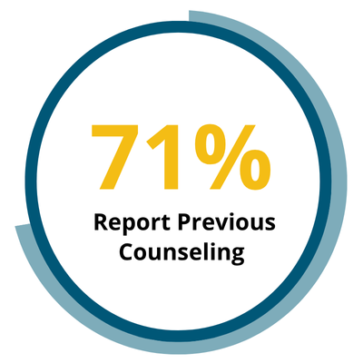
The percentage of UW counseling clients who report a prior mental health history has continued to increase and exceeds national averages. For example, 71% of UW counseling clients reported previous counseling in 2024-25, compared to 63% nationally; and 51% of clients had been prescribed medication for mental health, compared to 39% nationally. Self-reported safety risk indicators among clients also continue to indicate that many UW students who use counseling services experience more serious and complex mental health needs. Notably, 13%, or 700, of the students seen for counseling reported a history of suicide attempts, and 35% (1,855) indicated they had seriously considered suicide. (See Appendix 4, pp. 39-40.) With high percentages of students in the general population reporting a history of anxiety (39%) and depression (30%) diagnoses (American College Health Assessment, 2024), the combined data underscores the continued importance of providing accessible, high-quality mental health counseling to enhance the well-being and safety of individual students and their university communities.

DRUG & ALCOHOL USE/MISUSE HISTORY
The prevalence of problematic alcohol use among students seeking counseling has fluctuated only slightly over the last several years, impacting approximately 22% of clients in 2024-25. Since this report started sharing data on substance use, there has been continued growth in the percentage of students using marijuana, which was reported by 22% of students this year. UW university counseling centers provide screening and support services for students who show evidence of misuse of alcohol or other drugs, but they generally do not provide primary alcohol and other drug treatment. (See Appendix 4, pp. 39-40.)

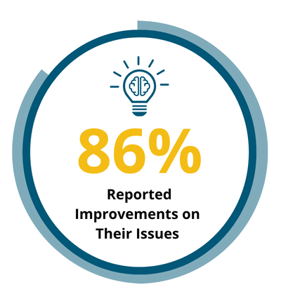
MENTAL HEALTH OUTCOMES
Students continue to experience improvements in multiple areas of functioning due to their participation in counseling. Data from post-counseling surveys this year showed students reporting improvements in specific issues for which they sought help (86% of clients), feeling better prepared to address future concerns and achieve goals (81%), and starting to live a healthier lifestyle in one or more areas (72%). Over three-fourths (77%) of counseling clients reported improved well-being due to counseling. (See Appendix 5, pp. 41-42.)

ACADEMIC OUTCOMES
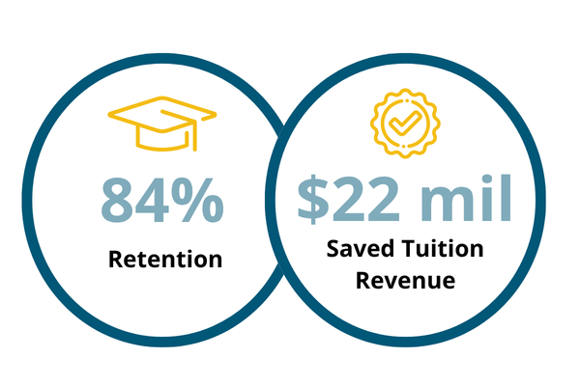
Students struggling with their academics or thinking of leaving school prior to using counseling continue to report that counseling helped them improve their academic performance and remain enrolled, consistent with research connecting emotional well-being to GPA, retention, and graduation (Levines, 2024). Among the 32% of clients who reported struggling academically prior to counseling, 66% reported improved focus on their coursework and 63% reported improved academic performance. Of the 19% who reported thinking of leaving school prior to counseling, 84% indicated counseling helped them remain in school—the highest percentage in 13 years. This represents an estimated 2,222 students across the Universities of Wisconsin that counseling centers helped retain in 2024-25, accounting for approximately $22 million in saved tuition revenue (based on average in-state tuition). (See Appendix 5, pp. 43-45.)

CLIENT SATISFACTION
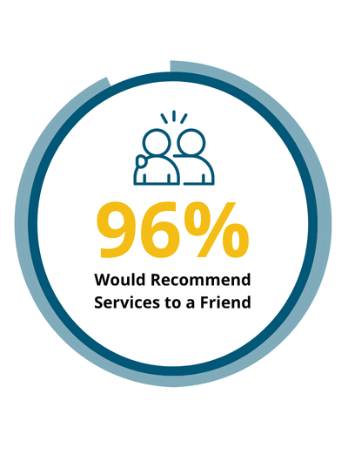
Universities of Wisconsin students attending counseling continue to report very high satisfaction with services, with 92% indicating they would return in the future and 96% saying they would recommend services to a friend. Client ratings of appointment availability remained strong this year, with 89% of clients reporting ability to secure their first appointment in a timely manner and 87% reporting timely access to follow-up appointments. Counseling clients (95%) consistently indicate that it is important to have counseling services located on campus. While telecounseling continues to be offered as an option for students through university counseling centers, 92% of clients using counseling services on campus prefer in-person sessions to telecounseling. (See Appendix 6, pp. 46-47.)

Other Center Services
Beyond core clinical services, counseling center clinicians also provide mental health expertise and guidance across their campus communities. Examples of these contributions include leadership on campus committees that address student mental health, well-being, and behavior; individual consultation to faculty and staff when they are concerned about student behavior or well-being; education and prevention programming to faculty, staff, and students in support of student well-being and creating a campuswide culture of care; and partnerships with athletic departments to meet NCAA mental health guidelines that include screening student athletes for mental health concerns. Clinicians also contribute to graduate programs and the counseling profession as a whole by supporting counselors-in-training with clinical supervision and education. This range of activities and responsibilities embeds university counseling center professionals into the fabric of the university community and distinguishes their work from counterparts working in other mental health settings outside higher education.

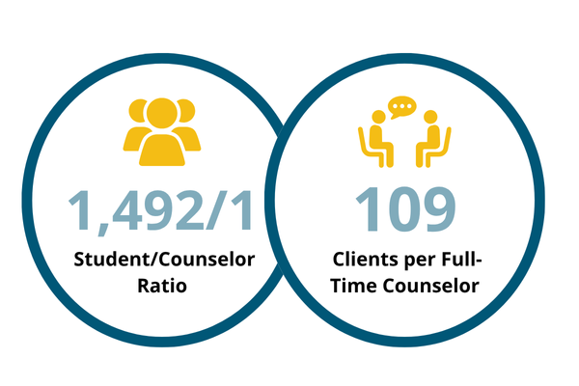
PERSONNEL & STAFFING
Staffing levels are a critical factor in a counseling center’s ability to provide timely and effective services and to retain students who might otherwise leave college early. The recommended student-to-counselor ratio in a high usage environment is 1,000:1. In 2024-25, five out of 13 UW counseling centers met the 1,000:1 standard, and eight had ratios higher than this threshold. The average student-to-counselor ratio was 1,492:1. An additional metric for assessing staffing and service levels, the Clinical Load Index (CLI), showed an average of 109 clients per full-time counselor this year, compared to 107 last year. This is above the national average of 92 for centers nationwide (CCMH, 2024). Ten of 13 UW counseling centers had a CLI above the national average.

STAFF RETENTION
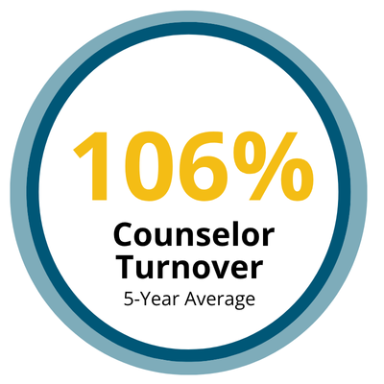
Staff retention remains a critical concern at Universities of Wisconsin counseling centers. The average counselor turnover across centers in the past five years was 106%, with two UW counseling centers experiencing over 200% turnover, four experiencing over 100%, and two others turning over 75% or more of their staff. At the same time, applicant pools remain small and increasingly composed of newer, unlicensed professionals who require significant supervision before they can practice independently. Salaries are consistently cited by directors as both the leading cause of staff departures and the main barrier to hiring licensed, experienced clinicians. Recruitment and retention challenges contribute to demand for services exceeding capacity, limiting student access, and reducing overall service effectiveness. Increasing both clinical FTEs and salaries to remain competitive in the market would strengthen access, reliability, and quality of services to better meet student needs.

TELEHEALTH SERVICES
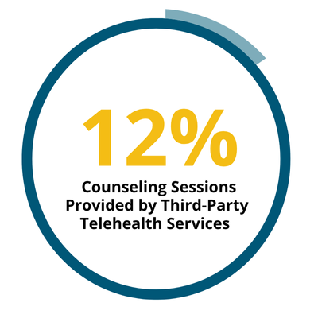
Students have the opportunity to use telehealth services from their on-campus counseling centers as well as through Mantra Health (at 12 UW universities) or Uwill (at UW-Madison). More than 2,400 students attended telecounseling services offered through Mantra Health and Uwill this year, with total sessions attended representing 12% of all university-funded counseling services used by UW students this year. The Mantra Health contract also included telepsychiatry (used by 377 students), a 24/7 mental health support service (fielding over 200 calls), YOU at College, a personalized well-being platform (accessed by over 5,000 students), and Togetherall, a professionally monitored peer support service (used by over 1,000 students). Finally, five UW universities (UW-Eau Claire, UW-Parkside, UW-Platteville, UW-River Falls, and UW-Stevens Point) piloted Mantra’s Whole Campus Care, which added emotional well-being self-help modules, well-being skills coaching, and on-demand video emotional support to the suite of available services. Over 2,000 students at participating UW universities completed a level of care assessment in the Mantra Care Hub to get recommendations on the best resources and services to meet their needs.

Clinical Services

Counseling centers across the 13 Universities of Wisconsin offer a broad range of clinical services designed to support student mental health and well-being. All campuses provide free, short-term individual counseling, often using a brief, solution-focused model to address common concerns such as anxiety, depression, stress, identity development, and academic challenges. Most centers also offer group counseling and psychoeducational workshops on topics like mindfulness, stress management, and self-care. Crisis and urgent care services are widely available, including same-day or drop-in appointments and after-hours support through on-call systems or third-party partnerships. Couples or relationship counseling is offered at many campuses when at least one partner is a currently enrolled student. Several UW counseling centers provide specialized assessments, such as for ADHD, alcohol and drug use, and eating disorders. Students in need of longer-term or off-campus specialized care can receive case management and referral support.
Counseling centers also play a key role in the broader campus community by offering consultation services to faculty, staff, and student leaders on how to support students in distress. Some campuses serve as clinical training sites, with graduate student clinicians providing therapy under the supervision of licensed practitioners. While services may vary by location, all UW universities are committed to providing comprehensive, accessible mental health care tailored to the needs of their student populations.
Client satisfaction and outcome data is collected through the Learning Outcome and Satisfaction Survey that is sent to all clients at the end of fall and spring semesters. In addition to containing several rating-scale questions, the survey has several open-ended questions. One prompt asks students to reflect on the most helpful aspects of their counseling experience. Notably, 33% of the responses this year were related to the safe and nonjudgmental space that counseling provided and 27% of responses commented on the value of having someone to talk to confidentially. Other student comments referred to receiving new perspectives, feeling understood and validated, learning new coping skills, accessibility and convenience, and professional guidance provided.
Sample comments supporting these themes:
- “Ability to just talk judgment free”
- “Having someone to listen to me”
- “Helped me learn to regulate my emotions”
- “It was free and located on campus”
- “The most wonderful support system in dealing with various problems...I feel so welcome and open every time I arrive to the counseling center”
- “Having someone that listens to my problems and allows me to understand why I feel that way, providing helpful feedback”
Another prompt asks students to reflect on the least helpful aspects of their counseling experience. The two most common themes for critical feedback have been consistent across recent annual reports: (1) infrequency of appointments and limited availability (34%) and (2) N/A, or no negative feedback provided (33%). Students commented on long gaps between sessions, difficulty securing regular or timely appointments, and staff shortages making it difficult for them to get the support they needed and make progress in counseling. Many students said they wanted more frequent and longer sessions.
Sample comments supporting these themes:
- “Wish I could have more frequent sessions”
- “Can’t think of anything”
- “I understand that many people are utilizing services, but it would be helpful to have longer time talking with my counselor, or more meetings closer together.”
- “I wish it was offered once a week”
- “We need more counselors”

Other Center Services

Outreach and Faculty/Staff Training

UW counseling centers engage in a wide range of outreach activities aimed at promoting mental health awareness, reducing stigma, and connecting students to services. Common outreach efforts include classroom presentations, often integrated into first-year seminar courses or general academic classes, covering topics such as mindfulness, suicide prevention, and general awareness of mental health services available to students.
Counseling center staff frequently provide training for key student leaders, including resident assistants, peer mentors, tutors, success coaches, and athletic teams. These trainings often focus on suicide prevention (for example, Question, Persuade, and Refer (QPR), Campus Connect), mental health literacy, and how to support peers in distress. Centers also maintain a strong presence at campus-wide events such as orientation fairs, wellness fairs, and open houses through tabling and interactive booths.
In addition, mental health screenings and psychoeducational workshops are regularly offered to increase awareness and early identification of concerns. Specialized programs like "Let’s Talk" drop-in consultations, “Ask a Therapist” initiatives, the Learning Is For Everyone (LIFE) program for students with disabilities, and identity-focused initiatives such as Barbershop Talks and community panels further expand the reach and accessibility of mental health support. Counselors are also involved in debriefing sessions following student deaths and other campus crises, providing both emotional support and psychoeducation to affected communities. In addition to outreach provided to the student population, many centers also provide mental health training to faculty and staff.

Committee Work
In addition to providing clinical and outreach services, counseling center staff are engaged in a wide range of university and system-level committees, task forces, and advisory groups, reflecting a strong commitment to integrated mental health support, student success, and institutional collaboration. A common theme across UW counseling centers is active participation in student support and crisis prevention/response teams, variously titled Behavioral Intervention Teams (BIT), Students of Concern Teams, Threat Assessment Teams, and CARE Teams—all of which address emerging behavioral and safety concerns.
Staff also contribute significantly to health and wellness committees, including campus wellness advisory boards, alcohol and other drug (AOD) committees, suicide prevention coalitions, employee wellness groups, and equity in mental health initiatives (for example, in collaboration with the Steve Fund national organization). Many centers also have roles in student affairs and academic policy groups, such as medical withdrawal committees, housing accommodations committees, academic appeals boards, and student healthcare advisory teams.
Additionally, staff are involved in multiple inclusivity efforts, like Pride Center partnerships, and maintaining a presence in multicultural spaces and activities specifically intended to promote broad inclusion. There is also substantial involvement in the university systemwide and statewide initiatives, including the Universities of Wisconsin Counseling Impact Assessment Committee (the committee that produces this report) and the President’s Advisory Committee on Mental Health and Well-Being.
Furthermore, centers contribute to campus planning and strategic development, through participation in strategic planning committees, emergency operations teams, and retention-focused workgroups. Finally, they support their universities through educational initiatives and professional development, including serving as host sites for graduate interns, providing training and consultation for faculty and staff, and coordinating campus-wide outreach.

TRAINING for COUNSELORS
Mental health professionals working at UW university counseling centers include licensed psychologists, counselors, social workers, and marriage and family therapists. In addition to employing professional credentialed staff, many centers also serve as training sites for graduate students seeking counseling-related degrees and hire staff who are in the process of accruing the clinical hours necessary for their license to practice independently.
These non-licensed individuals provide much-needed expansion of clinical and other service capacity—and they also require weekly clinical supervision. The clinical documentation of unlicensed staff needs to be reviewed and signed by licensed clinicians with proper credentials. For a supervisor with one supervisee who provides 25 clinical hours per week, supervision would involve reviewing and signing off on a minimum of 25 clinical notes per week and meeting for one hour of clinical supervision. With the amount of professional staff turnover experienced by counseling centers in recent years (detailed in the next sections), some supervisors within UW counseling centers have supervised up to six clinicians in training at the same time, resulting in as many as 150 notes to review each week. This is a significant administrative workload on top of providing the full range of services described above.

Personnel & Staffing

STAFFING LEVELS
The number of professional staff relative to university enrollment is a critical indicator of a counseling center’s ability to provide timely and effective services. This annual report has been tracking the ratio of students to counselors at UW universities for the past decade, displayed in Figure 1. According to standards established by the International Accreditation of Counseling Services (IACS, 2023), “Reasonable effort should be made to maintain minimum staffing ratios in the range of one FTE professional staff member (excluding trainees) for every 1,000-1,500 students” (p. 15). A high student-to-counselor ratio results in fewer appointments available for students. Higher ratios also increase the pressure felt by clinical staff to meet student needs without sufficient resources, which can lead to burnout.
Note in Figure 1 that the student-to-counselor ratio has improved over time but remains above the 1,000:1 ratio that is preferred in a high usage environment. The improved ratio has been the result of adding to the overall numbers of positions, combined with decreased enrollment at some UW universities.

Figure 1: 10-Year Trend: Average Ratio of Students to Counselors
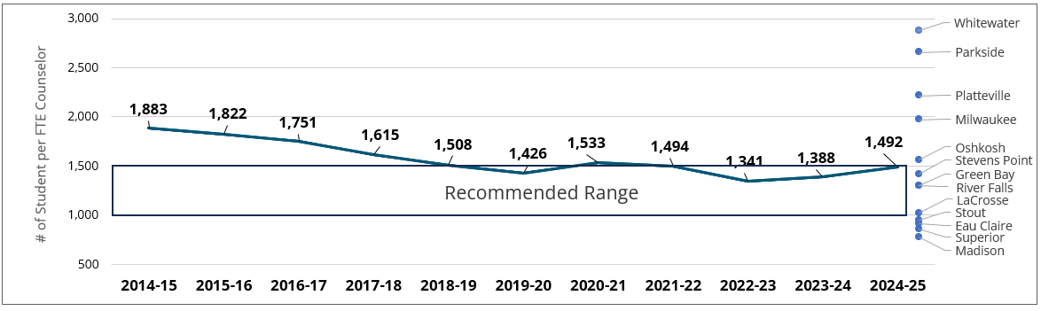

Figure 1 Description: Line graph depicting the student to counselor ratio from 2014/15 to 2023/24: 2014/15 1,883; 2015/16 1,822; 2016/17 1,751; 2017/18 1,615; 2018/19 1,508; 2019/20 1,426; 2020/21 1,533; 2021/22 1,494; 2022/23 1,341; 2023/24 1,388; 2024/25 1,492.

Figure 1 also illustrates that the improvement in student-to-counselor ratios has not been consistent across UW universities. In 2024-2025, five UW counseling centers met the 1,000:1 ratio, while five universities remained above the 1,500:1 ratio. This variation leads to significant differences in how many students can be served and the level of service provided across the UWs. The ten-year trend of students to counselors by university can be found below in Figure 2.

Figure 2: Ten-Year Trend: Ratio of Students to Counselors by University

Campus | 2015 | 2016 | 2017 | 2018 | 2019 | 2020 | 2021 | 2022 | 2023 | 2024
Eau Claire | 1599 | 1526 | 1312 | 1544 | 1100 | 1205 | 1084 | 884 | 889 | 884
Green Bay | 1983 | 2816 | 2840 | 2224 | 1944 | 2847 | 2041 | 1724 | 1331 | 1271
La Crosse | 1706 | 1573 | 1566 | 1568 | 1229 | 1190 | 984 | 1689 | 1172 | 990
Madison | 1636 | 981 | 951 | 830 | 708 | 867 | 902 | 1417 | 1125 | 750
Milwaukee | 2952 | 2252 | 2187 | 2134 | 1991 | 2747 | 2002 | 1781 | 1943 | 1940
Oshkosh | 1441 | 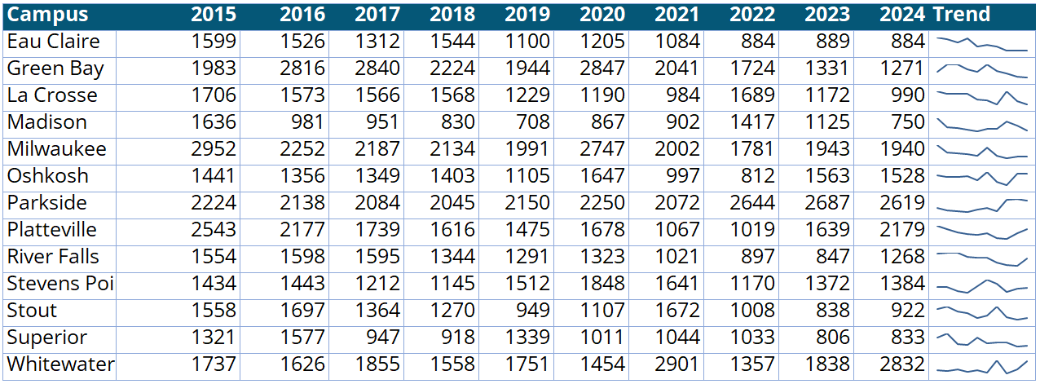  1356 | 1349 | 1403 | 1105 | 1647 | 997 | 812 | 1563 | 1528
Parkside | 2224 | 2138 | 2084 | 2045 | 2150 | 2250 | 2072 | 2644 | 2687 | 2619
Platteville | 2543 | 2177 | 1739 | 1616 | 1475 | 1678 | 1067 | 1019 | 1639 | 2179
River Falls | 1554 | 1598 | 1595 | 1344 | 1291 | 1323 | 1021 | 897 | 847 | 1268
Stevens Point | 1434 | 1443 | 1212 | 1145 | 1512 | 1848 | 1641 | 1170 | 1372 | 1384
Stout | 1558 | 1697 | 1364 | 1270 | 949 | 1107 | 1672 | 1008 | 838 | 922
Superior | 1321 | 1577 | 947 | 918 | 1339 | 1011 | 1044 | 1033 | 806 | 833
Whitewater | 1737 | 1626 | 1855 | 1558 | 1751 | 1454 | 2901 | 1357 | 1838 | 2832

An additional metric used to provide perspective on appropriate staffing and service levels for counseling centers is the Clinical Load Index (CLI), which was developed through a partnership between the Center for Collegiate Mental Health (CCMH), the International Accreditation of Counseling Services (IACS), and the Association for University and College Counseling Center Directors (AUCCCD). The CLI is a standardized metric that is most easily understood as the average annual caseload for a full-time counselor at a given center. Instead of focusing exclusively on full-time equivalent (FTE) staffing levels, the CLI considers the actual number of students seeking services (counseling center usage) and the amount of “clinical capacity” (weekly appointment availability) to calculate a score that describes the relationship between the supply and demand for counseling services at any given center. CLI numbers at UW universities are summarized in Table 4, along with other metrics important for assessing counseling center staffing and service levels. The average CLI across UW universities in 2024-2025 was 109, which compares to 92 for centers nationwide (CCMH, 2025). This equates to the average full-time counselor at a UW counseling center providing services to 109 individual students over the course of an academic year. Note that CLIs across UW counseling centers ranged from a low of 80 to a high of 165.

Table 4: University Breakdown of Usage, Avg. Sessions, Student/Counselor Ratio, & CLI
University | % of Total Enrollment Served (2024-2025) | Avg. Session Attendance (2024-2025) | Student/ Counselor Ratio (2024-2025) | Clinical Load Index (CLI) (2024-2025)
Eau Claire | 12.0% | 5.8 | 884 | 80
Green Bay | 9.9% | 4.9 | 1271 | 123
La Crosse | 6.0% | 3.4 | 990 | 80
Madison | 11.3% | 3.0 | 750 | 122
Milwaukee | 7.2% | 4.7 | 1940 | 159
Oshkosh | 10.3% | 6.4 | 1528 | 165
Parkside | 2.0% | 5.7 | 2619 | 82
Platteville | 6.8% | 3.7 | 2179 | 110
River Falls | 10.4% | 3.5 | 1268 | 112
Stevens Point | 7.4% | 6.7 | 1384 | 93
Stout | 10.4% | 6.8 | 922 | 94
Superior | 8.0% | 6.3 | 833 | 96
Whitewater | 7.3% | 5.0 | 2832 | 107
All UWs | 9.2% | 4.3 | 1492 | 109

The Center for Collegiate Mental Health (CCMH) classifies Clinical Load Index (CLI) scores as Low (<62), Mid (62–139), or High (>139). Among Universities of Wisconsin counseling centers, none fall in the Low category, 11 fall in the Mid-range, and two are in the High range. Low CLI centers, typically at smaller institutions, can offer full-length intakes, weekly individual counseling, and minimal wait times, all of which have been found to lead to greater symptom reduction. Mid CLI centers—where most UW institutions fall—begin to experience demand exceeding supply at certain times, resulting in reduced access to weekly individual counseling, and increased use of triage screenings, case management, rapid-access services, session limits, and expanded group options. High CLI centers tend to operate under the greatest supply/demand imbalance, leading to a greater focus on rapid access and crises-oriented services, diluted treatment with poorer outcomes, and elevated staff stress as they prioritize efficiency and broader referral pathways over routine weekly therapy (CCMH, 2020).

The interplay between staffing ratios and CLI can provide a more nuanced picture of what is happening at any given counseling center. To present an extreme example, note that the percentage of the student population receiving services at UW counseling centers ranged between 2% and 12%. The center that served 2% of their students, UW-Parkside, had a staff-to-student ratio of 1:2,619 (well above the recommended ratio) and a CLI of 82 (below average for UW centers), whereas the center that served 12% of its students, UW-Eau Claire, had a ratio of 1:884 (below the recommended ratio) and a CLI of 80 (very similar to UW-Parkside). These universities are very different in terms of residential vs. commuter populations and, despite much different staffing levels and usage rates, were able to serve the students who sought services at approximately the same level (5.7 and 5.8 sessions per student, respectively).

What this example highlights is that, while generalizations about staffing ratios and clinical capacity are helpful to consider, each university must review its own data within their local context to determine the appropriate level of resources needed to provide the type of service they want available to their students, while also ensuring manageable workloads for clinical staff.

Staff Retention

Counseling centers across the Universities of Wisconsin and nationally continue to express concerns about counselor retention and difficulties filling open positions. In 2024-2025, UW counseling centers had a total of 21 clinical positions turnover, with one university losing eight clinicians, another losing three, three universities losing two clinicians, four universities losing one clinician, and four universities retaining all of their clinicians. This represents a slight improvement from the previous two years, but still a concerning trend. Examining counselor turnover across the past five years (see Figure 3), two UW counseling centers experienced an extreme amount of turnover: 225% and 233%, respectively. Four centers reported 100%-133% turnover, two reported between 57-75% turnover, and two reported a five-year turnover average of 33% or lower.

Figure 3: Five-Year Staff Turnover

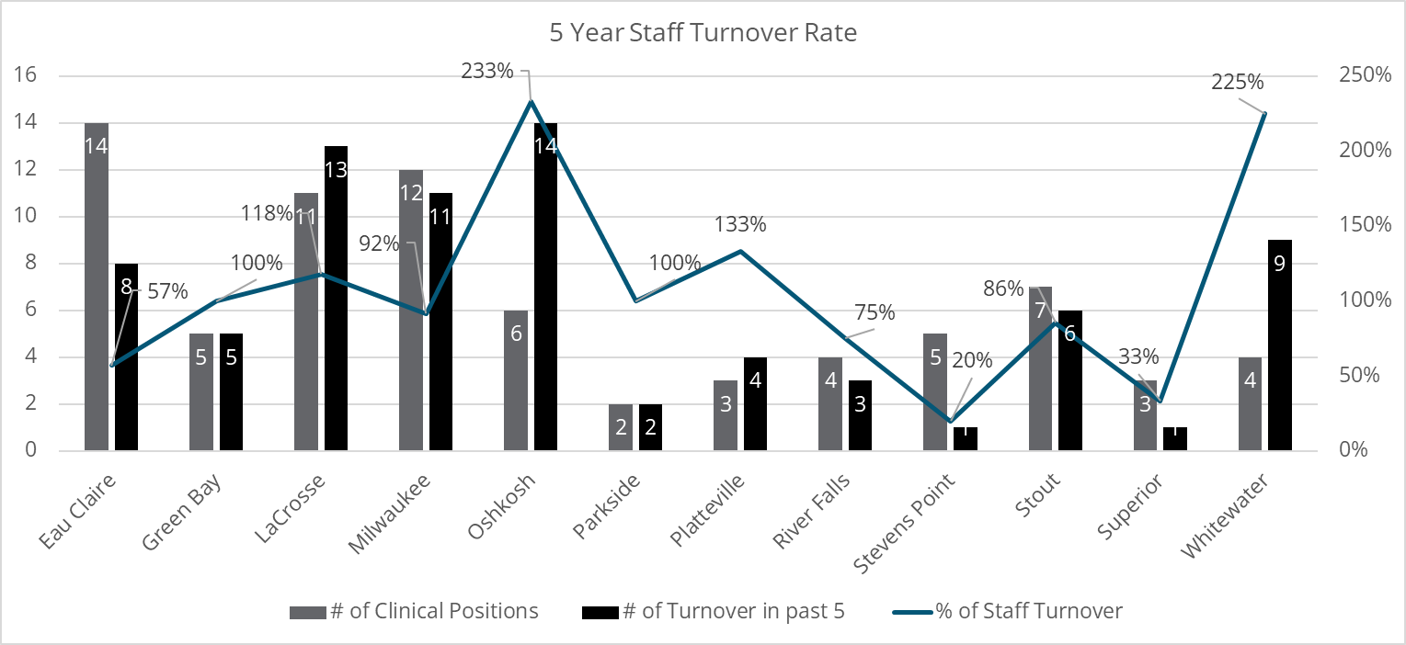

Staff turnover in UW counseling centers has led to a range of challenges that impact both service delivery and organizational health. Persistent turnover increases clinical workload for remaining staff, extends wait times and disrupts continuity of care for clients, reduces institutional knowledge and established campus partnerships, and weakens clinical supervision capacity. Turnover has also added to the issue of decreased staff diversity, as centers struggle to retain or recruit seasoned and diverse clinicians, instead filling roles with early-career professionals who require additional oversight, thereby further straining existing resources. These challenges contribute to low staff morale and organizational strain, as remaining staff face expanded responsibilities, ongoing restructuring, and burnout risk.
Budget constraints have also led to delayed hiring approvals or eliminated positions, worsening access to services even as demand remains high. One UW counseling center noted that it took over a year of advocating before securing permission to search for an open counselor position, due to the dire financial landscape of the university. Others reported losing positions due to budget shortfalls at their universities. While budget and staffing issues impact other student services offices across UW universities, they can have a differential impact on counseling centers due to the continued high demand for mental health services, even at universities where enrollment has been flat or declining.
Similar to last year, salary was reported as the primary driver of turnover and the biggest barrier to hiring open positions. Starting salaries and salaries for more experienced UW counseling staff continue to fall below national averages. Table 5 summarizes average annual salaries at UW counseling centers compared to national data published by the Association of University and College Counseling Center Directors (AUCCCD, 2025).

Table 5: Average Annual Salaries for University Counselors and Psychologists
 | Starting Salary Averages¹ |  | Overall Salary Averages
Position | UW | National | UW | National
Clinical Counselor | $60,122 | $73,893 | $68,500 | $73,893
Clinical Counselor in training (LPC-IT, APSW, LMFT-IT) | $57,944 | NA | $61,474 | NA
Psychologist | $75,000 | $86,660 | $79,379 | $90,980
Associate Director | NA | $97,725  (1-5 years of experience) | $89,500 | $104,748
Assistant Director | NA | $68,107 | $80,625 | $89,602
Director | NA | $110,597  (1-5 years of experience) | $113,329 | $116,723

With 12-month salaries already below benchmark comparisons, the use of 10-month contracts at many UW universities further suppresses compensation for UW counseling professionals. In addition, UW counseling centers note that pay discrepancies are even wider outside of the university setting and, as a result, staff more often leave for higher-paying community mental health positions rather than leaving for roles at other universities.
Not visible in the salary data, but likely an outcome of budget considerations faced by many UW universities, is the fact that only six UW counseling centers have one or more psychologists on staff. The lack of psychologists is an additional concern, because they possess advanced training in assessment, clinical supervision, and therapy and can provide clinical supervision to multiple disciplines (for example, psychologists, counselors, social workers, and marriage & family therapists), which is not the case for other mental health professionals. This decline in the diversity of professional credentials further exacerbates the stress put on counseling center staff and represents a culture shift from prior decades when more psychologists were employed at university counseling centers.
Finally, in addition to overall staff turnover, there has been a concerning trend of counseling center director turnover at UW counseling centers—with 85% director turnover in the last 10 years. While reasons for this vary, current directors note that the stress created by consistent staff turnover has undoubtedly contributed to making the director position more difficult. In addition to clinical and supervisory roles, directors are administratively responsible for supporting a healthy work environment, managing budgets with limited resources, and advocating for equitable and accessible services on campus, often with only indirect influence on university-level decision-making. Attention to work stressors and salary compression at the director level is an additional important factor to monitor to gain more stability in counseling center leadership and staffing in the future.
Centers have implemented a range of strategies to improve staff retention, satisfaction, and overall organizational functioning: advocating for pay adjustments (especially once a staff member is licensed), expanding contract lengths, offering flexible summer scheduling and some remote work, investing in recognition and workplace culture, and building opportunities for career development and advancement. Some centers are also exploring reduced full-time equivalent (FTE) options that support better work-life balance without sacrificing compensation. Finally, directors agree that their roles in communication and advocacy are critical, and that staff report higher morale when leadership communicates transparently, validates frustrations, and involves them in shaping their roles, even when broader systemic changes are not completely within their control.
Despite the ongoing staffing challenges, it is important to point out that many clinicians do choose to remain long-term in their roles. Five UW counseling centers reported having clinical staff who have been in their roles for 17 years or more, with the longest serving clinician employed for more than 25 years. Work satisfaction, strong team culture, flexibility, and attractive state benefits tied to longevity, including pension vesting and expanded leave accrual over time, are cited as reasons these staff decide to stay.

IMPLICATIONS & Recommendations
A collaborative analysis by AUCCCD and CCMH (Gorman & Scofield, 2023) found that growing student demand for mental health services—without parallel increases in staffing—drives higher clinician caseloads and forces counseling centers to modify their clinical models. This validates the experience of UW counseling centers in recent years. Demand is expected to remain high for some time, as data from both high school (CDC, 2024; WI DPI, 2024) and college surveys show rising psychological distress. At UW universities, 19% of students who completed the 2024 National College Health Assessment (ACHA, 2024) screened in the “high distress” range, more than double the 9.2% who currently access counseling services—indicating that many students with significant needs may not be receiving care. For centers already operating with high counselor-to-student ratios and/or elevated CLI scores, a sustained supply–demand imbalance could further increase caseloads, weaken treatment outcomes, and heighten work stress, making staff recruitment and retention even more difficult.
To improve staff retention and service quality, UW must prioritize market-competitive compensation, manageable workloads, and supportive conditions for both clinicians and directors, particularly as high student distress and demand for services persist. Addressing these issues would be a clear strategy in support of the student success and well-being goals embedded in both individual university and systemwide strategic plans.

Supplemental Telemental Health & Well-Being Services

Since the 2022-23 academic year, all UW universities have expanded access to student mental health resources through incorporation of telehealth services. Madison has funded its own third-party telehealth services, while the other 12 UWs have shared services funded by a $5 million grant of American Rescue Plan Act (ARPA) funds, allocated as part of Governor Evers’ “Get Kids Ahead” initiative.
The supplemental services at UW-Madison focused exclusively on the expansion of counseling services through telecounseling, via a contract with Uwill. The scope of services was broader at the other 12 UWs through a master contract with Mantra Health, including mental health treatment expansion (telecounseling and telepsychiatry) as well as evidence-based self-help resources, peer support, and a 24/7 support service. This full range of Mantra resources was made available at all 12 UWs, with each university determining the best way to market them based on their local campus context.
During the 2024-25 academic year, the final year of the ARPA-funded contract, all 12 universities also gained access to Togetherall, an anonymous, professionally moderated, peer-support service, and five UWs (UW-Eau Claire, UW-Parkside, UW-Platteville, UW-River Falls, and UW-Stevens Point) participated in a pilot of Mantra Health’s more comprehensive mental health support program, entitled “Whole Campus Care.” Whole Campus Care (WCC) includes on-demand video emotional support as well as a suite of well-being skills modules and access to wellness coaching, as options for students who may not want or need more intensive clinical services.

USE & IMPACT
YOU at College - YOU at College continued to be available as a self-help platform within the Mantra contract in 2024-25. As an upstream resource and the “digital front door” to both on-campus and online resources available to students, this tool has the broadest applicability to the entire student population. In total, 5,287 student accounts were created in 2024-25 across the 12 participating universities, and 9,275 over the course of three years. Below are the top priorities students established during their onboarding within the YOU platform, which informs the content that is recommended to them:

- Academics & Grades
- Stress & Anxiety
- Relationships & Making Friends
- Mindfulness and Balance
- Sleep
- Fitness & Nutrition
- Finances & Basic Needs
- Internships & Career
The platform has been helpful in directing students to resources to meet their needs, with students viewing 3,015 resources within the YOU platform and 885 campus resources this year. Students also accessed other components of the telehealth contract through the YOU platform, such as Mantra Health (260 students) and 24/7 support services (210 students). Students averaged 7.81 interactions in the platform, which could include completing self-check assessments, setting goals, reading content, using the crisis button, and working through a de-stress module.
UW Mental Health Support 24/7 – In Fall 2024, Mantra Health took over management of the 24/7 mental health support service previously delivered by a subcontracted third-party provider. This change led to a better overall customer service experience. Access to 24/7 phone support was retained in this transition; however, the text-messaging option was lost. Students at all 12 participating UWs were able to access 24/7 phone support, and those attending one of the five WCC pilot campuses also had access to on-demand video support for 12 hours each day (11 a.m.-11 p.m.). Table 7 summarizes usage of these services for 2024-25.

Table 7: UW Mental Health Support 24/7 Usage: July 2024-June 2025
 | Student Contacts
Telephone | 175
On-demand Video | 41

Mantra Health Clinical Services – A central goal of contracting with a telehealth provider was to increase access to counseling and psychiatry services, including providing greater treatment capacity, serving a wider range of student identities, providing evening and weekend appointments, and being available to students with limited access to on-campus services (for example, online, commuter, and out-of-state students).
A total of 1,486 unique students attended counseling and/or psychiatry appointments with Mantra providers in 2024-25. As shown in Table 8, 1,273 students attended counseling appointments and 377 attended psychiatry appointments, with 164 students receiving a combination of both services. The average number of counseling sessions attended with Mantra providers (4.9) was similar to the average session attendance for on-campus counseling (5.1) across UWs. The most common presenting concerns were also similar to students accessing on-campus care (for example, anxiety, depression, stress, relationships).

Table 8: Mantra Health Service Use July 2024-July 2025
Care Type | Unique Students Served | Completed Appointments | Average Session Attendance
Telecounseling | 1,273 | 6,287 | 4.94
Telepsychiatry | 377 | 1,732 | 4.59
To get a picture of the amount of additional clinical access provided by telehealth services, Figure 4 displays the number and proportion of counseling sessions attended on-campus compared to counseling sessions attended via telehealth. Madison’s telecounseling appointments through Uwill are also included in this graph. Across all 13 universities, 12.3% of all university-funded counseling sessions for students were provided by telehealth extension services, with the remaining provided by on-campus counseling services.

Figure 4: Number and Percentage of Counseling Sessions Provided by On-Campus and Telehealth Providers
Campus | Mantra Health and Uwill Sessions | On-Campus Sessions
Eau Claire | 6581 | 608
Green Bay | 3137 | 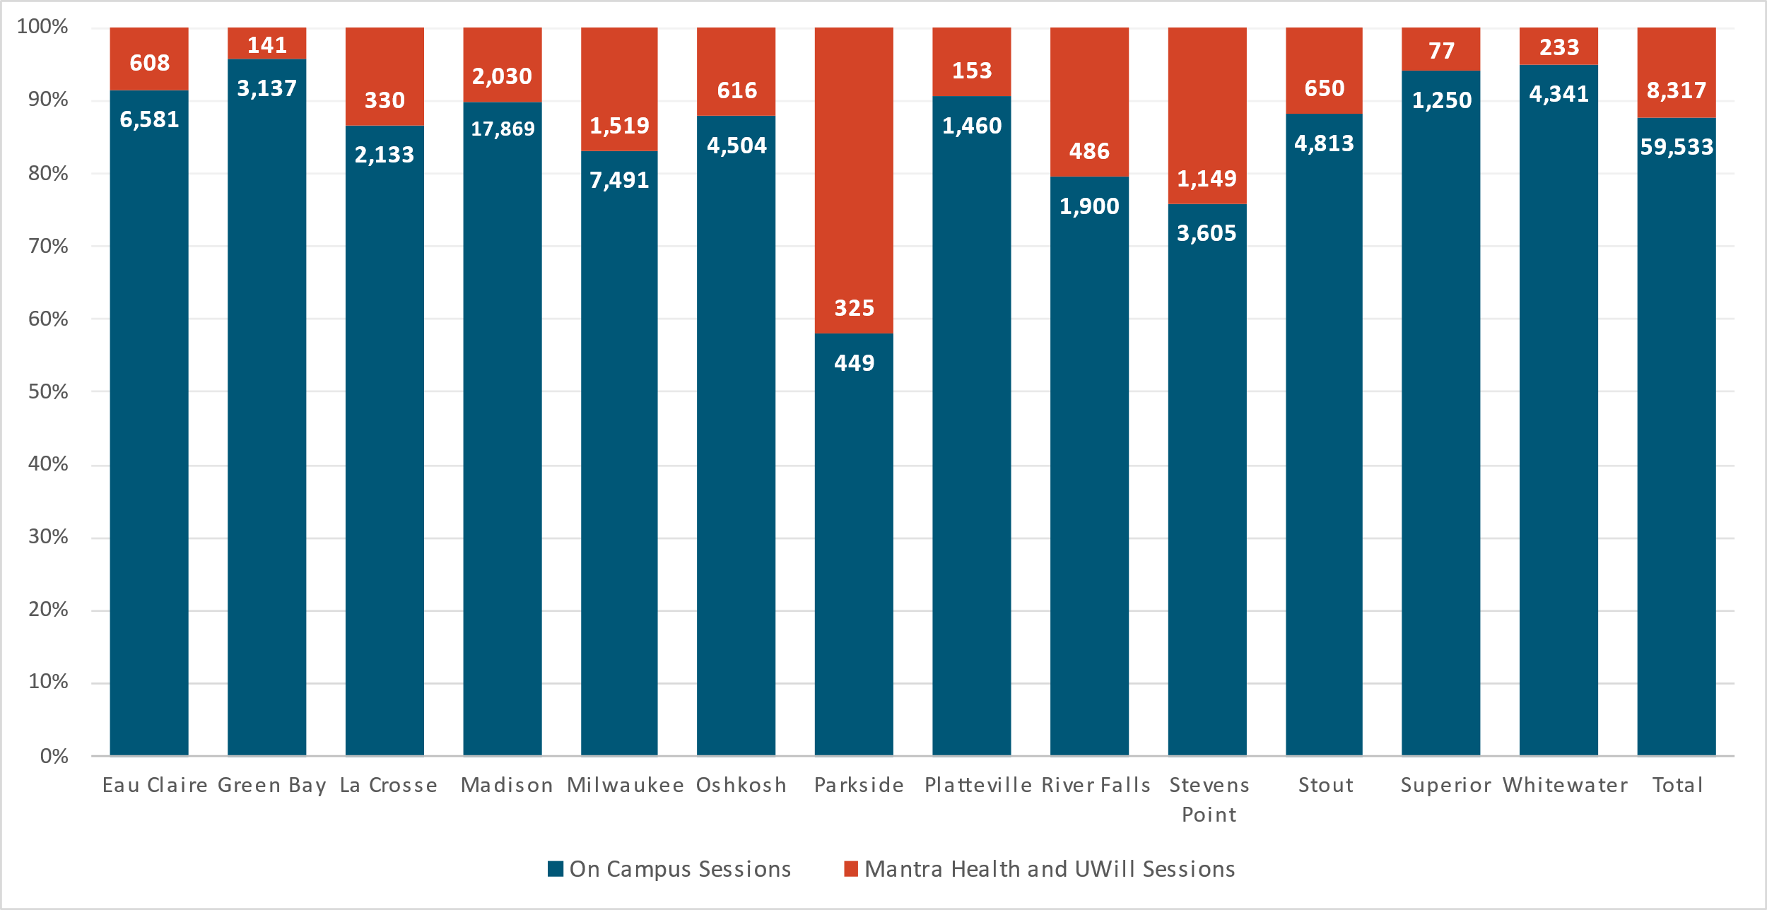  141
LaCrosse | 2133 | 330
Milwaukee | 7491 | 1519
Oshkosh | 4504 | 616
Parkside | 449 | 325
Platteville | 1460 | 153
River Falls | 1900 | 486
Stevens Point | 3605 | 1149
Stout | 4813 | 650
Superior | 1250 | 77
Whitewater | 4341 | 233
Madison | 17869 | 2030
Total | 59533 | 8317

In terms of client demographics, one goal for adding telehealth services was to increase the diversity of provider identities through Mantra Health to attract a wider range of students who desire services. Mantra providers do represent greater diversity of racial/ethnic and sexual orientations and, as illustrated in Table 9, Mantra Health served slightly higher percentages of students of color and LGBQ students compared to on-campus services.

Table 9: Client Demographics – Mantra and University Services
Category | UW University % | Mantra %
White | 81% | 75%
Students of Color | 19% | 21%
Heterosexual | 60% | 54%
LGBQ | 40% | 43%
Disability Status | 15% | 5%
Finally, regarding flexible scheduling options offered by extended telehealth services, 30% of counseling appointments and 60% of psychiatry appointments with Mantra Health providers occurred after 5 p.m. on weekdays or on weekends in 2024-2025, and 126 students accessed services from outside Wisconsin, extending the option of treatment to more enrolled students who would otherwise not have access to on-campus services.
Students reported satisfaction with their telehealth providers, with an average counselor “fit score” rated by clients at 8.75 (on a scale of 1-10, with 10 being the ideal fit). Treatment outcomes of telehealth services, as measured by common symptom assessments, showed that students receiving counseling from Mantra Health experienced benefit. For example, of students who scored in the moderate to severe range on a common measure of anxiety symptoms (GAD-7) at baseline, 67% improved by at least one category by their final assessment.

Mantra Health Whole Campus Care
For the five UW universities that piloted Whole Campus Care (UW-Eau Claire, UW-Parkside, UW-Platteville, UW-River Falls, and UW-Stevens Point), 2,671 unique students accessed the Mantra Care Hub in 2024-25. Services included in WCC include self-help modules focused on emotional well-being, well-being skills coaching with trained wellness coaches, and on-demand video emotional support with trained counselors.
When entering the Care Hub, students are presented with an option to take a level of care assessment that screens for common mental health concerns and recommends a level of care, which could include counseling, coaching, or self-help support. Students also have the option to explore hub contents on their own, without completing an assessment. The graphic in Figure 5 summarizes services students accessed after entering the Care Hub. Students can access multiple types of care (both therapy and psychiatry, for example) so students may be represented in more than one category.

Figure 5: Student Usage of Whole Campus Care Services (5 UW Universities)
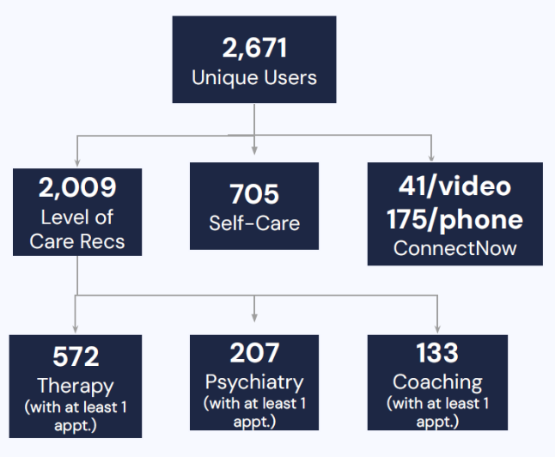
Within the self-care modules focused on emotional well-being, the modules entitled “Stop Freaking Out” (distress tolerance skills) and “Master Your Relationships” (interpersonal effectiveness skills) were accessed by the largest numbers of students.

Togetherall – Students from all 13 UW universities had access this year to Togetherall, an anonymous online peer support community that also includes a variety of evidence-based self-help content. Togetherall is a support resource designed especially for individuals who may be unlikely to seek traditional mental health services or to access on-campus support resources. In total, 1,163 students created accounts for Togetherall in 2024-25. Of those students, 54% indicated they were not seeking formal mental health support, 80% identified that they were not seeking similar support on their campus, and 8% said that they had no other support. Thirty-six percent of students who accessed Togetherall identified as students of color—over 15 percentage points higher than students accessing mental health treatment on-campus. Users completed an average of 20.62 activities within the platform, on average—which could include posting messages to give or receive support, taking a variety of mental health assessments, and/or completing one or more of several self-help courses embedded in the platform. Most UW students using Togetherall (89%) returned to the platform two or more times, and 54% of Togetherall activities took place outside traditional business hours.

UW-Madison Uwill Use Summary – Similar to the telecounseling services available from Mantra Health at 12 UWs, UW-Madison implemented supplemental telecounseling services during the 2022-23 academic year through the Uwill platform to expand counseling options for students. In 2024-2025, students could either be referred to Uwill by Mental Health Service staff member or could self-refer. Examples of common reasons for referrals to brief teletherapy through Uwill included: 1) student out of state or out of country; 2) schedule flexibility (such as sooner available appointments, availability outside MHS business hours, online booking with provider of choice); and 3) timing of year (such as student graduating at end of term). Students were initially offered enough “Uwill credits” for three, 30-minute sessions with an ability to request additional sessions.
For 2024-25, 569 students attended a total of 1,970 sessions with Uwill counselors, averaging 3.46 sessions per student. Unlike Mantra Health’s 45- to 60-minute sessions available in three languages, Uwill sessions are 30 minutes in length and are available in 20 total languages, which is a unique feature of Uwill’s offering. The most common focus areas for sessions included mood swings, academic concerns, eating concerns, and grief.

FUTURE DIRECTIONS
The 2024-2025 academic year marked the final year of the initial three-year Mantra Health contract. For the 2025-27 biennial budget, President Rothman requested $11 million to address staffing and salary gaps in on-campus services and to fund renewal of the full suite of virtual mental health services described above for all UW universities. The legislature ultimately approved $3.5 million in state funding for virtual mental health services at the 12 universities (excluding Madison) in the current Mantra contract. The additional funds sought for helping all UW universities reach the 1:1,000 staff to student ratio and for increasing clinician salaries were not approved. As a result of the funding for telehealth services, the 12 UW universities outside of Madison will have access to Mantra Health’s Whole Campus Care, in addition to peer support through Togetherall. You at College was not included in the contract renewal, as both Mantra and Togetherall include a broad range of evidence-based self-help content within their platforms.

Conclusion

This report documents both the successes and challenges of providing mental health counseling services at UW universities. The data presented over multiple years from university-based services, and more recently from telehealth services, consistently demonstrate the important role mental health services play in supporting student success. As Universities of Wisconsin counseling centers continue to experience high levels of student use, and students accessing care continue to report more serious and complex mental health needs than national averages, the need to provide an adequate range of mental health and well-being services has never been more critical. Providing these services supports student retention efforts—as evidenced by the estimated $20 million in tuition revenue saved annually from students who say counseling played a role in keeping them enrolled.

Addressing issues with counseling staff recruitment and retention have become high priorities, as has offering supplemental services to provide more options to students at any point along the mental health continuum. UW counseling centers will continue to work as strong partners to support the mental health and well-being of students, in service to their personal, educational, and professional goals.

References

American College Health Association. (2024). American College Health Association-National College Health Assessment III: Reference group executive summary Spring 2024. American College Health Association. UW data available at https://www.wisconsin.edu/student-behavioral-health/download/NCHA-IIIb-SPRING-2024-UW-REFERENCE-GROUP-EXECUTIVE-SUMMARY.pdf.
Association for University and College Counseling Center Directors. (2025). 2024-2025 annual survey report [PDF]. Association for University and College Counseling Center Directors. https://www.aucccd.org/assets/documents/Survey/2022-2023%20Annual%20Survey%20Report%20Public.pdf
Center for Collegiate Mental Health. (2020, January). 2019 annual report (Publication No. STA 20-244). Center for Collegiate Mental Health. https://ccmh.psu.edu/assets/docs/2019-CCMH-Annual-Report_3.17.20.pdf
Center for Collegiate Mental Health. (2024). Clinical load index (CLI), 2023-2024 distribution. Center for Collegiate Mental Health. https://ccmh.psu.edu/cli
Center for Collegiate Mental Health. (2025, January). 2024 annual report (Publication No. STA 24-147). Center for Collegiate Mental Health. https://ccmh.psu.edu/assets/docs/2023_Annual%20Report.pdf
Centers for Disease Control and Prevention. (2024, August 6). Youth risk behavior surveillance: Data summary. Centers for Disease Control and Prevention. https://www.cdc.gov/yrbs/dstr/index.html
Gorman, K. S., & Scofield, B. E. (2023, May). Why counseling center staff are leaving and why we should take notice. Joint CCMH and AUCCCD blog post. https://www.aucccd.org/assets/documents/CCMH%20Blog1_FINAL2.pdf
Levines, P. (2024). College counseling services: A high impact practice. Journal of College Student Mental Health, 38(4), 817-827.
International Accreditation of Counseling Services. (2023). Standards for university and college counseling services. International Accreditation of Counseling Services. https://iacsinc.org/wp-content/uploads/2024/09/IACS-2023-STANDARDS.pdf
Wisconsin Department of Public Instruction. (2024). 2023 Wisconsin Youth Risk Behavior Survey Summary Report. https://dpi.wi.gov/sspw/yrbsv

Appendices

Appendix 1: Counseling Use
Information about counseling usage is gathered via survey from counseling centers at the end of each academic year. Students were counted as using services in 2024-2025 if they attend at least one session with a staff counselor between July 1, 2024, and June 30, 2025.
Counseling Center Use, 2024-2025
Total Number of Clients | Total University Enrollment¹ | Percentage of Student Population Attending Counseling | Average Sessions Attended
13,920 | 151,125 | 9.2% | 5.1
¹Fall 2024, 10th day headcount of students eligible for counseling services (including branch campuses)
Counseling Center Usage, Eight-Year Trend
2016-17 | 2017-18 | 2018-19 | 2019-20 | 2020-21 | 2021-22 | 2022-23 | 2023-24 | 2024-25
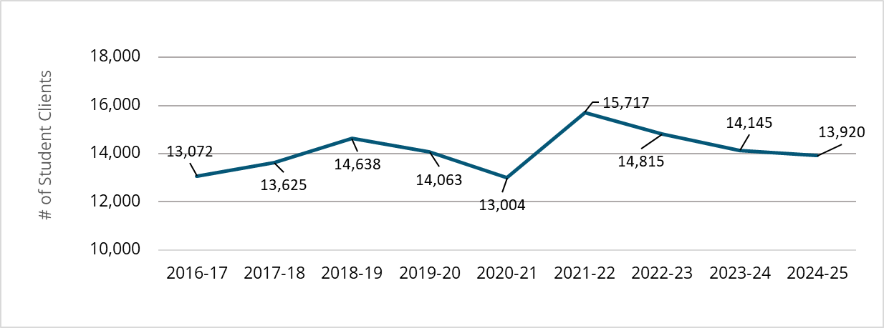  13072 | 13625 | 14638 | 14063 | 13004 | 15717 | 14815 | 14145 | 13920

Total Counseling Clients: 2019-2025
University | 2019-20 | 2020-21 | 2021-22 | 2022-23 | 2023-24 | 2024-25 | % of Total Enrollment 24-25 | 5-year Change in Use
Eau Claire | 1,206 | 910 | 1,162 | 1,079 | 1,110 | 1,136 | 12.0% | -5.8%
Green Bay | 509 | 391 | 528 | 657 | 557 | 646 | 9.9% | 26.9%
La Crosse | 996 | 742 | 1,091 | 826 | 663 | 627 | 6.0% | -37.0%
Madison | 4,600 | 5,523 | 6,689 | 6,358 | 6,410 | 5,880 | 11.3% | 27.8%
Milwaukee | 1,564 | 1,150 | 1,546 | 1,405 | 1,261 | 1,594 | 7.2% | 1.9%
Oshkosh | 1,348 | 1,401 | 1,401 | 888 | 803 | 706 | 10.3% | -47.6%
Parkside | 277 | 139 | 144 | 119 | 124 | 79 | 2.0% | -71.5%
Platteville | 596 | 390 | 531 | 651 | 535 | 398 | 6.8% | -33.2%
River Falls | 558 | 387 | 524 | 620 | 430 | 541 | 10.4% | -3.0%
Stevens Point | 495 | 483 | 534 | 520 | 538 | 541 | 7.4% | 9.3%
Stout | 781 | 537 | 694 | 743 | 694 | 709 | 10.4% | -9.2%
Superior | 185 | 160 | 150 | 215 | 200 | 200 | 8.0% | 8.1%
Whitewater | 948 | 791 | 723 | 734 | 820 | 863 | 7.3% | -9.0%
TOTAL | 14,063 | 13,004 | 15,717 | 14,815 | 14,145 | 13,920 | 9.2% | -1.0%

Appendix 2: Client Demographic Data
Taken from the Client Information Form (CIF), the following standard demographic items are requested prior to the first session with each counseling client. They are presented below with benchmark comparisons to national counseling center data collected by the Center for Collegiate Mental Health (CCMH, 2024b) during the 2022-2023 academic year (the most recent available).

Demographic Trends Summary
Item | 12-Year Change | 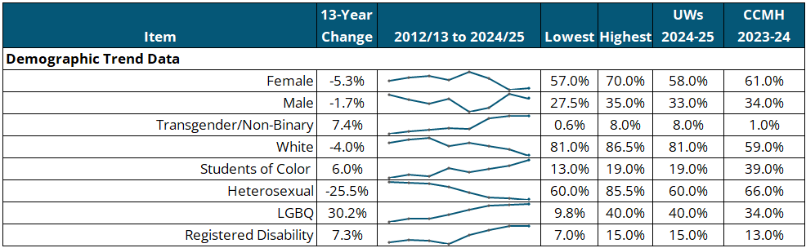 | Lowest | Highest | UWs  2024-25 | CCMH  2023-24
Demographic Trend Data
Female | -5.3% |  | 57.0% | 70.0% | 58.0% | 61.0%
Male | -1.7% |  | 27.5% | 35.0% | 33.0% | 34.0%
Transgender/Non-Binary | 7.4% |  | 0.6% | 8.0% | 8.0% | 1.0%
White | -4.0% |  | 81.0% | 86.5% | 81.0% | 59.0%
Students of Color | 6.0% |  | 13.0% | 19.0% | 19.0% | 39.0%
Heterosexual | -25.5% |  | 60.0% | 85.5% | 60.0% | 66.0%
LGBQ | 30.2% |  | 9.8% | 40.0% | 40.0% | 34.0%
Registered Disability | 7.3% |  | 7.0% | 15.0% | 15.0% | 13.0%
NOTE: 12-year change column is represented as percentage point change, subtracting the percentage of students in each category in 2012-13 from the percentage in 2024-2025.

Item | 2012-13 | 2014-15 | 2016-17 | 2018-19 | 2020-21 | 2022-23 | 2023-24 | 2024-25
Female | 63.3% | 65.6% | 66.9% | 64.0% | 70.0% | 65.0% | 57.0% | 58.0%
Male | 34.7% | 32.7% | 30.9% | 33.0% | 27.5% | 29.0% | 35.0% | 33.0%
Transgender/Self Identify | 0.6% | 1.7% | 2.2% | 3.0% | 2.5% | 7.0% | 8.0% | 8.0%
White | 85.0% | 86.0% | 86.5% | 84.0% | 85.0% | 84.0% | 83.0% | 81.0%
Students of Color | 13.0% | 14.1% | 13.5% | 16.2% | 15.0% | 16.0% | 17.0% | 19.0%
Heterosexual | 85.5% | 84.6% | 82.6% | 78.0% | 70.0% | 63.0% | 62.0% | 60.0%
LGBTQ | 9.8% | 15.4% | 15.4% | 22.0% | 30.0% | 37.0% | 38.0% | 40.0%
Registered Disability | 7.7% | 8.8% | 8.5% | 7.0% | 10.9% | 13.0% | 15.0% | 15.0%

Complete Client Demographic Data – 2024-2025
 | UW Counseling Clients  (n = 5,385) | Universities of Wisconsin Population  (n=164,436) | CCMH  (n=173,536)
Academic Status (%)
1st Year Undergraduate | 26% | 17% | 23%
2nd Year Undergraduate | 23% | 17% | 20%
3rd Year Undergraduate | 22% | 17% | 19%
4th Year Undergraduate | 16% | 22% | 14%
5th Year or More Undergraduate | 4% | 10% | 4%
Graduate/Professional Degree | 8% | 16% | 18%
Other | 1% | -% | 1%
Gender Identity (%)
Woman | 58% | 55% | 61%
Man | 33% | 45% | 34%
Transgender | 3% | -% | 1%
Self-identify | 5% | -% | 1%
Race/Ethnicity (%)
African American/Black | 4% | 3% | 10%
American Indian or Alaskan Native | <1% | <1% | 1%
Asian American/ Asian | 3% | 6% | 12%
Hispanic/ Latino(a) | 4% | 8% | 12%
Multi-racial | 6% | 4% | 5%
Native Hawaiian or Pacific Islander | <1% | <1% | <1%
White | 81% | 79% | 60%
Other | 1% | 2% | 2%
Sexual Orientation (%)
Bisexual | 19% | -% | 14%
Gay | 3% | -% | 3%
Heterosexual | 60% | -% | 66%
Lesbian | 4% | -% | 3%
Questioning | 3% | -% | 3%
Self-identify | 12% | -% | 1%
GPA [Mean (SD)] | 3.31 (0.618) | - | -
International Student (% Yes) | 3% | 7% | 9%
First-Generation Student (% Yes) | 28% | 31% | 25%
Age [Mean (SD)] | 21 (4.645) | 21-24 AVG | 22.06 (4.24)
US Military Service (% Yes) | 2% | 2% | 1%
Traumatic/Stressful Military Experience [% Yes (n)] | 1% (2,244) | -% (-) | 41% (1,102)
Athlete (% Yes) | 9% | - | 17%
Transfer Student (% Yes) | 19% | 4% | 9%
NOTE: Individual variable Ns for UW counseling clients differ from the total N because clients can choose not to respond to all demographic items. Universities of Wisconsin student population data that is available is indicated by a “-“ throughout this table. Because of rounding, the sum of percentages may not equal 100%.

 | UW Counseling Clients  (n = 5,385) | CCMH  (n = 173,536)
Current Housing (%)
On Campus | 51% | 42%
Off Campus | 48% | 57%
Other | 1% | 1%
Who Do You Live With (%)
Roommate(s) | 65% | 65%
Alone | 17% | 15%
Spouse, partner, or significant other | 7% | 10%
Parent(s) or guardian(s) | 9% | 14%
Family other | 4% | 6%
Children | 1% | 2%
Other | <1% | 1%
Relationship Status (%)
Single | 56% | 61%
Serious dating or committed relationship | 41% | 34%
Married | 2% | 4%
Divorced | <1% | <1%
Civil union, domestic partnership, or equivalent | <1% | <1%
Widowed | 0% | <1%
Separated | <1% | <1%
Current Financial Situation
Always stressful | 13% | 12%
Often stressful | 23% | 21%
Sometimes stressful | 37% | 35%
Rarely stressful | 21% | 23%
Never stressful | 7% | 9%
Registered Disability | 15% |  | 13%
If yes, which category - check all that apply (%)
Attention Deficit/Hyperactivity disorder | 41% | 52%
Difficulty Hearing | 2% | 3%
Specific Learning Disability | 9% | 12%
Mobility Impairments | 3% | 4%
Health Impairment/Condition | 9% | 12%
Psychological Disorder / Condition | 22% | 30%
Visual Impairments/Difficulty Seeing | <1% | 3%
Traumatic Brain Injury | <1% | 2%
Cognitive Difficulties/Intellectual Disability | 2% | 4%
Difficulty Speaking/Language Impairment | 1% | 1%
Autism Spectrum Disorder | 8% | 10%
Other | 11% | 14%

 | UW Counseling Clients  (n = 5,385) | CCMH  (n = 173,536)
Religious/Spiritual Preference (%) (n = 4,316)
Christian | 29% | 29%
Catholic | 11% | 13%
Agnostic | 18% | 17%
Atheist | 12% | 10%
Self-identify | 4% | 3%
Buddhist | 1% | 1%
Jewish | <1% | 2%
Muslim | 1% | 2%
Hindu | 1% | 2%
No preference | 25% | 20%
Hours of Work Per Week (%) (n = 5,128)
0 | 37% | 41%
1-5 | 8% | 6%
6-10 | 14% | 12%
11-15 | 13% | 11%
16-20 | 13% | 14%
21-25 | 8% | 6%
26-30 | 4% | 4%
31-35 | 1% | 2%
36-40 | 1% | 3%
40+ | 1% | 3%
NOTE: Because of rounding, the sum of percentages may not equal 100%.

Learning Outcome and Satisfaction Survey Demographics
The demographics below represent the subset of counseling clients who completed the Learning Outcome and Satisfaction (LOS) survey at the end of each semester. They can be compared against CIF demographics to assess the representativeness of clients completing the survey.

 | LOS Survey (n = 1,128)
Academic Status (%)
Freshman/First year | 21%
Sophomore | 21%
Junior | 23%
Senior | 25%
Graduate/professional degree student | 9%
Other | 2%
Gender Identity (%)
Woman | 69%
Man | 22%
Transgender | 4%
Self-identify | 5%

 | LOS Survey (n = 1,128)
Race/Ethnicity (%)
African American/Black | 2%
American Indian/Alaskan Native | 1%
Asian American/Asian | 6%
Hispanic/Latino(a) | 4%
Native Hawaiian/Pacific Islander | <1%
Multi-racial | 3%
White | 84%
Self-identify | 1%
Age [Mean (SD)] | 21.52 (4.56)
Number of Sessions [Mode] | 6
NOTE: N values for specific LOS demographic variables are less than the total N, as clients can choose not to respond to all items. Because of rounding, the sum of percentages may not equal 100%.

Appendix 3: Client Presenting Concerns and Academic Stress
The following items are taken from the Client Information Form (CIF), completed prior to the first counseling session for on-campus services. These items are unique to UW counseling centers, and therefore no national counseling center benchmark comparisons exist to share.

Presenting Concern Trends Summary
Item | 13-Year Change | 2012/13 to 2024/25 | Lowest | Highest | UWs  2024-25
Presenting Concerns
Anxiety | 17.1% |  | 59.9% | 77.0% | 77.0%
Stress | 7.3% |  | 59.0% | 72.0% | 72.0%
Depression | 9.9% |  | 54.1% | 67.1% | 64.0%
Procrastination | 16.0% |  | 36.0% | 52.0% | 52.0%
Low self-esteem | 9.5% |  | 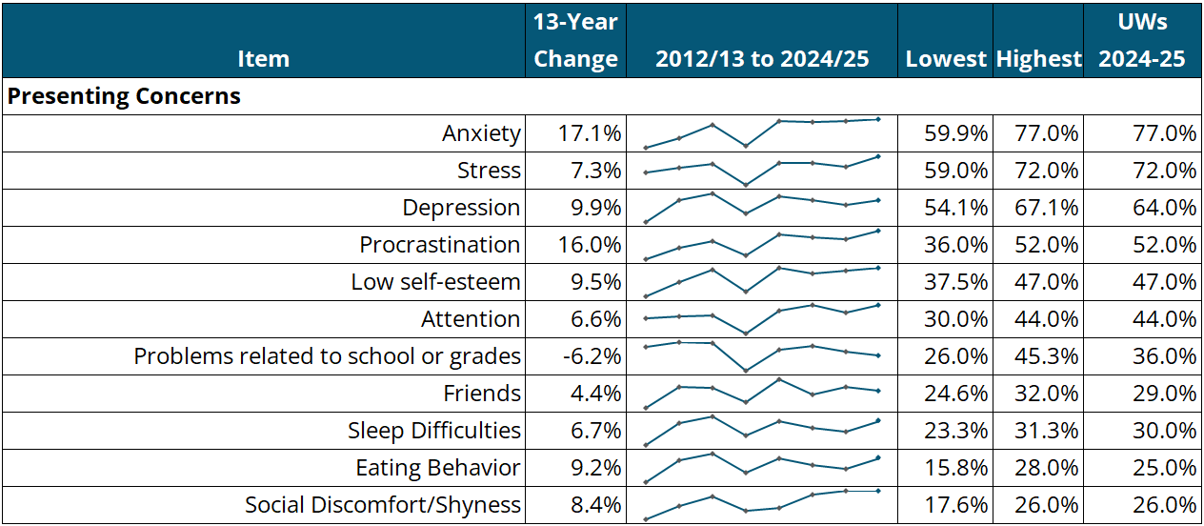  37.5% | 47.0% | 47.0%
Attention | 6.6% |  | 30.0% | 44.0% | 44.0%
Problems related to school or grades | -6.2% |  | 26.0% | 45.3% | 36.0%
Friends | 4.4% |  | 24.6% | 32.0% | 29.0%
Sleep Difficulties | 6.7% |  | 23.3% | 31.3% | 30.0%
Eating Behavior | 9.2% |  | 15.8% | 28.0% | 25.0%
Social Discomfort/Shyness | 8.4% |  | 17.6% | 26.0% | 26.0%

Presenting Concern Trends Detail
Item | 12-13 | 14-15 | 16-17 | 18-19 | 20-21 | 22-23 | 23-24 | 24-25
Anxiety/fears/worries (other than academic) | 59.9% | 65.4% | 73.3% | 61.0% | 76.0% | 75.0% | 76.0% | 77.0%
Stress/stress management | 64.7% | 66.7% | 68.3% | 59.0% | 69.0% | 69.0% | 67.0% | 72.0%
Depression/sadness/mood swings | 54.1% | 64.1% | 67.1% | 58.0% | 66.0% | 64.0% | 62.0% | 64.0%
Procrastination/motivation | 36.0% | 42.1% | 45.9% | 38.0% | 50.0% | 48.0% | 47.0% | 52.0%
Low self-esteem/confidence | 37.5% | 42.3% | 46.3% | 39.0% | 47.0% | 45.0% | 46.0% | 47.0%
Attention/concentration | 37.4% | 38.2% | 38.9% | 30.0% | 41.0% | 44.0% | 40.0% | 44.0%
Problems related to school or grades | 42.2% | 45.3% | 44.7% | 26.0% | 40.0% | 43.0% | 39.0% | 36.0%
Friends/roommates/dating concerns | 24.6% | 29.9% | 29.7% | 26.0% | 32.0% | 28.0% | 30.0% | 29.0%
Sleep difficulties | 23.3% | 29.4% | 31.3% | 26.0% | 30.0% | 28.0% | 27.0% | 30.0%
Eating behavior | 15.8% | 20.3% | 21.0% | 20.0% | 26.0% | 28.0% | 24.0% | 25.0%
Social discomfort/shyness | 17.6% | 21.6% | 24.2% | 20.0% | 21.0% | 25.0% | 26.0% | 26.0%

Complete Presenting Concern Data – 2024-2025
Items | Counseling Clients  (n = 5,385)
Anxiety/fears/worries (other than academic) | 77%
Stress/stress management | 72%
Depression/sadness/mood swings | 64%
Procrastination/motivation | 52%
Low self-esteem/confidence | 47%
Attention/concentration | 44%
Problems related to school or grades | 36%
Sleep difficulties | 30%
Friends/roommates/dating concerns | 29%
Shyness/social discomfort | 26%
Eating behavior/weight problems/eating disorders/body image | 25%
Anger/irritability | 21%
Choice of major/career | 16%
Physical symptoms/health (headaches, stomachaches, pain) | 15%
Grief/loss | 14%
Childhood abuse (physical, emotional, sexual) | 14%
Marital/couple/family concerns | 12%
Self-injury (cutting, hitting, burning) | 7%
Sexual assault/dating violence/stalking/harassment | 6%
Alcohol/drug use | 5%
Sexual orientation | 5%
Gender identity | 4%
Cultural adjustment | 3%
Seeing/hearing things others don’t | 2%
Bullying/harassment | 1%
Prejudice/discrimination | 1%
Urge to injure/harm someone else | 1%
Other | 2%

Students were asked to report the degree to which their academic success was being negatively impacted by their mental health. Students responded to each item on a scale from 1 (Strongly Disagree - SD) to 5 (Strongly Agree - SA).
Academic Stress Trends Summary
Item | 13-Year Change | 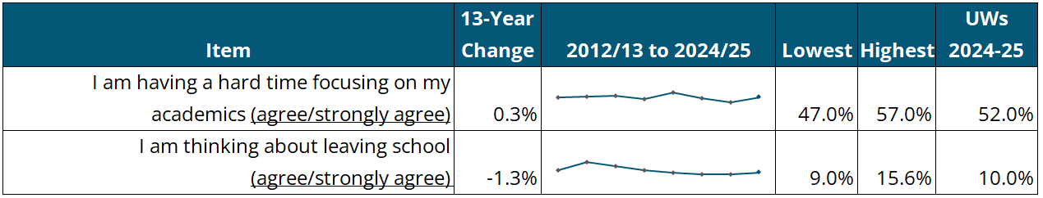  2012/13 to 2024/25 | Lowest | Highest | UWs  2024-25
I am having a hard time focusing on my academics (agree/strongly agree) | 0.3% |  | 47.0% | 57.0% | 52.0%
I am thinking about leaving school (agree/strongly agree) | -1.3% |  | 9.0% | 15.6% | 10.0%

Academic Stress Trends Detail
Item | 2012-13 | 2014-15 | 2016-17 | 2018-19 | 2020-21 | 2022-23 | 2023-24 | 2024-25
I am having a hard time focusing on my academics (agree/strongly agree) | 51.7% | 52.2% | 53.6% | 50.0% | 57.0% | 51.0% | 47.0% | 52.0%
I am thinking about leaving school (agree/strongly agree) | 11.3% | 15.6% | 13.5% | 11.0% | 10.0% | 9.0% | 9.0% | 10.0%

Complete Academic Stress Data – 2024-2025
Subscale Item | SD/Disagree | Neutral | Agree/SA | System Mean (n)
I am struggling with my academics | 44% | 25% | 33% | 3.73 (5,091)
I am thinking of leaving school | 78% | 12% | 10% | 2.15 (5,088)
My academic motivation and/or attendance are suffering | 40% | 18% | 42% | 4.01 (5,078)
I am having a hard time focusing on my academics | 28% | 20% | 52% | 4.54 (5,076)

Appendix 4: Mental Health and Alcohol/Drug Use History
For the items below, students were asked to indicate the frequency with which they have had various experiences in their lifetime. The UWs and CCMH columns represent the percentages of students who reported having the experiences at least once in their lifetime.

Mental Health and Alcohol/Drug Use History Trends Summary
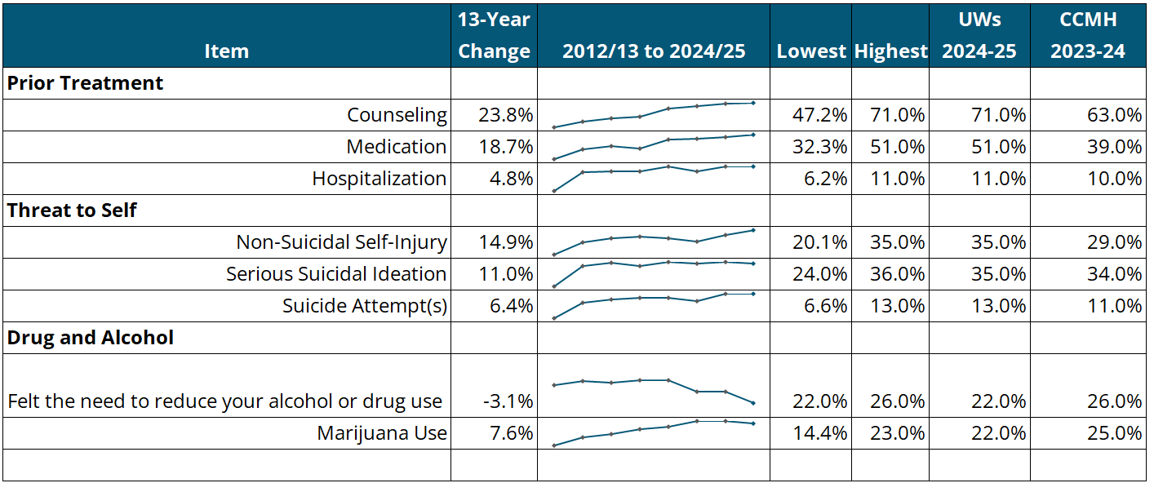  Item | 13-Year Change | 2012/13 to 2024/25 | Lowest | Highest | UWs  2024-25 | CCMH  2023-24
Prior Treatment
Counseling | 23.8% |  | 47.2% | 71.0% | 71.0% | 63.0%
Medication | 18.7% |  | 32.3% | 51.0% | 51.0% | 39.0%
Hospitalization | 4.8% |  | 6.2% | 11.0% | 11.0% | 10.0%
Threat to Self
Non-Suicidal Self-Injury | 14.9% |  | 20.1% | 35.0% | 35.0% | 29.0%
Serious Suicidal Ideation | 11.0% |  | 24.0% | 36.0% | 35.0% | 34.0%
Suicide Attempt(s) | 6.4% |  | 6.6% | 13.0% | 13.0% | 11.0%
Drug and Alcohol
Felt the need to reduce your alcohol or drug use | -3.1% |  | 22.0% | 26.0% | 22.0% | 26.0%
Marijuana Use | 7.6% |  | 14.4% | 23.0% | 22.0% | 25.0%

NOTE: 12-year change column is represented as percentage point change, subtracting the percentage of students in each category in 2012-13 from the percentage in 2024-25.

Mental Health and Alcohol/Drug Use History Trends Detail
Item | 2012-13 | 2014-15 | 2016-17 | 2018-19 | 2020-21 | 2022-23 | 2023-24 | 2024-25
Prior Treatment
Counseling | 47.2% | 52.5% | 55.7% | 57.0% | 65.0% | 68.0% | 70.0% | 71.0%
Medication | 32.3% | 39.9% | 42.2% | 40.0% | 47.0% | 48.0% | 49.0% | 51.0%
Hospitalization | 6.2% | 9.9% | 10.0% | 10.0% | 11.0% | 10.0% | 11.0% | 11.0%
Threat to Self
Non-Suicidal Self-Injury | 20.1% | 27.6% | 30.2% | 31.0% | 30.0% | 28.0% | 32.0% | 35.0%
Serious Suicidal Ideation | 24.0% | 34.0% | 35.7% | 34.0% | 36.0% | 35.0% | 36.0% | 35.0%
Suicide Attempt(s) | 6.6% | 10.7% | 11.4% | 12.0% | 12.0% | 11.0% | 13.0% | 13.0%
Drug and Alcohol
Felt the need to reduce your alcohol or drug use | 25.1% | 25.9% | 25.6% | 26.0% | 26.0% | 24.0% | 24.0% | 22.0%
Marijuana Use | 14.4% | 17.3% | 18.5% | 20.0% | 21.0% | 23.0% | 23.0% | 22.0%

Complete Mental Health and Alcohol/Drug History Items – 2024-2025
Items |  |  |  | Never |  |  | 1 Time |  | 2-3 Times |  |  | 4-5 Times |  | More than 5 Times |  |  | System % (n) |  |  | CCMH  % (n)
Been hospitalized for mental health concerns |  |  |  | 89% |  |  | 7% |  | 3% |  |  | 1% |  | <1% |  |  | 11% (5,222) |  |  | 10% (107,627)
Felt the need to reduce your alcohol or drug use |  |  |  | 78% |  |  | 7% |  | 9% |  |  | 2% |  | 5% |  |  | 22% (5,203) |  |  | 26% (97,041)
Others expressed concern about your alcohol or drug use |  |  |  | 87% |  |  | 5% |  | 5% |  |  | 1% |  | 2% |  |  | 13% (5,191) |  |  | 13% (97,053)
Received treatment for alcohol or drug use |  |  |  | 97% |  |  | 2% |  | 1% |  |  | <1% |  | 1% |  |  | 3%  (5,185) |  |  | 2% (101,110)
Purposely injured yourself w/o suicidal intent (e.g., cutting, hitting, burning, etc.) |  |  |  | 65% |  |  | 6% |  | 8% |  |  | 4% |  | 17% |  |  | 35% (4,487) |  |  | 29% (105,747)
Seriously considered attempting suicide |  |  |  | 65% |  |  | 12% |  | 13% |  |  | 3% |  | 7% |  |  | 35% (4,567) |  |  | 34% (104,020)
Made a suicide attempt |  |  |  | 87% |  |  | 8% |  | 4% |  |  | 1% |  | 1% |  |  | 13% (4,588) |  |  | 11% (104,145)
Considered causing serious physical injury to another person |  |  |  | 95% |  |  | 2% |  | 2% |  |  | <1% |  | 1% |  |  | 5% (4,583) |  |  | 6% (103,663)
Intentionally caused serious physical injury to another |  |  |  | 98% |  |  | 1% |  | 1% |  |  | <1% |  | <1% |  |  | 2% (4,583) |  |  | 1% (102,961)
Someone had sexual contact with you w/o your consent |  |  |  | 73% |  |  | 12% |  | 9% |  |  | 2% |  | 5% |  |  | 27% (5,146) |  |  | 26% (102,073)
Experienced harassing, controlling, and/or abusive behavior from another person (e.g., friend, family member, partner, or authority figure) |  |  |  | 60% |  |  | 6% |  | 8% |  |  | 2% |  | 24% |  |  | 40% (4,497) |  |  | 37% (103.494)
Experienced a traumatic event that caused you to feel intense fear, helplessness, or horror |  |  |  | 51% |  |  | 16% |  | 17% |  |  | 4% |  | 12% |  |  | 49% (4,314) |  |  | 45% (100,965)
Items |  |  | Never |  |  | Prior to College |  |  |  | After Starting College |  |  | Both |  |  | System % (n) |  |  | CCMH % (n)
Attended counseling for mental health concerns |  |  | 29% |  |  | 30% |  |  |  | 18% |  |  | 24% |  |  | 71% (5,257) |  |  | 63% (103,083)
Taken a prescribed medication for mental health concerns |  |  | 49% |  |  | 14% |  |  |  | 14% |  |  | 23% |  |  | 51% (5,193) |  |  | 39% (102,249)
Items | None | Once |  |  | Twice |  |  | 3 to 5 Times |  |  | 6 to 9 Times |  | 10 or More Times |  | System % (n) |  |  | CCMH % (n)
Think back over the last two weeks. How many times have you used marijuana? | 78% | 5% |  |  | 4% |  |  | 6% |  |  | 3% |  | 5% |  | 22% (5,213) |  |  | 25% (84,638)

Appendix 5: Mental Health and Academic Outcomes
Mental Health and Well-Being Outcome Trends Summary
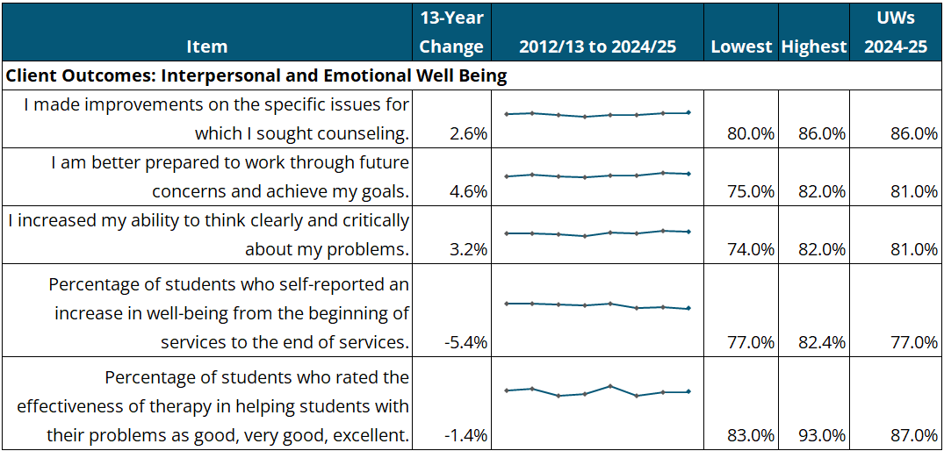  Item | 13-Year Change | 2012/13 to 2024/25 | Lowest | Highest | UWs  2024-25
Client Outcomes: Interpersonal and Emotional Well Being
I made improvements on the specific issues for which I sought counseling. | 2.6% |  | 80.0% | 86.0% | 86.0%
I am better prepared to work through future concerns and achieve my goals. | 4.6% |  | 75.0% | 82.0% | 81.0%
I increased my ability to think clearly and critically about my problems. | 3.2% |  | 74.0% | 82.0% | 81.0%
Percentage of students who self-reported an increase in well-being from the beginning of services to the end of services. | -5.4% |  | 77.0% | 82.4% | 77.0%
Percentage of students who rated the effectiveness of therapy in helping students with their problems as good, very good, excellent. | -1.4% |  | 83.0% | 93.0% | 87.0%

NOTE: 12-year change column is represented as percentage point change, subtracting the percentage of students in each category in 2012-13 from the percentage in 2024-25.

Outcome Trends Detail
Items | 2012-13 | 2014-15 | 2016-17 | 2018-19 | 2020-21 | 2022-23 | 2023-24 | 2024-25
I made improvements on the specific issues for which I sought counseling. | 83.4% | 86.0% | 82.0% | 80.0% | 83.0% | 83.0% | 86.0% | 86.0%
I am better prepared to work through future concerns and achieve my goals. | 76.4% | 80.2% | 76.8% | 75.0% | 78.0% | 78.0% | 82.0% | 81.0%
I increased my ability to think clearly and critically about my problems. | 77.8% | 78.7% | 76.3% | 74.0% | 79.0% | 78.0% | 82.0% | 81.0%
Percentage of students who self-reported an increase in well-being from the beginning of services to the end of services. | 82.4% | 82.0% | 81.0% | 80.0% | 82.0% | 78.0% | 79.0% | 77.0%
% of students who rated the effectiveness of therapy in helping students with their problems as good, very good, excellent. | 88.4% | 90.0% | 83.0% | 85.0% | 93.0% | 83.0% | 87.0% | 87.0%
Complete Mental Health and Well-Being Outcome Data – 2024-2025
Subscale Items |  | SD/Disagree |  |  | Neutral | Agree/SA |  |  | System  Mean (n)
I made improvements on the specific issues for which I sought counseling. |  | 5% |  |  | 9% | 86% |  |  | 4.24 (1,114)
I have started to live a healthier lifestyle in at least one area (e.g. sleep, diet, exercise, alcohol/drug use). |  | 5% |  |  | 23% | 72% |  |  | 3.95 (1,080)
I have improved my ability to manage stress. |  | 6% |  |  | 21% | 73% |  |  | 3.91 (1,102)
I am better prepared to work through future concerns and achieve my goals. |  | 5% |  |  | 14% | 81% |  |  | 4.10 (1,111)
I increased my self-confidence and/or self-esteem. |  | 8% |  |  | 25% | 67% |  |  | 3.85 (1,091)
The counseling process helped me understand cultural, family, ethnic, and/or community differences. |  | 10% |  |  | 33% | 57% |  |  | 3.70 (945)
I have gained a greater understanding of myself or a clearer sense of identity. |  | 5% |  |  | 16% | 79% |  |  | 4.11 (1,082)
I increased my ability to think clearly and critically about my problems. |  | 4% |  |  | 15% | 81% |  |  | 4.13 (1,099)
I improved my communication skills. |  | 6% |  |  | 18% | 76% |  |  | 4.01 (1,079)
Total Subscale |  | 6% |  |  | 19% | 70% |  |  | 4.00 (1,078)
Item | Poor | Fair | Good |  | Very Good | Excellent |  | System Mean (n)
My level of well-being when I started counseling. | 34% | 43% | 19% |  | 3% | 1% |  | 1.93 (1,087)
My level of well-being now. | 3% | 17% | 49% |  | 26% | 5% |  | 3.12 (1,087)
 | Decline |  |  | No change |  |  | Improvement
Overall perceived change in well-being | 2% (19) |  |  | 21% (233) |  |  | 77% (835)
Note: Because of rounding, the sum of percentages may not equal 100%.

Academic Outcome Trends Summary
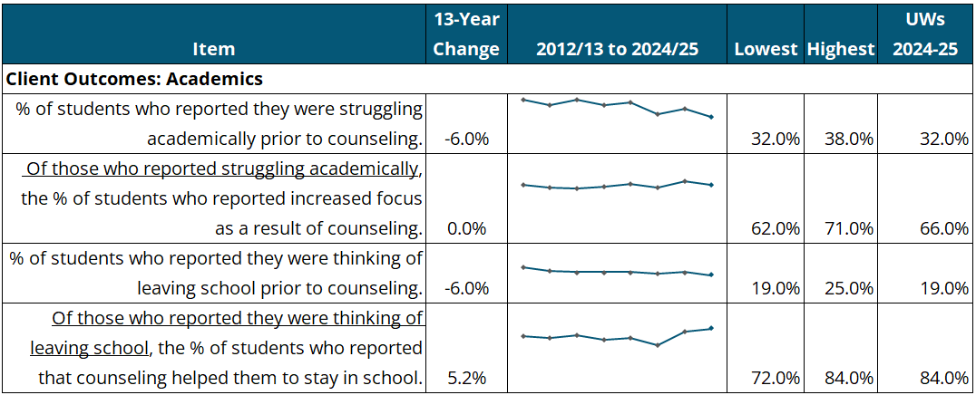  Item | 13-Year Change | 2012/13 to 2024/25 | Lowest | Highest | UWs  2024-25
Client Outcomes: Academics
% of students who reported they were struggling academically prior to counseling. | -6.0% |  | 32.0% | 38.0% | 32.0%
Of those who reported struggling academically, the % of students who reported increased focus as a result of counseling. | 0.0% |  | 62.0% | 71.0% | 66.0%
% of students who reported they were thinking of leaving school prior to counseling. | -6.0% |  | 19.0% | 25.0% | 19.0%
Of those who reported they were thinking of leaving school, the % of students who reported that counseling helped them to stay in school. | 5.2% |  | 72.0% | 84.0% | 84.0%

NOTE: 12-year change column is represented as percentage point change, subtracting the percentage of students in each category in 2012-13 from the percentage in 2024-25.

Academic Outcome Trends Detail
Item | 12-13 | 14-15 | 16-17 | 18-19 | 20-21 | 22-23 | 23-24 | 24-25
% of students who reported they were struggling academically prior to counseling | 38.0% | 36.0% | 38.0% | 36.0% | 37.0% | 33.0% | 35.0% | 32.0%
% of students who reported increased focus as a result of counseling. | 66.0% | 63.0% | 62.0% | 64.0% | 67.0% | 63.0% | 71.0% | 66.0%
% of students who reported they were thinking of leaving school prior to counseling. | 25.0% | 22.0% | 21.0% | 21.0% | 21.0% | 20.0% | 21.0% | 19.0%
% of students who reported that counseling helped them to stay in school. | 78.8% | 77.0% | 79.0% | 76.0% | 77.0% | 72.0% | 82.0% | 84.0%

Complete Academic Outcome Data – 2024-2025
Items | SD/Disagree | Neutral | Agree/SA | UWs  Mean (n)
Counseling has increased my academic motivation and/or class attendance. | 15% | 43% | 42% | 3.35 (1,008)
Counseling has helped me to focus better on my academics. | 12% | 32% | 56% | 3.54 (1,036)
Counseling has helped with my academic performance. | 13% | 40% | 47% | 3.45 (1,023)
Counseling has helped me stay at school. | 14% | 33% | 53% | 3.55 (946)
Total Subscale | 14% | 37% | 50% | 3.47 (1,003)
NOTE: Because of rounding, the sum of percentages may not equal 100%.

For the table below, students were separated by whether they reported struggling with academics prior to counseling, to compare how counseling affected academic performance.
Academic Outcomes: Clients Struggling with Academics vs. Clients not Struggling
Item |  | SD/Disagree | Neutral | Agree/SA | Overall UWS Mean (n)
Counseling has increased my academic motivation and/or class attendance. | Struggling Academically | 11% | 28% | 62% | 3.72 (343)
 | Not Struggling | 17% | 51% | 32% | 3.14 (655)
 | Total (average) |  |  |  | 3.35 (1,008)
Counseling has helped me to focus better on my academics. | Struggling Academically | 11% | 23% | 66% | 3.77 (344)
Counseling has helped me to focus better on my academics. | Not Struggling | 13% | 38% | 50% | 3.40 (674)
Counseling has helped me to focus better on my academics. | Total (average) |  |  |  | 3.54 (1,036)
Counseling has helped with my academic performance. | Struggling Academically | 10% | 27% | 63% | 3.75 (345)
Counseling has helped with my academic performance. | Not Struggling | 14% | 47% | 39% | 3.28 (665)
Counseling has helped with my academic performance. | Total (average) |  |  |  | 3.45 (1,023)
Counseling has helped me stay at school. | Struggling Academically | 8% | 22% | 70% | 3.94 (321)
Counseling has helped me stay at school. | Not Struggling | 17% | 39% | 44% | 3.33 (617)
Counseling has helped me stay at school. | Total (average) |  |  |  | 3.55 (946)
NOTE: Because of rounding, the sum of percentages may not equal 100%.
For the table below, students were separated by those who reported that they were or were not thinking of leaving school at the beginning of counseling to compare whether counseling services impacted retention.

Retention Impact: Clients Thinking of Leaving School vs. Not Thinking of Leaving School
Counseling has helped me stay at school. | SD/Disagree | Neutral | Agree/SA | System Mean (n)
Thinking of Leaving | 6% | 10% | 84% | 4.20 (203)
Not Thinking of Leaving | 16% | 40% | 44% | 3.35 (733)
TOTAL (Average) | 11% | 25% | 64% | 3.55 (936)

Appendix 6: Client Satisfaction

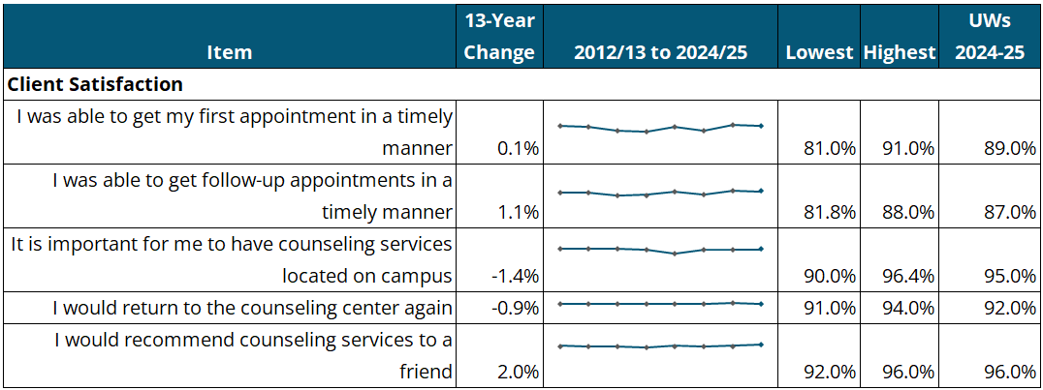
Client Satisfaction Trends Summary
Item | 13-Year Change | 2012/13 to 2024/25 | Lowest | Highest | UWs  2024-25
Client Satisfaction
I was able to get my first appointment in a timely manner | 0.1% |  | 81.0% | 91.0% | 89.0%
I was able to get follow-up appointments in a timely manner | 1.1% |  | 81.8% | 88.0% | 87.0%
It is important for me to have counseling services located on campus | -1.4% |  | 90.0% | 96.4% | 95.0%
I would return to the counseling center again | -0.9% |  | 91.0% | 94.0% | 92.0%
I would recommend counseling services to a friend | 2.0% |  | 92.0% | 96.0% | 96.0%

NOTE: 12-year change column is represented as percentage point change, subtracting the percentage of students in each category in 2012-13 from the percentage in 2024-25.

Client Satisfaction Trends Detail
Item | 12-13 | 14-15 | 16-17 | 18-19 | 20-21 | 22-23 | 23-24 | 24-25
I was able to get my first appointment in a timely manner | 88.9% | 87.5% | 83.1% | 81.0% | 88.0% | 83.0% | 91.0% | 89.0%
I was able to get follow-up appointments in a timely manner | 85.9% | 85.8% | 81.8% | 82.0% | 87.0% | 83.0% | 88.0% | 87.0%
It is important for me to have counseling services located on campus | 96.4% | 95.5% | 96.0% | 95.0% | 90.0% | 95.0% | 95.0% | 95.0%
I would return to the counseling center again | 92.9% | 91.6% | 92.6% | 91.0% | 92.0% | 92.0% | 94.0% | 92.0%
I would recommend counseling services to a friend | 94.0% | 93.6% | 93.3% | 92.0% | 94.0% | 93.0% | 94.0% | 96.0%

Counseling Satisfaction – 2024-2025
Item | SD/Disagree | Neutral | Agree/SA | UWS  Mean (n)
The office staff were helpful in providing information and direction. | 2% | 7% | 91% | 4.35 (1,064)
This counselor displayed sensitivity/acceptance to individual differences (culture, gender, ethnicity, etc.). | 1% | 4% | 95% | 4.61 (1,064)
This counselor helped me clarify my concerns and provide guidance. | 3% | 5% | 92% | 4.51 (1,081)
This counselor supported me in making my own decisions and reaching my personal goals. | 3% | 5% | 92% | 4.49 (1,080)
The counseling environment was warm and inviting. | 2% | 4% | 94% | 4.64 (1,077)
It is important for me to have counseling services located on campus. | 1% | 4% | 95% | 4.71 (1,059)
I would return to the counseling center again. | 3% | 5% | 92% | 4.63 (1,056)
I would recommend counseling services to a friend. | 2% | 4% | 96% | 4.65 (1,070)
Total Subscale | 2% | 5% | 93% | 4.57 (1,069)
NOTE: Because of rounding, the sum of percentages may not equal 100%.
Appointment Availability – 2024-2025
Item | SD/Disagree | Neutral | Agree/SA | UWs  Mean (n)
I was able to get my first appointment in a timely manner. | 5% | 6% | 89% | 4.41 (1,071)
I was able to get follow-up appointments in a timely manner. | 5% | 8% | 87% | 4.35 (1,048)
NOTE: Because of rounding, the sum of percentages may not equal 100%.
Overall Satisfaction – 2024-2025
Item | Poor | Fair | Good | Very Good | Excellent | UWs  Mean (n)
Overall effectiveness of counseling in helping with my problems. | 4% | 10% | 34% | 39% | 14% | 3.50 (1,088)
Overall quality of the services I received. | 2% | 3% | 19% | 37% | 39% | 4.07 (1,088)

