

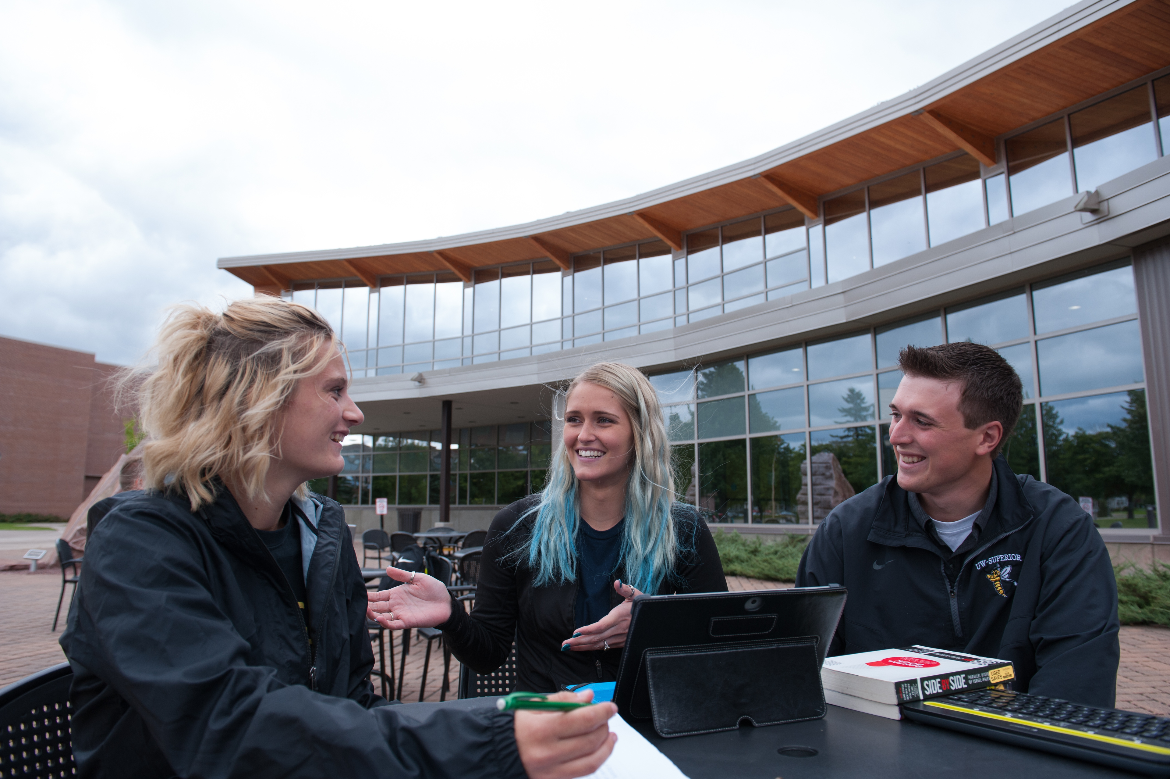COUNSELING IMPACT ASSESSMENT REPORT

2022-23

# Picture of three students interacting outside at a UW universityUniversities of Wisconsin 2022-23 Counseling Impact Assessment Report

Table of Contents

Counseling Impact Assessment Committee 5

Counseling Center Directors 5

Acknowledgements 6

Foreword 7

Methods 8

Table 1: Measures 8

Table 2: Participation by UW University 8

Executive Summary 9

Introduction 11

Client Utilization and Demographics 11

Table 3: Counseling Center Utilization, 2022-23 11

Figure 1: Counseling Center Utilization, Five-Year Trend 12

Table 4: Demographic Trend Data 13

Client Presenting Concerns and Personal Histories 13

Table 5: Presenting Concerns 14

Table 6: Academic Impact 14

Table 7: Prior Mental Health and Alcohol/Drug Use History 15

Client Outcomes 15

Table 8: Interpersonal and Emotional Well-Being Outcomes 16

Table 9: Academic Outcomes 17

Client Satisfaction 17

Table 10: Client Satisfaction 18

Personnel/Staffing 19

Figure 2: Six-Year Trend: Ratio of Students to Counselors 20

Table 11: Eight-Year Trend: Ratio of Students to Counselors by University 21

Figure 3: Clinical Load Index (CLI) Distribution (2021-2022 Comparison Data) 22

Staff Retention 22

Figure 4: Five-Year Staff Turnover 23

Table 12: Average Starting Salaries for University Counselors and Psychologists 24

Conclusion 24

References 25

Appendices 26

Appendix 1: Number and Percentage of Students Attending Counseling, by Campus 26

Appendix 2: Client Information Form (CIF) 27

CIF Client Demographics 27

Client Reported Presenting Concerns - % Reporting Yes 29

Academic Outcomes 30

Mental Health History Items 31

Extended Mental Health History Items 31

Reported Marijuana Use 32

Appendix 3: Learning Outcomes and Satisfaction Survey (LOS) 33

LOS Demographic Data 33

Lifestyle and Self-Efficacy 34

Counseling Satisfaction 34

Academic Outcomes 35

Retrospective Academic Functioning Items 35

Appointment Availability 35

Overall Satisfaction 35

Retrospective Ratings of Well-Being 36

Perceived Change in Well-Being from Start of Counseling 36

Effectiveness of Counseling Support 36

Effect of Counseling on Academic Retention 37

Appendix 4: CIF and LOS Survey Trend Data Tables 38

Demographics 38

Presenting Concerns 38

Mental Health History 39

Client Outcomes: Interpersonal and Emotional Well-Being 39

Client Outcomes: Academics 40

Client Satisfaction 40

Appendix 5: UW System Telemental Health and Wellbeing Services Pilot 41

Table 13: Telehealth Implementation Cohorts 41

Table 14: YOU at College Utilization: November 2022-May 2023 42

Figure 6: UW Mental Health Support 24/7: Volume of Contacts, by Month 42

Figure 7: Number and Percentage of Students Utilizing On-Campus and Mantra Counseling 43

Table 15: Client Demographics – Mantra Services 44

# Counseling Impact Assessment Committee

**Deirdre Dalsing,** UW-Platteville  
Director, Counseling Services  
Committee Chair

**Chasidy Faith,** UW-StoutDirector, Student Counseling Center

**Stacey Gerken**, UW-Stevens PointDirector, Counseling Center

**Bjorn Hanson**, UW-Madison  
Coordinator of Data, Quality, and Informatics

**Amy Henniges,** UW-Green Bay  
Director, Health & Counseling Services

**Riley McGrath**, UW-Eau Claire  
Director, Counseling Services

**Veronica Warren,** UW-Whitewater  
Director, Counseling Center

*Data Analyst:*

**Justin Sullivan**, UW-Stout  
Project Manager, Catalyst

*System Liaison:*

**John Achter,** UW System Administration  
Senior Director of Student Success and Wellbeing  
Office of Enrollment and Student Success

# Counseling Center Directors

**Riley McGrath**, UW-Eau Claire  
Director, Counseling Services

**Amy Henniges**, UW-Green Bay  
Director, Health & Counseling Services

**Crystal Champion**, UW-La Crosse  
Director, Counseling & Testing

**Sarah Nolan,** UW-Madison  
Director of Mental Health Services

**Carrie Fleider**, UW-Milwaukee  
Director, University Counseling Services

**Leah Folks**, UW Oshkosh  
Director, Counseling Center

**Renee’ Sartin Kirby**, UW-Parkside  
Director, Student Health & Counseling Center

**Deirdre Dalsing**, UW-Platteville  
Director, Counseling Services

**Debbie Janis**, UW-River Falls  
Director, Student Health & Counseling

**Stacey Gerken**, UW-Stevens Point  
Director, Counseling Center

**Chasidy Faith**, UW-Stout  
Director, Student Counseling Center

**Randy Barker**, UW-Superior  
Director for Health, Counseling & Well-Being

**Veronica Warren**, UW-Whitewater  
Counseling Director, University Health & Counseling Services

# Acknowledgements

This work would not be possible without the commitment of time and effort from the participating counseling centers and the UW System Counseling Impact Assessment Committee. Special appreciation is extended to UW System Administration for their recognition of this important project and decision to annually fund the work, and to Catalyst at UW-Stout for coordinating data gathering and reporting.

Gratitude is extended to all counseling center staff who work tirelessly to provide effective and lasting services even during times of financial and personnel strain.



# 

# Foreword

This annual report summarizes results from the twelfth year of data collection by the Universities of Wisconsin System Counseling Impact Assessment Project, overseen by a systemwide committee of the same name. The project tracks a core set of common data elements across UW university counseling centers, for the purposes of providing benchmark data for each campus and to allow for system-level analyses of counseling utilization and impact. Incremental progress has been made each year in establishing a systematic and sustainable assessment process that both serves day-to-day clinical needs of counseling center professionals and helps them evaluate and improve upon their work. By moving thoughtfully and systematically, we hope to continue to strengthen the ways in which we assess our work for the betterment of the clients we serve.

This year’s report includes data based on the utilization of extended behavioral health services available to 12 of the 13 campuses that were implemented this academic year through a UW System contract with Mantra Health. Mantra provided extended services for telecounseling and telepsychiatry and with their partner, Didi Hirsch, coordinated the UW Mental Health Support 24/7, a crisis line that provided students access through phone, text, and chat. The Mantra contract also included onboarding You@College, a web portal dedicated to student health, happiness, and success.

This report emphasizes the value of providing mental health services on a college campus and the impact it has, including timely assessment of needs, improved well-being, and student retention.

As noted in the Acknowledgements, this work would not be possible without the commitment of time and effort from individual campuses and UW System partners. We hope the resulting report proves thought-provoking to readers and provides a useful context for them to understand our evolving needs and consider ways to continue supporting the mental health and well-being of our student body.



**Deirdre Dalsing,** UW-Platteville  
Committee Chair

# Methods

The current report summarizes data collected across all 13 UW universities. The report uses two primary sources of data collection that are summarized in the table below. In addition to these two primary sources of data, counseling center directors responded to survey questions to inform the *Utilization* and *Personnel/Staffing* sections of this report.

## Table 1: Measures

|  |  |
| --- | --- |
| **Client Information Form (CIF)** | |
| * A standard intake form created by the Counseling Impact Assessment Committee and first implemented in 2012-13 | * Utilizes items from the Center for Collegiate Mental Health (CCMH), which allows for national comparisons |
| * Gathers information about presenting concerns, mental health background, and academic functioning at counseling intake | * Consists of varying response scales, depending on type of item |
| **Learning Outcomes and Satisfaction (LOS) Survey** | |
| * A survey created by the committee for students who utilize counseling services, administered on a semesterly basis | * Includes an overall measure of satisfaction with services and impact of counseling on academic and other areas of life functioning |
| * Assesses the extent to which clients perceive counseling as helpful in the context of intrapersonal learning (such as stress management) and academic outcomes | * Consists of the response scales Disagree (1) to Strongly Agree (5) and Poor (1) to Excellent (5) |

Campuses collect CIF data as part of routine clinical practice when clients first request services. These data are shared in a deidentified manner with Catalyst at the end of the academic year and aggregated for reporting purposes. LOS surveys are administered at the end of each semester.

## Table 2: Participation by UW University

|  |  |  |
| --- | --- | --- |
|  | **CIF – Intake**  ***n = 6,603*** | **LOS - End of Semester**  ***n = 1,297*** |
| **UW-Eau Claire** | 16% (1086) | 14% (185) |
| **UW-Green Bay** | 1% (84) | 7% (87) |
| **UW-La Crosse** | 10% (642) | 8% (103) |
| **UW-Madison** | 13% (866) | 9% (116) |
| **UW-Milwaukee** | 11% (751) | 11% (145) |
| **UW Oshkosh** | 10% (620) | 4% (53) |
| **UW-Parkside** | 1% (62) | 1% (17) |
| **UW-Platteville** | 7% (471) | 13% (164) |
| **UW-River Falls** | 6% (408) | 7% (83) |
| **UW-Stevens Point** | 6% (419) | 3% (35) |
| **UW-Stout** | 8% (524) | 13% (165) |
| **UW-Superior** | 2% (126) | 2% (24) |
| **UW-Whitewater** | 8% (544) | 9% (120) |

*UW-Madison contributed to all data sources this year. CIF and LOS data prior to 2022-23 does not include UW-Madison.

# Executive Summary

* Counseling Utilization: Nearly 15,000 students utilized campus counseling services across UW universities in 2022-23, the second highest since tracking began in 2012-13. This represented nearly 10% of the student body for the second consecutive year. **Note**: all data in this report comes from students attending counseling at UW university counseling centers and should not be considered representative of the general student population.
* Demographics: Female students (65%) remain more likely than male students (29%) to attend counseling, and the gender gap widened this year after narrowing in 2021-22. Students who identify as transgender or other nonbinary gender category (7%) continued to increase in number, suggesting increasing willingness to self-identify and seek services. Similarly, the percentage of LGBQ students (37%) and students with disabilities (13%) have risen significantly since tracking began and are higher than national benchmark comparisons. Students of color (16%) increased as a proportion of students attending counseling this year and is consistent with proportions in the overall student population.
* Presenting Concerns and Academic Impact: Anxiety (75% of counseling clients), stress (69%), and depression (64%) continue to dominate the issues for which students seek counseling. All three increased slightly in prevalence this year. Concerns with procrastination/ motivation (48%), low self-esteem (45%), attention/concentration (43%), and problems with school/grades (43%) round out the most common presenting concerns. Of note, the percentage of students reporting eating concerns (28%) continues to rise and has almost doubled over the past 10 years. At the onset of counseling, fewer students reported having a hard time focusing on academics than last year (51% vs. 57%) and only 9% reported thinking about leaving school, the lowest since tracking began.
* Mental Health History: UW university counseling clients reporting a prior mental health history continue to increase and exceed national averages for past counseling (68% UW vs. 58% nationally) and taking medications (48% vs. 35%) and being hospitalized for mental health reasons (10% vs. 9%). After years of rising safety risk indicators, all three markers leveled off this year and are more consistent with national benchmarks: clients with a history of suicidal thoughts (35%), non-suicidal self-injury (28%), and suicide attempts (11%). These trends continue to suggest that many UW university students seeking counseling experience longstanding, serious and complex mental health needs.
* Drug and Alcohol Use/Misuse History: The prevalence of problematic alcohol use history among students attending counseling has been one of the most stable data points tracked by this report, consistently reported by approximately 25% of counseling clients. However, the two-week prevalence of marijuana use has increased nearly 10 percentage points since tracking began, from 14% to 23% of clients—likely the result of more relaxed attitudes and increasing legalization of recreational marijuana around the country, despite the fact that it remains illegal in Wisconsin.
* Mental Health Outcomes: On post-counseling surveys, over three-fourths of students continue to experience improvements across a variety of self-reported metrics, including overall well-being and the specific issues for which they sought counseling, consistent with psychotherapy research in other settings. Fluctuating patterns in outcome metrics over time (that is, whether they rise or fall slightly in any given year) seem reliably tied to changing patterns in utilization of services and available staffing levels, which continues to point to a link between timely access to counseling and improved client outcomes.
* Academic Outcomes: Compared to the academic years impacted by the COVID-19 pandemic, fewer counseling clients reported struggling with academics (33%) or thinking of leaving school (20%) when they entered counseling. Of those who did report struggling academically, almost two-thirds reported an increase in academic focus as a result of counseling. Of the students who reported thoughts of leaving school, 72% indicated that counseling helped them stay in school. This represents an estimated 2,100 students that counseling centers helped retain in 2022-23, accounting for approximately $19 million in saved tuition revenue.
* Client Satisfaction: UW students report very high satisfaction with counseling services and a strong desire for access to on-campus services. Client ratings of appointment availability have declined slightly since the pandemic as utilization has rebounded, once again putting more strain on services. On-campus services remain the primary student preference as reflected in both high utilization of counseling centers and student self-report on the counseling follow-up survey. Students also continue to express desire for the flexibility of telehealth options under some circumstances.
* Personnel/Staffing: The student-to-counselor ratio was at its lowest level this year since tracking began, averaging 1,341:1. This ratio has improved slowly and steadily over several years, yet remains higher than the recommended ratio of 1,000:1 in a high utilization environment. The Clinical Load Index (CLI), which reflects standardized caseload levels, showed an average of 112 clients per counselor this year, compared to 110 last year. This is slightly higher than the national average (106). Staff retention has continued to be a concern, with 80% of centers reporting attrition this year and over 50 positions turning over in the past five years—with some centers experiencing more than 100% turnover in that time period. These data underscore the continued need to attend to adequate staffing levels to both provide high-quality mental health treatment services and attend to staff well-being and retention.
* Telehealth Services: Beginning in January 2023, all UW universities except Madison implemented three telemental health and wellbeing services as a supplement to on-campus services: 1) *You at College* – online, personalized, self-help and skill-building portal addressing academic and career success, purpose and connection, and physical and mental well-being; 2) *UW Mental Health Support 24/7* - Phone, text, and chat services with trained counselors, available 24/7; 3) *Mantra Health* – telecounseling and telepsychiatry services, coordinated with campus-based services. One semester of data indicated that students are finding and appreciating the additional services and that the services are showing signs of addressing important service gaps. These services are funded through the American Rescue Plan Act through 2025. The next two years will further inform whether they provide added value to current campus offerings.

# Introduction

Counseling services on university campuses play a critical role in the success of today’s students as mental health issues have become more normalized and students continue to seek services in record numbers. From the core services of individual and group counseling to the equally important work of crisis intervention, prevention education, skills workshops, and campus consultation, counseling center professionals strive to be responsive to the evolving mental health and well-being needs of their campus communities.

This report shares the latest data from the Counseling Impact Assessment Project (CIAP), initiated by UW university counseling directors in 2010 to provide a systematic way to track trends, assess their work, and engage in ongoing quality improvement. This project continues to support the work done in our counseling centers by providing data and responses from students who continue to find value in the services provided. Data in this report are in alignment with national research that shows when students improve as a result of counseling, they are more likely to persist in their education.

Finally, an important reminder to all readers of this report: all data in this report comes from students attending counseling at UW university counseling centers and should not be considered representative of the general student population.

# Client Utilization and Demographics

Confidential and free short-term counseling services are available to all UW students as a part of tuition and fees paid at each university. As shown in Table 3, nearly 15,000 students utilized campus counseling services across UW universities in 2022-23, representing almost 10% of the overall student population. With an average session attendance of five sessions, this translates to almost 75,000 counseling sessions provided across our university counseling centers.

## Table 3: Counseling Center Utilization, 2022-23

|  |  |  |  |
| --- | --- | --- | --- |
| Total number of clients | Total university enrollment1 | Percentage of student population attending counseling | Average sessions attended |
| 14,815 | 150,821 | 9.8% | 5.0 |

1Fall 2022, 10th day headcount of students eligible for counseling services (including branch campuses)

Figure 1 illustrates the five-year trend in the number of students receiving counseling services. This remained 4% higher than the previous five-year average, confirming that counseling centers continue to be a highly utilized resource by students seeking help with their mental health. A campus-by-campus breakdown of counseling utilization over the past five years can be found in Appendix 1. In addition to campus counseling services, the 12 UW universities that implemented supplemental telecounseling services through Mantra Health added almost 1% to the proportion of students on their campuses attending counseling this year. Initial data on the full range of telemental health and well-being services implemented can be found in Appendix 5.

## A graph showing changes in counseling center utilization from 2017-18 to 2022-23: 2017-18, 13,625 students; 2018-19, 14,638; 2019-20, 14,063; 2020-21, 13,004; 2021-22, 15,717; 2022-23, 14,815.Figure 1: Counseling Center Utilization, Five-Year Trend

As can be seen in Table 4, during 2022-23, centers saw an increased percentage of female clients (65%) and decreased percentage of male clients (29%) from the prior year. This is consistent with typical clientele in counseling centers nationally, though a shift from the previous year when the gender gap was the narrowest it has been since tracking began. Also, important to note is the increasing number of students identifying as transgender or other nonbinary gender category, which represented 7% of counseling clients in 2022-23. This percentage is higher than the national average of 5%, according to the latest data from the Center for Collegiate Mental Health (CCMH, 2023). These students report higher levels of mental health symptoms in population surveys (ACHA, 2022) and have been a focus of mental health outreach in recent years. Their increasing numbers suggests greater willingness to self-identify and to seek services.

Some historically underrepresented populations of students who also report higher levels of mental health symptoms have been accessing services in greater numbers in recent years —including Lesbian, Gay, Bisexual and Queer or Questioning (LGBQ) students (37%) and students with disabilities (13%). Students of color (16%) seeking counseling also increased in percentage during 2022-23 and is slightly lower than the percentage of students of color in the overall UW student population (19% in Fall 2022). The comparable CCMH benchmark for students of color is much higher (39%), which reflects greater levels of racial/ethnic diversity in universities around the U.S. Students with documented disabilities appear to be overrepresented in counseling, comprising 13% of counseling clients compared to 11% in the national CCMH dataset and 8.7% of the overall UW student population, according to the most recent *Services for Students with Disabilities Annual Report* (Universities of Wisconsin System, 2023). LGBQ students are also likely to be overrepresented in counseling, and to a greater degree. While no UW university benchmark exists for LGBQ students, a 2021 Gallup poll of Generation Z (into which most current college students fall) indicated that just over 15% identify as nonheterosexual. It is therefore remarkable that 37% of UW counseling clients identified as LGBQ this year, a proportion that also exceeds the 32% CCMH benchmark of counseling clients at other U.S colleges and universities in 2021-22. See Appendix 2 for a complete summary of client demographics and Appendix 4 for the full data on trends displayed in Table 4.

## Table 4: Demographic Trend Data

Table showing 10-year demographic trend data for counseling center clients: gender, race, sexual orientation, and disability status.

NOTE: 10-year change in this and all subsequent tables is represented as percentage point change, subtracting the percentage of students in each category in 2012-13 from the percentage in 2022-23. Appendix 4 contains the multi-year data used for these calculations.

# Client Presenting Concerns and Personal Histories

Counseling centers assist students with a wide variety of personal and mental health concerns. Similar to previous years, the top concerns for which students sought counseling in 2022-2023 were anxiety, fears, or worries (75% of students), stress and stress management (69%), and depression, sadness, or mood swings (64%) (see Table 5). Just under half of all clients noted procrastination/ motivation concerns (48%) followed by low self-esteem/self-confidence (45%). Concerns about eating behavior and the possibility of eating disorders continues to increase since the pandemic, with 28% of students presenting this as their reason for seeking counseling. Best-practice models encourage a multidisciplinary team approach because of the complexity of presenting issues which is considered challenging in the college environment due to limited resources including staffing capacity and specialized training. Data supports a downward trend in students considering withdrawal from college (prior to entering counseling), which could be a result of stabilizing factors with return to in-person classes and campus engagement effort. The full list of presenting concerns and academic impacts can be found in Appendix 2. The full data on trends displayed in Tables 5 and 6 can be found in Appendix 4.

## Table 5: Presenting Concerns

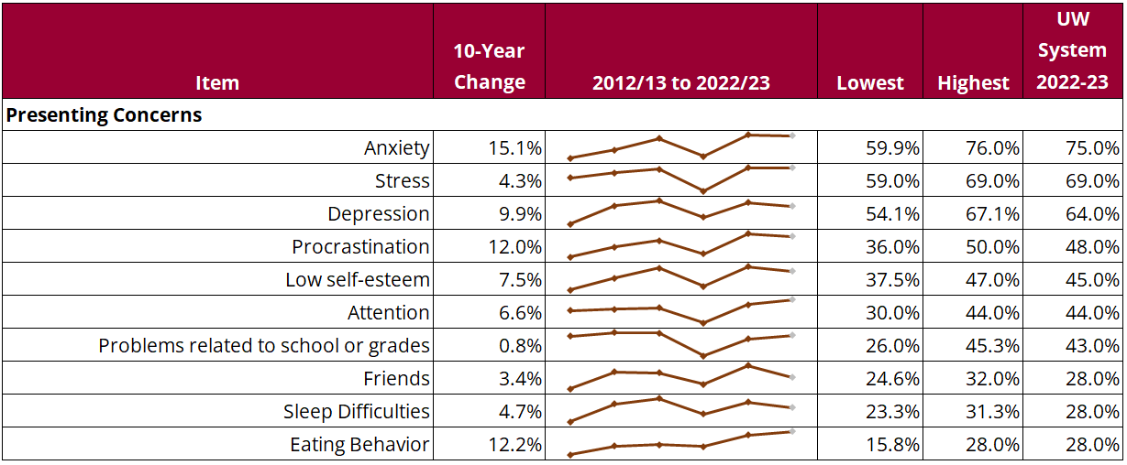

## Table 6: Academic Impact

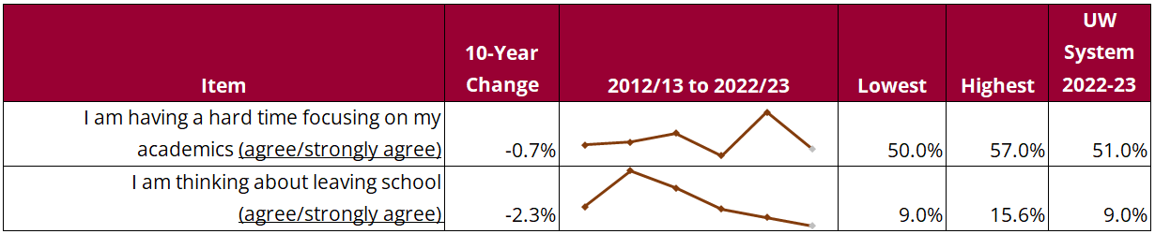

As shown in Table 7, trends in responses to some mental health history items continue to increase, including the proportion of counseling clients reporting a history of previous counseling and use of medication for mental health reasons. The proportion of students reporting prior mental health hospitalization has remained relatively consistent. It should be noted that all of these mental health history markers are reported at a rate higher than national benchmarks, indicating that UW university counseling centers have needed to be more prepared for students with higher levels of need, including chronic conditions. After years of an increasing percentage of students endorsing safety-risk concerns, we are starting to see a small drop on all three items assessed (history of nonsuicidal self-injury, seriously considering suicide, and making one or more suicide attempts), which puts them more in line with national benchmarks.

## Table 7: Prior Mental Health and Alcohol/Drug Use History

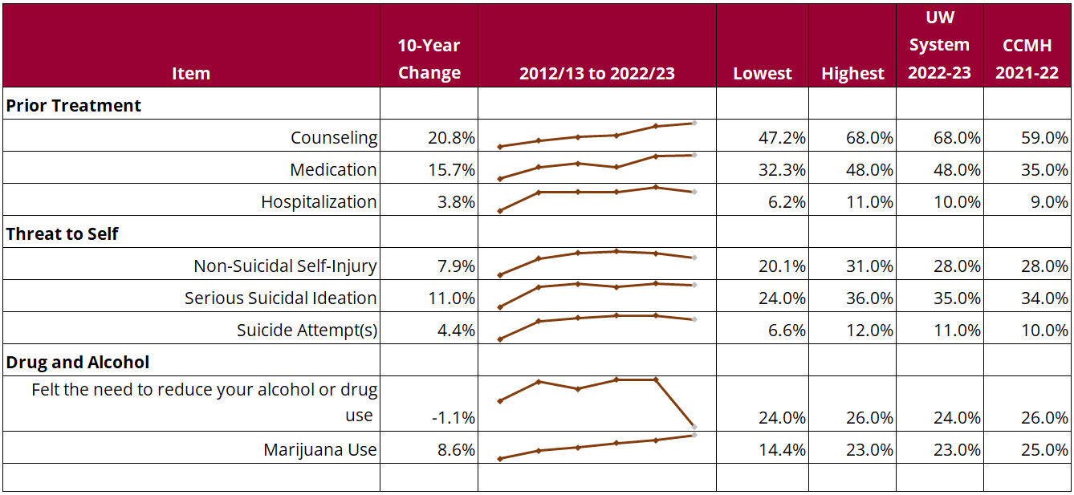

In terms of drug and alcohol history, it is notable that the prevalence of problematic alcohol use has remained highly stable over time (around 25% of clients), while the two-week prevalence of marijuana use among counseling clients has continued to rise, moving almost 10 percentage points (from 14% to 23% of clients) since we began tracking. This remains slightly below the national average. As more states legalize recreational use of marijuana, more accepting attitudes will likely lead to a continued rise in marijuana use prevalence, despite the fact that it remains illegal in Wisconsin. It is important to note that only a small percentage of clients identify alcohol or drug use as a presenting concern upon intake, and campus counseling centers generally do not provide a full continuum of substance abuse treatment. Rather, their scope is limited to harm-reduction approaches to address mild to moderate levels of alcohol and other drug misuse, with community referrals made for those in need of more specialized treatment.

# Client Outcomes

To assess the impact of counseling on student intrapersonal learning and emotional well-being, the Learning Outcome and Satisfaction (LOS) survey looks at several key self-report indicators. Data presented in Table 8 shows that positive outcomes are consistently reported by over three-fourths of students in several areas, including 1) making improvements on their identified issues, 2) feeling better prepared to work through future concerns, and 3) experiencing an improvement in well-being from the beginning to the end of counseling.

The vast majority of counseling clients also continue to rate the effectiveness of services offered as good, very good, and excellent, although fluctuations seen from year-to-year parallel fluctuations in number of students seeking services and staffing levels. As noted in previous reports, research supports that the number and frequency of counseling appointments attended impacts the amount of improvement experienced (CCMH, 2020). It is anticipated that if counseling centers continue to struggle to fill positions or maintain adequate staffing levels to meet student demand, students will experience poorer outcomes.

See Appendix 3 for a complete summary of LOS data and Appendix 4 for the full data on trends displayed in Tables 8-10.

## Table 8: Interpersonal and Emotional Well-Being Outcomes

Table showing 10-year trend data for client outcomes: making improvements on specific issues, feeling prepared to work through future concerns, increasing ability to think clearly about problems, percentage of students self-reporting an increase in wellbeing, percentage of students rating therapy effectiveness as good, very good, or excellent.

Improvements in well-being often translate into academic improvements. To assess the impact of counseling services on academic outcomes, students who sought counseling were asked if they were struggling with academics and/or thinking about leaving school (see Table 9). The percentage of students who report struggling with academics (33%) has decreased slightly since the pandemic, as has the percentage of students who indicated they were thinking about leaving school (20%). Of the students who indicated they were struggling academically; counseling has continued to assist them in increasing focus on academics (63%). And of the students who indicated they were thinking about leaving school, 72% indicated that counseling helped them stay in school.

Extrapolating the percentage of students who were thinking of leaving school (20%) but decided to stay after their experience in counseling (72%) to the approximately 14,815 students attending counseling in 2022-23, we estimate that counseling centers helped retain approximately 2,133 students this year who otherwise might have left because their mental health was significantly impacting their ability to be successful. Assuming an average undergraduate resident tuition and fee rate across UW universities of $8,840, this accounts for approximately $19 million in saved tuition revenue that can be at least partially attributed to having counseling services on campus.

## Table 9: Academic Outcomes

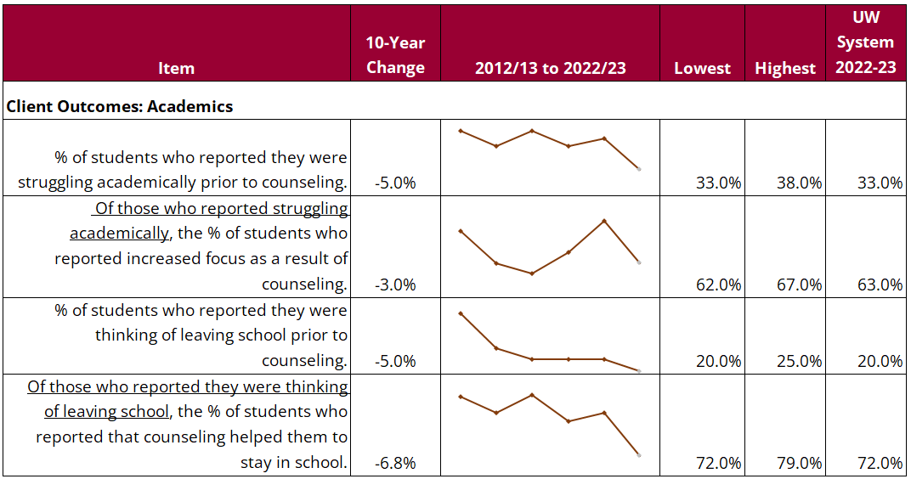

# Client Satisfaction

UW university students utilizing counseling have consistently reported high satisfaction with services received on the Learning Outcome and Satisfaction Survey (LOS). Table 10 shows 10-year satisfaction trends for appointment scheduling, access to services, and willingness to return and refer others, with a range of 83% to 95% of students giving favorable ratings on items assessing these service categories this year. While client satisfaction levels remain high overall, metrics assessing appointment availability have declined slightly since the pandemic as utilization rebounded, putting more strain on appointment availability. Almost all clients (95%) continue to express a value in having access to counseling services on campus. While UW System launched a three-year contract with Mantra Health in 2022-23 to expand mental health treatment access through telecounseling and telepsychiatry across twelve UW universities (excluding Madison; see Appendix 5), on-campus services remain the primary student preference as reflected in both high utilization of counseling centers and student self-report on the counseling follow-up survey (described further in this section).

## Table 10: Client Satisfaction

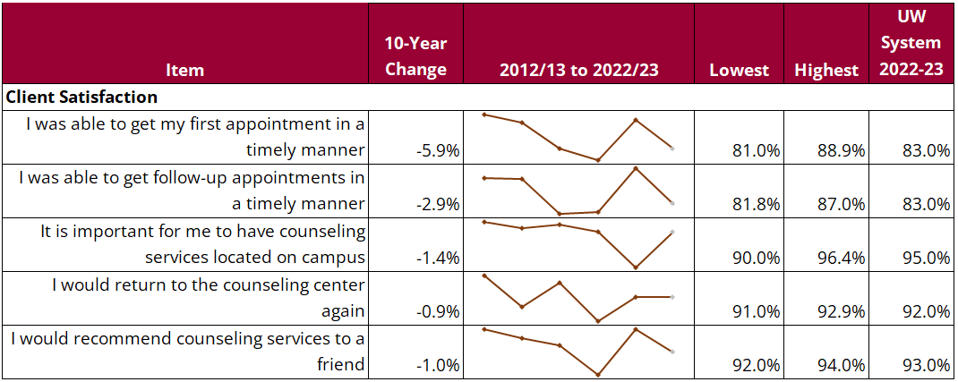

Qualitative data continues to emphasize this desire for increased access to on-campus care. When asked what could be improved about their counseling experience, one student commented: “how difficult it was to get in and see a counselor. In March, I was only able to see my counselor once because of how busy she was. The infrequency of appointments made it hard to feel like we were making any progress on the issues that I am having.“ Client comments frequently reference a wish that they “could have more sessions” and that “the sessions could be longer, or more frequent,” giving voice to the link between level of service and client outcomes.

Students provided qualitative feedback on their counseling experiences via three questions: *What was most helpful?; What was least helpful?;* and, *What are your suggestions for improvement?* A representative sample of responses is included below, offering insights into the needs of students and counseling centers.

*What was most helpful about attending counseling?*

* “I was never able to open up to therapists because it was very hard for me to meet a BIPOC therapist and also build trust. [The counselor] really helped me and saved my life…. I finally believe I met a therapist and psychiatrist I can work with. They really did an excellent job with someone who was suicidal and in the dark to bring me out to hope and light at the end of the tunnel.”
* “It’s helpful to talk to someone about your issues without bias. They are also trained to deal with topics like suicide and self-harm that I can’t really talk to anyone else with.”
* “Convenient location on campus, free of charge.”
* “Having a safe space on campus to talk about and openly process my struggles without fear of judgment. It took me a couple of sessions to overcome my anxiety about opening up to someone because I feared being a burden. Therapy helped me realize that it’s ok for me to open up to others about my struggles and that it’ part of self-care, not being a burden. I started being more open with my parents and close friends and that has been very beneficial in my life.”

*What was least helpful?*

* “Nothing” (most frequent response)
* “I would say that the least helpful is that sometimes appointments go a bit between each other – but I know it is because there are so many students that demand the resources that the counseling center provides – so it doesn’t really make me too upset, I am glad people are getting access to things that they otherwise may not have access too.”
* “Scheduling.”
* “Since the services are so popular and needed, it’s hard to get an appointment.”
* “That are so few counselors compared to the number of students. It can be quite a while before you can have your first meeting because the counselors are so booked.”

*Suggestions for Improvement.*

* “You should hire more counselors for the students. It made a great impact in my life and I wish the same things for other students.”
* “Y’all are very understaffed. It took about a month to get my first appointment, and my appointments are 30 minutes each through to the end of the semester because the demand for counseling is so much higher than it was earlier in the semester. This is not okay. People with mental illness should have access to local and in-person care and be able to get it quickly. All of these problems would be less severe with more staff members on your team. PLEASE hire more staff and get clients in more quickly and for full sessions.”
* “Maybe a counseling portal of some sort, to see past appointments and future appointments, topics discussed and counselors.”
* “Give the counselors a raise.”
* “Hire more people – I know there’s a huge demand, and online help through Mantra just isn’t the same.”
* “I just wish it was more accessible to every student. My case was deemed urgent because I was having suicidal thoughts, so I was thankfully able to get in. But, I know this is not the case for everyone.”

Finally, the LOS continues to ask a few questions related to telecounseling experiences and preferences. While most students (71%) indicated that most or all of their counseling appointments were attended in-person, a sizable minority (29%) indicated that some or all of their appointments were attended via telehealth, indicating that centers continue to provide flexible options for students. In terms of preferences, 84% expressed a preference for in-person care vs. 16% for telehealth. When asked whether telehealth should continue to be offered as an option, 43% indicated a strong desire, 39% were neutral, and 19% indicated no desire. Consistent with the past few years, these results communicate a primary preference for in-person services and appreciation for the availability of telecounseling as an alternative option.

# Personnel/Staffing

Mental health professionals working at UW University counseling centers include licensed psychologists, counselors, social workers, and marriage and family therapists. Many centers also hire staff that are in the process of accruing the clinical hours needed for independent practice and require weekly clinical supervision. The number of professional staff relative to campus enrollment is a critical indicator of a counseling center’s ability to provide timely and effective services. This annual report has been tracking the ratio of students to counselors over the course of several years. According to the International Accreditation of Counseling Services (IACS) *Standards for University and College Counseling Services (*2020), “Every effort should be made to maintain minimum staffing ratios in the range of one FTE professional staff member (excluding trainees) for every 1,000-1,500 students, depending on services offered and other campus mental health agencies.” Figure 2 displays the average ratio of students to counselors across UW universities over the past six academic years. After a one-year rise in the ratio two years ago, the ratio continued to recover slightly in 2022-23 to an average of 1,341 students to every one counselor—the lowest ratio since this report began tracking and in between the upper lower limits of the minimum recommended ratio. The lower ratio of 1,000:1 has become the preferred minimum standard given the increase in utilization of counseling services over the last several years.

## Figure 2: Six-Year Trend: Ratio of Students to Counselors

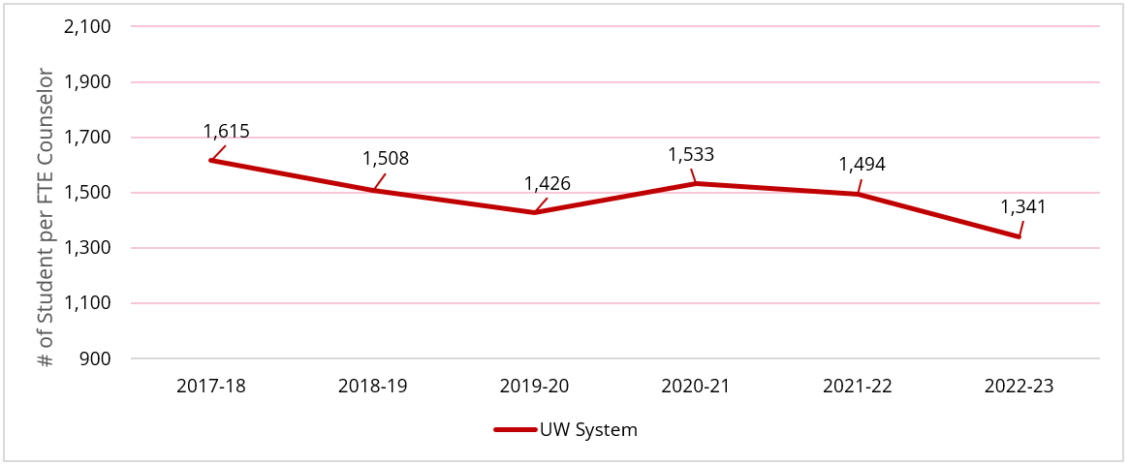

To illustrate the variability of the student-to-counselor ratio across UW Universities, Table 11 displays the eight-year trend of students to counselors by campus. This year, nine of 13 counseling centers met the 1,500:1 higher minimum ratio; and only three met the 1,000:1 preferred minimum ratio (with four others getting close to meeting this standard). As state funding has dwindled as a proportion of UW institutional budgets in recent decades, most counseling centers turned to segregated fees as a primary source of service funding. While this has helped many campuses improve staffing levels, it has also resulted in unequal funding levels and staffing discrepancies systemwide because segregated fees are subject to individual institutional priorities and approval processes. The UW System behavioral health initiative has recognized these inequities and highlighted them as an important issue to address.

In spring 2020, a systemwide behavioral health workgroup recommended that all UW universities work toward the 1,000:1 ratio considering the significant spike in utilization seen in the last decade. Without this level of staffing, campuses are forced to make decisions that place limits on timeliness of access and amount of services provided, which contribute to lower levels of improvement in both well-being and academic outcomes that are delineated elsewhere in this report. The addition of supplemental telecounseling services through Mantra Health during the spring semester helped to partially address access issues on some of our campuses (see Appendix 5), and the 2023-24 academic year will continue to inform the impact these services might have on improving student access to care.

## Table 11: Eight-Year Trend: Ratio of Students to Counselors by University

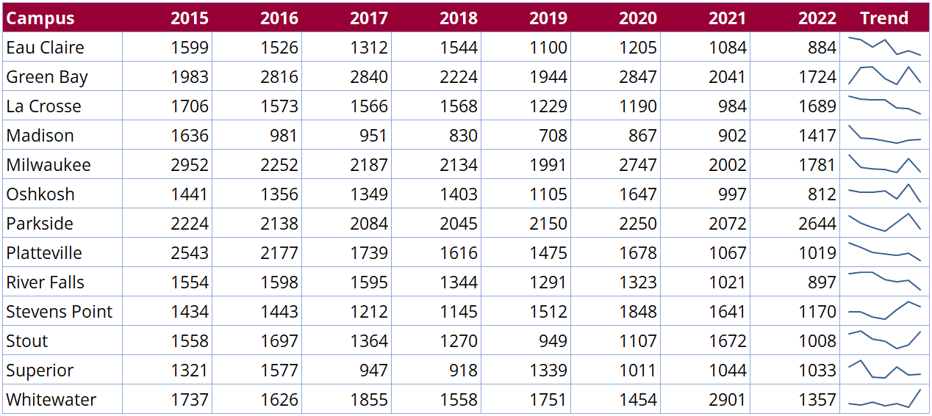

An additional metric used to provide perspective on appropriate staffing and service levels for counseling centers is the Clinical Load Index (CLI), developed through a partnership between the Center for Collegiate Mental Health (CCMH), the International Accreditation of Counseling Services (IACS), and the Association for University and College Counseling Center Directors (AUCCCD). The CLI is a standardized metric that is most easily thought of as the average annual caseload for a full-time counselor at a given center. Instead of focusing exclusively on full-time equivalent (FTE) staffing levels, the CLI considers the actual number of students seeking services (counseling center utilization) and the amount of “clinical capacity” (weekly appointment availability) to calculate a score that describes the relationship between the supply and demand for counseling at any given center.

Figure 3 shows the CLI distribution for UW university counseling centers (represented by blue dots) during the 2022-23 academic year, compared to the 2021-22 national reference group of campuses collected by CCMH (represented by gray dots). The average CLI score reported by CCMH in 2021-22 was 106 (which translates to 106 students seen by each full-time counselor, per year). This compares to an average CLI of 112 (range: 82 to 181) across UW University counseling centers in 2022-23, similar to last year. This puts most of our campuses in the mid-range of this metric. It should be noted, however, that the outliers on both ends of the continuum have significantly different capabilities when it comes to serving students. As CCMH (2020) research has documented, higher CLI scores are associated with lower treatment dosages (fewer and less frequent appointments), which are, in turn, associated with less improvement in symptoms of common concerns like depression, anxiety, and general distress. Lower CLI scores are associated with the opposite—higher treatment dosage and greater levels of improvement.

Subsequent CCMH guidance related to the CLI suggest that it should be used to help university leaders engage in honest discussions to seek alignment between staffing levels, scope of service, and the expectations of critical stakeholders including students, faculty, staff, administrators, and parents/family (Locke, 2021). When there is a misalignment between what is expected and what is possible, this has the potential to contribute to stress and discontent among all affected parties.

## Figure 3: Clinical Load Index (CLI) Distribution (2021-2022 Comparison Data)

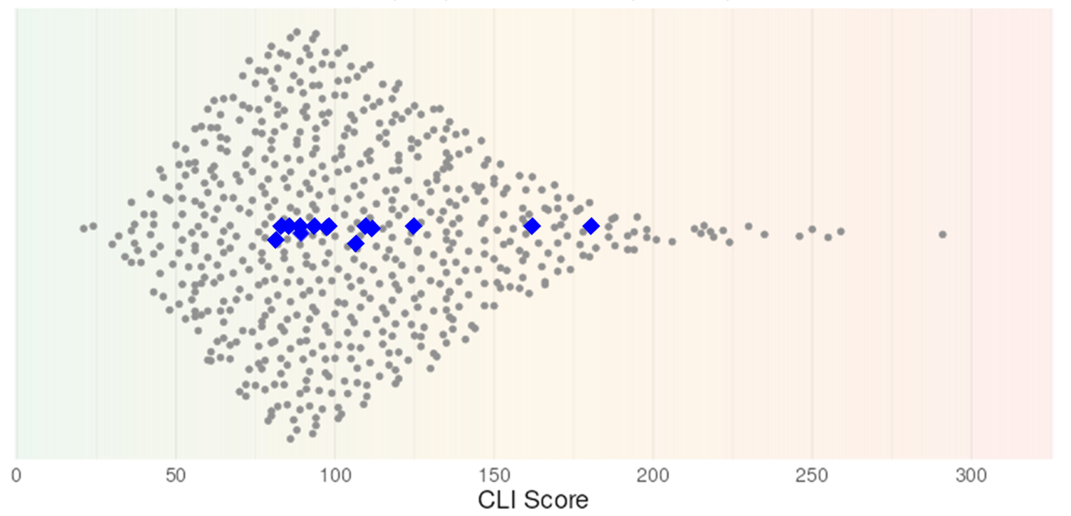

Both student-to-counselor ratios and the CLI provide important ways of monitoring our ability to provide quality mental health treatment services on our campuses. These two metrics will continue to inform efforts to reach more favorable and equitable staffing levels to better serve the needs of our students in the future.

## Staff Retention

In response to anecdotal reports across UW universities and nationally in the past couple of years, counseling center directors were once again surveyed to explore growing concerns about counselor retention and difficulties filling open positions. Ten of 13 directors completed the survey, which did not include UW-Madison or UW-Milwaukee, the UW universities with the largest number of counseling staff. Among the 10 responding centers, eight of them (80%) reported the loss of at least one counselor in 2022-23—three reported losing three or more, and only two centers reported that all clinical staff were retained. This is very similar to the data from the previous year when four centers reported losing three or more clinical staff and two retained all of their clinical staff. These numbers suggest slightly higher attrition than reported in the most recent national survey of counseling center directors (AUCCCD, 2022), which showed that 69% of centers experienced turnover in 2021-22, accounting for one in five clinical positions.

Expanding the exploration of turnover beyond a single year, nine centers responded to a survey question related to turnover in the past five years. Those universities reported losing a total of 52 counseling staff in the past five years (see Figure 4), which is 1 more than the total staff FTE (51) employed at these centers in 2022-23—representing an aggregate turnover rate of 100%. Three centers reported losing 10 or more counselors each during this time period, and no center retained all of their clinical staff. When looking at the percentage of staff turnover by university, three universities turned over 100% or more of their positions during this time period, one university turned over 71%, three universities were in the 40-50% range, and one university reported 33% turnover. It should also be noted that turnover has impacted the director ranks. Eight of 13 counseling director positions have turned over in the last six years, with only three due to retirement. These survey results appear to confirm the anecdotal reports of concern about professional staff turnover in UW university counseling centers, consistent with national trends.

## Figure 4: Five-Year Staff Turnover

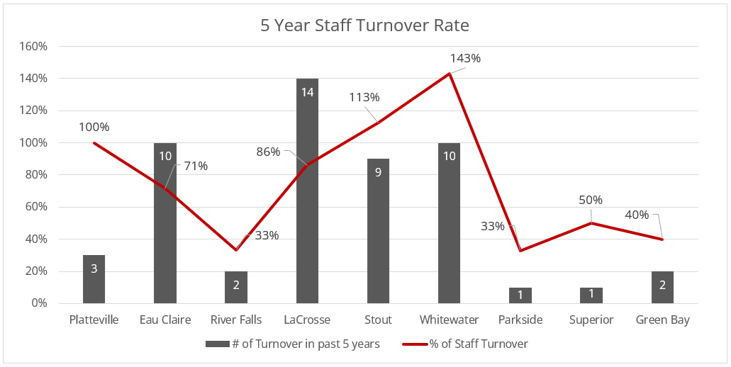

When asked about the impact losing staff has on centers, there was a clear consensus that the impact has been significant. Below are a few of the impacts identified by directors:

* Loss of institutional knowledge and clinical experience
* Negative impact on clients (gaps in appointment availability; loss of continuity of care)
* Increased workload for remaining staff, contributing to lower morale and burnout
* Search processes that are slow, produce low numbers of applicants, and are not always successful
* Onboarding of new, unlicensed staff, requires clinical supervision, taking time away from clinical services
* Challenge to replace staff with specialized training (for example, eating disorders, trans health, sexual trauma)

Directors noted that recruiting and hiring has remained challenging, with eight of the nine directors identifying having a hard time recruiting for clinical vacancies. When asked about the reasons counseling staff are leaving, the top three answers given were:

1. Low salary
2. Work conditions (such as hectic schedules, heavy client load, severity of cases, lack of support)
3. Lack of flexibility

The top two reasons are identical to those given in the most recent national director survey (AUCCCD, 2022). The third most frequent reason in that report was “departure from the counseling field.”

Since salary was identified as the primary barrier to hiring new clinicians, we include a comparison of average starting salaries at UW university counseling centers compared to national data published by AUCCCD (2022). As can be seen in Table 12, the average starting salaries for counselors and psychologists at UW universities lag behind both national and Midwest averages.

## Table 12: Average Starting Salaries for University Counselors and Psychologists

|  |  |  |  |
| --- | --- | --- | --- |
| Position | UW Starting Salary | Midwest Starting Salary | National Starting Salary |
| Counselor | $52,431 | $61,993 | $65,877 |
| Psychologist | $72,444 | $77,600 | $79,278 |

According to our survey, the average starting salary for masters-level counselors at UW University counseling centers in the last year was over $9,000 lower than the average for universities in the Midwest, and over$13,000 lower than the national average. It is also notable that the average salary for all counselors at UW universities was $53,947, only $1,500 greater than the average starting salary, suggesting either that most counselors are relatively new in their positions and/or that there are issues with salary compression. The discrepancy between psychologist pay at UW counseling centers compared to averages in the Midwest (approx. $5,000 lower) and nationally (approx. $7,000 lower) is slightly less than for counselors, but still significant. These data show that, on average, UW university counseling centers are not currently offering competitive salaries when compared to peer universities.

Directors have implemented several strategies to help improve staff retention, including offering work-from-home days, prioritizing wellness, building a positive and affirming workplace environment, and advocating for salary increases. These efforts will continue, but until workload and compensation levels can be improved, turnover will continue to be a challenge that poses direct adverse impacts on our students.

# Conclusion

This report documents both the successes and challenges of providing mental health counseling services at UW universities. The data presented over multiple years—both quantitative and qualitive—strongly supports the contributions of counseling services to student success and well-being. The report also makes clear that the challenges to providing adequate service levels continue due to high demand, greater complexity of student needs, and, most recently, issues with recruitment, retention, and pay levels for staff.

As UW universities enter the 2023-24 academic year, budget challenges loom even larger across the state due to persistent challenges with enrollment, structural deficits at many of our universities, and reduced state funding, all adding to already difficult circumstances. As recognition of the role of student mental health and well-being as a critical factor in student success has grown over the past several years, we hope that funding for these services will be prioritized when difficult programmatic and staffing decisions need to be made at our universities. The data in this report can inform critical conversations among stakeholders about the role that counseling centers play in student success and the scope of services they can reasonably provide. This is a critically important aspect of a holistic, campuswide approach to promoting student mental health and well-being. Counseling center staff, working together with other staff, faculty, and administrators, will continue to be leaders in these important discussions.

# References

American College Health Association (ACHA) (2022, Spring). *American College Health Association-National College Health Assessment III: Reference group executive summary*. Silver Spring, MD: American College Health Association; 2022. Retrieved from <https://www.acha.org/documents/ncha/NCHA-III_SPRING_2022_REFERENCE_GROUP_EXECUTIVE_SUMMARY.pdf>.

Association for University and College Counseling Center Directors (AUCCCD) (2022). *Annual survey 2022*. Retrieved from <https://www.aucccd.org/assets/documents/Survey/2021-22%20Annual%20Survey%20Report%20Public%20FINAL.pdf>.

Center for Collegiate Mental Health (CCMH) (2023, January). *2022 Annual Report* (Publication No. STA 23-168). Retrieved from <https://ccmh.psu.edu/assets/docs/2022%20Annual%20Report.pdf>.

Center for Collegiate Mental Health (CCMH) (2021). *COVID-19’s impact on college student mental health*. Five-part blog series retrieved from <https://ccmh.psu.edu/index.php?option=com_dailyplanetblog&tag=covid-19>.

Center for Collegiate Mental Health (2021, August). The Alignment Model: Using the Clinical Load Index (CLI) to Guide Counseling Center Staffing. Blog series entry retrieved from <https://ccmh.psu.edu/index.php?option=com_dailyplanetblog&view=entry&year=2021&month=08&day=20&id=18:the-alignment-model-using-the-clinical-load-index-cli-to-guide-counseling-center-staffing>.

Center for Collegiate Mental Health (CCMH) (2021, January). *2020 Annual Report* (Publication No. STA 21-045). Retrieved from <https://ccmh.psu.edu/assets/docs/2020%20CCMH%20Annual%20Report.pdf>.

Center for Collegiate Mental Health (CCMH) (2020, January). *2019 Annual Report* (Publication No. STA 20-244). Retrieved from <https://ccmh.psu.edu/assets/docs/2019-CCMH-Annual-Report_3.17.20.pdf>.

International Accreditation of Counseling Services (IACS) (2020). *Standards for university and college counseling services.* Retrieved from <https://iacsinc.org/wp-content/uploads/2021/02/IACS-2020-STANDARDS.pdf>.

Universities of Wisconsin System (2023). *Services for students with disabilities: 2022-23 Annual report.* Retrieved from <https://www.wisconsin.edu/disability-resources/ccsd/>.

# Appendices

## Appendix 1: Number and Percentage of Students Attending Counseling, by Campus

|  |  |  |  |  |  |  |  |
| --- | --- | --- | --- | --- | --- | --- | --- |
|  | **Total Counseling Clients** | | | | |  |  |
| **Campus** | 2018-19 | 2019-20 | 2020-21 | 2021-22 | 2022-23 | **% of Total Enrollment 2022-23** | **5-year Change in Utilization** |
| Eau Claire | 1,140 | 1,206 | 910 | 1,162 | 1,079 | 11.2% | -5.3% |
| Green Bay | 440 | 509 | 391 | 528 | 657 | 9.4% | 49.3% |
| La Crosse | 1,018 | 996 | 742 | 1,091 | 826 | 8.0% | -18.9% |
| Madison | 5,658 | 4,600 | 5,523 | 6,689 | 6,358 | 12.7% | 12.4% |
| Milwaukee | 1,401 | 1,564 | 1,150 | 1,546 | 1,405 | 6.1% | 0.3% |
| Oshkosh | 1,280 | 1,348 | 1,401 | 1,401 | 888 | 10.9% | -30.6% |
| Parkside | 169 | 277 | 139 | 144 | 119 | 3.0% | -29.6% |
| Platteville | 522 | 596 | 390 | 531 | 651 | 11.6% | 24.7% |
| River Falls | 529 | 558 | 387 | 524 | 620 | 11.9% | 17.2% |
| Stevens Point | 652 | 495 | 483 | 534 | 520 | 7.1% | -20.2% |
| Stout | 758 | 781 | 537 | 694 | 743 | 11.4% | -2.0% |
| Superior | 165 | 185 | 160 | 150 | 215 | 6.9% | 30.3% |
| Whitewater | 906 | 948 | 791 | 723 | 734 | 6.6% | -19.0% |
| **TOTAL** | **14,638** | **14,063** | **13,004** | **15,717** | **14,815** | **9.8%** | **1.2%** |

## Appendix 2: Client Information Form (CIF)

Designed to measure client characteristics and history, the CIF consists of a presenting concerns checklist, four items assessing intake academic functioning, and the standard demographic and personal history items established by the Center for Collegiate Mental Health (CCMH). The 2022-23 results of the CIF are presented below, with benchmark comparisons to national counseling center data collected by CCMH during the 2021-22 academic year (the most recent available).

### CIF Client Demographics

|  | Counseling Clients  (n = 6,603) | UW System Population  (n=160,782) | CCMH  (n =190,907) |
| --- | --- | --- | --- |
| **Academic Status (%)** (n = 5,647) | | | |
| Freshman/ First year | 27% | 19% | 21% |
| Sophomore | 22% | 17% | 19% |
| Junior | 20% | 17% | 22% |
| Senior | 21% | 23% | 20% |
| Graduate/Professional Degree | 8% | 16% | 17% |
| Other | 2% | -% | 1% |
| **Gender Identity (%)** (n = 5,647) | | | |
| Woman | 65% | 45% | 63% |
| Man | 29% | 55% | 32% |
| Transgender | 2% | -% | 1% |
| Other Non-Binary/Self-Identify | 5% | -% | 4% |
| **Race/Ethnicity (%)** (n = 5,589) | | | |
| White | 84% | 73% | 61% |
| Asian American/ Asian | 4% | 2% | 11% |
| Multi-racial | 3% | 3% | 5% |
| Hispanic/ Latino(a) | 5% | 7% | 11% |
| African American/Black | 3% | 3% | 10% |
| American Indian or Alaskan Native | -% | <1% | 1% |
| Self-identify | <1% | 2% | 2% |
| Native Hawaiian or Pacific Islander | <1% | <1% | <1% |
| **Sexual Orientation (%)** (n = 5,545) | | | |
| Heterosexual | 63% | -% | 68% |
| Bisexual | 19% | -% | 14% |
| Self-identify | 9% | -% | 1% |
| Questioning | 4% | -% | 4% |
| Lesbian | 3% | -% | 2% |
| Gay | 3% | -% | 3% |
| **GPA [Mean (SD)]** | 3.29 (.59) | - | - |
| **International Student (% Yes)** | 2% | 6% | 8% |
| **First Generation Student (% Yes)** | 25% | 30% | 30% |
| **Age [Mean (SD)]** | 21 (3.54) | 21-24 AVG | 22 (4.02) |
| **US Military Service (% Yes)** | 2% | 2% | 1% |
| **Traumatic/Stressful Military Experience [% Yes (n)]** | 1% (29) | -% (-) | 34% (121,718) |
| **Student Athlete (% Yes)** | 12% | -% | 14% |
| **Transfer Student (% Yes)** | 18% | 4% | 00% |

|  |  |  |
| --- | --- | --- |
|  | Counseling Clients  (n = 6,603) | CCMH  (n = 190,907) |
| **Current Housing (%)** (n = 5,742) | | |
| On-campus residence hall/ apartment | 48% | 36% |
| Off-campus apartment/house | 49% | 61% |
| On/off-campus co-operative housing | 1% | 1% |
| On/off-campus fraternity/sorority house | 1% | 2% |
| Other | 1% | 1% |
| **Who do you Live With (%)** (n = 6,602) | | |
| Roommate(s) | 66% | 66% |
| Alone | 17% | 14% |
| Spouse, partner, or significant other | 8% | 10% |
| Parent(s) or guardian(s) | 8% | 10% |
| Family other | 4% | 6% |
| Children | 1% | 2% |
| Other | 1% | 1% |
| **Relationship Status (%)** (n = 4,481) | | |
| Single | 58% | 61% |
| Serious dating or committed relationship | 39% | 34% |
| Married | 2% | 4% |
| Divorced | <1% | <1% |
| Civil union, domestic partnership, or equivalent | <1% | <1% |
| Widowed | 0% | <1% |
| Separated | <1% | <1% |
| **Current Financial Situation** (n = 6,317) | | |
| Always stressful | 13% | 11% |
| Often stressful | 23% | 15% |
| Sometimes stressful | 38% | 24% |
| Rarely stressful | 20% | 28% |
| Never stressful | 6% | 21% |
| **Registered Disability (% Yes)** | 13% | 11% |
| **If yes, which category- check all that apply (%)** |
| Attention Deficit/Hyperactivity Disorder | 51% | 47% |
| Difficulty Hearing | 4% | 3% |
| Specific Learning Disability | 16% | 13% |
| Mobility Impairments | 3% | 4% |
| Health Impairment/Condition | 10% | 11% |
| Psychological Disorder/Condition | 31% | 31% |
| Visual Impairments/Difficulty Seeing | 2% | 2% |
| Traumatic Brain Injury | 3% | 2% |
| Cognitive Difficulties/Intellectual Disability | 5% | 4% |
| Difficulty Speaking/Language Impairment | 1% | 1% |
| Autism Spectrum Disorder | 6% | 7% |
| Other | 17% | 16% |
| **Religious/Spiritual Preference (%)** (n = 4,813) | | |
| Christian | 25% | 30% |
| Catholic | 12% | 13% |
| Agnostic | 19% | 17% |
| Atheist | 13% | 10% |
| Self-identify | 4% | 4% |
| Buddhist | <1% | 1% |
| Jewish | 1% | 2% |
| Muslim | 1% | 2% |
| Hindu | <1% | 2% |
| No preference | 25% | 21% |
| **Hours of Work Per Week (%)** (n = 3,638) | | |
| 0 | 35% | 41% |
| 1-5 | 8% | 6% |
| 6-10 | 18% | 11% |
| 11-15 | 12% | 10% |
| 16-20 | 12% | 13% |
| 21-25 | 6% | 7% |
| 26-30 | 5% | 4% |
| 31-35 | 1% | 2% |
| 36-40 | 2% | 3% |
| 40+ | 2% | 3% |

### Client Reported Presenting Concerns - % Reporting Yes

|  |  |
| --- | --- |
| **Items** | **Counseling Clients**  **(n = 6,603)** |
| Anxiety/fears/worries (other than academic) | 75% |
| Stress/stress management | 69% |
| Depression/sadness/mood swings | 64% |
| Procrastination/motivation | 48% |
| Low self-esteem/confidence | 45% |
| Attention/concentration | 44% |
| Problems related to school or grades | 43% |
| Friends/roommates/dating concerns | 28% |
| Eating behavior/weight problems/eating disorders/body image | 28% |
| Sleep difficulties | 28% |
| Shyness/social discomfort | 25% |
| Anger/irritability | 23% |
| Choice of major/career | 18% |
| Grief/loss | 14% |
| Other | 14% |
| Childhood abuse (physical, emotional, sexual) | 13% |
| Marital/couple/family concerns | 12% |
| Physical symptoms/health (headaches, stomachaches, pain) | 9% |
| Alcohol/drug use | 9% |
| Sexual assault/dating violence/stalking/harassment | 6% |
| Self-injury (cutting, hitting, burning) | 6% |
| Sexual orientation | 5% |
| Gender identity | 4% |
| Cultural adjustment | 3% |
| Seeing/hearing things others don’t | 2% |
| Bullying/harassment | 2% |
| Prejudice/discrimination | 2% |
| Urge to injure/harm someone else | 1% |

Students were asked to report the degree to which their academics were being negatively impacted by their mental health. Students responded to each item on a scale from 1 (Strongly Disagree - SD) to 5 (Strongly Agree - SA).

### Academic Outcomes

|  |  |  |  |  |
| --- | --- | --- | --- | --- |
| **Subscale Item** | **SD/Disagree** | **Neutral** | **Agree/SA** | **System Mean (*n*)** |
| I am struggling with my academics | 46% | 21% | 33% | 3.69 (1246) |
| I am thinking of leaving school | 78% | 13% | 9% | 2.19 (1253) |
| My academic motivation and/or attendance are suffering | 40% | 19% | 41% | 4.00 (1246) |
| I am having a hard time focusing on my academics | 29% | 20% | 51% | 4.52 (1253) |

For the items below, students were asked to report the frequency with which they have had various experiences in their lifetime. The System and CCMH columns represent the percentages of students who reported having the experiences at least one time.

### Mental Health History Items

| **Items** | **Never** | **1 Time** | **2-3 Times** | **4-5 Times** | **More than 5 Times** | **System % (*n*)** | **CCMH**  **% (n)** |
| --- | --- | --- | --- | --- | --- | --- | --- |
| Been hospitalized for mental health concerns | 90% | 7% | 3% | 1% | <1% | 10% (6405) | 9% (124,748) |
| Felt the need to reduce your alcohol or drug use | 76% | 9% | 9% | 2% | 6% | 24% (6385) | 26% (110,109) |
| Others expressed concern about your alcohol or drug use | 89% | 5% | 4% | 1% | 2% | 11% (6422) | 13% (110,117) |
| Received treatment for alcohol or drug use | 98% | 1% | <1% | <1% | <1% | 2%  (6459) | 2% (115,797) |
| Purposely injured yourself w/o suicidal intent (such as cutting, hitting, burning, etc.) | 72% | 7% | 7% | 3% | 11% | 28% (5717) | 28% (112,025) |
| Seriously considered attempting suicide | 65% | 13% | 13% | 3% | 7% | 35% (5659) | 34% (119,484) |
| Made a suicide attempt | 89% | 7% | 4% | 1% | 1% | 11% (5726) | 10% (119,603) |
| Considered causing serious physical injury to another person | 96% | 2% | 2% | <1% | 1% | 4% (5752) | 6% (118,802) |
| Intentionally caused serious physical injury to another | 99% | 1% | <1% | <1% | <1% | 1%  (5732) | 1% (118,802) |
| Someone had sexual contact with you w/o your consent | 71% | 14% | 9% | 2% | 5% | 29% (6360) | 27% (117,754) |
| Experienced harassing, controlling, and/or abusive behavior from another person (such as friend, family member, partner, or authority figure) | 61% | 7% | 8% | 2% | 22% | 39% (5940) | 40% (119,644) |
| Experienced a traumatic event that caused you to feel intense fear, helplessness, or horror | 56% | 17% | 13% | 5% | 10% | 44% (2383) | 45% (116,477) |

### Extended Mental Health History Items

|  |  |  |  |  |  |  |
| --- | --- | --- | --- | --- | --- | --- |
| **Items** | **Never** | **Prior to College** | **After Starting College** | **Both** | **System % (*n*)** | **CCMH % (n)** |
| Attended counseling for mental health concerns | 32% | 28% | 20% | 20% | 68% (6369) | 59% (120,639) |
| Taken a prescribed medication for mental health concerns | 52% | 12% | 15% | 21% | 48% (6308) | 35% (120,656) |

### Reported Marijuana Use

|  |  |  |  |  |  |  |  |  |
| --- | --- | --- | --- | --- | --- | --- | --- | --- |
| **Items** | **None** | **Once** | **Twice** | **2 to 3 Times** | **4 to 5 Times** | **5 or More Times** | **System % (*n*)** | **CCMH % (n)** |
| Think back over the last two weeks. How many times have you used marijuana? | 77% | 6% | 4% | 6% | 4% | 4% | 23% (6297) | 25% (103,164) |

## Appendix 3: Learning Outcomes and Satisfaction Survey (LOS)

The Learning Outcomes and Satisfaction (LOS) Survey is the standard outcome measure created by the Counseling Impact Assessment Committee in 2011. Administered to clients at the end of the semester, the LOS is designed to measure the extent to which clients believe that counseling helped them to make improvements on intrapersonal skills, academic functioning, and well-being, as well as their satisfaction with services. The LOS contains three subscales: the Intrapersonal Learning Outcomes Subscale, the Client Satisfaction Subscale, and the Academic Outcomes Subscale. Additional items that do not factor onto the three subscales are presented separately. The 2020-21 results of the LOS are presented below with all client LOS entries included.

### LOS Demographic Data

|  |  |
| --- | --- |
|  | **System Survey (n = 1,297)** |
| **Academic Status (%) (n = 1,198)** | |
| Freshman/First year | 287 (24.0%) |
| Sophomore | 277 (23.1%) |
| Junior | 241 (20.1%) |
| Senior | 247 (20.6%) |
| Graduate/Professional degree student | 131 (10.9%) |
| Other | 15 (1.3%) |
| **Gender Identity (%) (n = 1,197)** | |
| Woman | 834 (69.7%) |
| Man | 248 (20.7%) |
| Transgender | 43 (3.6%) |
| Self-identify | 72 (6.0%) |
| **Race/Ethnicity (%) (n = 1,193)** | |
| African American/Black | 21 (1.8%) |
| American Indian/Alaskan Native | 7 (.6%) |
| Asian American/Asian | 62 (5.2%) |
| Hispanic/Latino(a) | 56 (4.7%) |
| Native Hawaiian/Pacific Islander | - (0%) |
| Multiracial | 36 (3.0%) |
| White | 998 (83.7%) |
| Self-identify | 13 (1.1%) |
| **Age [Mean (*SD*)]** | 21.57 (5.35) |
| **Number of Sessions [Mode]** | 5 |

For the tables below, students were asked to report their level of agreement with statements on a scale from 1 (Strongly Disagree - SD) to 5 (Strongly Agree - SA).

### Lifestyle and Self-Efficacy

|  |  |  |  |  |
| --- | --- | --- | --- | --- |
| **Subscale Items** | **SD/Disagree** | **Neutral** | **Agree/SA** | **System**  **Mean (n)** |
| I made improvements on the specific issues for which I sought counseling. | 7% | 11% | 83% | 4.13 (1271) |
| I have started to live a healthier lifestyle in at least one area (e.g., sleep, diet, exercise, alcohol/drug use). | 9% | 21% | 70% | 3.85 (1225) |
| I have improved my ability to manage stress. | 10% | 23% | 67% | 3.80 (1257) |
| I am better prepared to work through future concerns and achieve my goals. | 7% | 15% | 78% | 4.02 (1266) |
| I increased my self-confidence and/or self-esteem. | 11% | 26% | 63% | 3.75 (1244) |
| The counseling process helped me understand cultural, family, ethnic, and/or community differences. | 13% | 31% | 56% | 3.63 (1088) |
| I have gained a greater understanding of myself or a clearer sense of identity. | 8% | 16% | 76% | 4.01 (1239) |
| I increased my ability to think clearly and critically about my problems. | 7% | 15% | 78% | 4.02 (1255) |
| I improved my communication skills. | 9% | 21% | 71% | 3.89 (1255) |
| **Total Subscale** | **9.0%** | **19.8%** | **71.2%** | **3.90 (1233)** |

### Counseling Satisfaction

| **Items** | **SD/Disagree** | **Neutral** | **Agree/SA** | **System**  **Mean (*n*)** |
| --- | --- | --- | --- | --- |
| The office staff were helpful in providing information and direction. | 3% | 7% | 90% | 4.33 (1199) |
| This counselor displayed sensitivity/acceptance to individual differences (such as culture, gender, ethnicity, etc.). | 2% | 4% | 95% | 4.61 (1208) |
| This counselor helped me clarify my concerns and provide guidance. | 4% | 6% | 90% | 4.45 (1232) |
| This counselor supported me in making my own decisions and reaching my personal goals. | 3% | 6% | 91% | 4.48 (1226) |
| The counseling environment was warm and inviting. | 3% | 5% | 93% | 4.56 (1228) |
| It is important for me to have counseling services located on campus. | 2% | 4% | 94% | 4.69 (1213) |
| I would return to the counseling center again. | 5% | 3% | 92% | 4.58 (1214) |
| I would recommend counseling services to a friend. | 4% | 4% | 93% | 4.60 (1227) |
| **Total Subscale** | **3%** | **5%** | **92%** | **4.53 (1218)** |

### Academic Outcomes

|  |  |  |  |  |
| --- | --- | --- | --- | --- |
| **Items** | **SD/Disagree** | **Neutral** | **Agree/SA** | **System**  **Mean (*n*)** |
| Counseling has increased my academic motivation and/or class attendance. | 19% | 39% | 43% | 3.29 (1145) |
| Counseling has helped me to focus better on my academics. | 16% | 32% | 53% | 3.46 (1177) |
| Counseling has helped with my academic performance. | 17% | 37% | 46% | 3.38 (1160) |
| Counseling has helped me stay at school. | 18% | 33% | 49% | 3.43 (1099) |
| **Total Subscale** | **18%** | **35%** | **48%** | **3.39 (1145)** |

### Retrospective Academic Functioning Items

|  |  |  |  |  |
| --- | --- | --- | --- | --- |
| **Items** | **SD/Disagree** | **Neutral** | **Agree/SA** | **System**  **Mean (n)** |
| Prior to counseling, I was struggling with my academics. | 50% | 16% | 34% | 2.80 (1246) |
| Prior to counseling, I was thinking of leaving school. | 70% | 10% | 20% | 2.19 (1253) |

### Appointment Availability

|  |  |  |  |  |
| --- | --- | --- | --- | --- |
| **Item** | **SD/Disagree** | **Neutral** | **Agree/SA** | **System Mean (*n*)** |
| I was able to get my first appointment in a timely manner. | 10% | 7% | 83% | 4.20 (1235) |
| I was able to get follow-up appointments in a timely manner. | 10% | 7% | 83% | 4.20 (1212) |

For the tables below, students were asked to respond to each item on a scale from 1 (Poor) to 5 (Excellent).

### Overall Satisfaction

|  |  |  |  |  |  |  |
| --- | --- | --- | --- | --- | --- | --- |
| **Item** | **Poor** | **Fair** | **Good** | **Very Good** | **Excellent** | **System Mean (*n*)** |
| Overall effectiveness of counseling in helping with my problems. | 6% | 12% | 34% | 34% | 15% | 3.40 (1241) |
| Overall quality of the services I received. | 4% | 6% | 22% | 35% | 33% | 3.88 (1241) |

### 

### Retrospective Ratings of Well-Being

|  |  |  |  |  |  |  |
| --- | --- | --- | --- | --- | --- | --- |
| **Item** | **Poor** | **Fair** | **Good** | **Very Good** | **Excellent** | **System Mean (*n*)** |
| My level of well-being when I started counseling. | 38% | 44% | 16% | 2% | 1% | 1.84 (1241) |
| My level of well-being now. | 5% | 21% | 47% | 24% | 4% | 3.00 (1241) |

### Perceived Change in Well-Being from Start of Counseling

|  |  |  |  |
| --- | --- | --- | --- |
|  | **Decline** | **No change** | **Improvement** |
| System Survey | 2% (20) | 20% (252) | 78% (969) |

For the table below, students were separated by those who reported that they were or were not struggling with their academics prior to counseling to compare how counseling affected academic performance for each group. Students responded to each item on a scale from 1 (Strongly Disagree - SD) to 5 (Strongly Agree - SA).

### Effectiveness of Counseling Support

|  |  |  |  |  |  |
| --- | --- | --- | --- | --- | --- |
| Scale Items | | SD/Disagree | Neutral | Agree/SA | Overall System  Mean (*n*) |
| Counseling has increased my academic motivation and/or class attendance. | Struggling | 56 (14%) | 107 (26%) | 247 (60%) | 3.62 (410) |
| Not Struggling | 157 (22%) | 331 (46%) | 232 (32%) | 3.11 (720) |
| **Total (average)** | | | | **3.29 (1130)** |
| Counseling has helped me to focus better on my academics. | Struggling | 55 (13%) | 277 (23%) | 498 (63%) | 3.66 (415) |
| Not Struggling | 129 (17%) | 274 (36%) | 346 (46%) | 3.34 (749) |
| **Total (average)** | | | | **3.46 (1164)** |
| Counseling has helped with my academic performance. | Struggling | 55 (13%) | 107 (26%) | 250 (61%) | 3.63 (412) |
| Not Struggling | 138 (19%) | 317 (43%) | 281 (38%) | 3.23 (736) |
| **Total (average)** | | | | **3.38 (1148)** |
| Counseling has helped me stay at school. | Struggling | 52 (13%) | 93 (22%) | 246 (63%) | 3.72 (391) |
| Not Struggling | 148 (21%) | 265 (38%) | 794 (40%) | 3.26 (693) |
| **Total (average)** | | | | **3.43 (1048)** |

For the table below, students were separated by those who reported that they were or were not thinking of leaving school at the beginning of counseling to compare whether counseling services impacted retention. Students responded to each item on a scale from 1 (Strongly Disagree - SD) to 5 (Strongly Agree - SA).

### Effect of Counseling on Academic Retention

|  |  |  |  |  |
| --- | --- | --- | --- | --- |
| **Counseling has helped me stay at school.** | **SD/Disagree** | **Neutral** | **Agree/SA** | **System Mean (*n*)** |
| Thinking of Leaving | 38 (16%) | 31 (13%) | 173 (72%) | 3.80 (242) |
| Not Thinking of Leaving | 164 (19%) | 329 (39%) | 355 (42%) | 3.32 (848) |
| **TOTAL (Average)** | **18.4%** | **32.8%** | **48.7%** | **3.43 (1090)** |

## Appendix 4: CIF and LOS Survey Trend Data Tables

### Demographics

|  |  |  |  |  |  |  |
| --- | --- | --- | --- | --- | --- | --- |
| **Item** | **2012-13** | **2014-15** | **2016-17** | **2018-19** | **2020-21** | **2022-23** |
| Female | 63.3% | 65.6% | 66.9% | 64.0% | 70.0% | 65.0% |
| Male | 34.7% | 32.7% | 30.9% | 33.0% | 27.5% | 29.0% |
| Transgender/Self-identify | 0.6% | 1.7% | 2.2% | 3.0% | 2.5% | 7.0% |
| White | 85.0% | 86.0% | 86.5% | 84.0% | 85.0% | 84.0% |
| Students of Color | 13.0% | 14.1% | 13.5% | 16.2% | 15.0% | 16.0% |
| Heterosexual | 85.5% | 84.6% | 82.6% | 78.0% | 70.0% | 63.0% |
| LGBQ | 9.8% | 15.4% | 15.4% | 22.0% | 30.0% | 37.0% |
| Registered Disability | 7.7% | 8.8% | 8.5% | 7.0% | 10.9% | 13.0% |

### Presenting Concerns

|  |  |  |  |  |  |  |
| --- | --- | --- | --- | --- | --- | --- |
| **Item** | **2012-13** | **2014-15** | **2016-17** | **2018-19** | **2020-21** | **2022-23** |
| Anxiety/fears/worries (other than academic) | 59.9% | 65.4% | 73.3% | 61.0% | 76.0% | 75.0% |
| Stress/stress management | 64.7% | 66.7% | 68.3% | 59.0% | 69.0% | 69.0% |
| Depression/sadness/mood swings | 54.1% | 64.1% | 67.1% | 58.0% | 66.0% | 64.0% |
| Procrastination/motivation | 36.0% | 42.1% | 45.9% | 38.0% | 50.0% | 48.0% |
| Low self-esteem/confidence | 37.5% | 42.3% | 46.3% | 39.0% | 47.0% | 45.0% |
| Attention/concentration | 37.4% | 38.2% | 38.9% | 30.0% | 41.0% | 44.0% |
| Problems related to school or grades | 42.2% | 45.3% | 44.7% | 26.0% | 40.0% | 43.0% |
| Friends/roommates/dating concerns | 24.6% | 29.9% | 29.7% | 26.0% | 32.0% | 28.0% |
| Sleep difficulties | 23.3% | 29.4% | 31.3% | 26.0% | 30.0% | 28.0% |
| Eating behavior | 15.8% | 20.3% | 21.0% | 20.0% | 26.0% | 28.0% |
| I am having a hard time focusing on my academics (agree/strongly agree) | 51.7% | 52.2% | 53.6% | 50.0% | 57.0% | 51.0% |
| I am thinking about leaving school (agree/strongly agree) | 11.3% | 15.6% | 13.5% | 11.0% | 10.0% | 9.0% |

### Mental Health History

|  |  |  |  |  |  |  |
| --- | --- | --- | --- | --- | --- | --- |
| **Item** | **2012-13** | **2014-15** | **2016-17** | **2018-19** | **2020-21** | **2022-23** |
| **Prior Treatment** |  |  |  |  |  |  |
| Counseling | 47.2% | 52.5% | 55.7% | 57.0% | 65.0% | 68.00% |
| Medication | 32.3% | 39.9% | 42.2% | 40.0% | 47.0% | 48.00% |
| Hospitalization | 6.2% | 9.9% | 10.0% | 10.0% | 11.0% | 10.00% |
| **Threat to Self** |  |  |  |  |  |  |
| Nonsuicidal Self-Injury | 20.1% | 27.6% | 30.2% | 31.0% | 30.0% | 28.00% |
| Serious Suicidal Ideation | 24.0% | 34.0% | 35.7% | 34.0% | 36.0% | 35.00% |
| Suicide Attempt(s) | 6.6% | 10.7% | 11.4% | 12.0% | 12.0% | 11.00% |
| **Drug and Alcohol** |  |  |  |  |  |  |
| Felt the Need to Reduce Your Alcohol or Drug Use | 25.1% | 25.9% | 25.6% | 26.0% | 26.0% | 24.00% |
| Marijuana Use | 14.4% | 17.3% | 18.5% | 20.0% | 21.0% | 23.00% |

### Client Outcomes: Interpersonal and Emotional Well-Being

| **Item** | **2012-13** | **2014-15** | **2016-17** | **2018-19** | **2020-21** | **2022-23** |
| --- | --- | --- | --- | --- | --- | --- |
| I made improvements on the specific issues for which I sought counseling | 83.4% | 86.0% | 82.0% | 80.0% | 83.0% | 83.0% |
| I am better prepared to work through future concerns and achieve my goals | 76.4% | 80.2% | 76.8% | 75.0% | 78.0% | 78.0% |
| I increased my ability to think clearly and critically about my problems | 77.8% | 78.7% | 76.3% | 74.0% | 79.0% | 78.0% |
| Percentage of students who self-reported an increase in well-being from the beginning of services to the end of services | 82.4% | 82.0% | 81.0% | 80.0% | 82.0% | 78.0% |
| Percentage of students who rated the effectiveness of therapy in helping students with their problems as good, very good, excellent | 88.4% | 90.0% | 83.0% | 85.0% | 93.0% | 83.0% |

### Client Outcomes: Academics

|  |  |  |  |  |  |  |
| --- | --- | --- | --- | --- | --- | --- |
| **Item** | **2012-13** | **2014-15** | **2016-17** | **2018-19** | **2020-21** | **2022-23** |
| % of students who reported they were struggling academically prior to counseling | 38.0% | 36.0% | 38.0% | 36.0% | 37.0% | 33.0% |
| % of students who reported increased focus as a result of counseling | 66.0% | 63.0% | 62.0% | 64.0% | 67.0% | 63.0% |
| % of students who reported they were thinking of leaving school prior to counseling | 25.0% | 22.0% | 21.0% | 21.0% | 21.0% | 20.0% |
| % of students who reported that counseling helped them to stay in school | 78.8% | 77.0% | 79.0% | 76.0% | 77.0% | 72.0% |

### Client Satisfaction

|  |  |  |  |  |  |  |
| --- | --- | --- | --- | --- | --- | --- |
| **Item** | **2012-13** | **2014-15** | **2016-17** | **2018-19** | **2020-21** | **2022-23** |
| I was able to get my first appointment in a timely manner | 88.9% | 87.5% | 83.1% | 81.0% | 88.0% | 83.0% |
| I was able to get follow-up appointments in a timely manner | 85.9% | 85.8% | 81.8% | 82.0% | 87.0% | 83.0% |
| It is important for me to have counseling services located on campus | 96.4% | 95.5% | 96.0% | 95.0% | 90.0% | 95.0% |
| I would return to the counseling center again | 92.9% | 91.6% | 92.6% | 91.0% | 92.0% | 92.0% |
| I would recommend counseling services to a friend | 94.0% | 93.6% | 93.3% | 92.0% | 94.0% | 93.0% |

## Appendix 5: UW System Telemental Health and Wellbeing Services Pilot

Background

In spring 2022, as part of Governor Evers’ “Get Kids Ahead” initiative, $5 million in American Rescue Plan Act (ARPA) funds were allocated to the UW System to help address student mental health needs that were exacerbated by the pandemic. With this allocation of funds, UW System Administration and UW university stakeholders led a competitive bid process to procure telemental health and well-being services intended to fill critical gaps in currently available on-campus services. Mantra Health, Inc. was awarded the contract in October, 2023. Mantra Health works with two subcontractors to integrate the three requested services described below.

Through this contract, telemental health and well-being services were expanded for 12 UW universities (excluding UW-Madison, where another telehealth vendor is in use) near the mid-point of the 2022-23 academic year. Three services are now available to students at each participating campus:

* *YOU at College* – A personalized well-being platform that directs students toward campus-based and online resources to promote academic and career success (Succeed), purpose and connection (Matter), and physical and mental well-being (Thrive). This platform serves as a “digital front door” to on-campus and online services available to students and can assist the entire student population.
* *UW Mental Health Support 24/7* – Phone, text, and chat services with trained counselors, available 24/7. This service can be used for general support as well as crisis.
* *Mantra Health* - Telecounseling and telepsychiatry services that serve as a supplement to, and coordinate with, campus-based counseling and psychiatry services. Mantra Health expands access by offering evening and weekend scheduling, out-of-state services, and a more diverse pool of providers.

Implementation

Each university created their own protocols in cooperation with the vendors, considering the specific needs and resources on their own campuses. Universities implemented the extended resources in four cohorts during the winter of 2022-23 (see Table 13). Because universities onboarded on different dates, and marketed and utilized services differently, comparisons among universities in utilization are difficult to make. The intention of a systemwide implementation is that each university will be able to benefit from the services in the ways that best serve their students in their local university context.

### Table 13: Telehealth Implementation Cohorts

|  |  |  |
| --- | --- | --- |
| **Group** | **Universities** | **Implementation Period** |
| 1 | Green Bay, Parkside, Whitewater | November 2022 |
| 2 | Eau Claire, Stevens Point, Stout | November 2022 |
| 3 | Oshkosh, Milwaukee, River Falls | December 2022 |
| 4 | La Crosse, Platteville, Superior | January 2023 |

Utilization and Impact

*YOU at College -* In total, 1,034 accounts were created within the individualized YOU at College portals across all 12 universities. As an upstream resource and the “digital front door” to both on-campus and online services available to students, this tool has the broadest applicability to the student population and should eventually see utilization by the highest number of students. Vendor experience at other institutions suggest an aspirational metric of 20% of the student population using this tool annually. Table 14 summarizes a few additional metrics from the first semester of implementation.

### Table 14: YOU at College Utilization: November 2022-May 2023

|  |  |  |  |  |
| --- | --- | --- | --- | --- |
| **Total Accounts** | **Campus Resources Viewed** | **Self-Check Assessments Completed** | **Referrals to Mantra** | **Crisis Button Clicks** |
| 1034 | 550 | 412 | 194 | 112 |

Because YOU embeds campus resources into its portal, it is important to monitor how often students access these resources. Through May 2023, 550 content views within YOU—accounting for 40% of total content views—have been of campus-specific resources. As a personalized resource, students are also able to complete self-check assessments to monitor their progress on identified areas of concern. In the first few months of implementation, 412 self-check assessments were completed. Finally, links to both Mantra Health (for telecounseling and telepsychiatry; 194 referrals) and Mental Health Support 24/7 services (112 button clicks) are embedded in the YOU platform, with early data indicating that students are finding and connecting to these services in this way. The top priorities students established during their onboarding within the YOU platform, which informs the content that is recommended to them, are the following:

* Destressing
* Healthy eating and exercise
* Academics and grades
* Practicing mindfulness
* Getting better sleep

*UW Mental Health Support 24/7 –* Between implementation and May 2023, there were a total of 215 contacts (phone calls, texts, or chats) to UW Mental Health Support 24/7. The most common concerns identified by students were very similar to those presented by students attending counseling in on-campus counseling centers: Anxiety/Stress, Relationships, Depression, School, and Loneliness/Isolation. Figure 6 shows the volume of contacts by month.

### Figure 6: UW Mental Health Support 24/7: Volume of Contacts, by Month

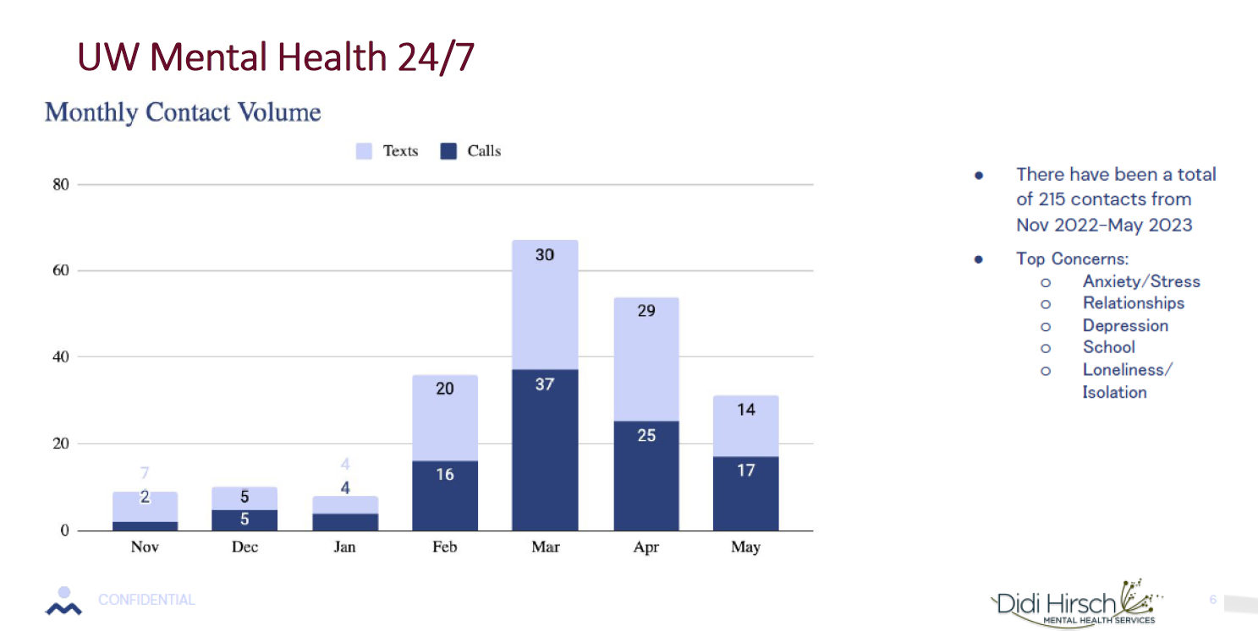

Note that contacts are fairly evenly divided between phone calls and chats/texts, indicating that offering multiple ways to reach out is appealing to our students.

*Mantra Health* – Telecounseling and telepsychiatry services through Mantra Health were available to students as a supplement to on-campus services for the full spring semester. Students can access counseling services directly through a link in the YOU portal or campus website, or they can be referred by a campus health or counseling provider. Psychiatric appointments require referral from a campus provider. Across the 12 UW universities implementing the service, 710 students attended counseling through Mantra, for a total of 2,361 sessions through May 2023. Additionally, 93 students attended telepsychiatry appointments. Telepsychiatry utilization was slightly lower than anticipated and will be monitored in Fall 2023 to determine the appropriate level of service needed.

Since a major goal in contracting with a telehealth provider was to address issues with access to counseling that have been identified over several years, it is important to monitor 1) the extent to which these services are utilized, 2) which demographics of students use the services, and 2) at what times the services are accessed.

In one full semester of operation, the 710 students using Mantra Health represented 7.9% of the total number of students attending counseling at these 12 universities during the 2022-23 academic year. To further answer the utilization question, the bar graph below shows the proportion of students served by both on-campus and Mantra Health through May 2023. A total of 8,313 students attended counseling on campus at these 12 universities, accounting for 8.2% of their respective student populations. With the addition of Mantra services, that percentage increased to 8.9% in its first semester of operation. The total proportion of students attending counseling at these universities in 2021-22 was 8%, suggesting that the addition of telehealth options did increase access to a greater number of students.

As can be seen in the graph, there is significant variability across universities in the proportions of students receiving both campus services and telehealth services. This can be attributed to varying levels of staffing for on-campus counseling, help-seeking behaviors of students, and other characteristics of the universities and student populations themselves. One benefit of a systemwide contract is that students at each university have equal access to the services, regardless of the nature of local resources available to them.

### Figure 7: Number and Percentage of Students Utilizing On-Campus and Mantra Counseling

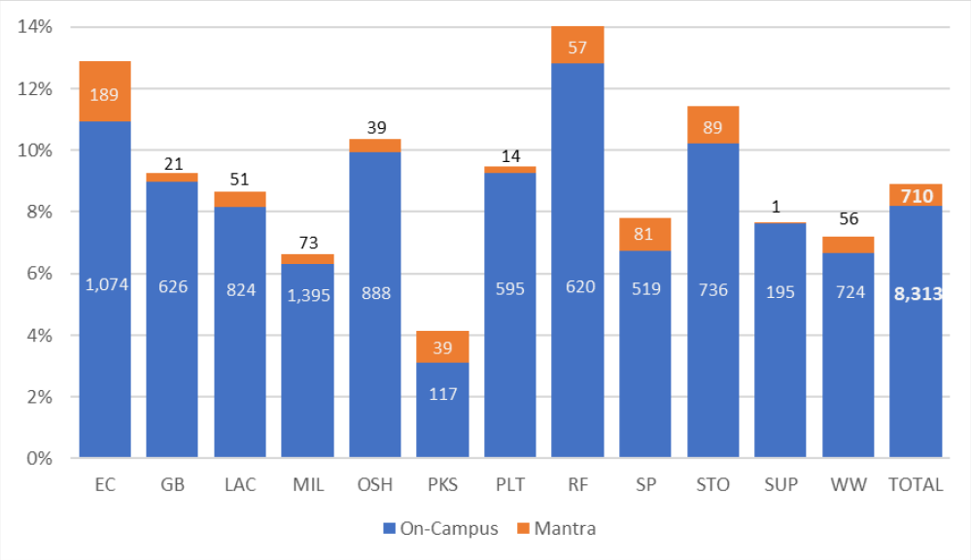

To speak to the second question about the demographics of students using the services, a goal is that an increased diversity of providers available through Mantra will diversify the range of students seeking services. Nearly 48% of Mantra’s counselors and psychiatric providers are non-white and 45% identify as LGBQ. As can be seen in Table 15, early signs are that percentages of both LGBQ and students of color accessing Mantra services are slightly greater than the percentages accessing on-campus services.

### Table 15: Client Demographics – Mantra Services

|  |  |  |
| --- | --- | --- |
| **Category** | **Campus %** | **Mantra %** |
| White | 86% | 84% |
| Students of Color | 14% | 16% |
| Heterosexual | 67% | 60% |
| LGBQ | 31% | 38% |
| Disability Status | 12% | 3% |

Finally, speaking to the question about when students attend appointments (daytime, evenings, or weekends), a goal was to expand the availability of services after hours. In the first full semester of services, one-third of Mantra appointments occurred on weekends or after 5 p.m. on weekdays.

While early experiences vary across our universities, the data above suggests that this telemental health and well-being services contract is having a positive impact on addressing service gaps as intended. Student satisfaction with services thus far is high, with 94% of students attending counseling through Mantra indicating that they felt well-matched with their provider and individual session ratings averaging 4.9 on a five-point scale. As the contract enters year two, the metrics above—as well as additional satisfaction and outcome metrics—will be monitored to further evaluate the value of these services in the overall scope of responding to student mental health and well-being needs.

UW-Madison *Uwill* Utilization Summary

UW-Madison implemented its own supplemental telecounseling services during the 2022-23 academic year through the Uwill platform to bolster the options available for students seeking mental health services at UW-Madison’s Mental Health Services (MHS). Students utilizing Uwill were referred by MHS staff primarily from an initial screening appointment where presenting concerns, resources, and appropriate service options were discussed. Examples of common reasons for referrals to brief teletherapy through Uwill included: (1) Student out of state or out of country; (2) Flexibility with schedule (that is, sooner available appointments; availability outside MHS business hours; online booking with provider of choice); (3) Timing of year (such as student graduating at end of term). Students were initially offered 10 sessions, with an ability to request additional sessions.

From October 2022 to June 2023, 461 UW-Madison students were referred to Uwill, with 333 completing initial registration, and 280 completing at least one counseling session. A total of 955 sessions were provided, for an average of 2.87 sessions per registered student and 3.41 sessions per treatment-engaged student. Sessions are based on a 30-minute session length. The Uwill contract has been adjusted for 2023-24, such that students will have the ability to sign up directly for services, in addition to the option of being referred by a UHS provider. This makes it more similar to Mantra services available at the other twelve universities.