President’s Advisory Committee on Mental Health and Well-being

Background: At the urging of Senior Student Affairs Officers during the 2018-19 academic year, and following a presentation to the Universities of Wisconsin Board of Regents in April 2019, former President Ray Cross established the Student Behavioral Health Initiative and charged three workgroups with developing recommendations to address the growing influence of mental health issues on the personal and academic lives of students. Counseling, health, and other academic and student affairs professionals representing all 13 UW universities participated in the workgroups during Summer/Fall 2019 and completed reports summarizing their recommendations in Spring 2020. The overarching goal of the initiative is to improve the emotional health and well-being of students, in service to their personal and academic goals.

The workgroups adopted a comprehensive public health framework to guide the work, represented below:

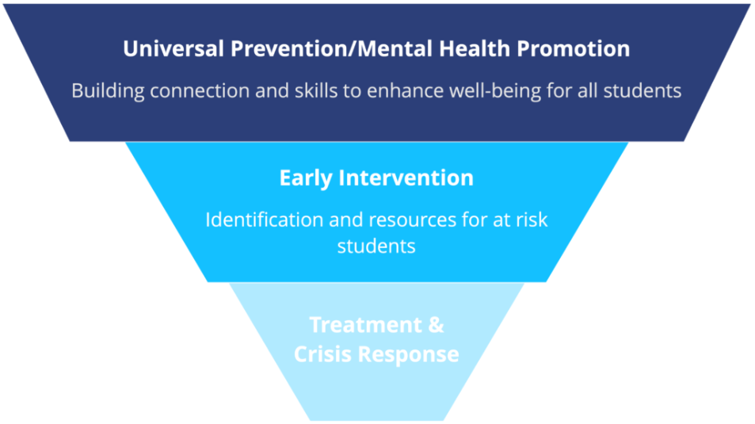

Since Fall 2020, the initiative has carried out many of the workgroup recommendations, which are outlined in this Activity Summary. The work has been achieved through engagement with key campus stakeholders and coordinating support from Universities of Wisconsin Administration.

As the initiative has progressed and the mental health and well-being needs of students have continued to evolve, the need to establish a sustainable foundation for ongoing support, guidance, and accountability for mental health and well-being efforts has become apparent. The establishment of a President’s Advisory Committee on Mental Health and Well-being attempts to provide that foundation.

Charge: The purpose of the President’s Advisory Committee on Mental Health and Well-being is to engage in critical discourse related to effective and impactful provision of equitable systemwide support for students’ mental health and well-being. The committee will rely on subject matter expertise of members to review and provide feedback on ongoing and new intiatives to ensure they are evidence-based, culturally relevant, and inclusive. The committee may also review and recommend innovative and promising practices that could provide benefit to students across the Universities of Wisconsin.
Roles and Responsibilities:
- Review existing activities and provide feedback and recommendations for improvement and scaling.
- Review and recommend effective, equitable practices to address students’ mental health and well-being systemwide.
- Identify policy and process roadblocks, and make recommendations for improvement.
- Identify existing and promising resources and partnerships to support student mental health and well-being.
- Serve as liaison for two-way communication between the advisory committee and committee members’ respective communities of practice.

Scope:
- A holistic, public-health framework undergirds committee efforts. The committee is especially encouraged to focus on upstream efforts that promote well-being to the broadest range of students.
- The focus of the behavioral health initiative, and thus this advisory committee, should be on efforts that support all or most UW universities.
- When reviewing or recommending projects at individual universities, the committee will consider the extent to which successful projects could be scaled at other UW universities.

Duration and Time Commitment:
- The committee will meet three times per year (e.g., September, January, and May), beginning Fall 2024.
- Meetings will generally be via Zoom or Teams, with one in-person meeting considered each year.
- Additional meetings or workgroups may be scheduled, depending on need.

Meeting Times and Dates:
- Specific meeting dates and times will be determined based on the committee’s membership and availability.
- Virtual meetings will be recorded and made available to committee members. Alternative methods for providing feedback and perspective will be made available.

Executive Sponsors: The executive sponsors will support the committee through reviewing and approving membership and receiving reports and recommendations from the committee to inform system-level decision-making.
- Senior Student Affairs Officers
- Associate Vice President for Enrollment & Student Success
- Sr. Director of Student Success & Wellbeing

Membership: Membership will comprise subject matter experts representing the following functional areas across the Universities of Wisconsin, with attention to ensuring that every university is represented. Members will be nominated by campus leadership to serve two-year terms. Continuous membership will not exceed 3 terms:
- Student membership, preferably student leaders serving in peer-health roles, student organizations focused on student health and well-being, or pre-professional health students (2)
- Counseling center directors or professional staff (2)
- Health center directors or professional staff (2)
- Dean of students/student conduct (2)
- Health promotion professional (2)
- Disability/accessibility services director or professional (1)
- Faculty in a mental health and well-being related field (1)
- Faculty rep from shared governance (1)
- Academic advisor/success coach (1)
- Student basic needs coordinator (1)
- Alcohol/drug prevention coordinator (1)
- Athletic director, coach, trainer, or other professional (1)
- University recreation professional (1)
- Student involvement/leadership professional (1)
- Gender-based violence prevention education professional (1)
- Diversity, equity, inclusion and belonging professional (1)
- Admissions/enrollment management professional(1)
- University housing professional (1)
- University police (1)
- Veteran services professional (1)

Committee Leadership: The committee will elect two co-chairs at the first meeting of each new academic year, one of whom will be a counseling center director or professional staff. The co-chairs should represent distinct subject matter expertise and will serve no more than three consecutive one-year terms. The Sr. Director of Student Success & Wellbeing will serve as convenor for the committee and provide administrative support to the co-chairs and the committee.

Expectations of Committee Members:
- Review materials shared before meetings to ensure substantive discourse related to recommendations and decisions.
- Participate in meetings or provide feedback and perspective via alternative methods.
- Identify barriers and challenges to supporting students’ mental health and well-being systemwide and make recommendations for improvement.
- Provide intentional, strategic review of policies and processes that impact students’ ability to be well and succeed at Universities of Wisconsin.
- Identify and evaluate promising practices related to inclusive support for mental health and well-being that can be scaled equitably systemwide.
- Consider the value and impact of existing resources and partners and make recommendations for new resources and partners.
- Seek input from, and share updates with, members’ communities of practice regarding mental health and well-being topics being discussed by the committee.

Resources:
- Committee listserv/email list hosted by Universities of Wisconsin
- Microsoft Teams Site hosted by Universities of Wisconsin

Consultation and Decision-Making Process: Committee members are expected to seek input from, and share updates with, the respective communities of practice they represent within the Universities of Wisconsin. Feedback and recommendations from the President’s Advisory Committee on Mental Health and Well-being will be shared with the executive sponsors for consideration in planning and implementing systemwide efforts. The executive sponsors will inform the Universities of Wisconsin President and other senior leadership at the system and campus level of key recommendations and decisions.

Links:
- Behavioral Health Initiative
- Advisory Committee website (Coming Soon)

Universities of Wisconsin Administration Support:
- John Achter, Sr. Director of Student Success & Wellbeing (john.achter@wisconsin.edu)
- Kristen Jasperson, Advisor for Student Success Initiatives (kristen.jasperson@wisconsin.edu)

Drafted: June 2024
Approved: August 2024
Review Date: July 2025

