ADDING WISER TILE TO HOMEPAGE
From the Actions List select Personalize Homepage:
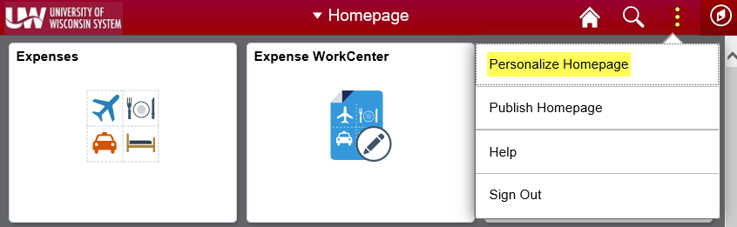
Click Add Tile:
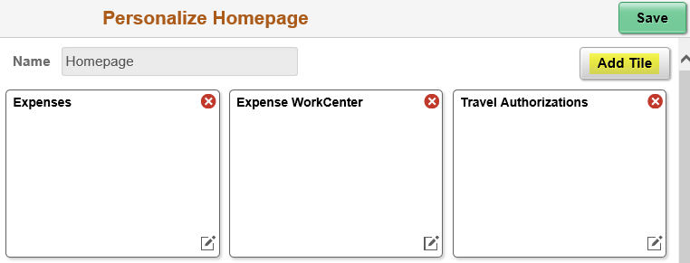
Select UW Tiles:
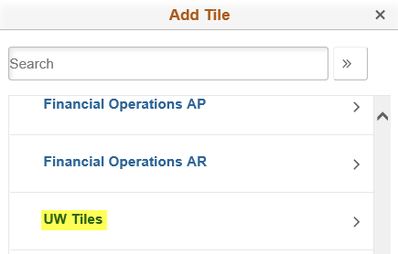
Select WISER:
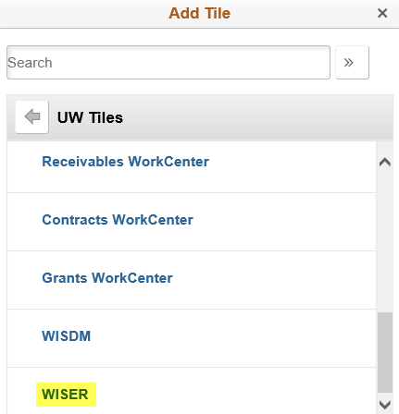

Final step is to click Save:

The WISER tile should now be included on your Homepage:

