To begin a WISPER Search select it from the Main Menu
Main Menu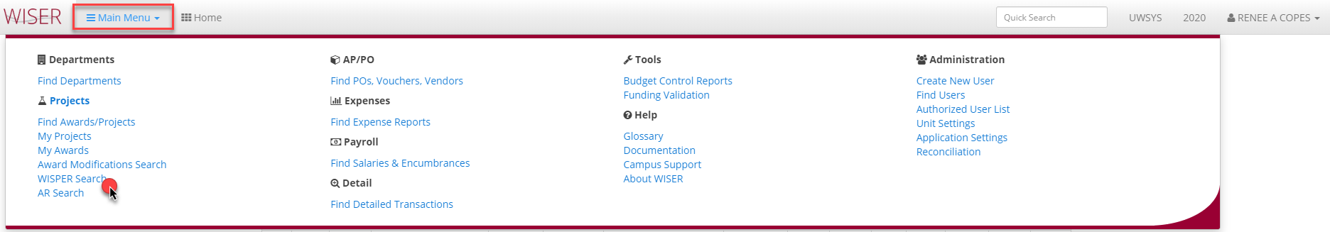

WISPER Search 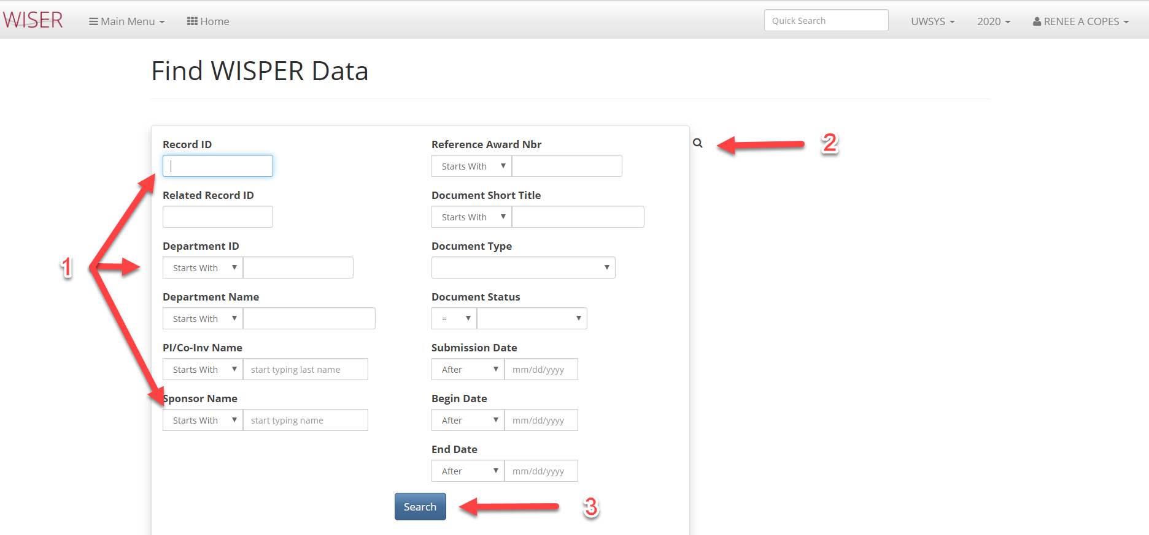
- Enter criteria for search
  - The more criteria entered, the narrower the search
- Toggle between search screen & results
- Begin search using criteria entered

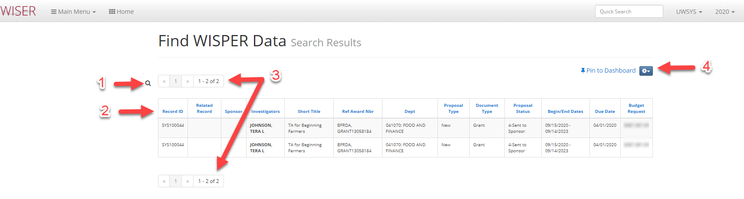

- Toggle back to search criteria
- Column headers will sort results
- Page navigators
- Pin to Dashboard/Export and records per page options

