Useful Basics:
- Hover for hints
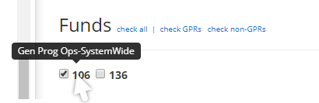
- This symbol within WISER toggles between search and result screens
- No more “favorites”, instead use pin tile (to dashboard)
- Items available/viewable are dependent on individual permissions
- Top menu bar is always available during WISER navigation
- WISER is read only – users are not able to permanently change data
- This symbol (on a screenshot in this document) indicates what was selected to move to the next screenshot shown.
Initial screen prior to any personalization
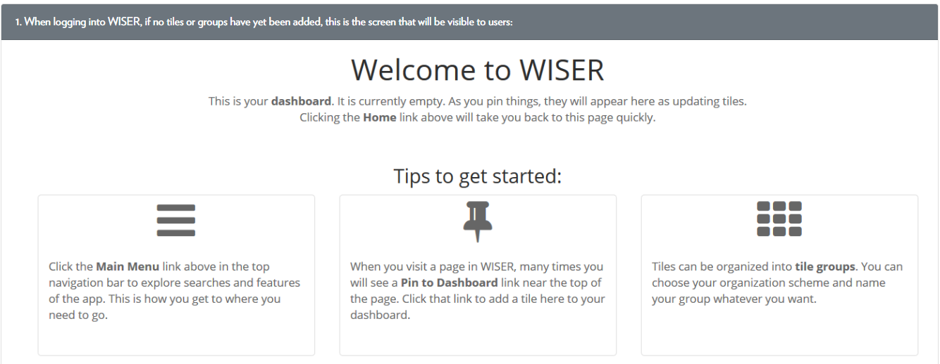

Home Page
Main Menu
Find Departments
Find Awards/Projects
My Projects
Award Modification Search
Wisper – find data
AR Search
Find AP/PO
PO Search
Voucher Search
Vendor Search
Find Expense Reports
Find Salaries & Encumbrances
Find Detailed Transactions
Tools
Budget Control Report
Funding Validation
Help Topics
Administration
Create New User
Find Users
Authorized User List
Unit Settings
Reconciliation
Home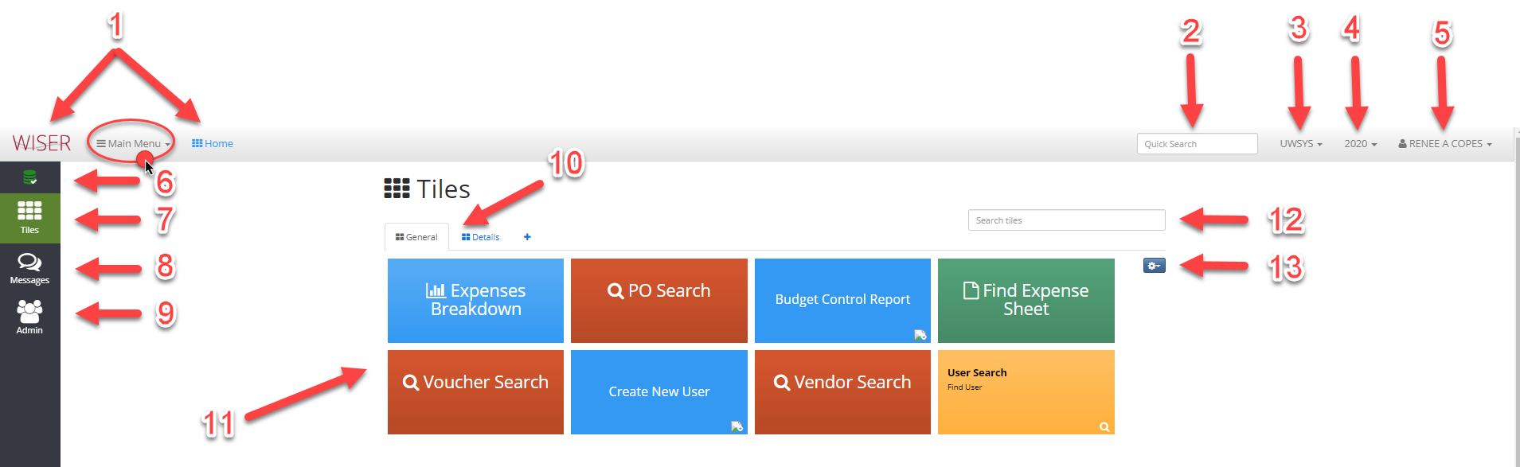
- Home
- Quick Search
  - Enter any information you have (example: Dept #, Account #, project #)
- Business Unit selector
  - Only available on certain screens (Home or Main Menu) to change selection (if an option)
- Fiscal Year selector
- User settings/log out
  - Color scheme for tiles
  - Datamart details and documentation
  - Change password (not used for logging in to WISER, only for datamart access)
- Database Status
  - Details – List of processes run during ETL (Extract-Transform-Load, nightly process that imports SFS data into WISER)
  - Daily Verify – lists journals added in the last ETL
- Tiles
  - What tiles you have pinned (option of pinning available on screen when possible)
    - Delete
    - Adjust size
    - Rearrange order
  - Tab for each group
  - Add group
- Messages
  - Indicator for new messages
- Admin
  - Only visible if your permissions are as an Administrator
- Tile tabs
  - Navigate between groups of tiles or add group
- Tiles pinned
  - select tile to access the function/area
- Search Tiles
  - Enter tile name from any group to display
- Tile Group Tools
  - Delete
  - Rename
  - New (can be added here, or when given the option on location screen)

Main Menu
*Available options dependent on your permissions.
Main Menu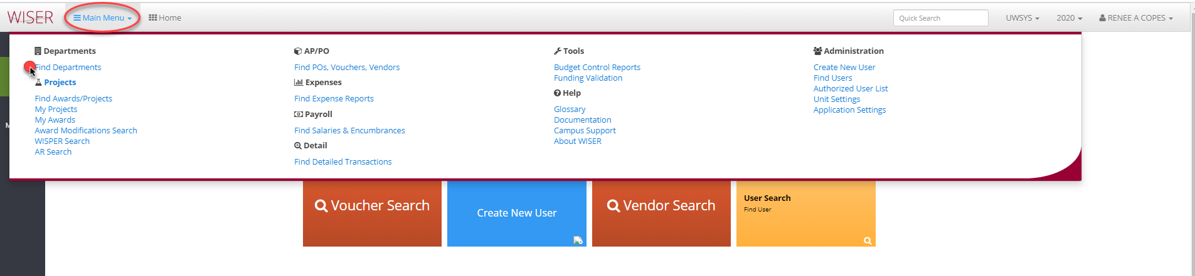
Find Departments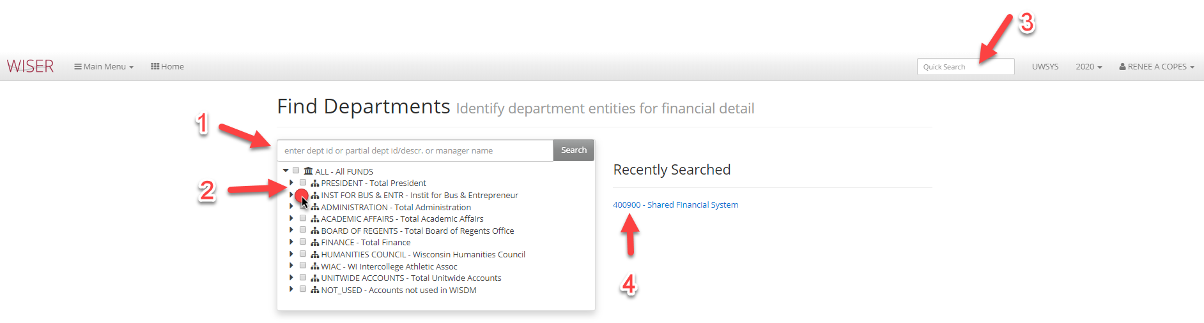
- Search by department ID, description, or manager name
- Expand, collapse, or select
- Quick search still available
- List of recently searched can be selected
Find Departments – selection made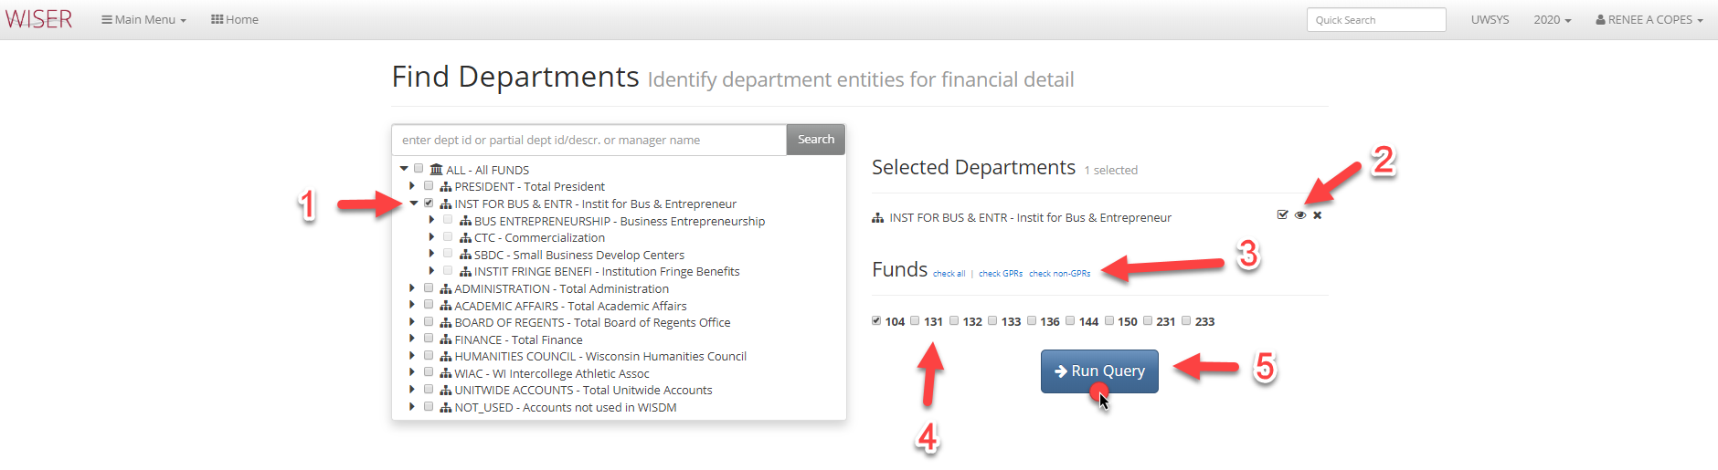
- Selected
- Department options
  - Check all children
  - Locate in Tree
  - Remove
- Select funds by group
  - Check all
  - Check GPRs
  - Check non-GPRs
- Options for fund selection
  - Available funds displayed - Toggle/untoggled individual funds
- Run Query with parameters selected
Department Summary Report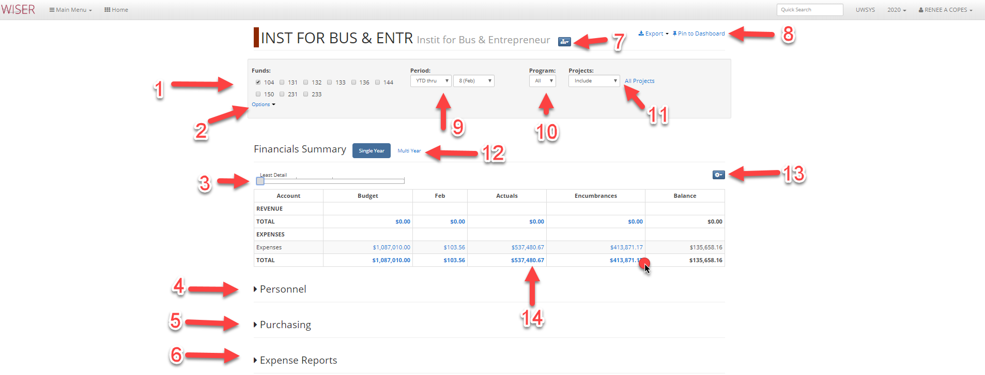
- Funds available for inclusion – select/deselect individually
- Fund options by group
  - Select GPR
  - Select non-GPR
  - Select All
- Detail slider
  - Slide to increase or decrease tree level displayed on report
- Un-collapse to view Personnel detail
  - Option to Export to Excel
- Un-collapse to view Purchasing detail
  - Option to Export to Excel
- Un-collapse to view Expense Reports
  - Option to Export to Excel
- Department selected options
  - Scope up to All Funds
  - View in Dept Tree
- Export Report to Excel or Pin to Dashboard (Tiles)
- Period options
  - YTD
  - ITD
  - Period Only
  - Quarter Only
- Program Options
  - All
  - Available are listed and can be individually selected
- Project Options
  - Include
  - Exclude
  - Only
  - All
- Financial Summary Single Year or Multi Year selector
  - Multi Year displays a 5-year span
- Settings
  - Tree selector
  - Set to default
  - Include AJE Ledger
- Amounts are hyperlinks – select for detail

Detail displayed after hyperlink selected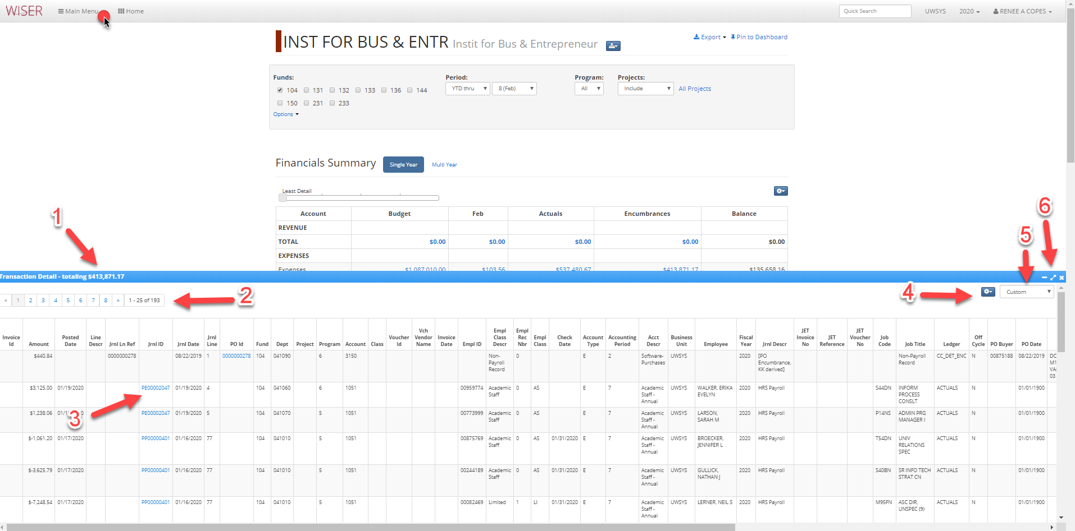
- Amount of hyperlink selected for detail currently displayed
- Page navigation
- Hyperlinks to further detail
- Settings
  - Export to Excel or PDF
  - Customize columns
    - Select/deselect columns to include
    - Reorder column display
    - Revert to default
- Detail source
  - Custom
  - AP
  - Standard
  - Salary/Fringe
- Minimize/Expand/Close Transaction Detail section
Main Menu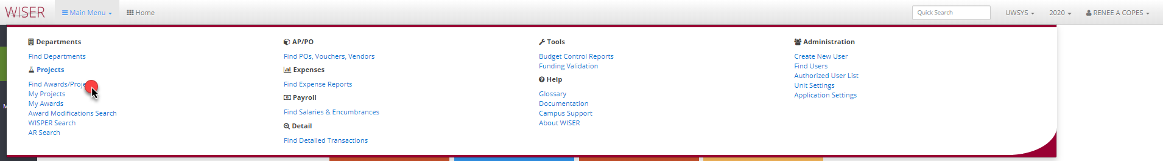
Find Awards/Projects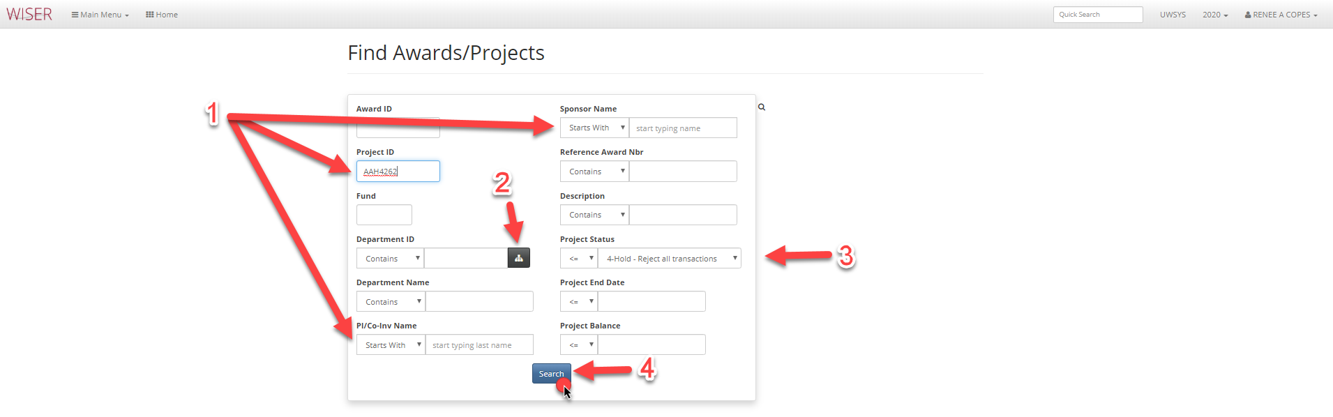
- Enter any search criteria
  - The more criteria, the narrower the search
  - All are optional
  - For open text fields a partial ID/# can be entered to return a list of matches
- Show Department picker
  - Displays tree view of departments for selection
- Default value can be changed
- Search using criteria entered
Search Results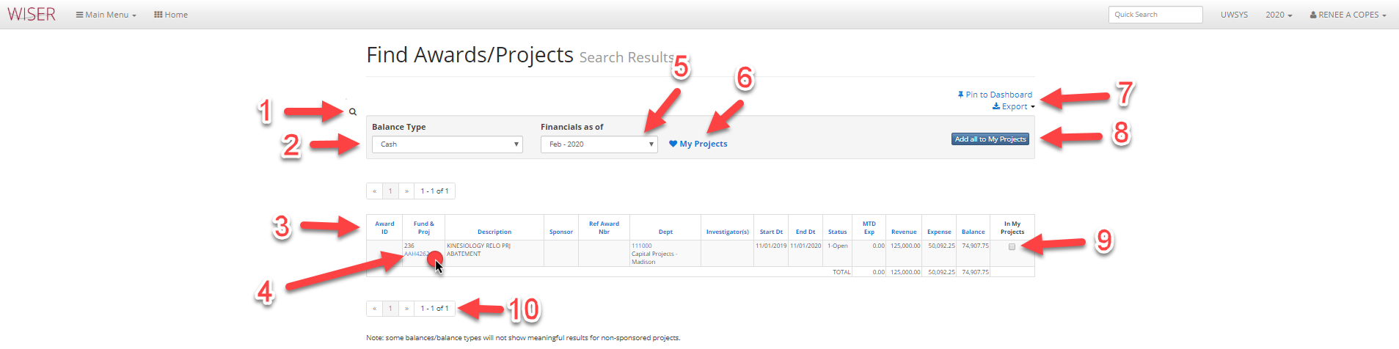
- Return to Find Awards/Projects search
- Drop down menu to choose Balance Type
- Column headers can be used to sort list (if multiple results shown)
- Project ID is a hyperlink to details
- Drop down selector for month to display financials for
- Add to My Projects list
- Pin to Dashboard (create tile or add to existing group on Homepage) and Export options
- Add All to my projects – useful for lists of results
- Checkbox to add to My Projects list – useful when selecting multiple, but not all from list
- Page navigation
Hyperlink detail Results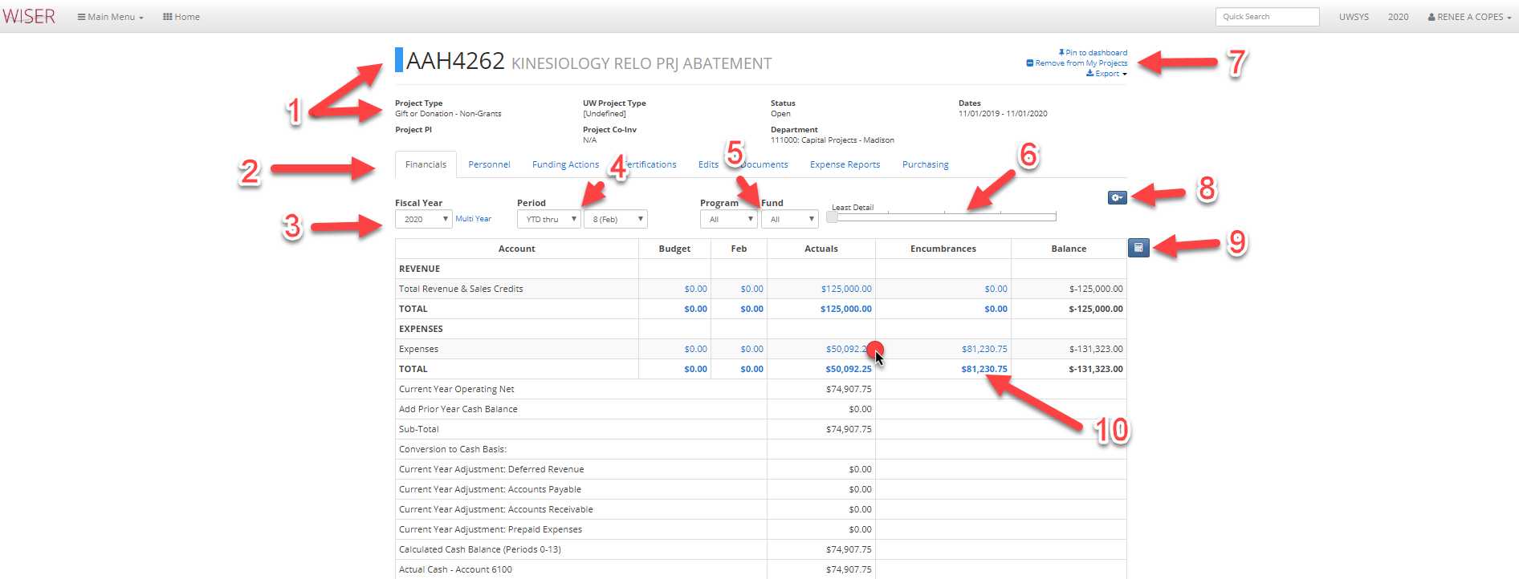
- Details on Project
- Tabs for additional information (if any)
- Fiscal year selector and option for Multi Year
- Period selector
- Program and Fund selector (available options included in drop down)
- Slide to increase or decrease detail
- Options for Project
  - Pin to Dashboard (tile)
  - Remove from My Projects list
  - Export options
- More options
  - Change Tree used
  - Set current level to default
  - Toggle to include Period 998
- Toggle cell selection mode
  - Allows you to select amounts and calculates Sum, Count, and Average
  - Select again to toggle off cell selection mode
- Blue amounts are hyperlinks to further detail
Hyperlink Transaction Details results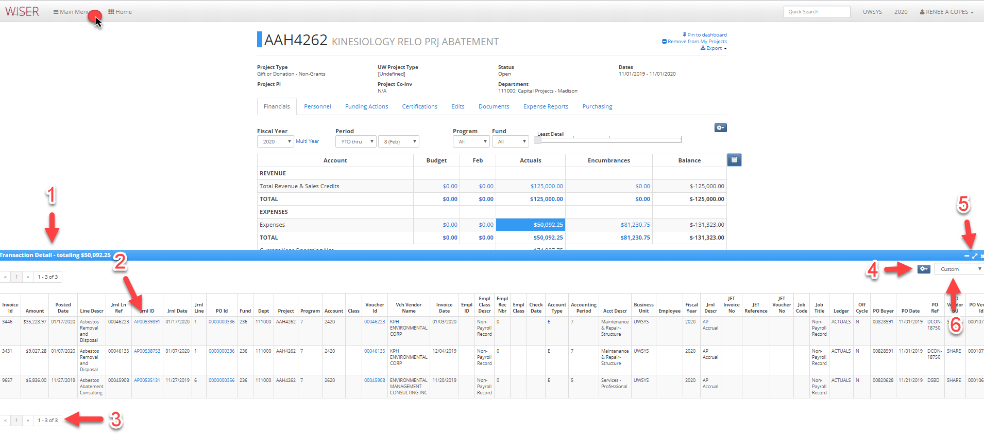
- Total of transaction detail selected/displayed
- Blue text signifies hyperlinks to further detail
- Page navigation
- Detail options
  - Export to Excel or PDF
  - Customize – can add, remove, or reorder columns
  - Records per page
- Minimize, maximize, or close detail window
- View presented as - AP, Standard, Salary/Fringe, Custom
Main Menu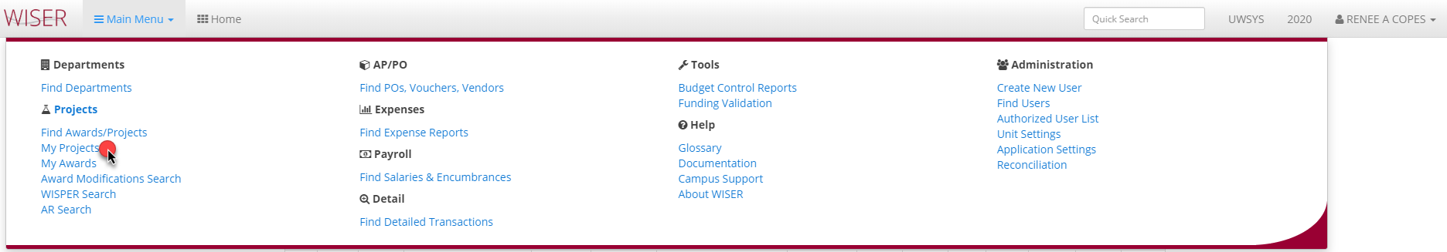
*My Awards has the same following screen/options as My Projects
My Projects list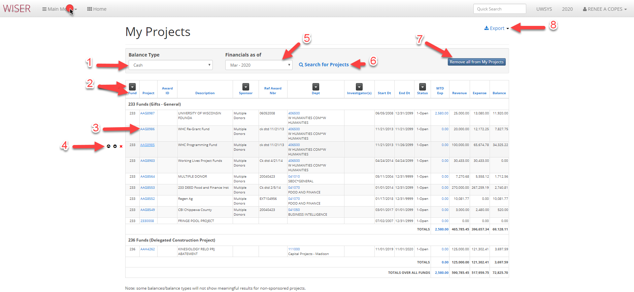
- Select Balance Type displayed
- Arrow is filter & column headings sort items in display
- Blue hyperlinks within project listing
  - Project/Award = search results (summary report)
  - Dept = list of all projects within that department
  - Investigator = list of projects having that investigator
  - Dollar amount = detail that comprises the amount
- Options to move project up/down on list, or remove
- Dropdown of month timeframe
- Search
- Remove all listed from My Projects
- Export options
Main Menu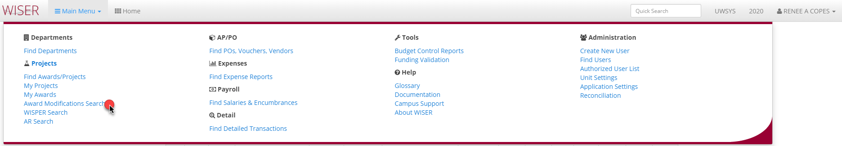
Award Modification Search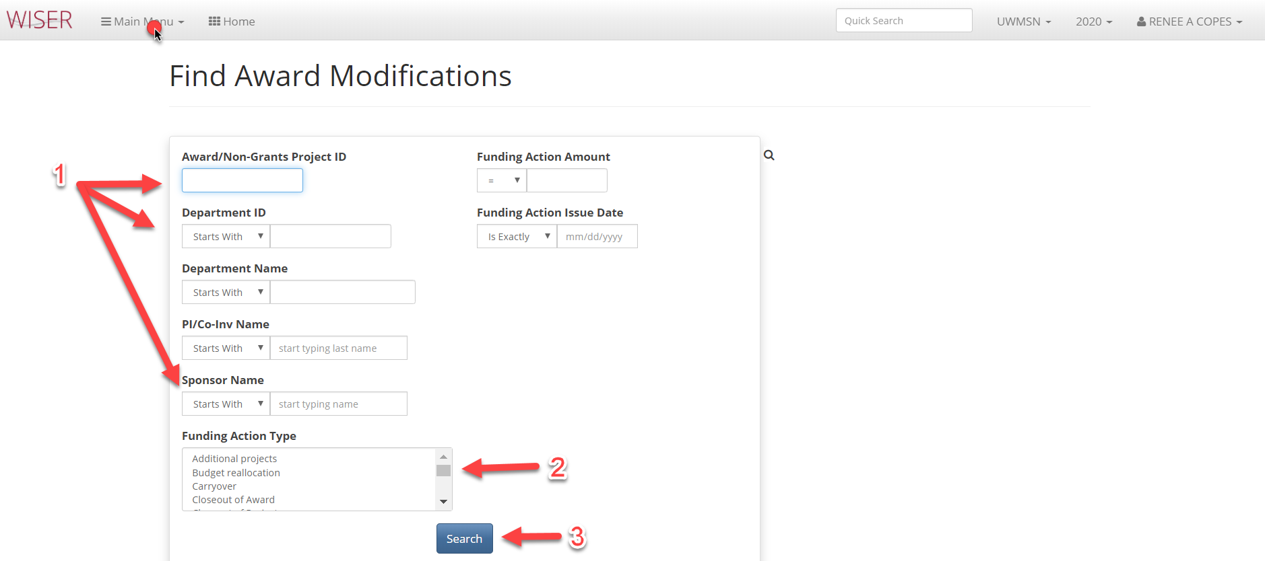
- Enter criteria for search
  - The more criteria entered, the narrower the search
- Listing of available funding action types to use as criteria
- Begin search using criteria entered

Main Menu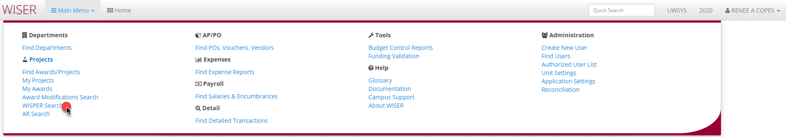

WISPER Search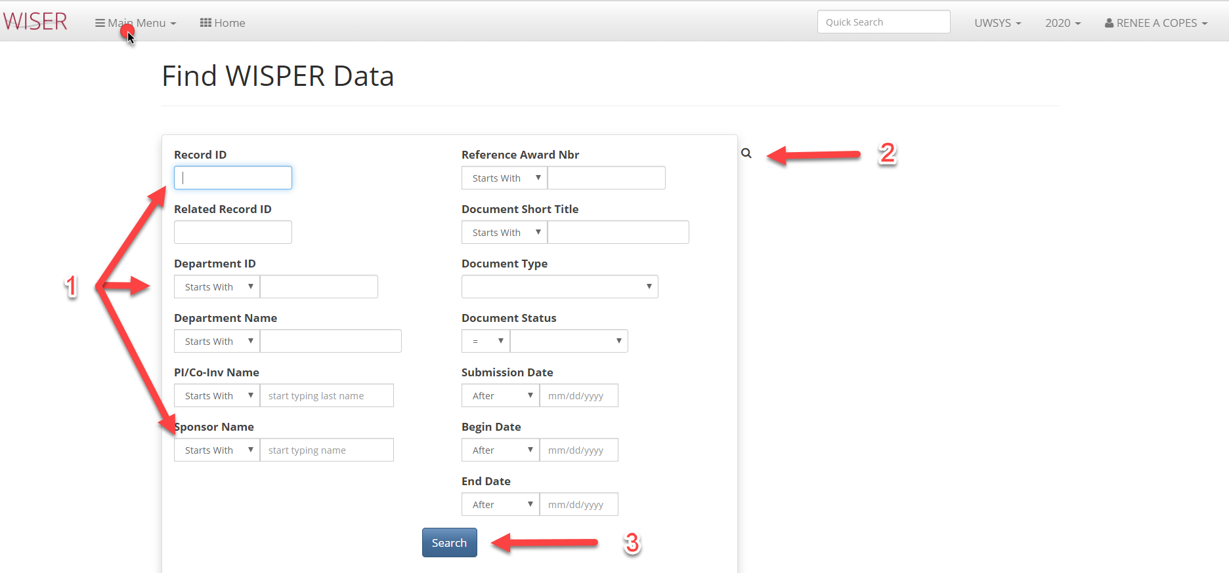
- Enter criteria for search
  - The more criteria entered, the narrower the search
- Toggle between search screen & results
- Begin search using criteria entered
Main Menu
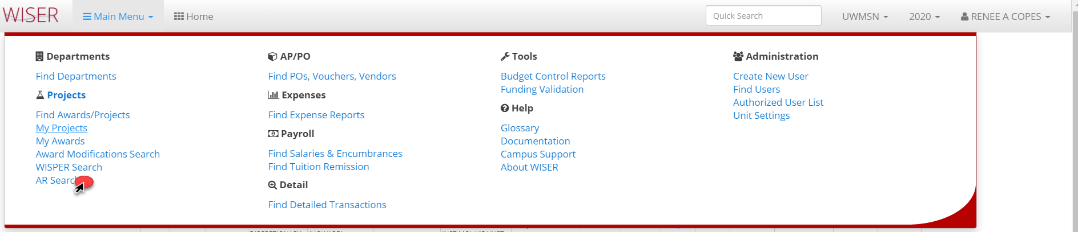

AR Search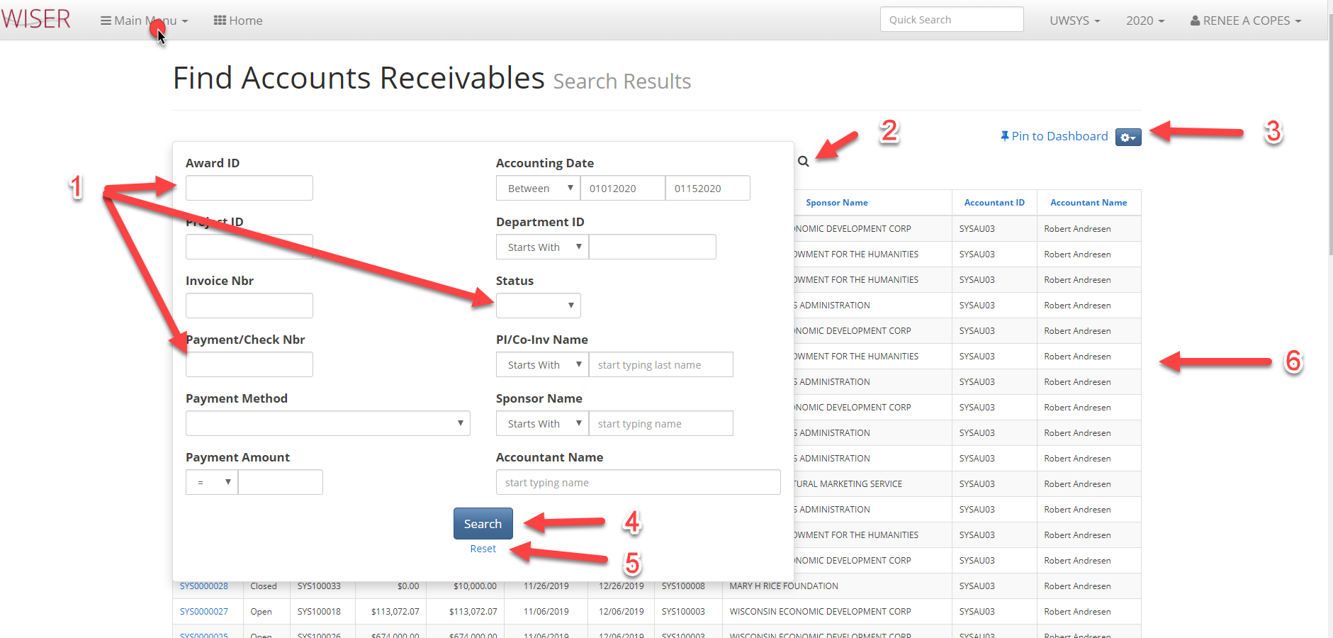
*shown with search screen over results
- Input criteria
  - The more criteria supplied, the narrower the search results
- Toggle between search screen & results
- Pin to dashboard (create tile)/export and view options
- Begin search using supplied criteria
- Clear entered criteria
- Search results using date range criteria

Main Menu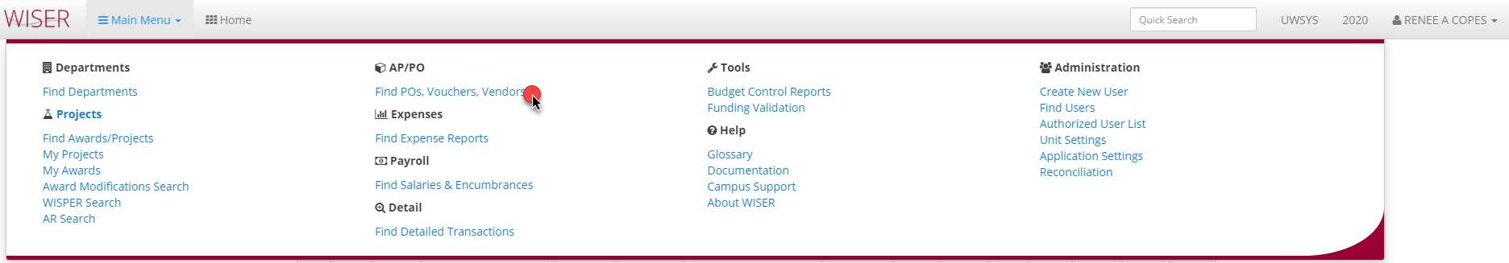

Find POs, Vouchers, Vendors
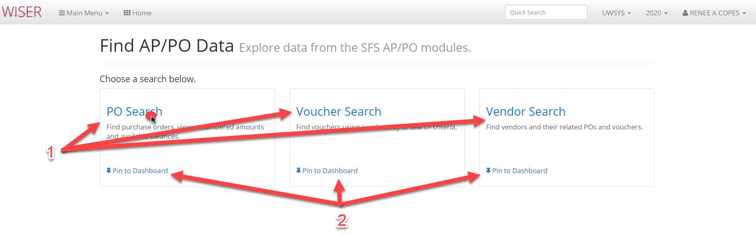

- Select from search options
- Pin (create tile) search type to dashboard

Find POs with results
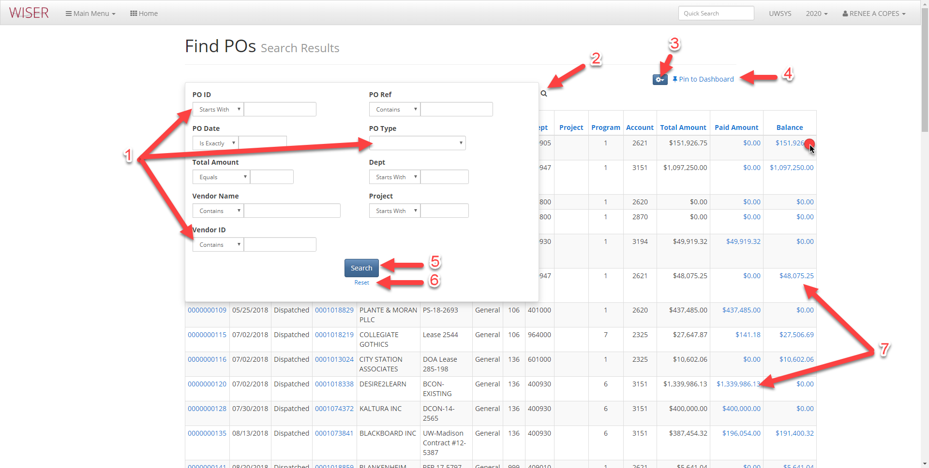
*search screen shown over results
- Enter criteria for search
  - More criteria = narrower search
- Toggle between search screen & results
- Export & records per page options
- Pin (create tile on homepage)
- Begin search on criteria supplied
- Reset search screen
- Blue hyperlinks on results lead to detail

Find PO search results with hyperlink selected
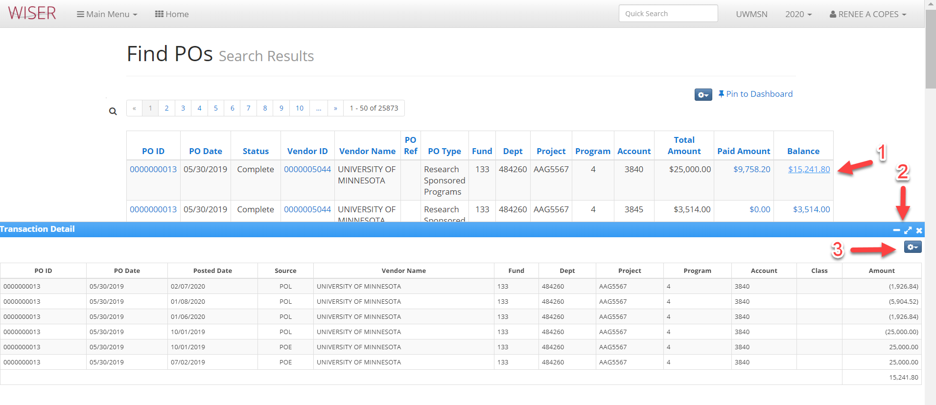

- Hyperlink selected
- Minimize/maximize/close Transaction Detail area
- Export detail to Excel

Main Menu > find POs, Vouchers, Vendors
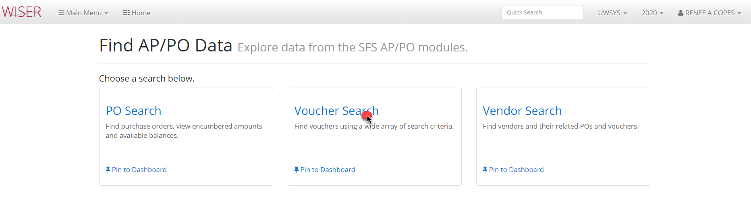

Find Vouchers with results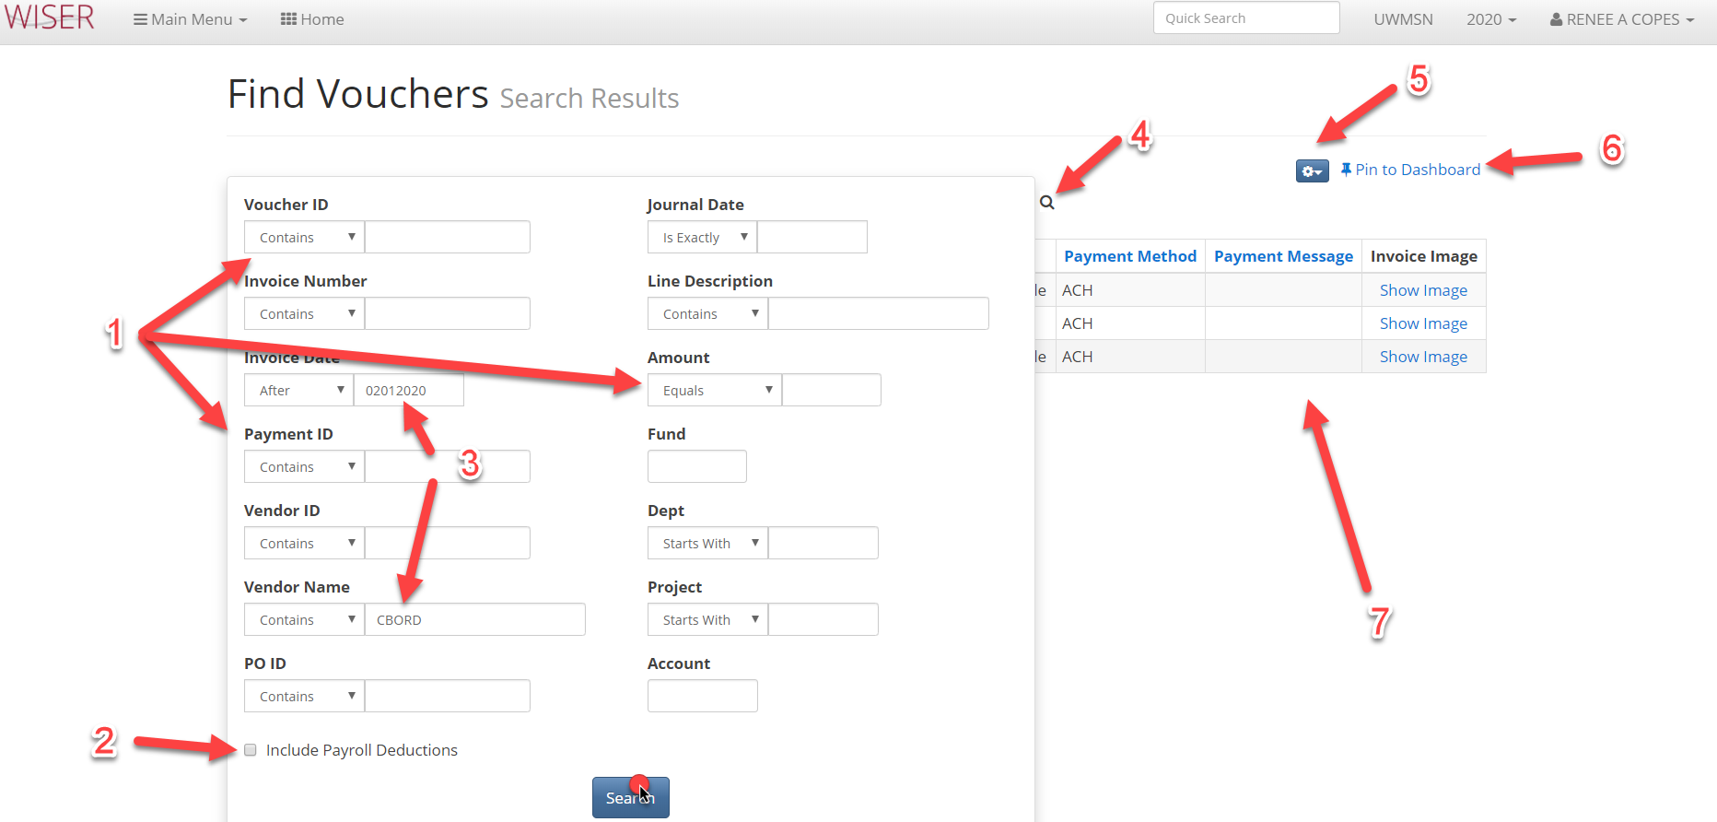
*search screen shown over results
- Enter search criteria
  - More criteria = narrower search
- Toggle to include/exclude Payroll deductions
- Criteria entered
- Toggle between search and result screens
- Export to Excel and records per page option
- Pin to Dashboard (create tile)
- Search results

Find Vouchers results
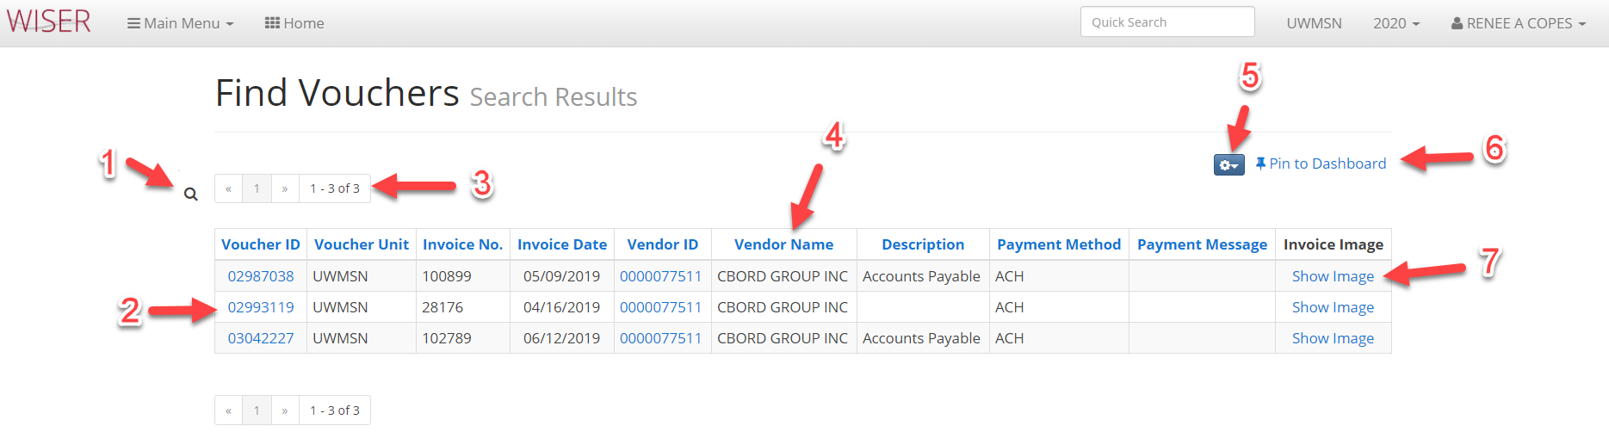
- Toggle between search and result screens
- Blue hyperlinks to further detail
- Page navigation
- Column headers used to sort
- Export to Excel & select records per page
- Pin to Dashboard (create tile)
- If authorized to view

Main menu > Find POs, Vouchers, Vendors > Vendors Search
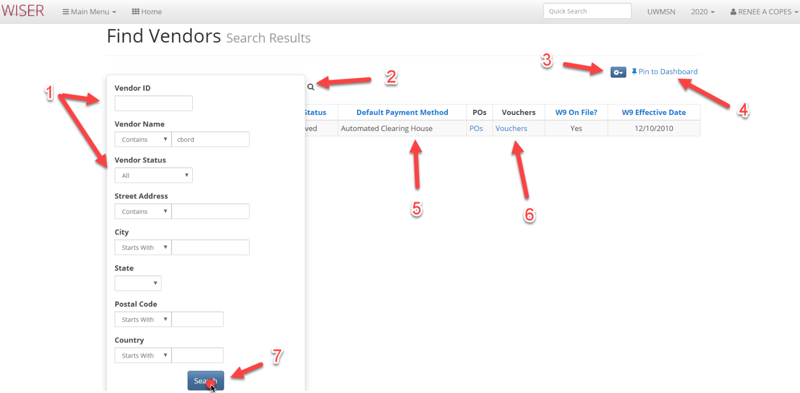
*search screen shown over results
- Search criteria
  - Criteria narrows search
- Toggle between search screen and results
- Export to Excel and number of items displayed on page
- Pin to Dashboard (create tile)
- Details resulting from search
- Blue hyperlinks to further detal
- Run search with criteria entered

Find Vendors results
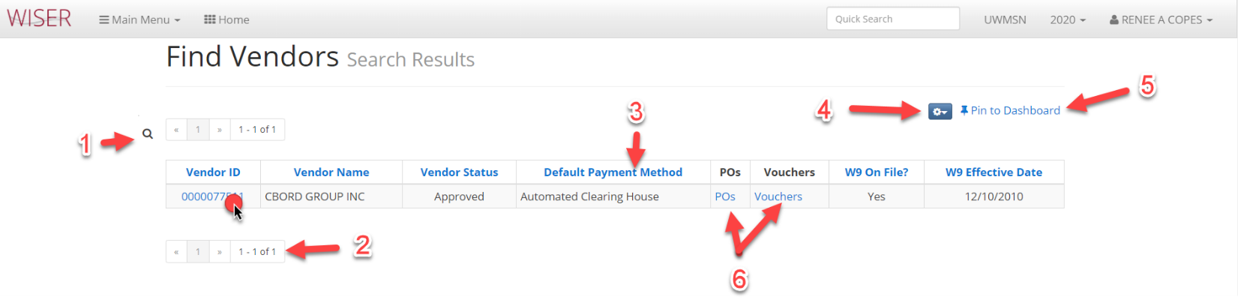

- Toggle between search screen & results
- Page navigation
- Column headers used to sort
- Export to Excel and number of displayed items per page
- Pin to Dashboard (create tile)
- Blue hyperlinks to further detail
Vendor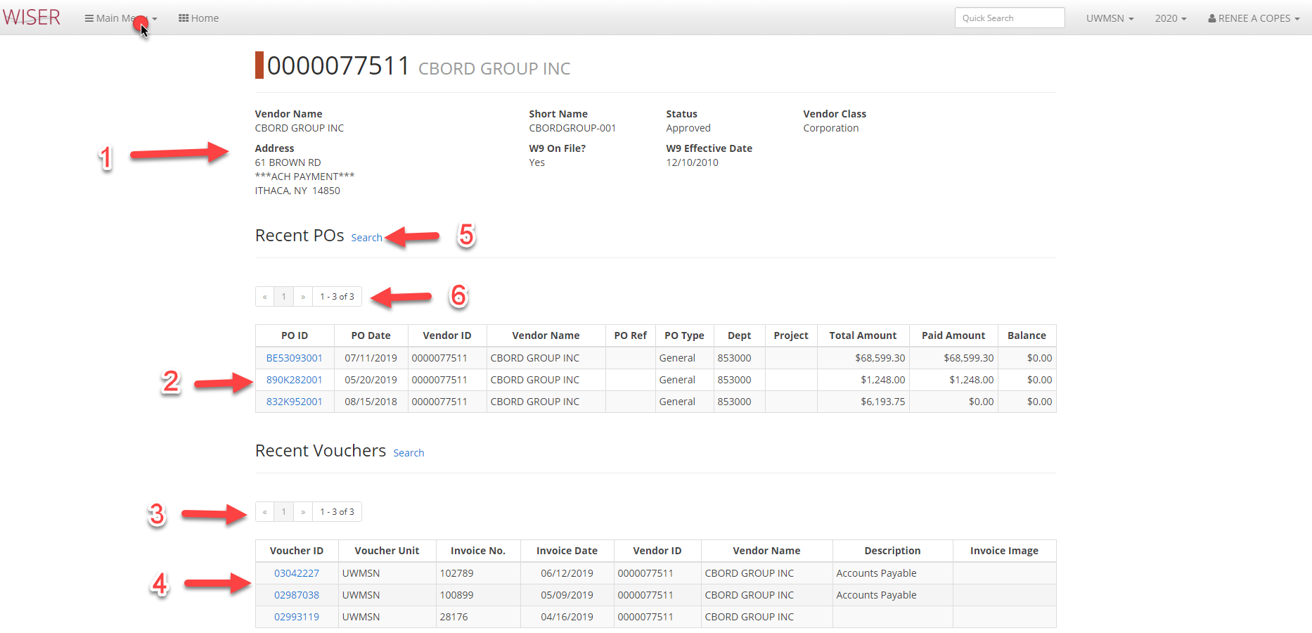
- Vendor details
- PO list
  - Hyperlink to detail
- Page navigation
- Voucher list
  - Hyperlink to detail
- Find Pos search results
- Page navigation

Main Menu
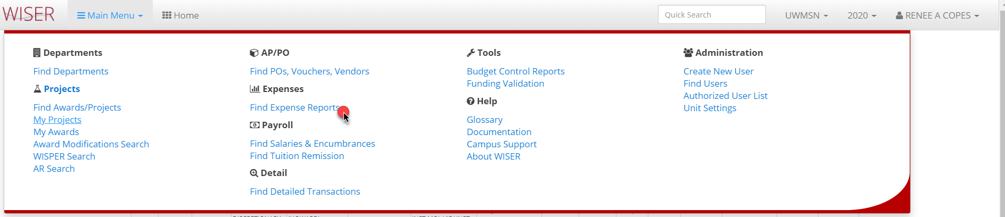

Find Expense Reports
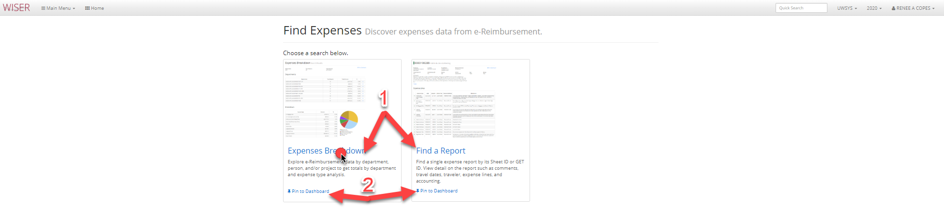

- Search Expenses Breakdown or Find a Report
- Pin to Dashboard (create a tile)

Search results shown beneath criteria
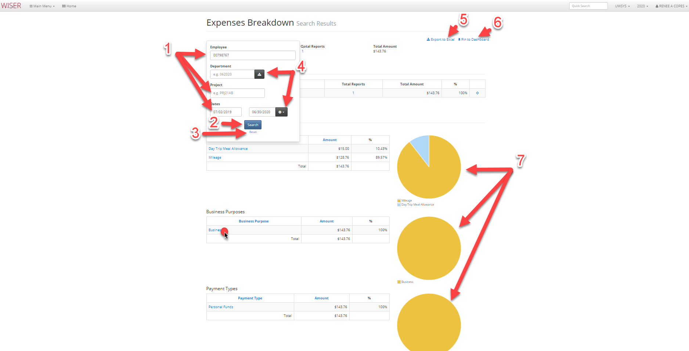
- Enter search criteria
  - More criteria narrows search
- Begin search with criteria entered
- Reset search criteria
- Department picker and timeframe selector
  - Last 30 days
  - Last month
  - This Fiscal Year
  - Last Fiscal Year
  - Clear
- Export to Excel
- Pin to Dashboard (create tile)
- Graphical depictions of Expense breakdown

Expense Report Listing
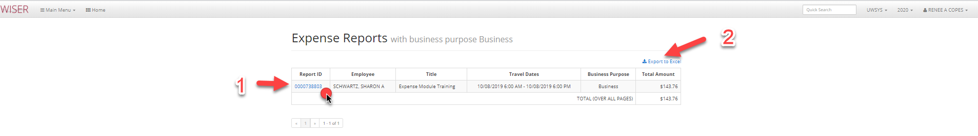

- Hyperlink to Expense Report
- Export to Excel
Expense Report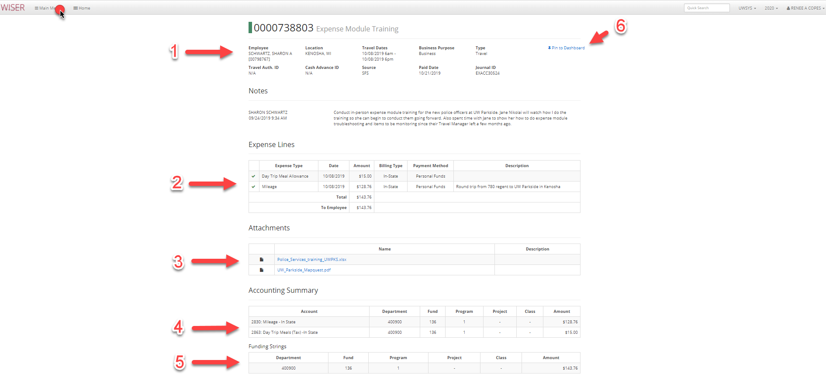
*This is the screen displayed if “Find a Report” is selected from the initial Find Expenses screen options and a report number is entered as the search criteria
- Expense Report details
- Line breakdown
- Hyperlinks to attachments
- Accounting Summary
- Funding Strings
- Pin to Dashboard (create tile)
Main Menu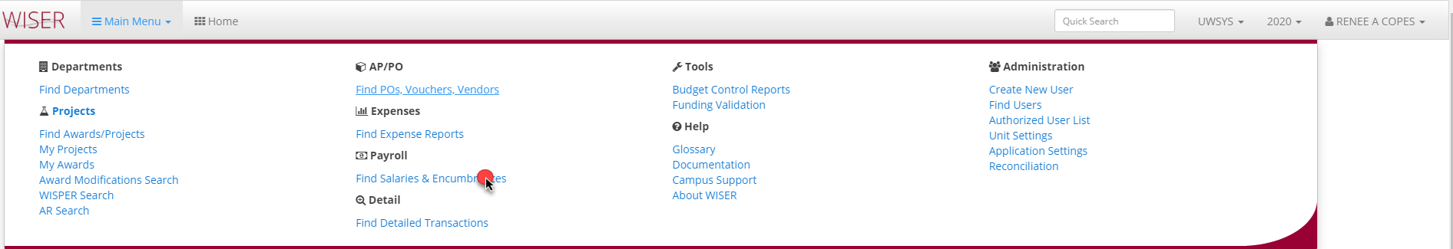

Find Salaries & Encumbrances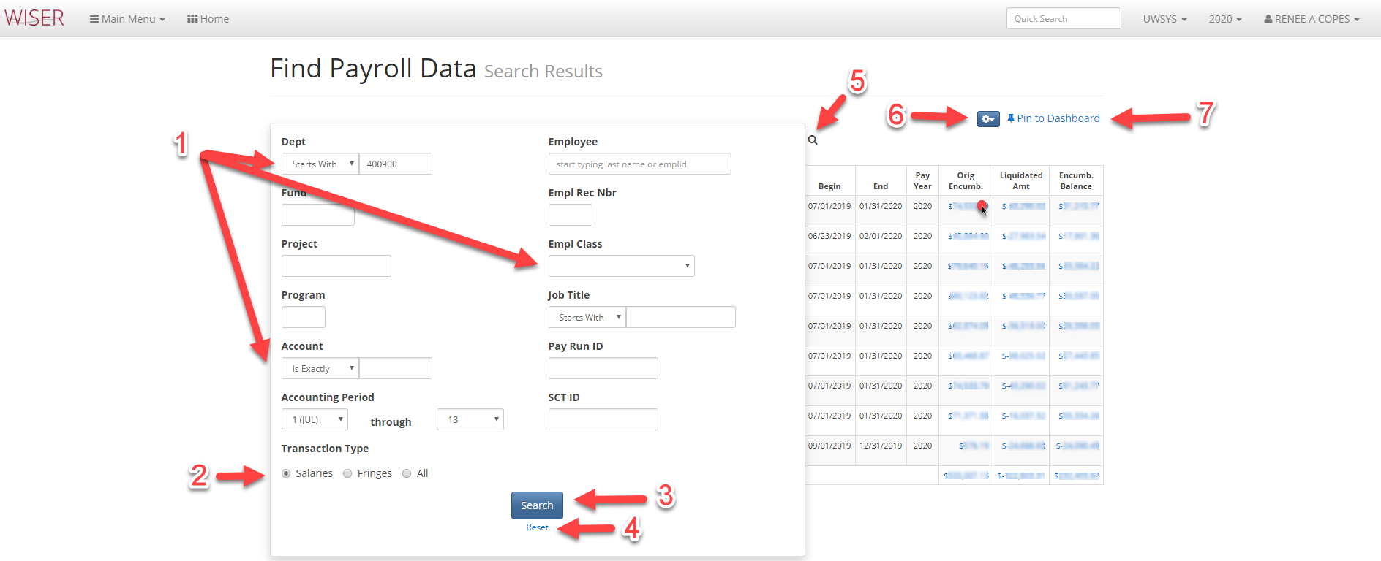
*Search screen shown over results
- Enter search criteria
  - More criteria narrows search
- Select desired data types to return
- Initiate search with criteria entered
- Reset search criteria
- Toggle between search screen and results
- Export to Excel/set records per page to view
- Pin to Dashboard – create tile

Payroll Detail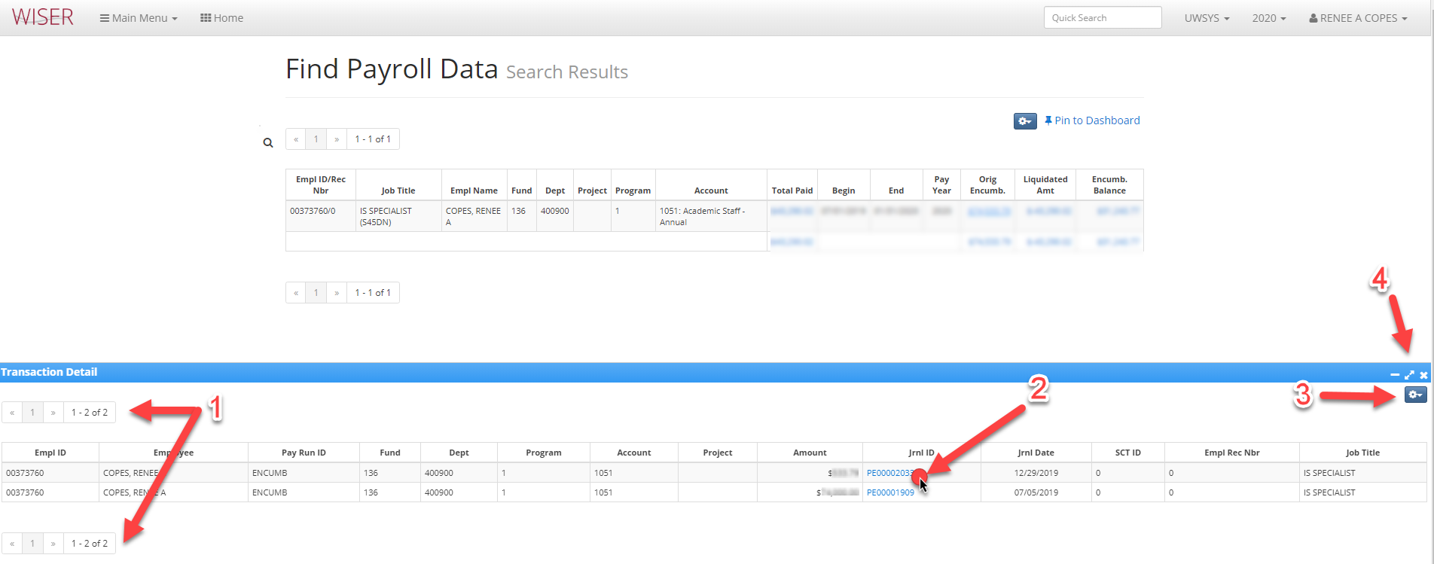

- Page navigation
- Hyperlink to Journal detail
- Displayed detail options
  - Export to Excel
  - Customize columns
  - Records per page
  - Include Earn Dates

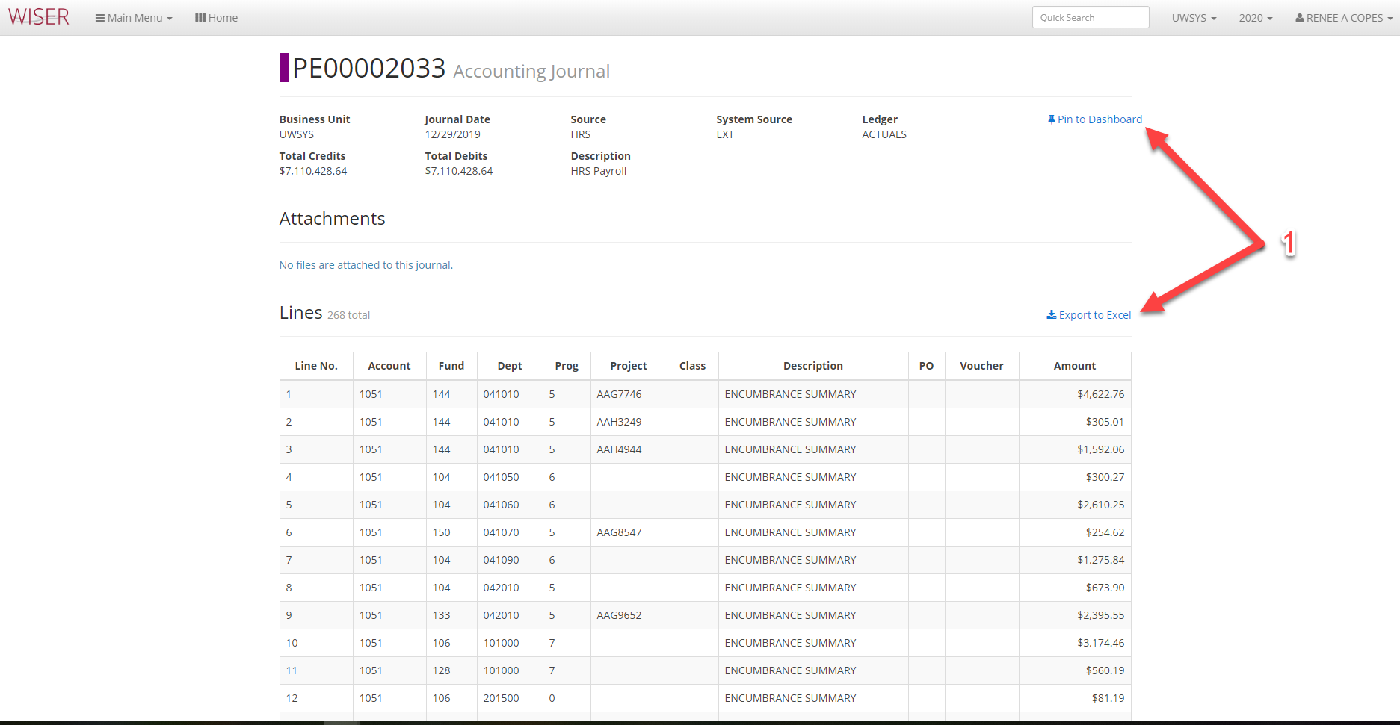
*this final level of detail opens in new browser tab
- Options for this page
  - Pin to Dashboard (tile)
  - Export to Excel
Main Menu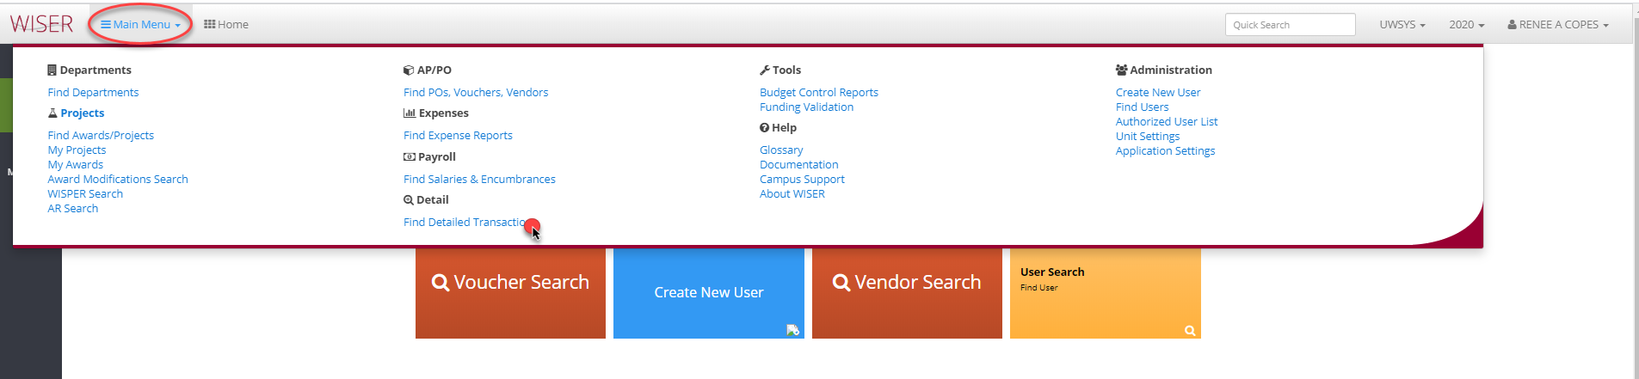
Find Detailed Transactions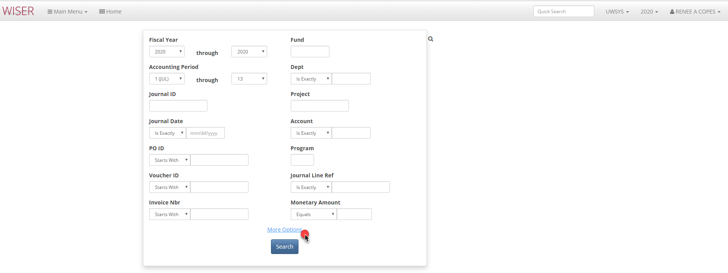
Detailed Transaction Search with Results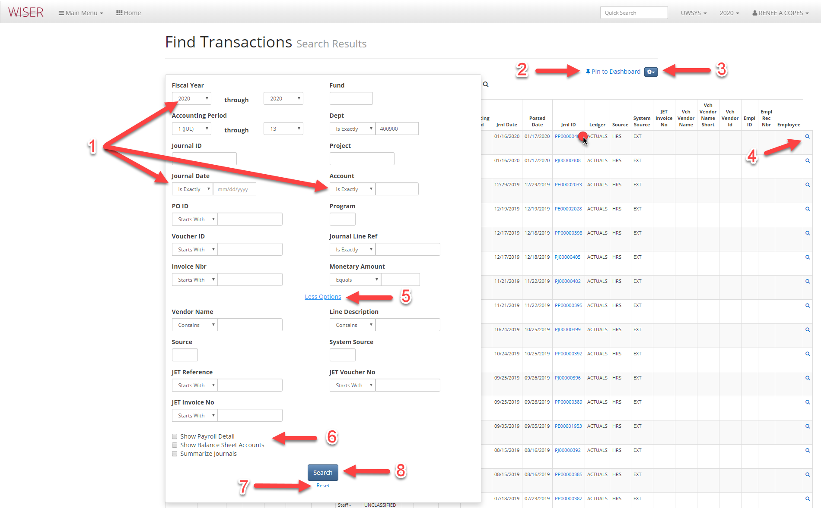
*search screen shown over results
- Enter criteria
  - More criteria will narrow search
- Pin to Dashboard (create tile)
- More options
  - Export to Excel
  - Customize columns
    - Select/deselect columns to include
    - Reorder column display
    - Revert to default
  - Records to view per page
- More Details (if available)
Journal Detail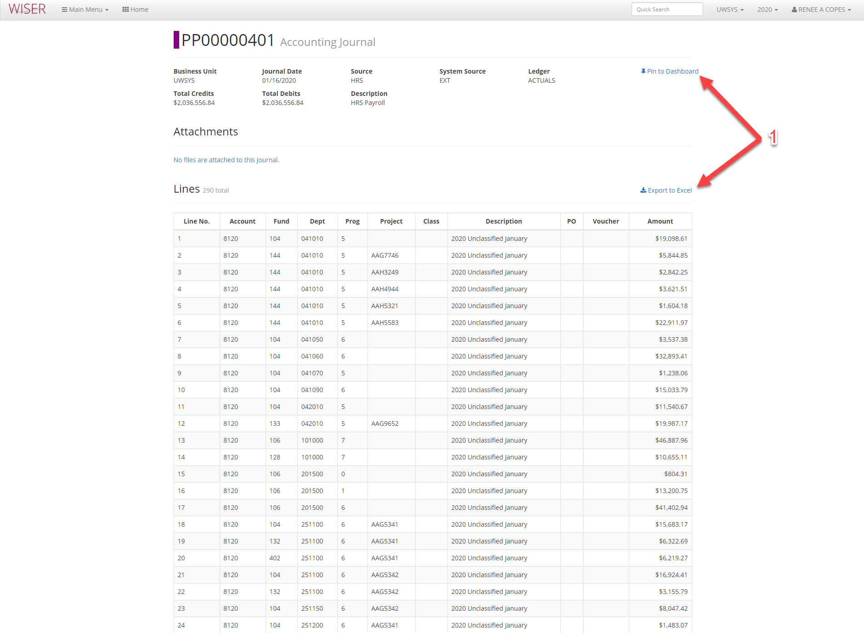
*last level of drill (detail) opens in new browser tab
- Available options for this Journal detail
Man Menu
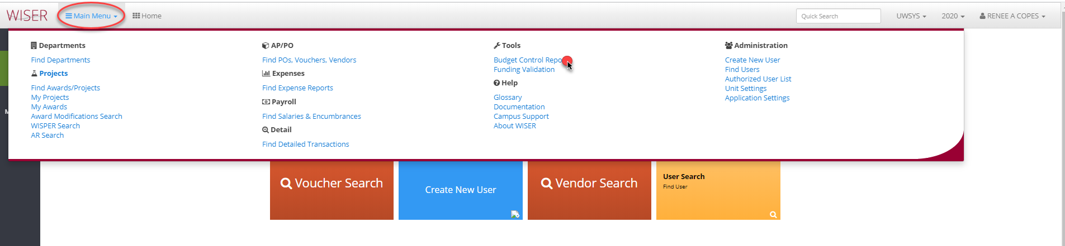
Budget Control Reports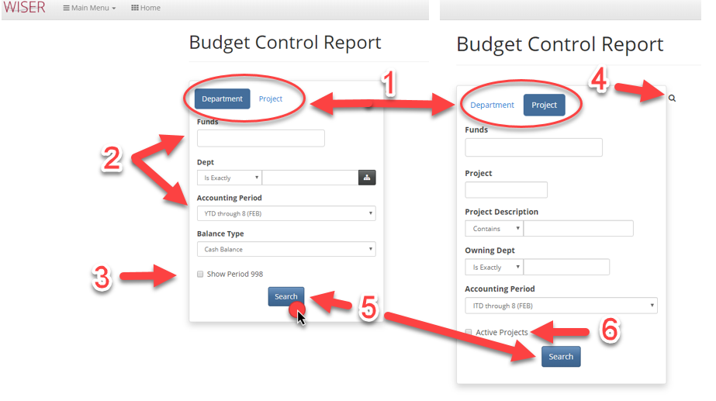

- Select option to create reports for Department or Project
- Enter criteria
  - More criteria narrows the search
- Toggle Show Period 998
- Toggle between criteria panel and results
- Begin search with supplied criteria
- Toggle for active projects
Budget control Report Listing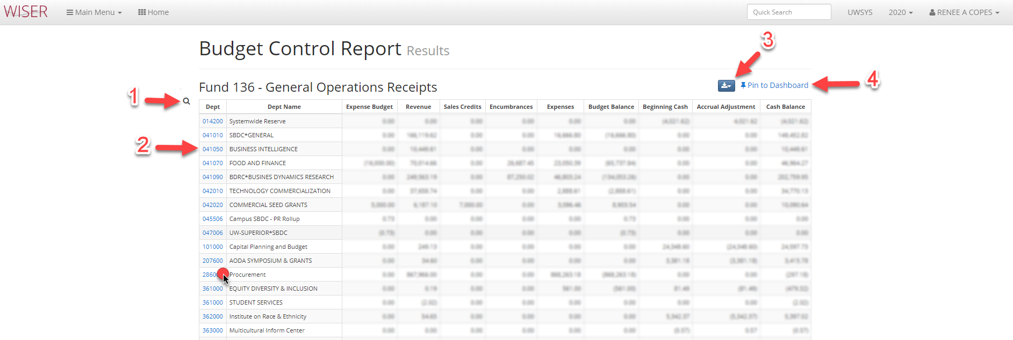
- Toggle between criteria panel & results
- Hyperlink to Department Summary Report
- Export options
- Pin to Dashboard (create tile)

Main Menu
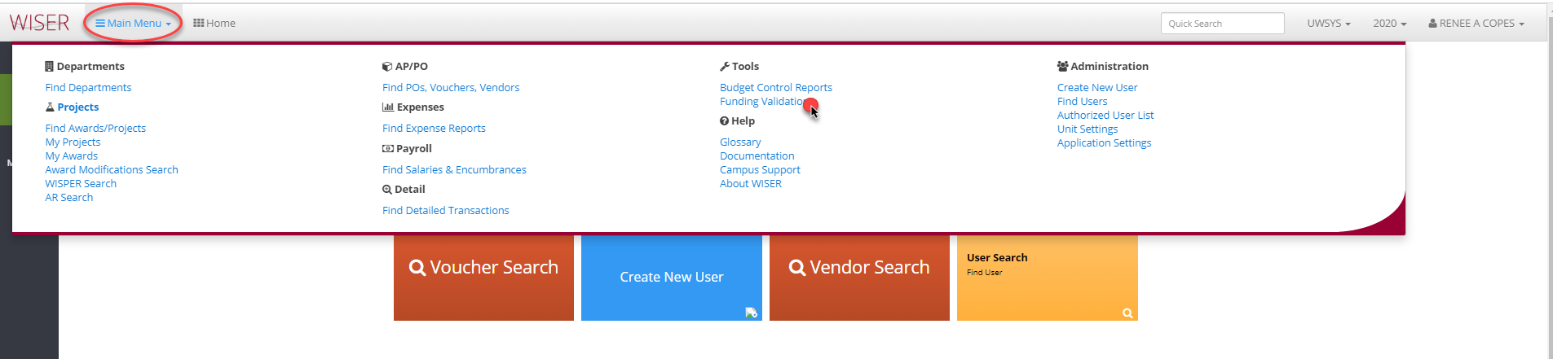

Funding Validation
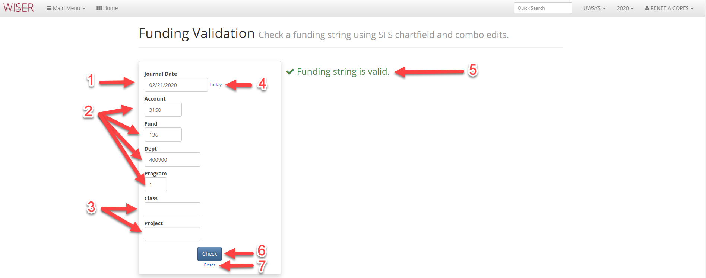

- Enter Date of Journal
- Mandatory entry fields
- Optional entry fields
- Update date to today
- Validation message (example of invalid error message below)
- Check if funding string entered is valid
- Reset search criteria
Funding Validation with Error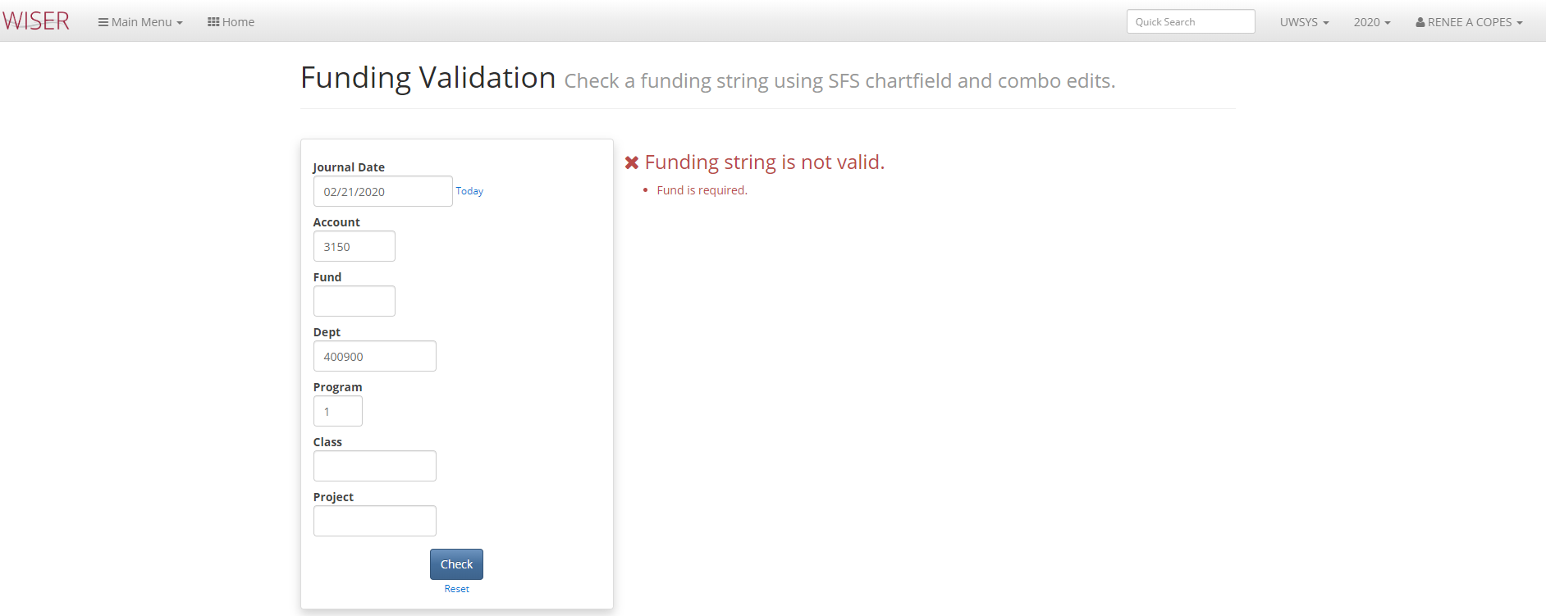
Help Items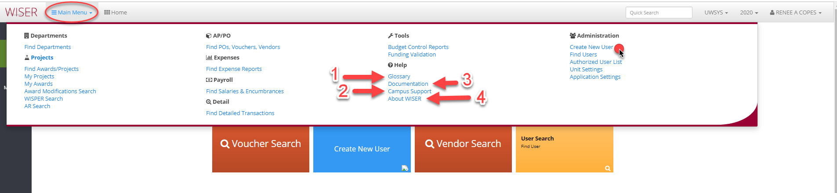
- Glossary – WISER terms & definitions
- Campus Support – Listing of campus WISER support contacts
- Documentation – link to SFS webpage containing WISER information
- About WISER – Copyright and licensing details
Administration tasks
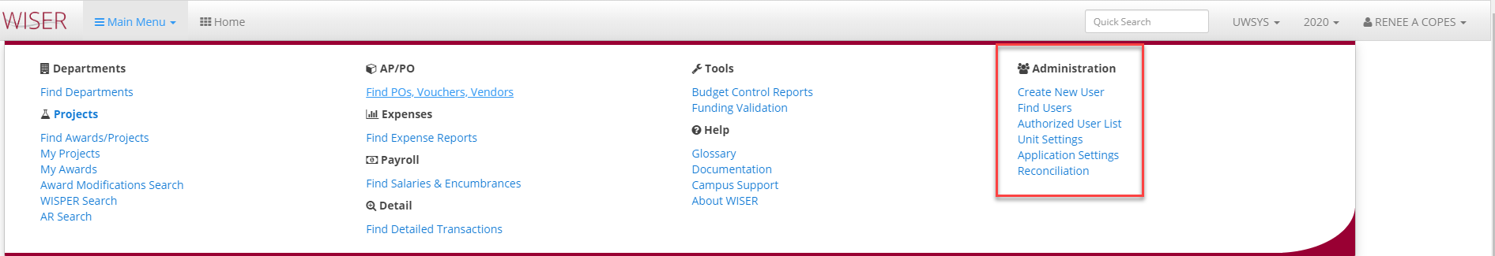

Create User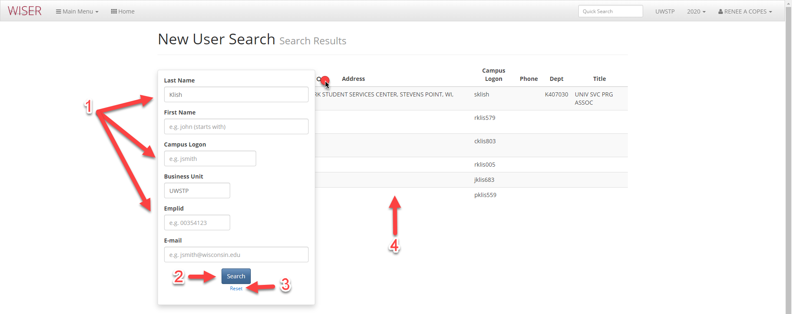
*Search screen shown over results
- Available search criteria fields
- Begin search with criteria entered
- Reset/clear search criteria
- List of users matching supplied criteria
*******not yet available in WISER. Function will be moved to WISER when WISDM access removed*******

Create User – User hyperlink in results selected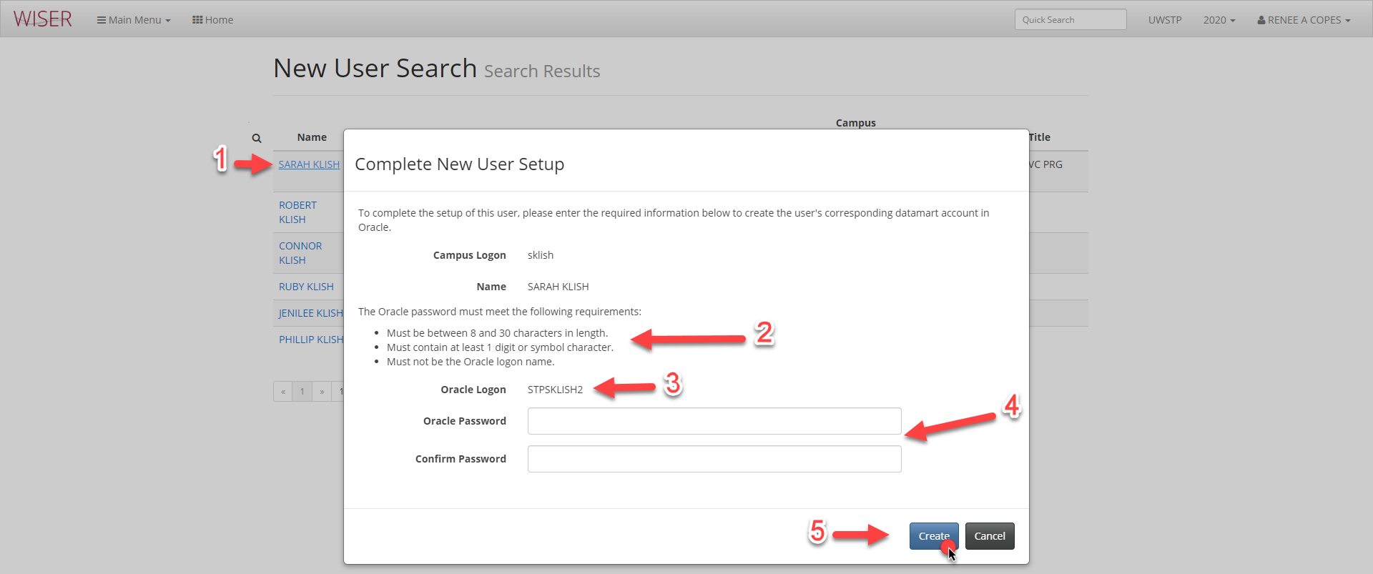
- Selected user
- Password requirements (datamart)
- Oracle logon created
- Password entry & confirmation
- Create or Cancel setup
Find Users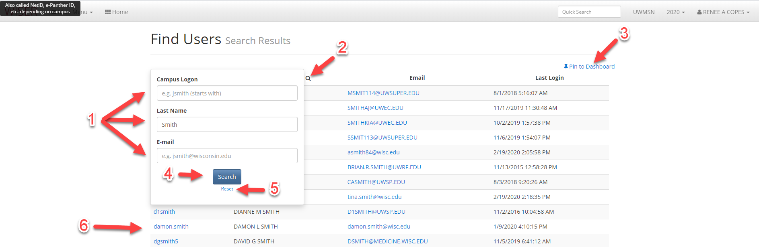
- Search Criteria
- Toggle between Search Criteria screen & results
- Pin search results to Dashboard (create tile)
- Begin search with criteria entered
- Reset search (clear criteria)
- Result listing (Users matching search criteria used)
Authorized User List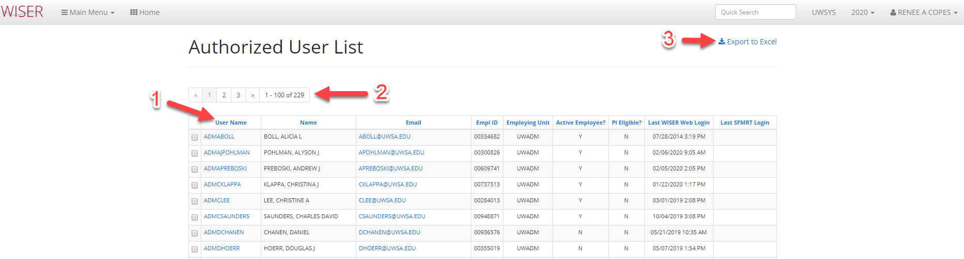
- Column headings – click to sort by
- Page navigation
- Export

Unit Settings-Features
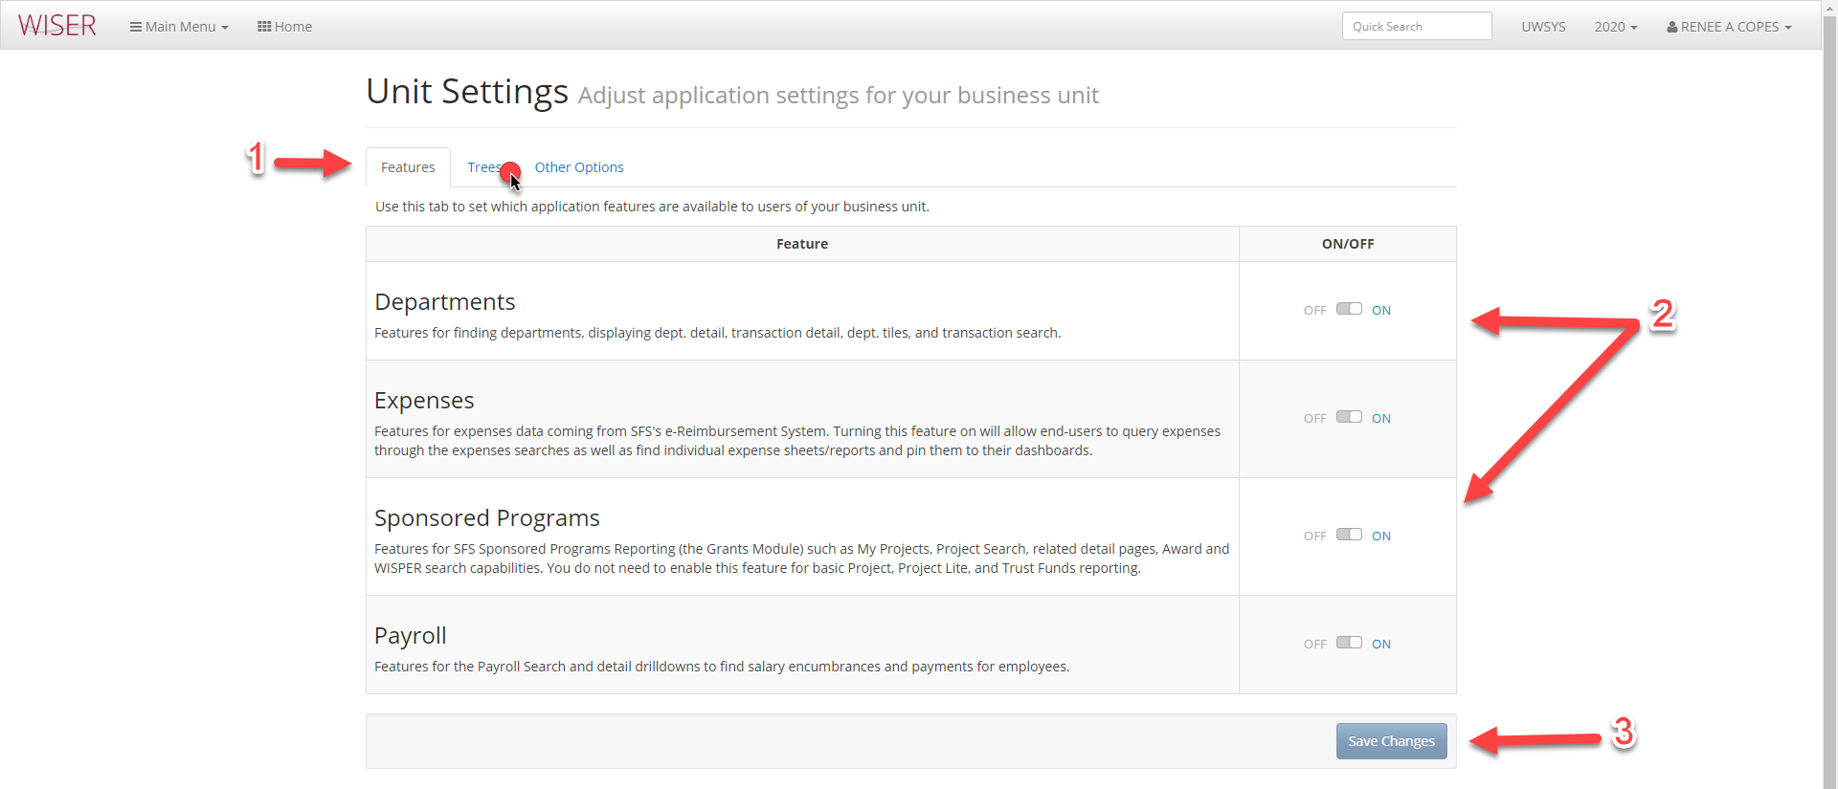

- Unit Setting group navigation
- Toggle features
- Save

Unit Settings-Trees-Default
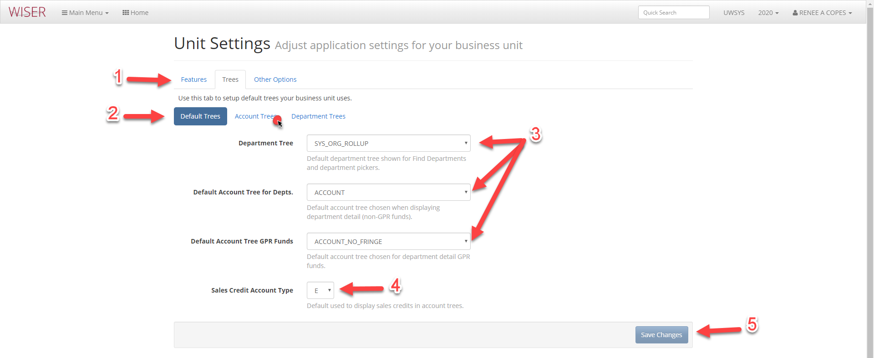
- Unit Setting group navigation
- Tree type setting navigation
- Default Trees
- Sales Credit – show as either Revenue or Expense
- Save any changes made
Unit Settings-Trees-Account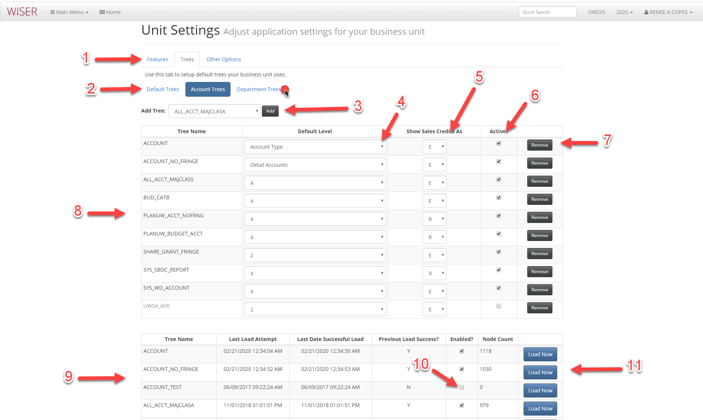
- Unit Setting group navigation
- Tree type setting navigation
- Add Tree
- Default level setting
- Sales Credit – show as either Revenue or Expense
- Toggle Active/Inactive
- Remove Tree
- Tree list
- Tree load detail
- Tree enabled toggle
- Option to load tree now

Unit Settings-Department Trees
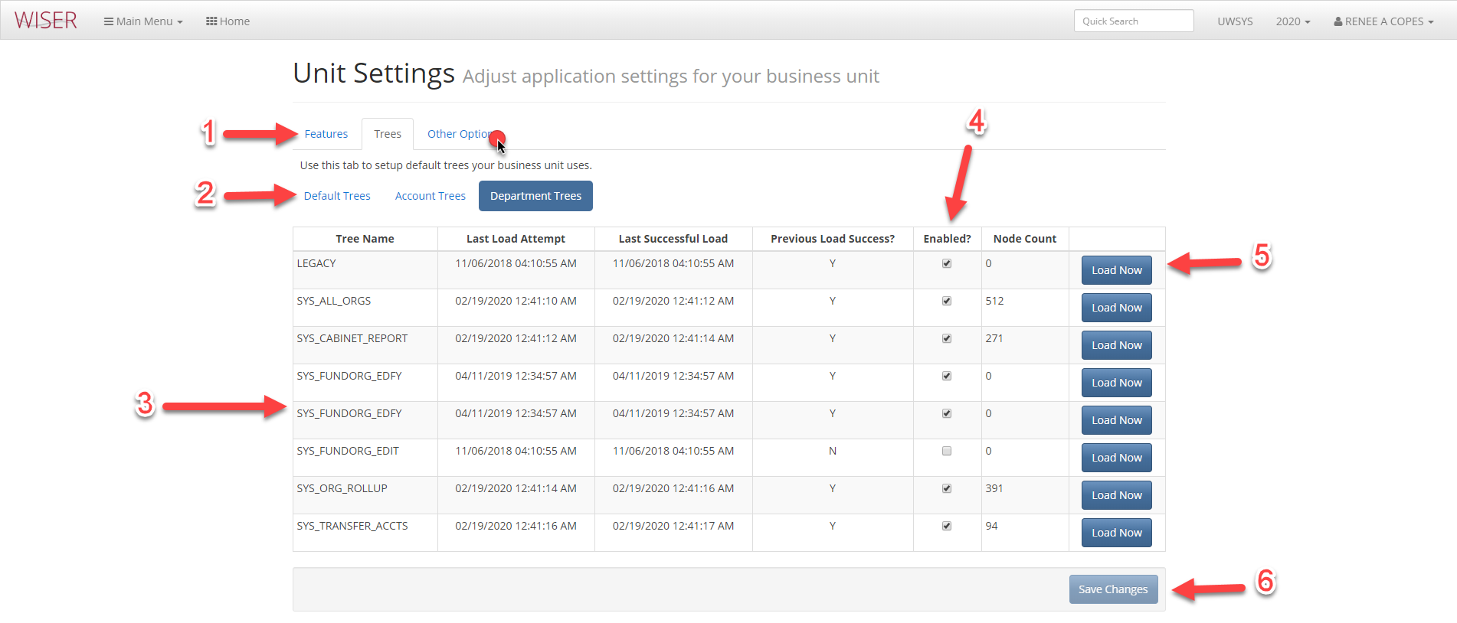
- Unit Setting group navigation
- Tree type setting navigation
- Department Tree details
- Enabled toggle
- Load now
- Save changes made

Unit Settings-Other Options
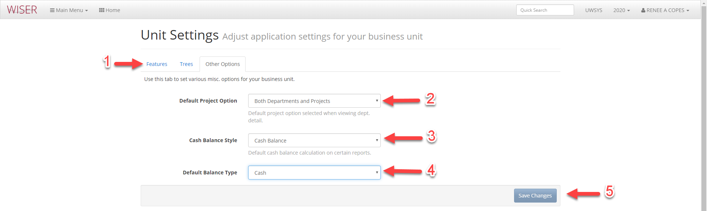
- Unit Setting group navigation
- Project view options
- Cash balance calculation options
- Default balance type
- Save changes made
Reconciliation