To view or maintain your My Projects list, select My Projects from the Main Menu.
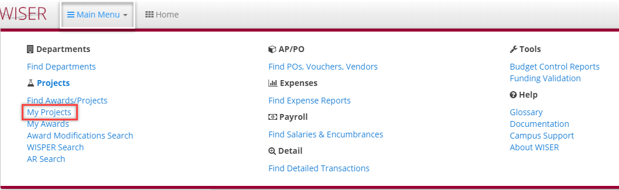
*Before delving into My Projects, there are 2 ways to add Projects to your list.
Option from within the project summary page -
Second option is from within the My Projects list -
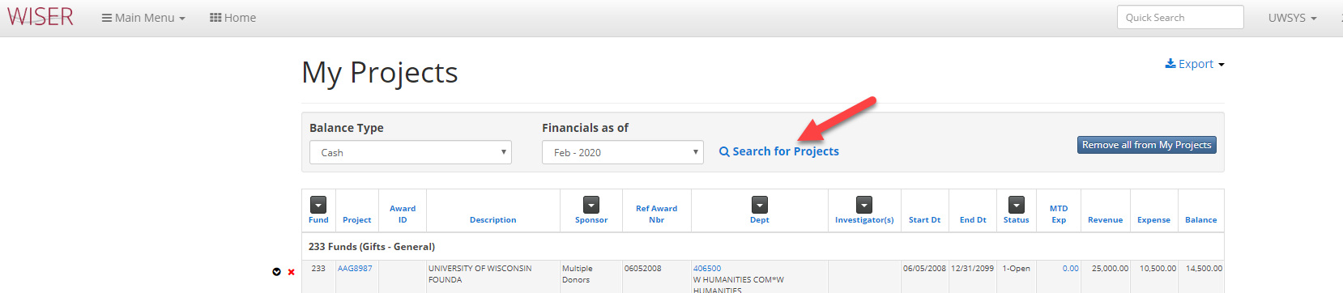

My Projects – display of items currently included on your list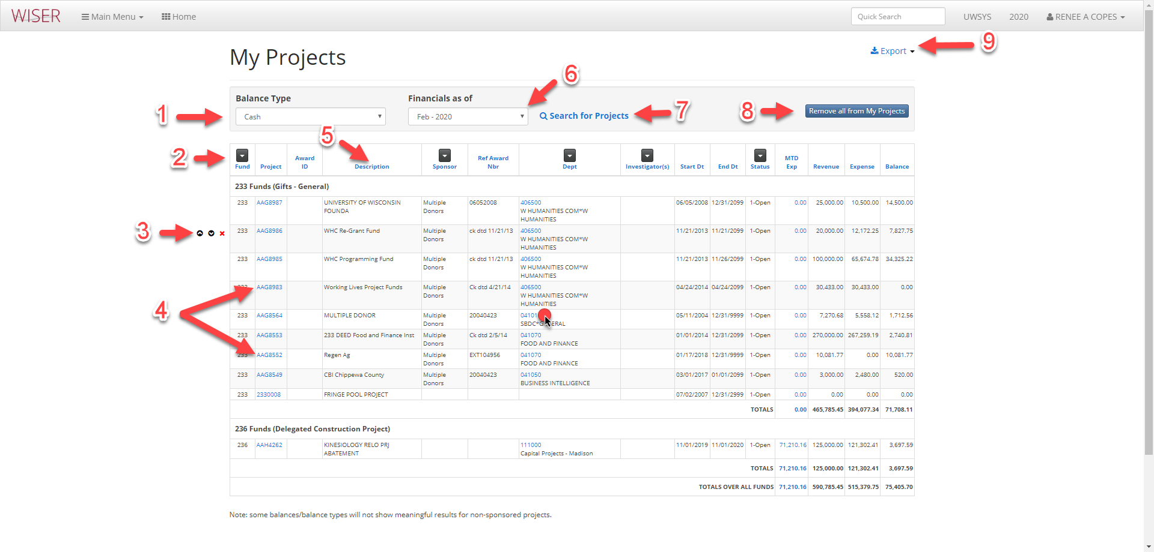
- Choose balance type to display
  - Budget Category
  - Budget Category – No Encumbrances
  - Budget Category – Direct Only
  - Unencumbered Cash
  - Cash
- Filter by available options (Listed Project’s attributes)
- Line option
  - Move project up in list
  - Move project down in list
  - Remove from list
- Hyperlink to Project Summary Report
- Sort by column headers
- Financials as of date drop down selector
- Search for Project – takes you to search criteria screen
- Clear all projects from listing
- Export options
  - Excel
  - PDF

Selecting Dept Hyperlink from My Projects takes you to listing of all projects within that Department-
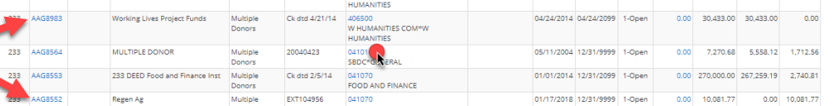
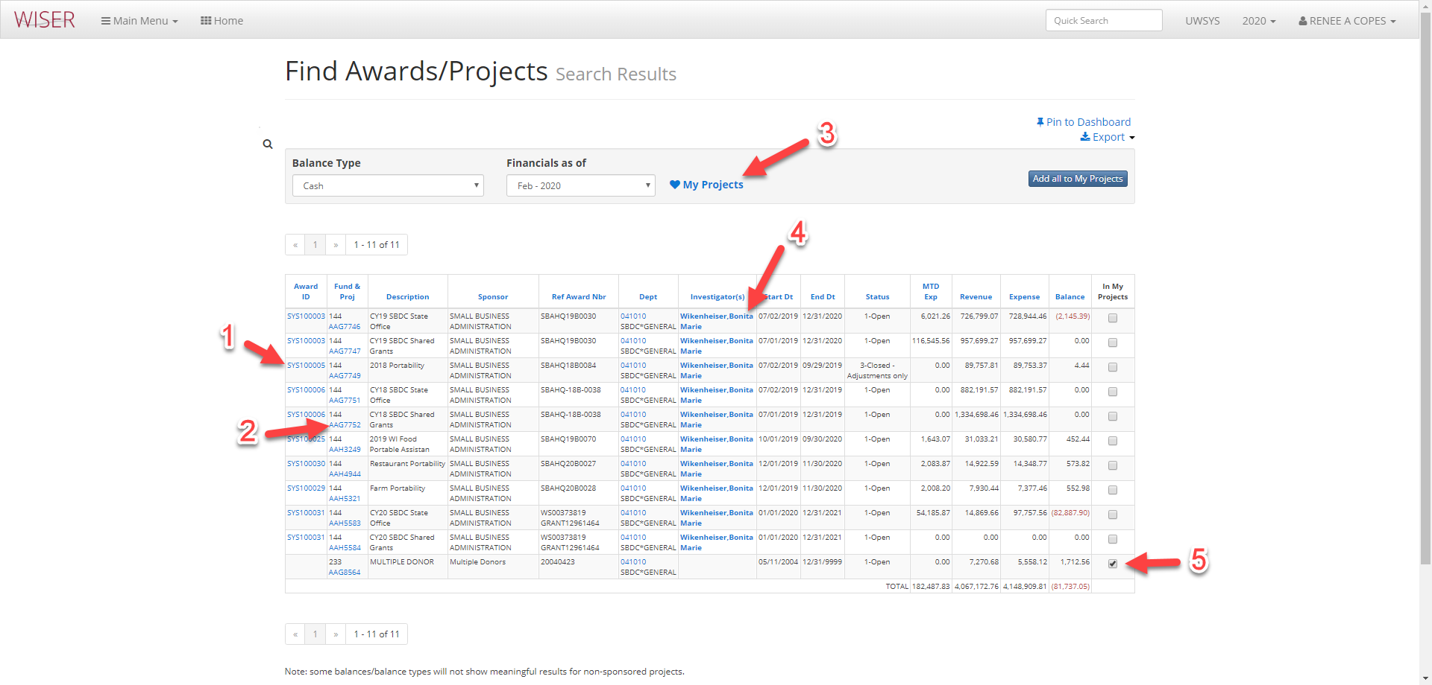*some options not explained here, but still available on this screen, were identified on previous screenshot
- Hyperlink to Award Summary Report
- Hyperlink to Project Summary Report
- Return to My Project List
- Hyperlink to list of selected Investigator’s projects
- Indicator of items listed that exist in My Projects

