Main Menu 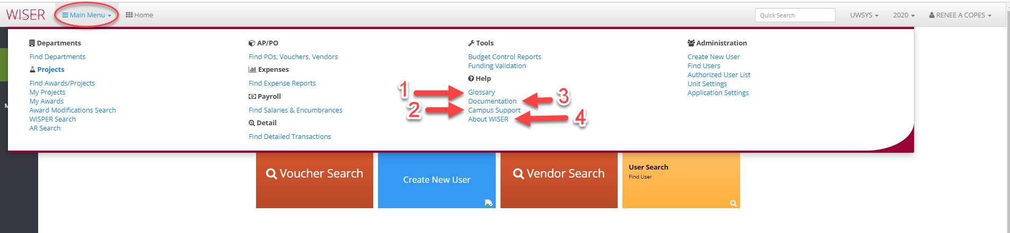
- Glossary – WISER terms & definitions
- Campus Support – Listing of campus WISER support contacts
- Documentation – link to SFS webpage containing WISER information
- About WISER – Copyright and licensing details

