Begin by selecting Funding Validation from Main Menu

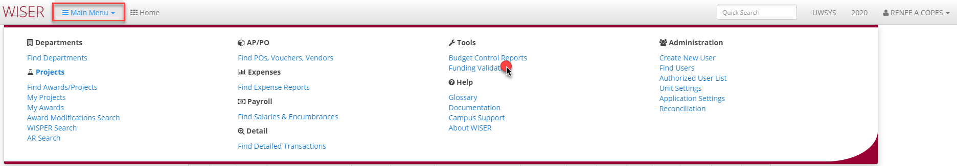

Funding Validation
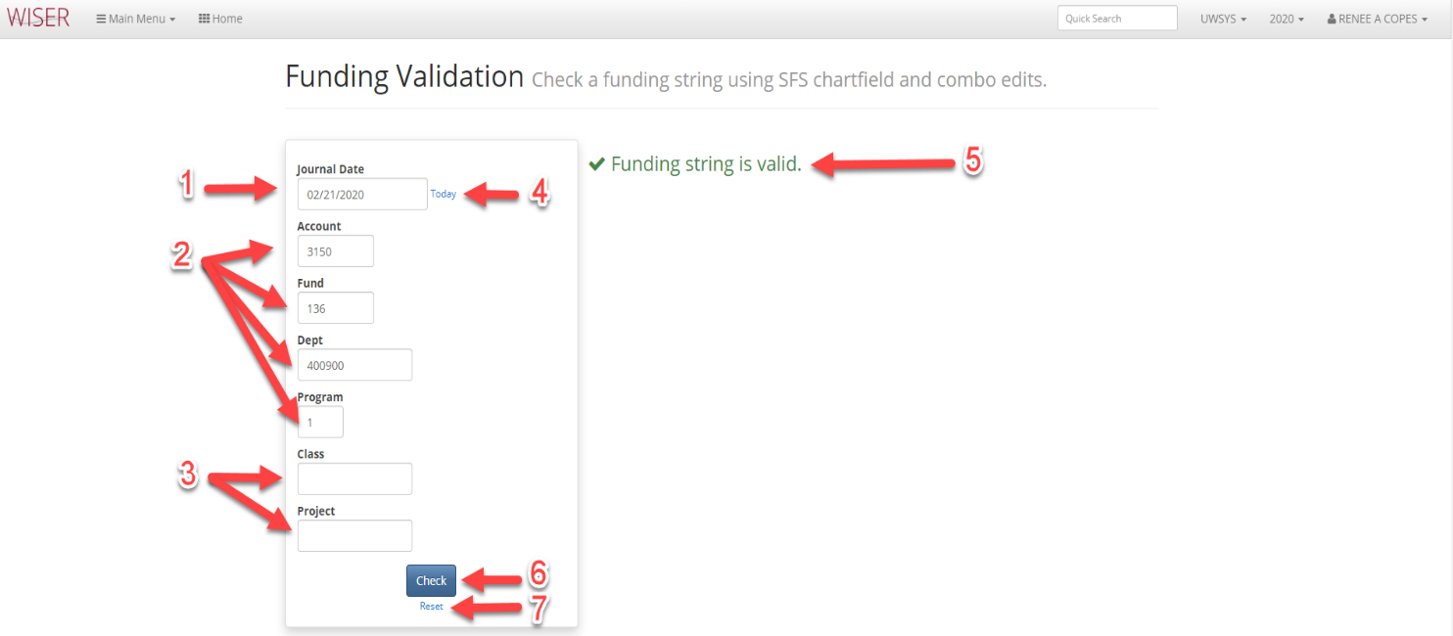
- Enter Date of Journal
- Mandatory entry fields
- Optional entry fields
- Update date to today
- Validation message (example of invalid error message below)
- Check if funding string entered is valid
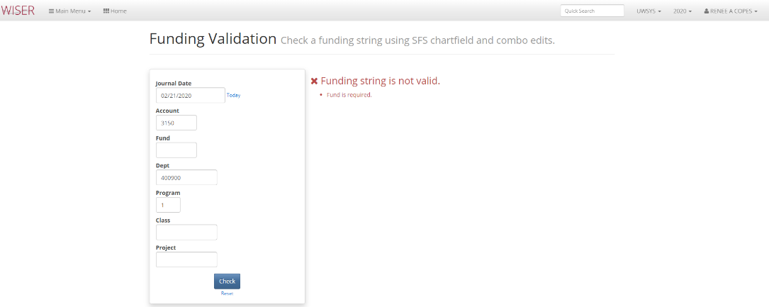
- Reset search criteria

