To perform a Payroll search select Find Salaries & Encumbrances from the Main Menu
Main Menu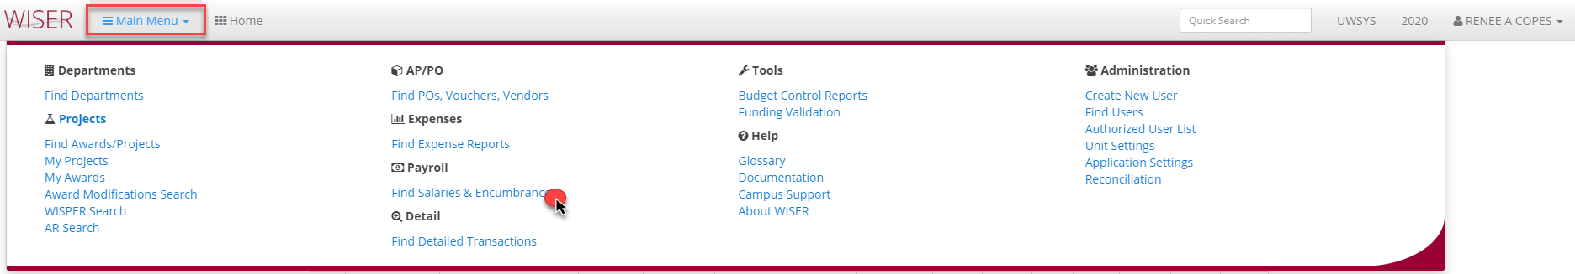

Find Salaries & Encumbrances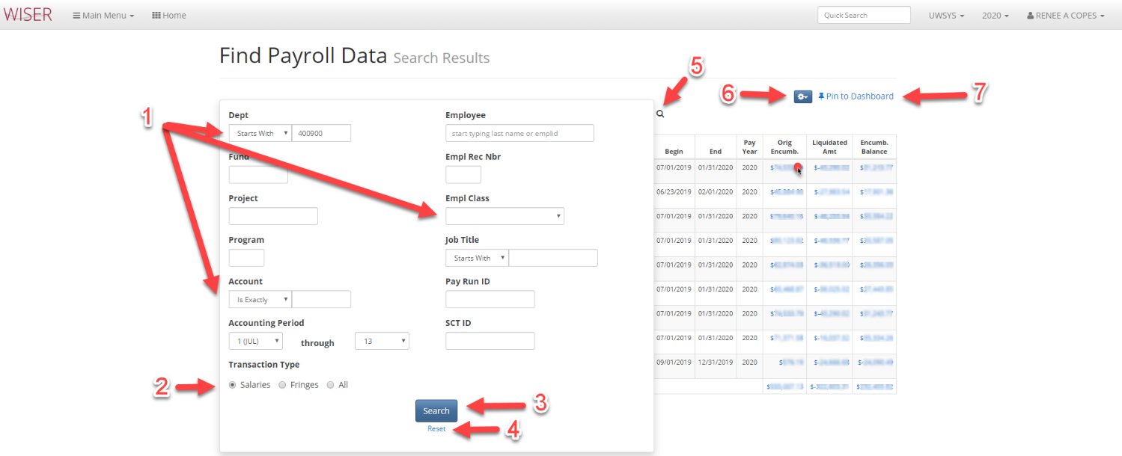
*Search screen shown over results
- Enter search criteria
  - More criteria will narrow search
- Select desired data types to return
  - Salaries
  - Fringe
  - All
- Initiate search with criteria entered
- Reset search criteria
- Toggle between search screen and results
- Export to Excel/set records per page to view
- Pin to Dashboard – create tile

Transaction Detail-Orig Encumb. hyperlink selected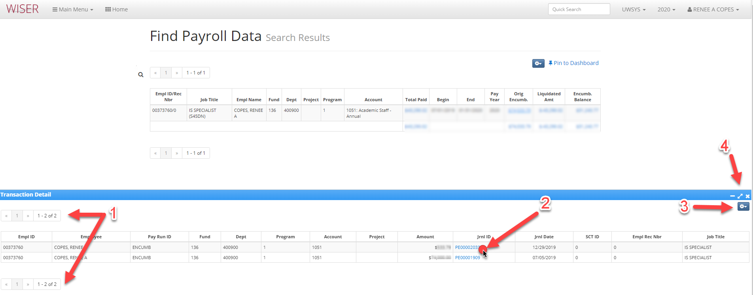
- Page navigation
- Hyperlink to Journal detail
- Displayed detail options
  - Export to Excel
  - Customize columns
  - Records per page
  - Include Earn Dates
Result when Journal Id hyperlink selected
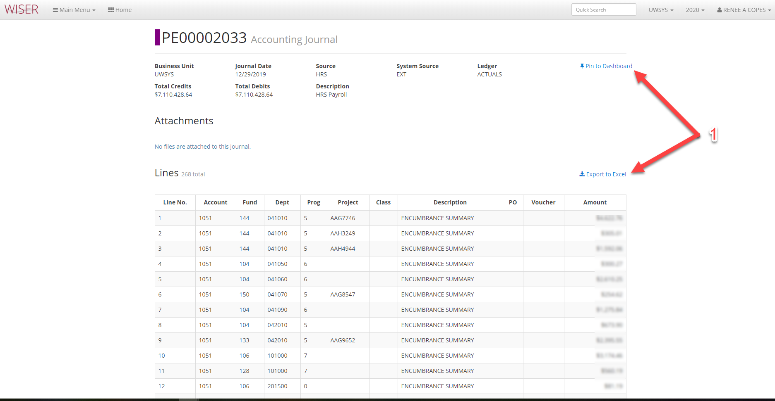
*this final level of detail opens in new browser tab
- Options for this page
  - Pin to Dashboard (tile)
  - Export to Excel

