To search POs, Vouchers, and Vendors select this option from the Main Menu
Main Menu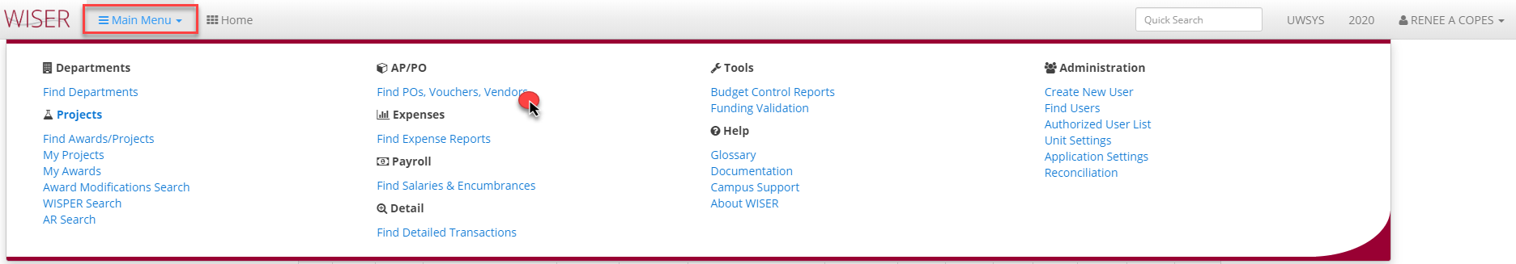
Find POs, Vouchers, Vendors
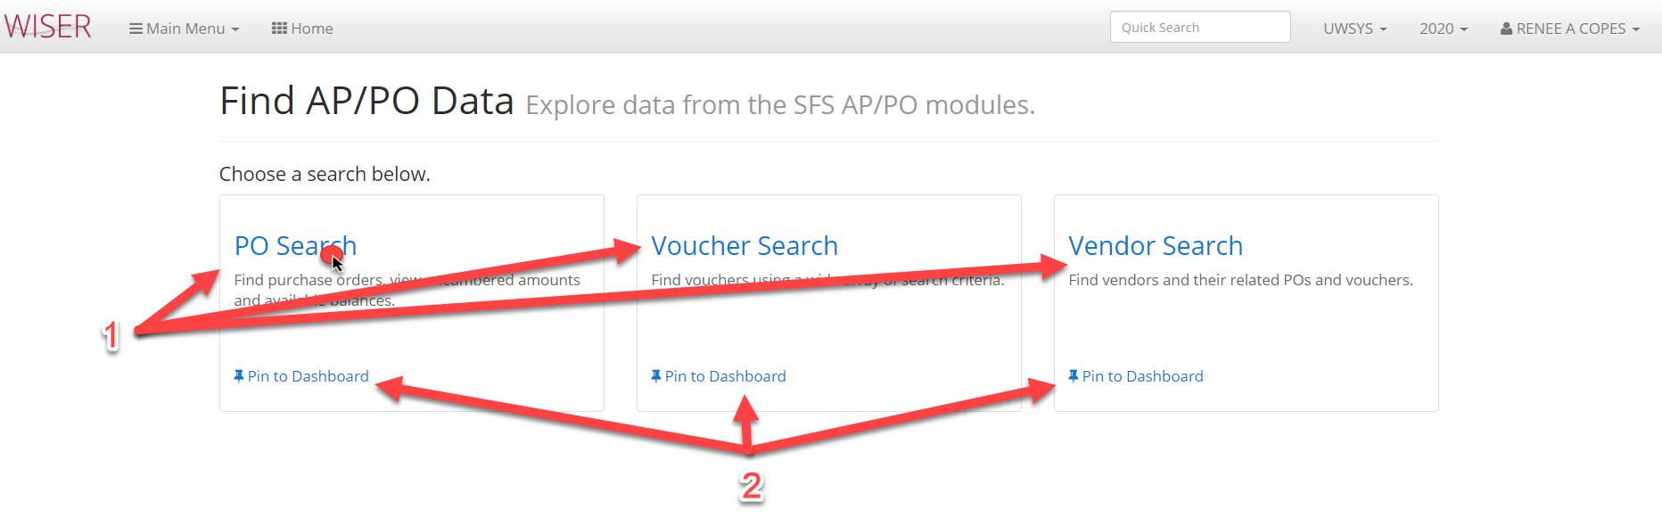

- Select from search options
- Pin (create tile) search type to dashboard

Find POs with results
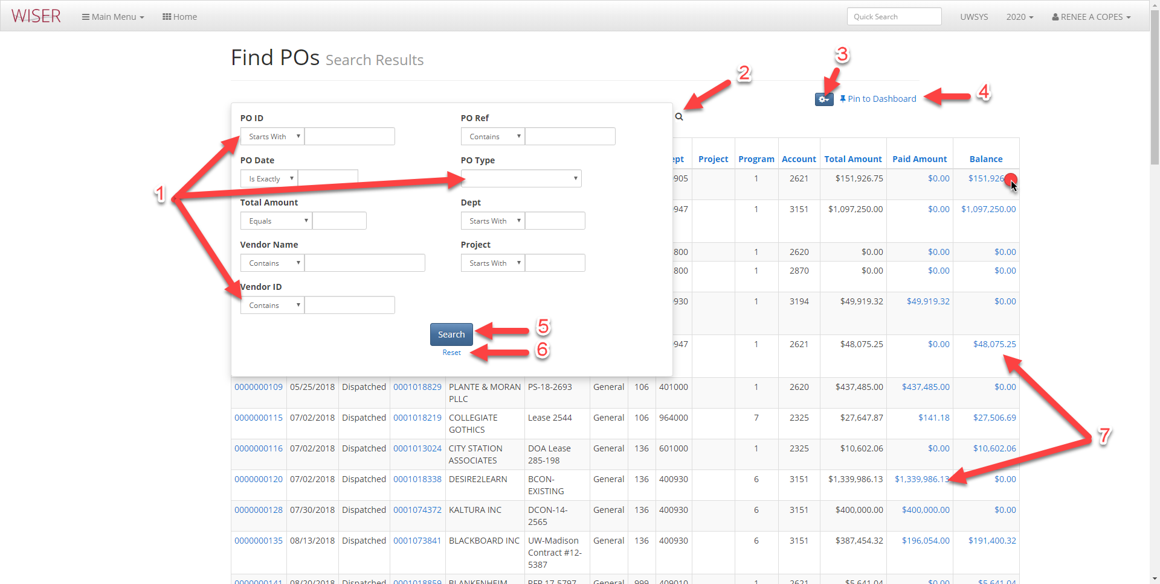
*search screen shown over results
- Enter criteria for search
  - More criteria = narrower search
- Toggle between search screen & results
- Export & records per page options
- Pin (create tile on homepage)
- Begin search on criteria supplied
- Reset search screen
- Blue hyperlinks on results lead to detail

Find PO search results with hyperlink selected
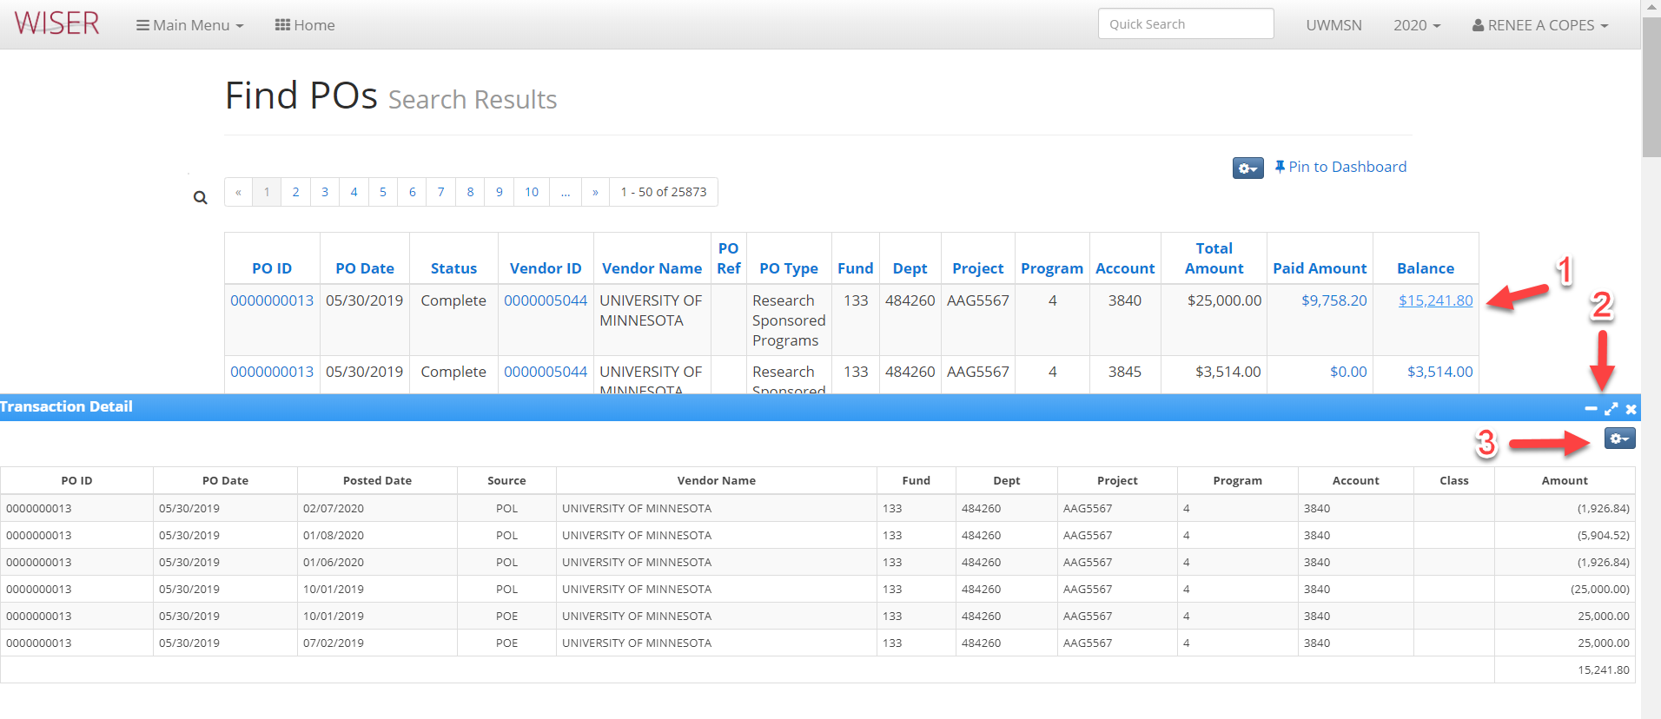
*Shown with Transaction Detail pane displayed after hyperlink clicked
- Hyperlink selected
- Minimize/maximize/close Transaction Detail area
- Export detail to Excel

Main Menu > find POs, Vouchers, Vendors > Voucher Search
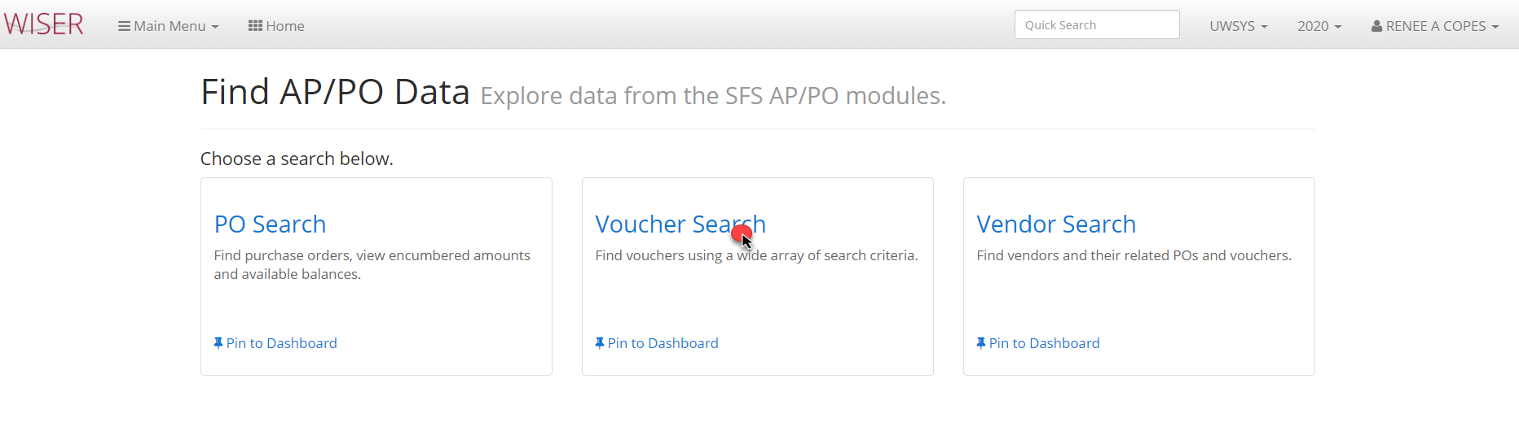

Find Vouchers with results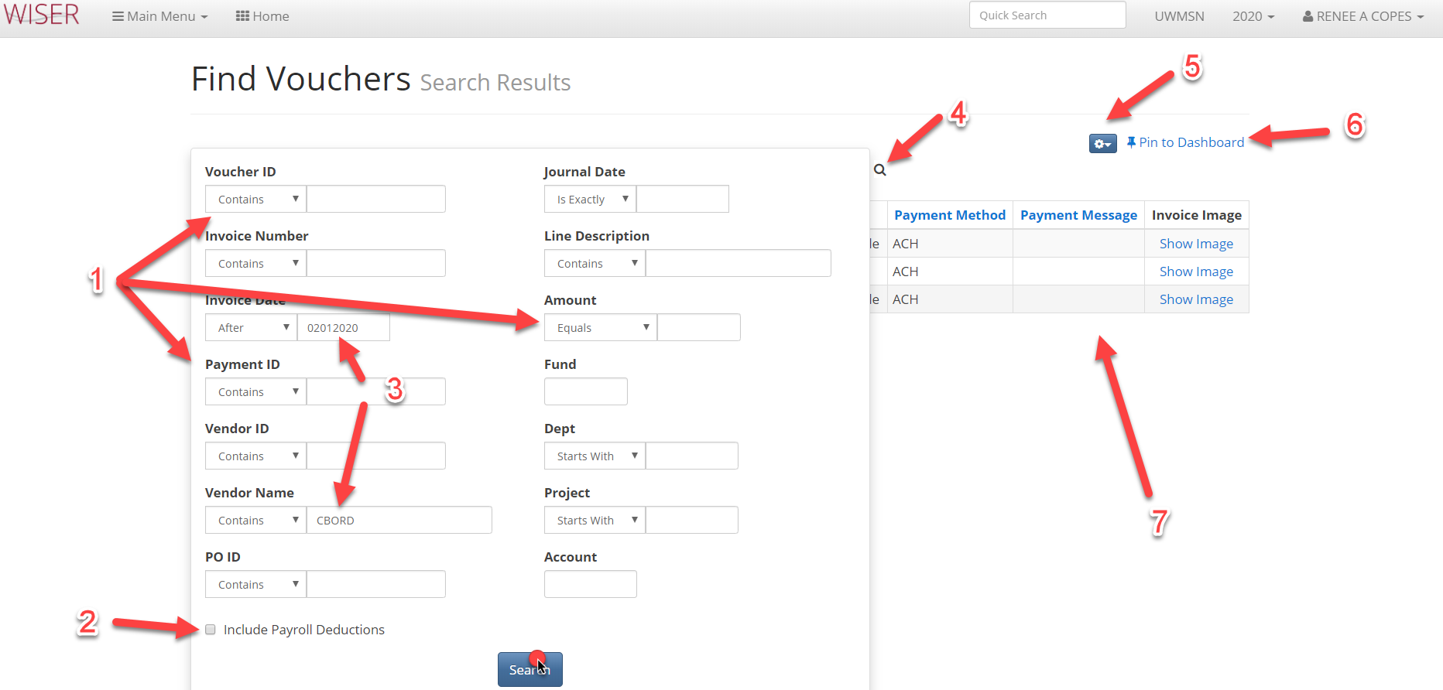
*search screen shown over results
- Enter search criteria
  - More criteria = narrower search
- Toggle to include/exclude Payroll deductions
- Criteria entered
- Toggle between search and result screens
- Export to Excel and records per page option
- Pin to Dashboard (create tile)
- Search results

Find Vouchers results
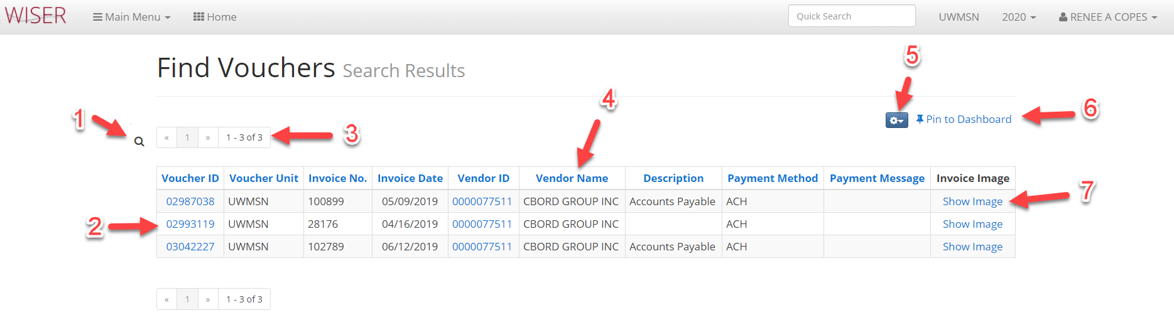
- Toggle between search and result screens
- Blue hyperlinks to further detail
- Page navigation
- Column headers used to sort
- Export to Excel & select records per page
- Pin to Dashboard (create tile)
- If authorized to view (controlled by each campus)

Main menu > Find POs, Vouchers, Vendors > Vendor Search
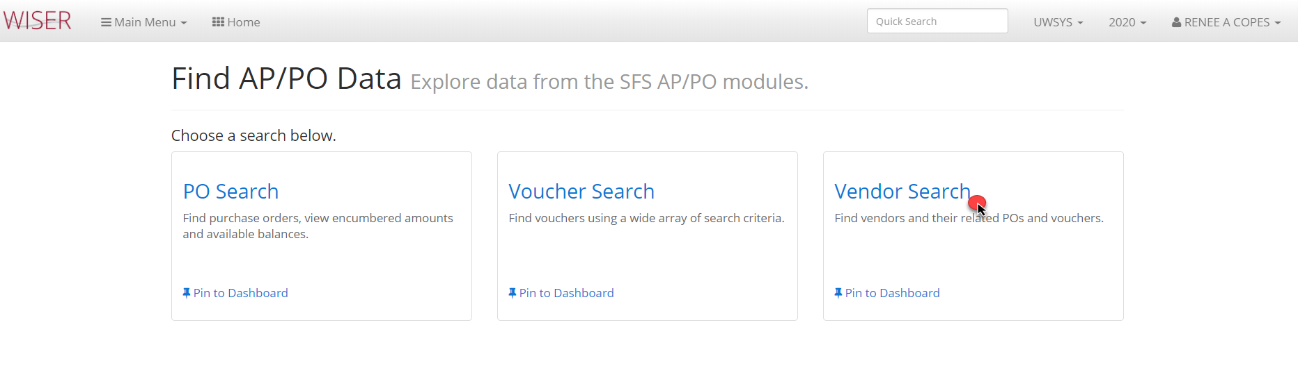
Find Vendors
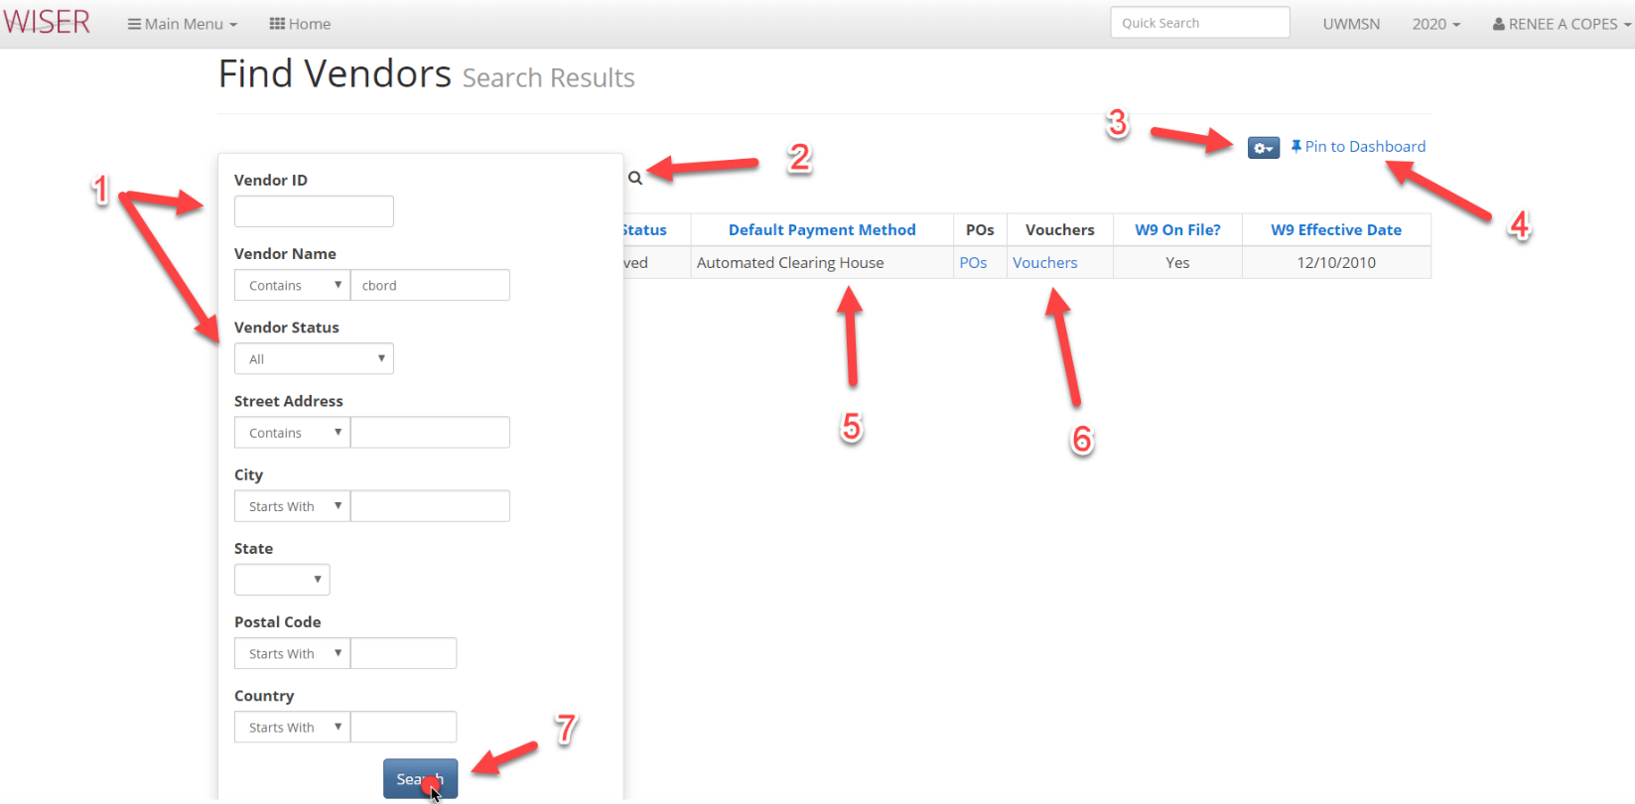
*search screen shown over results
- Search criteria
  - Criteria narrows search
- Toggle between search screen and results
- Export to Excel and number of items displayed on page
- Pin to Dashboard (create tile)
- Details resulting from search
- Blue hyperlinks to further detail
- Run search with criteria entered

Find Vendors results
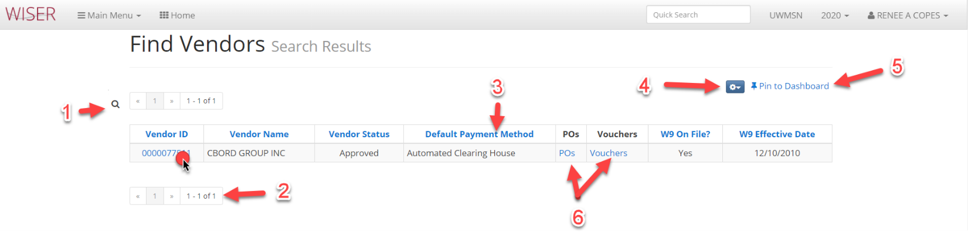

- Toggle between search screen & results
- Page navigation
- Column headers used to sort
- Export to Excel and number of displayed items per page
- Pin to Dashboard (create tile)
- Blue hyperlinks to further detail
Vendor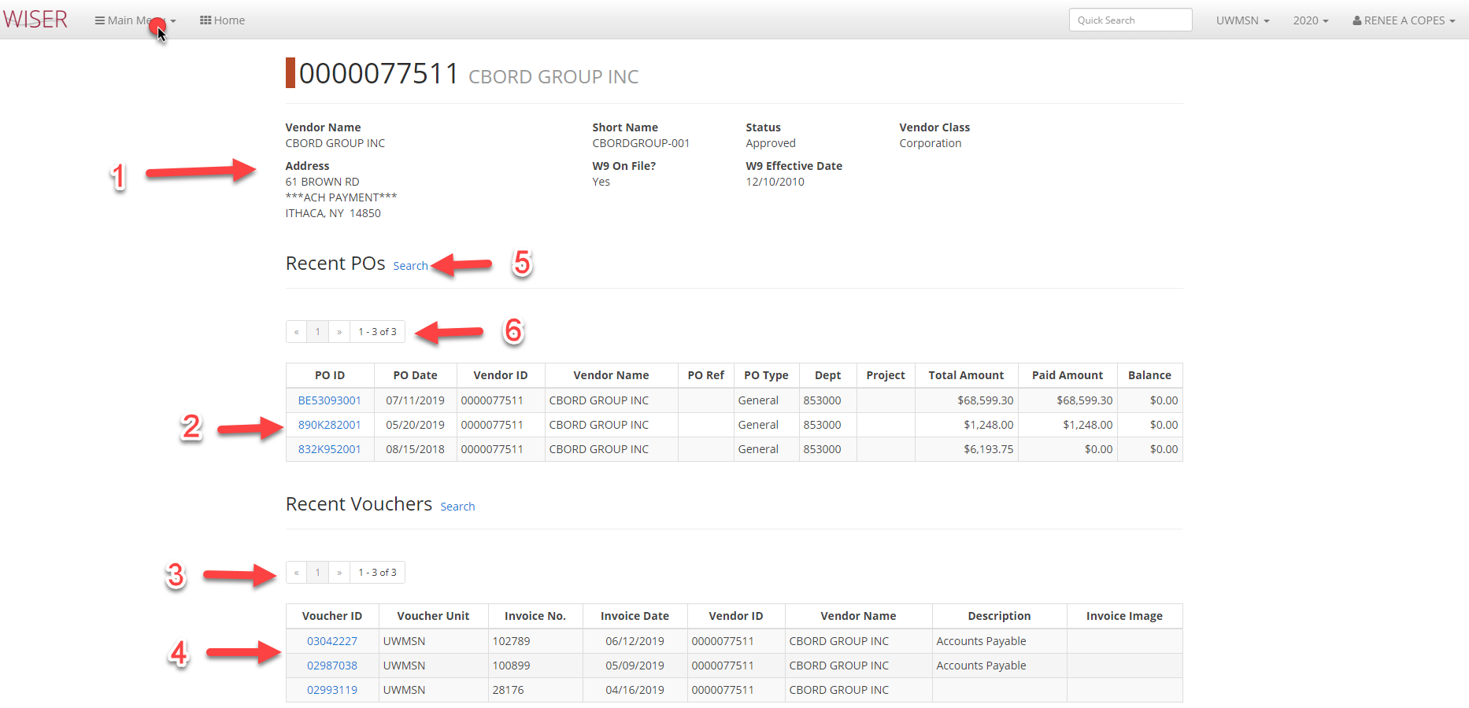
- Vendor details
- PO list
  - Hyperlink to detail
- Page navigation
- Voucher list
  - Hyperlink to detail
- Find Pos search results
- Page navigation

