To search for detailed transactions select Find Detailed Transactions from Main Menu
Main Menu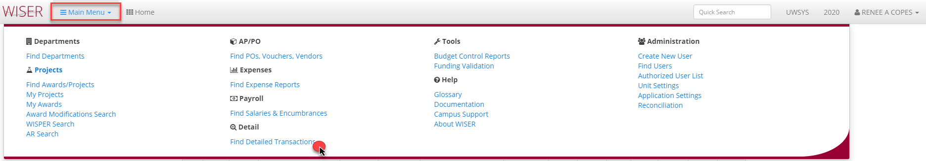
Find Detailed Transactions Search with Results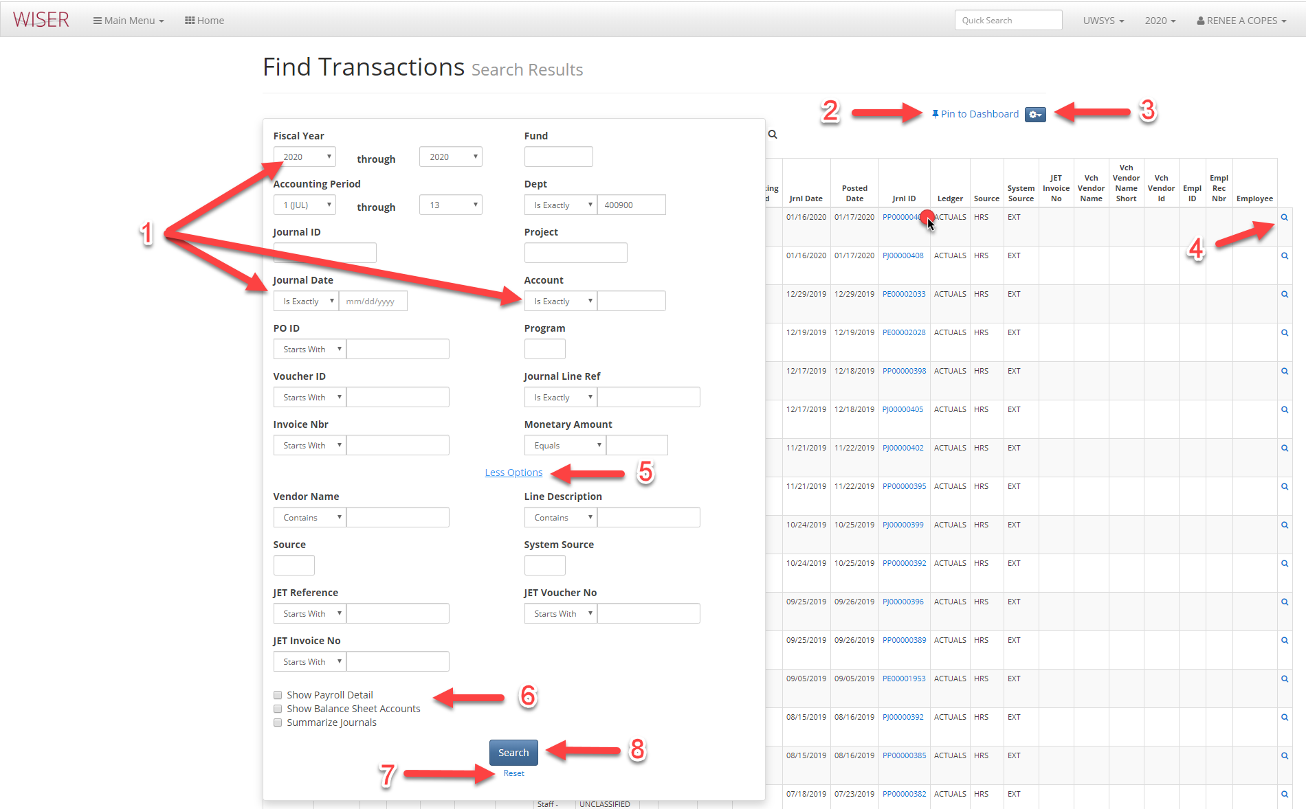
*search screen shown over results
- Enter criteria
  - More criteria will narrow search
- Pin to Dashboard (create tile)
- More options
  - Export to Excel
  - Customize columns
    - Select/deselect columns to include
    - Reorder column display
    - Revert to default
    - Records to view per page
- More Details (if available)

Journal Detail-hyperlink in Jrnl ID column selected 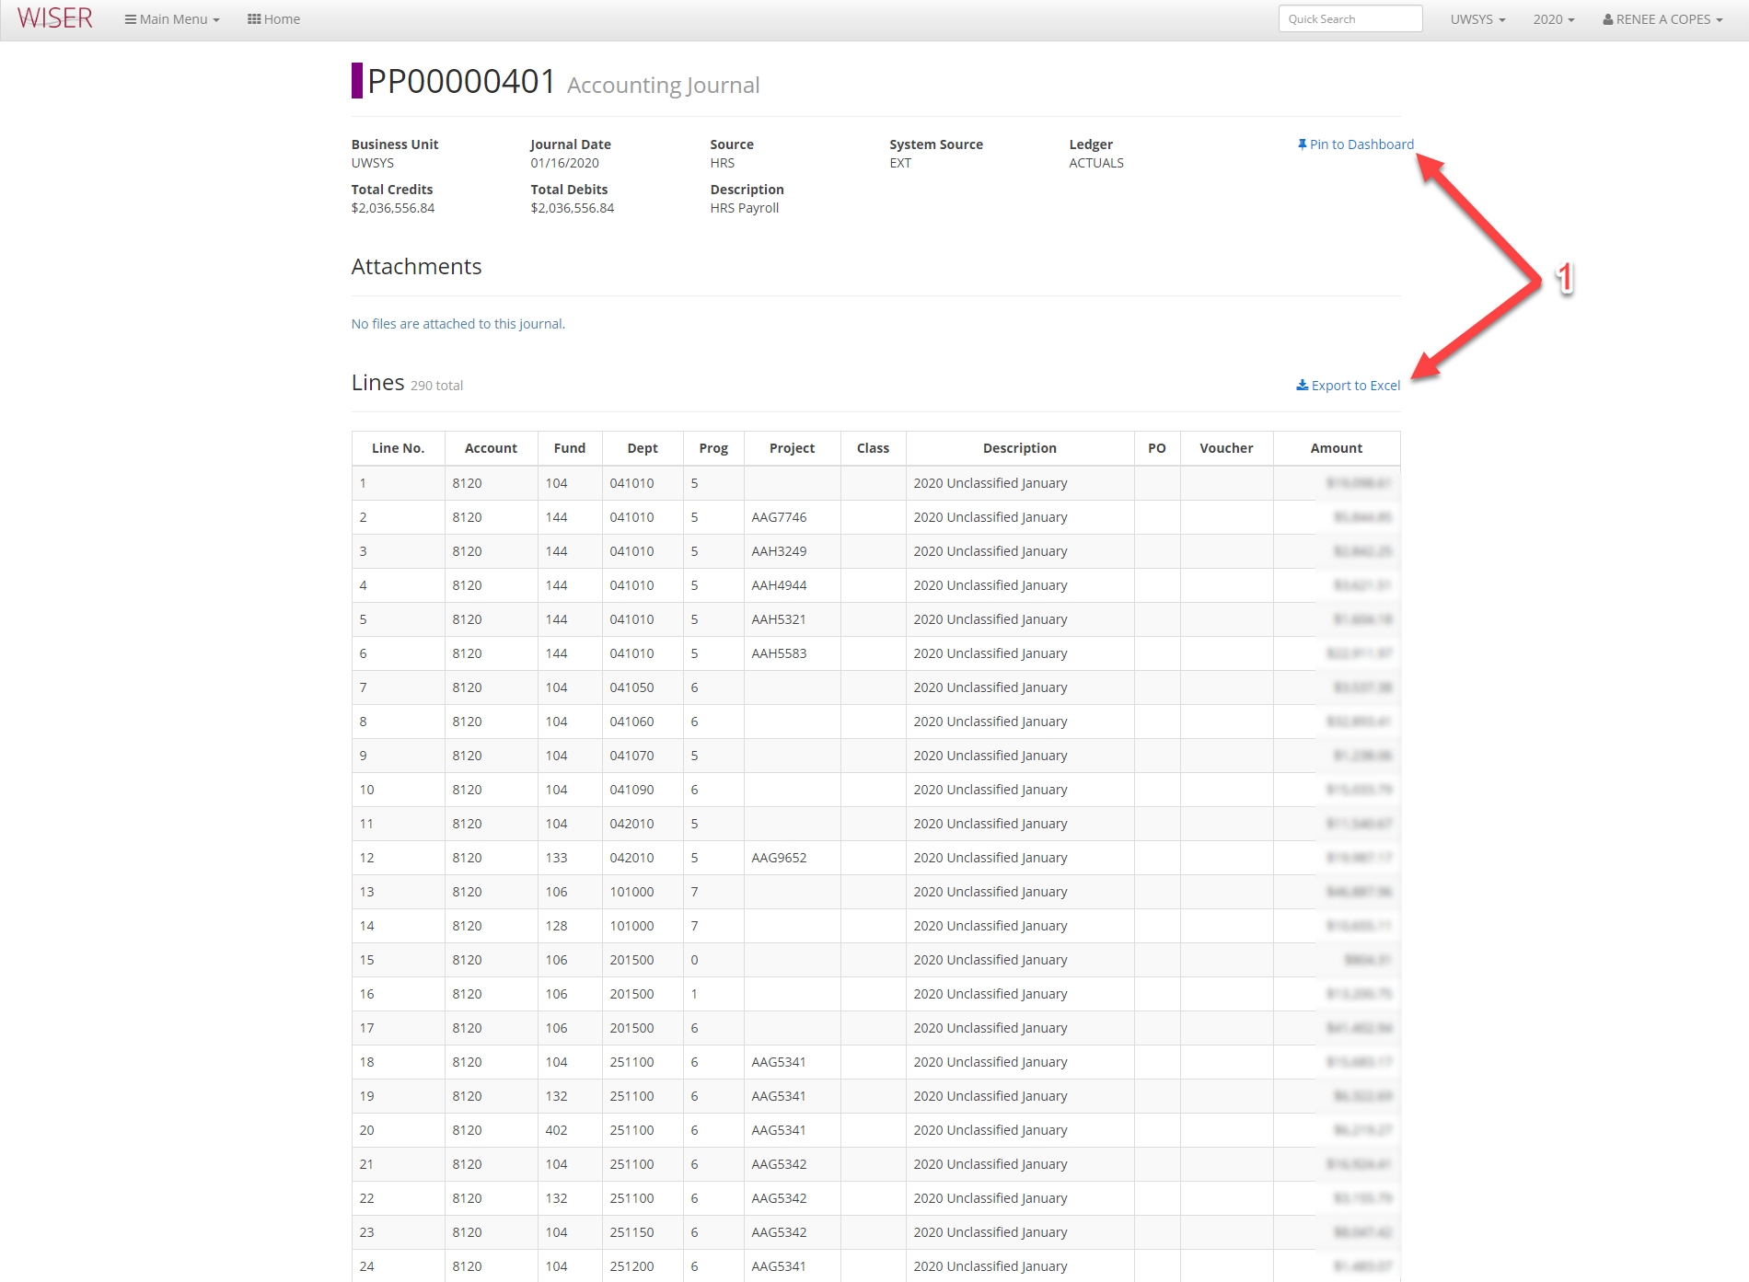
*last level of drill (detail) opens in new browser tab
- Available options for this Journal detail
  - Pin to Dashboard – create a tile
  - Export to Excel

