To search for Departments select Find Departments from the Main Menu.
Main Menu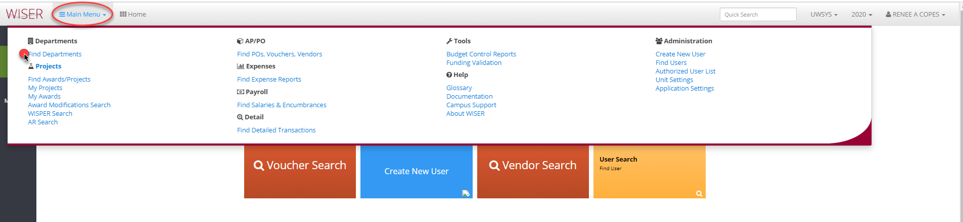
Find Departments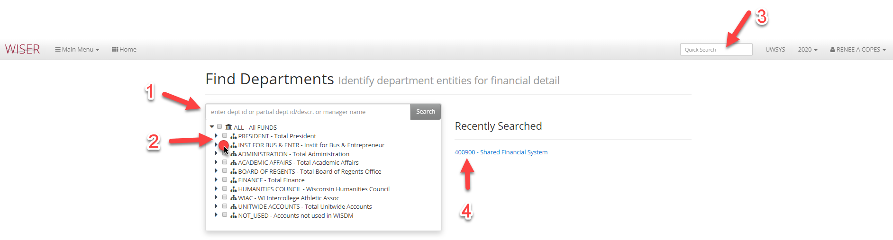
- Search by department ID, description, or manager name
- Expand, collapse, or select
- Quick search still available
- List of recently searched can be selected
Find Departments – selection made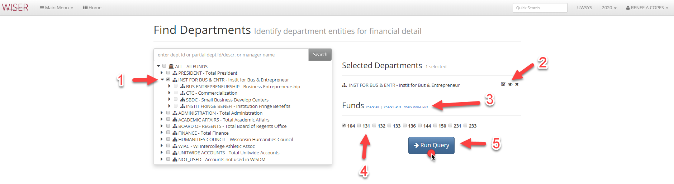
- Selected
- Department options
  - Check all children
  - Locate in Tree
  - Remove
- Select funds by group
  - Check all
  - Check GPRs
  - Check non-GPRs
- Options for fund selection
  - Available funds displayed - Toggle/untoggled individual funds
- Run Query with parameters selected
Department Summary Report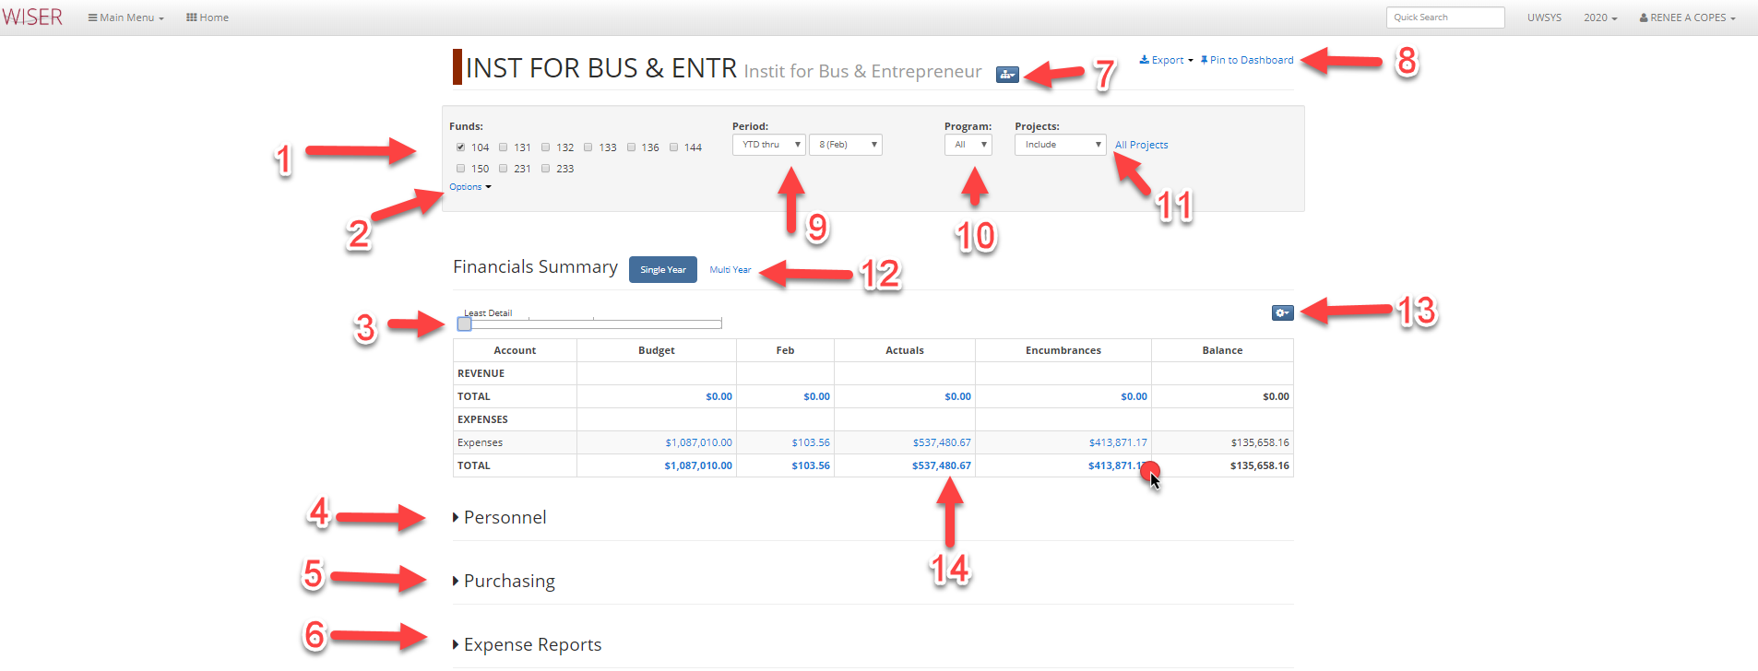
- Funds available for inclusion – select/deselect individually
- Fund options by group
  - Select GPR
  - Select non-GPR
  - Select All
- Detail slider
  - Slide to increase or decrease tree level displayed on report
- Un-collapse to view Personnel detail
  - Option to Export to Excel
- Un-collapse to view Purchasing detail
  - Option to Export to Excel
- Un-collapse to view Expense Reports
  - Option to Export to Excel
- Department selected options
  - Scope up to All Funds
  - View in Dept Tree
- Export Report to Excel or Pin to Dashboard (Tiles)
- Period options
  - YTD
  - ITD
  - Period Only
  - Quarter Only
- Program Options
  - All
  - Available are listed and can be individually selected
- Project Options
  - Include
  - Exclude
  - Only
  - All
- Financials Summary Single Year or Multi Year selector
  - Multi Year displays a 5 year span
- Settings
  - Tree selector
  - Set to default
  - Include AJE Ledger
- Amounts are hyperlinks – select for detail

Detail displayed after hyperlink selected 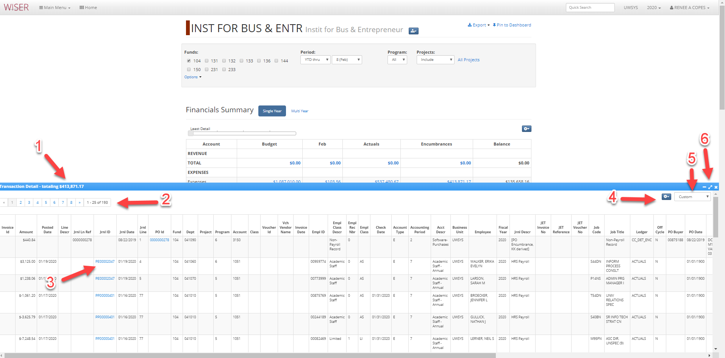

- Amount of hyperlink selected for detail currently displayed
- Page navigation
- Hyperlinks to further detail
- Settings
  - Export to Excel or PDF
  - Customize columns
    - Select/deselect columns to include
    - Reorder column display
    - Revert to default
- Detail source
  - Custom
  - AP
  - Standard
  - Salary/Fringe
- Minimize/Expand/Close Transaction Detail section

