To access Find Awards/Projects select it from the Main Menu
Main Menu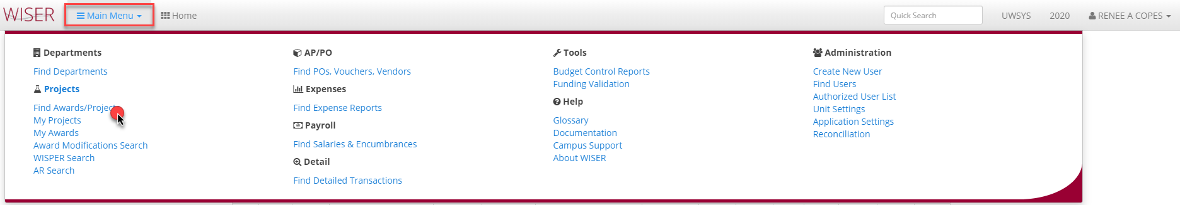
Find Awards/Projects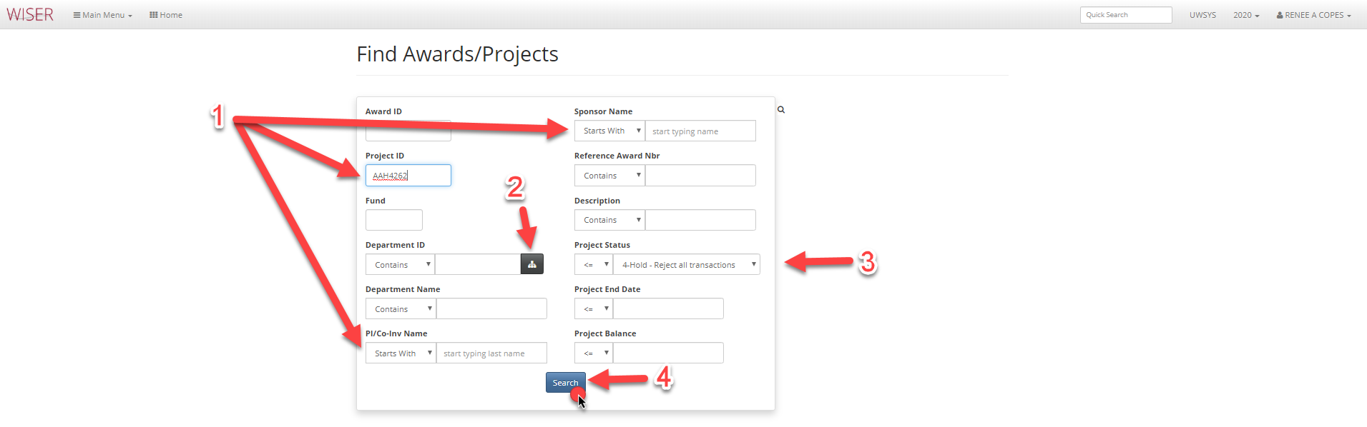
- Enter any search criteria
  - The more criteria, the narrower the search
  - All are optional
- Show Department picker
  - Displays tree view of departments for selection
- Default value can be changed
- Search using any criteria entered
Search Results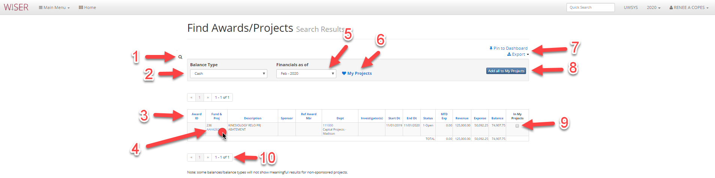
- Return to Find Awards/Projects search
- Drop down menu to choose Balance Type
- Column headers can be used to sort list (if multiple results shown)
- Project ID is a hyperlink to details
- Drop down selector for month to display financials for
- Add to My Projects list
- Pin to Dashboard (create tile or add to existing group on Homepage) and Export options
- Add All to my projects – useful for lists of results
- Checkbox to add to My Projects list – useful when selecting multiple, but not all from list
- Page navigation
Hyperlink detail Results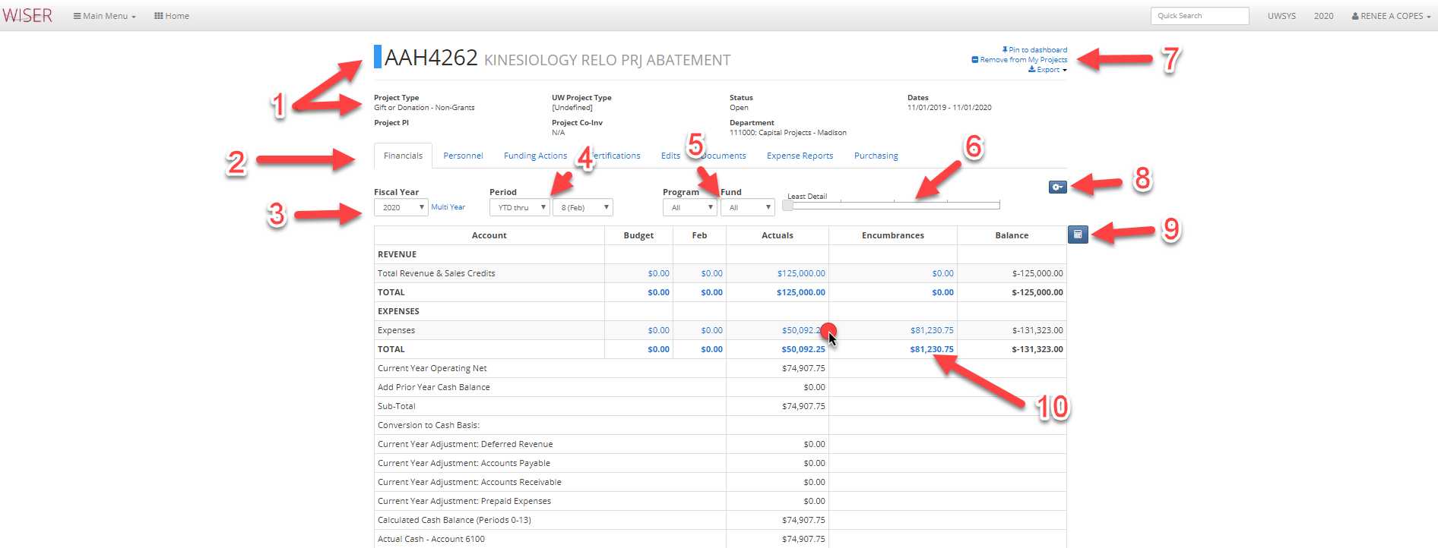
- Details on Project
- Tabs for additional information (if any)
- Fiscal year selector and option for Multi Year
- Period selector
- Program and Fund selector (available options included in drop down)
- Slide to increase or decrease detail
- Options for Project
  - Pin to Dashboard (tile)
  - Remove from My Projects list
  - Export options
- More options
  - Change Tree used
  - Set current level to default
  - Toggle to include Period 998
- Toggle cell selection mode
  - Allows you to select amounts and calculates Sum, Count, and Average
  - Select again to toggle off cell selection mode
- Blue amounts are hyperlinks to further detail
Hyperlink Transaction Details results 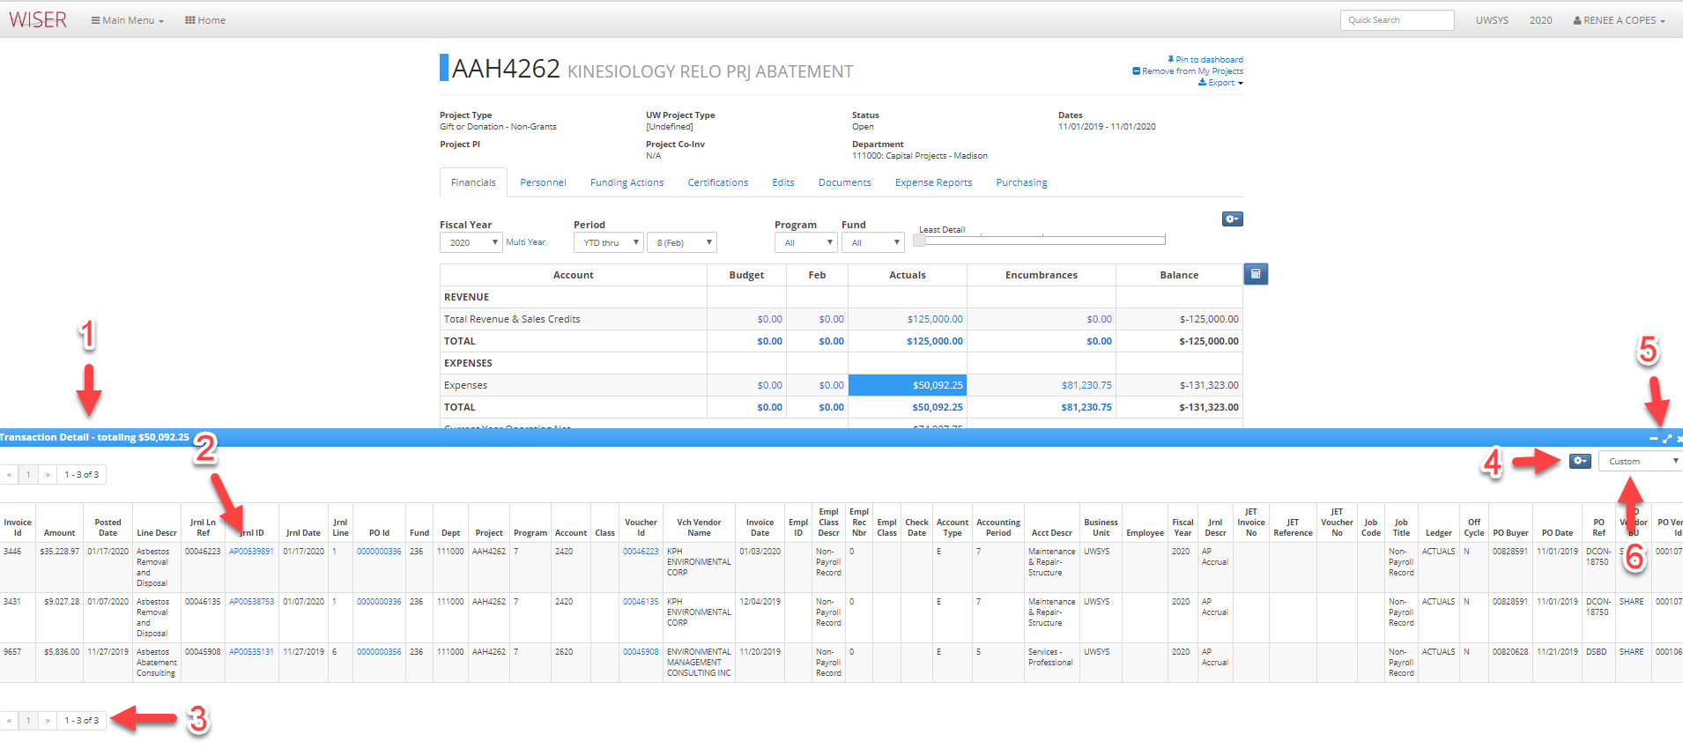
- Total of transaction detail selected/displayed
- Blue text signifies hyperlinks to further detail
- Page navigation
- Detail options
  - Export to Excel or PDF
  - Customize – can add, remove, or reorder columns
  - Records per page
- Minimize, maximize, or close detail window
- View presented as - AP, Standard, Salary/Fringe, Custom

