To access Award Modification Search select it from the Main Menu
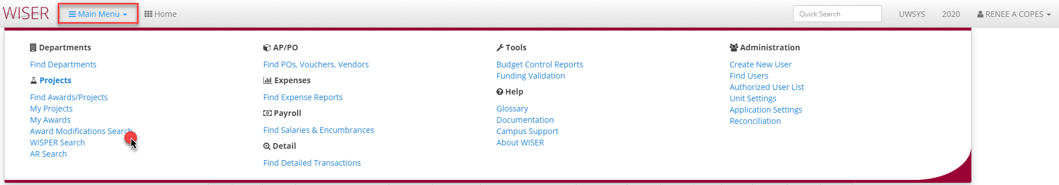
Award Modification Search 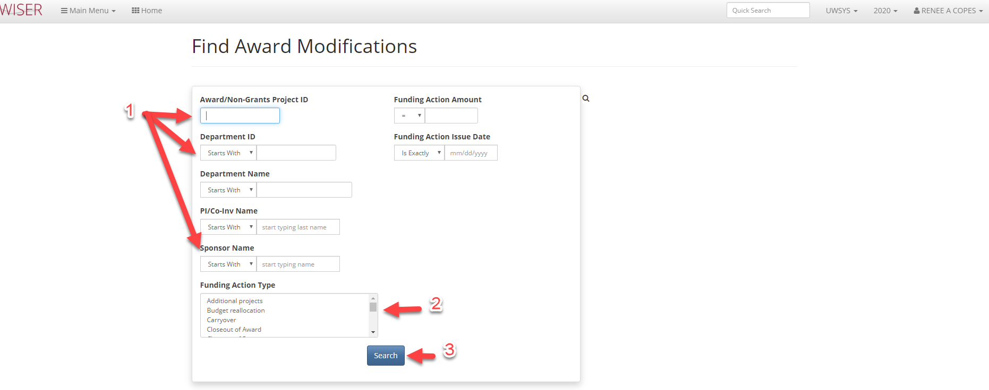

- Enter criteria for search
  - The more criteria entered, the narrower the search
- Listing of available funding action types to use as criteria
- Begin search using criteria entered

Award Modification Search Results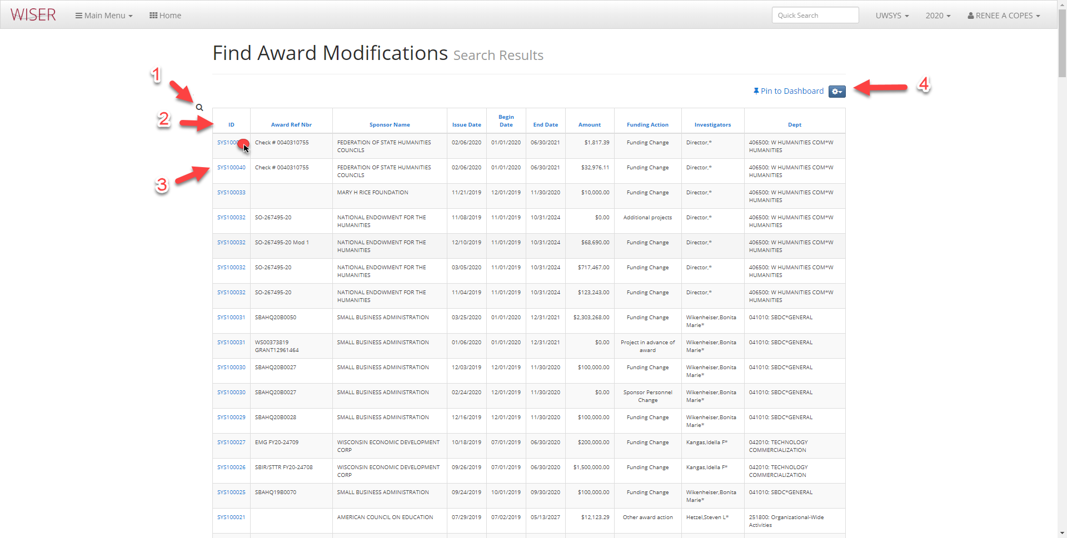
- Toggle back to Search screen
- Headers used to sort listed items
- Hyperlink to Award
- Pin to Dashboard/Setting for Export options

Award Summary Report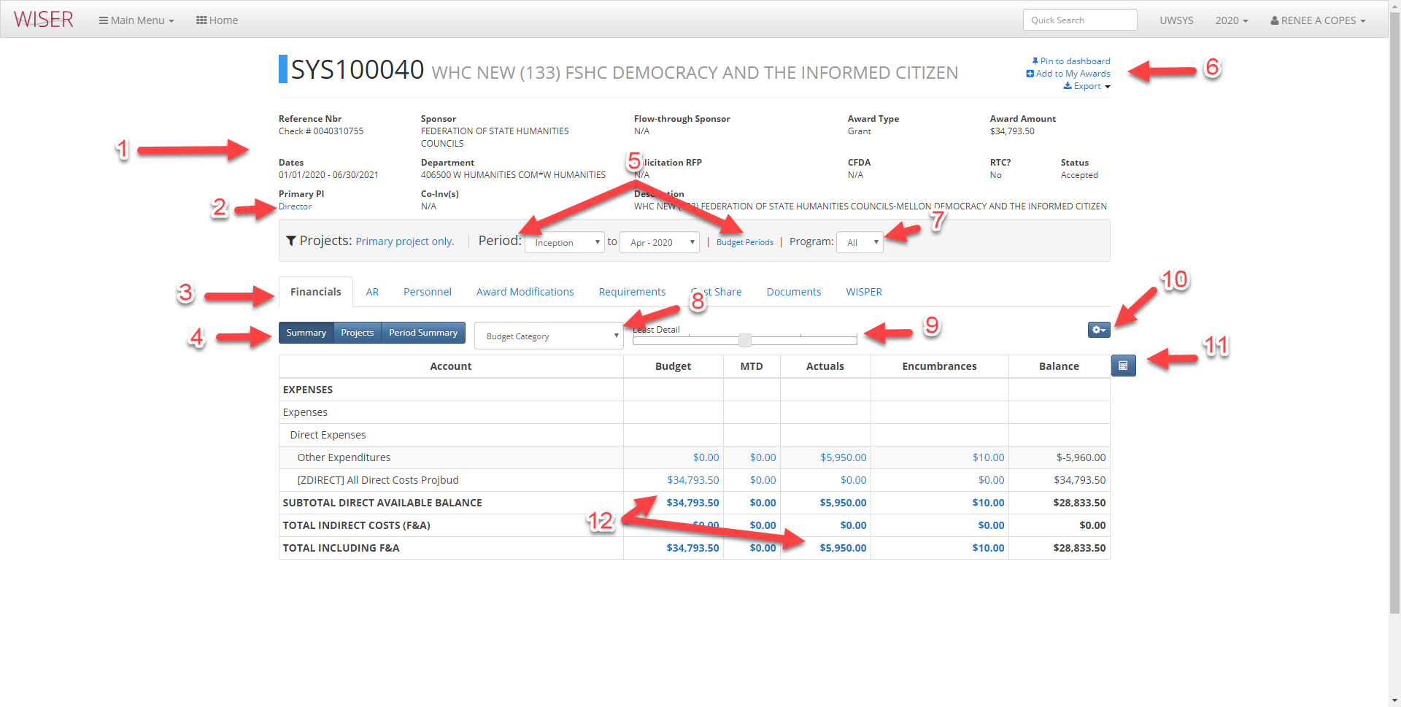
- Award Information
- Hyperlink to PI
- Tabs containing additional information
- Financials view options
- Toggle between Period or Budget Period timeframe
- Pin to Dashboard/create tile, add to My Awards, Export
- Program dropdown
- Balance Calculation Method selector
- Detail slider
- More options: Tree selector
- Toggle Cell Selection Mode
  - Selecting cells will give results of: Sum, Count, Avg
- Select to display Transaction Detail

