To begin an AR Search select the option from the Main Menu
Main Menu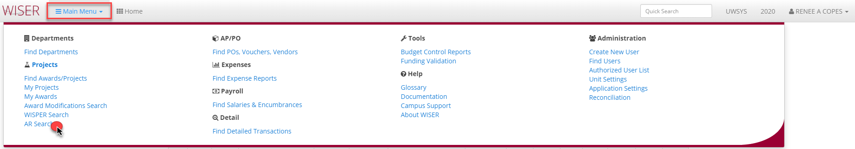

AR Search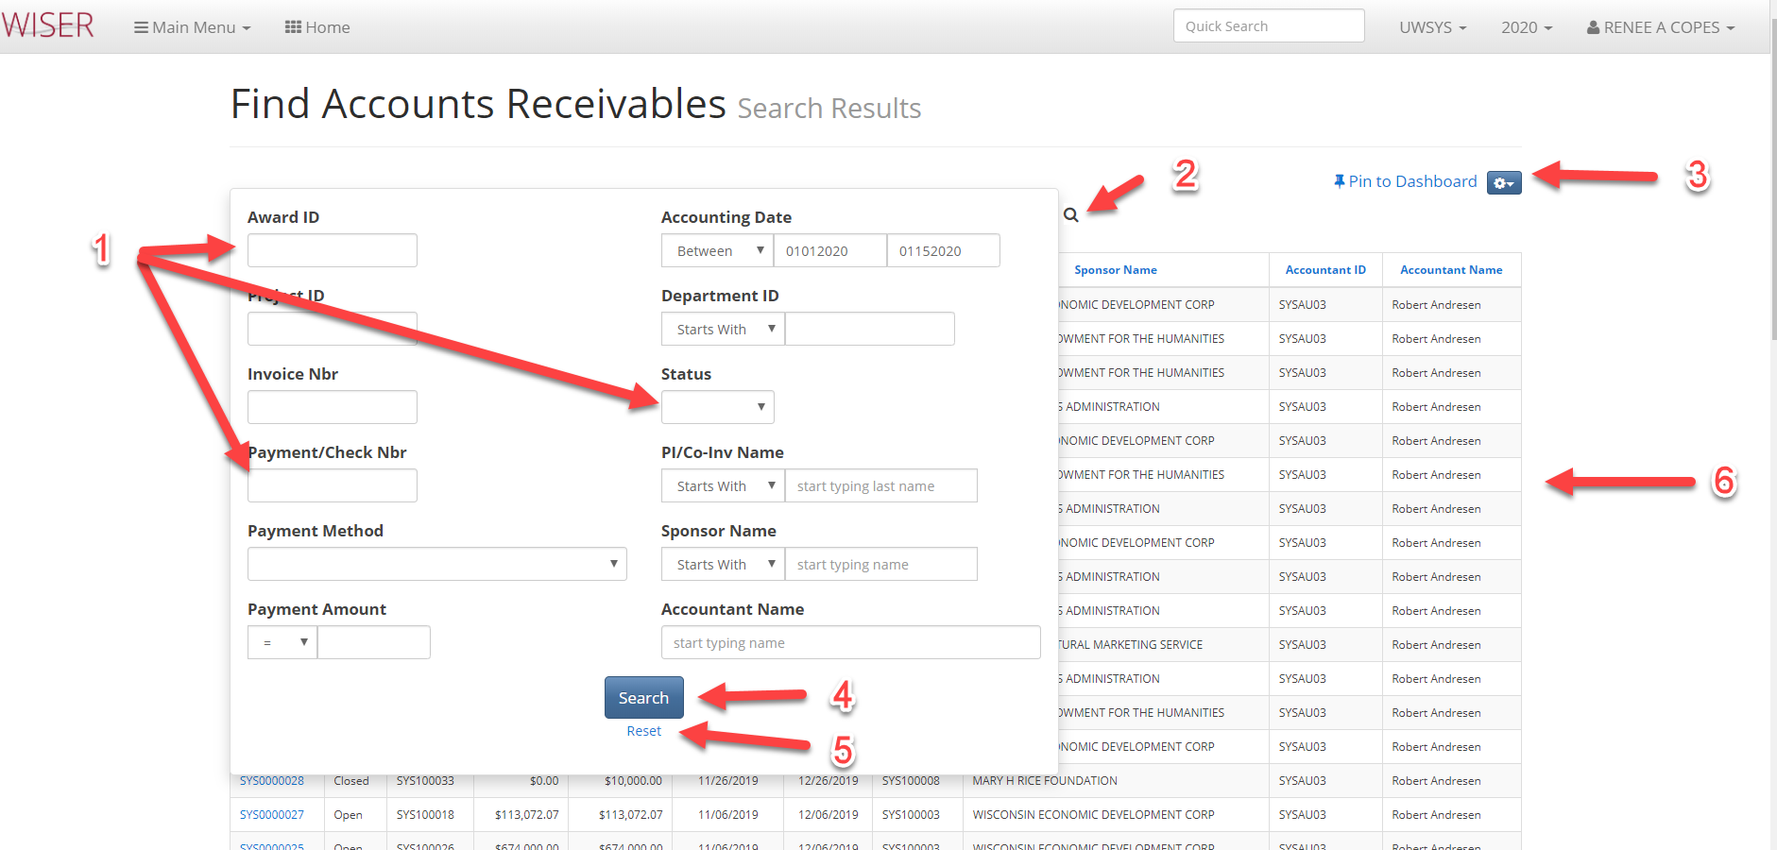
*shown with search screen over results
- Input criteria
  - The more criteria supplied, the narrower the search results
- Toggle between search screen & results
- Pin to dashboard (create tile)/export and view options
- Begin search using supplied criteria
- Clear entered criteria
- Search results using date range criteria

Search Results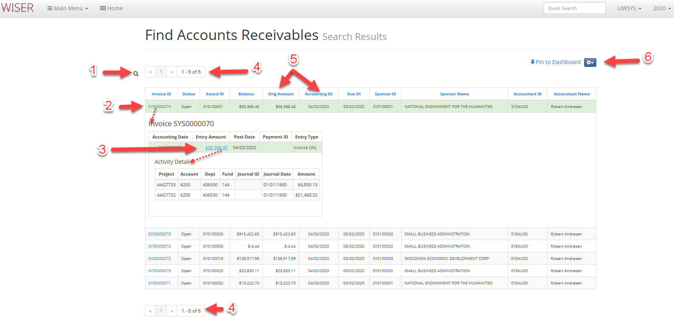
- Toggle back to search criteria screen
- Expand to Invoice details
- Expand Invoice activity details
- Page navigator
- Column headers to sort results
- Pin to Dahsboard/Export & records per page options

