How to Change Where Your Report Output is Directed in nVision

Updating the Directory Template in nVision Client Report Request
The directory template field allows nVision client users to save reports to a specified drive location or folder automatically when the report is run. With the advent of the Remote App connection to the nVision client, the filepath for existing reports may need to be updated so that reports are saved properly. 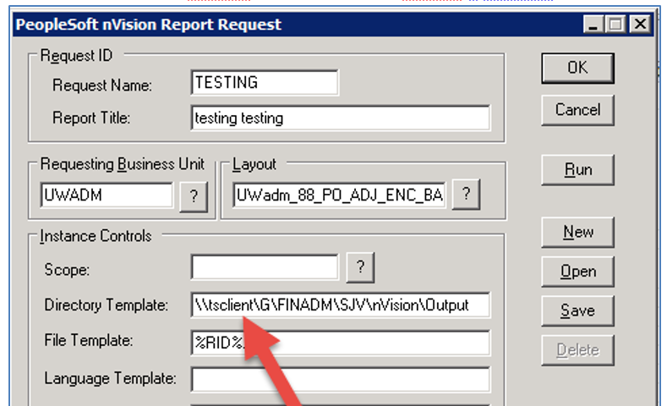

You may receive a similar error if you run a report with an old/invalid filepath:
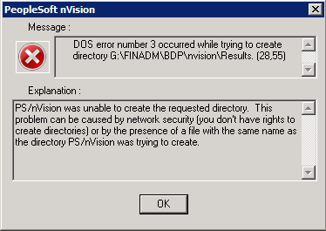

Step by step directions on how to update the report request:
- In the nVision client window, click “Open Layout”. 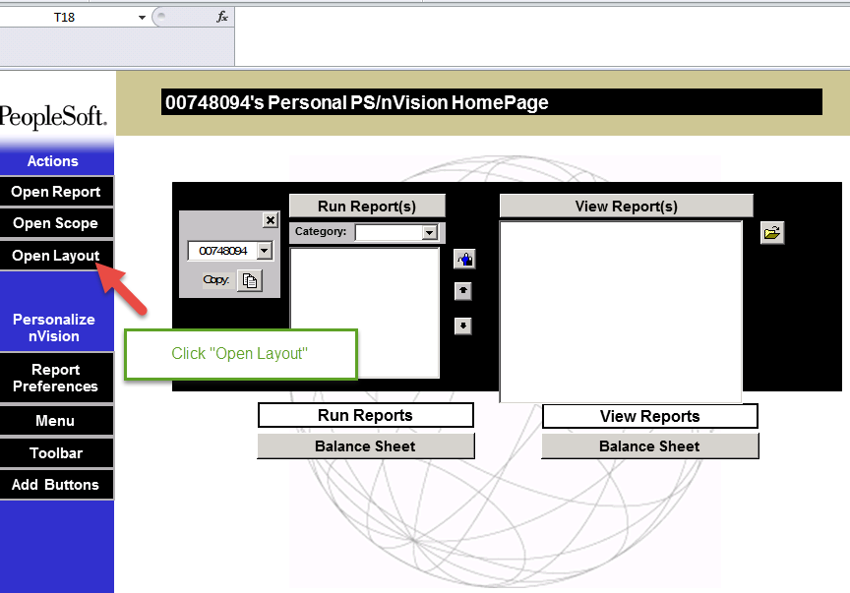
- Find the appropriate drive for your files.
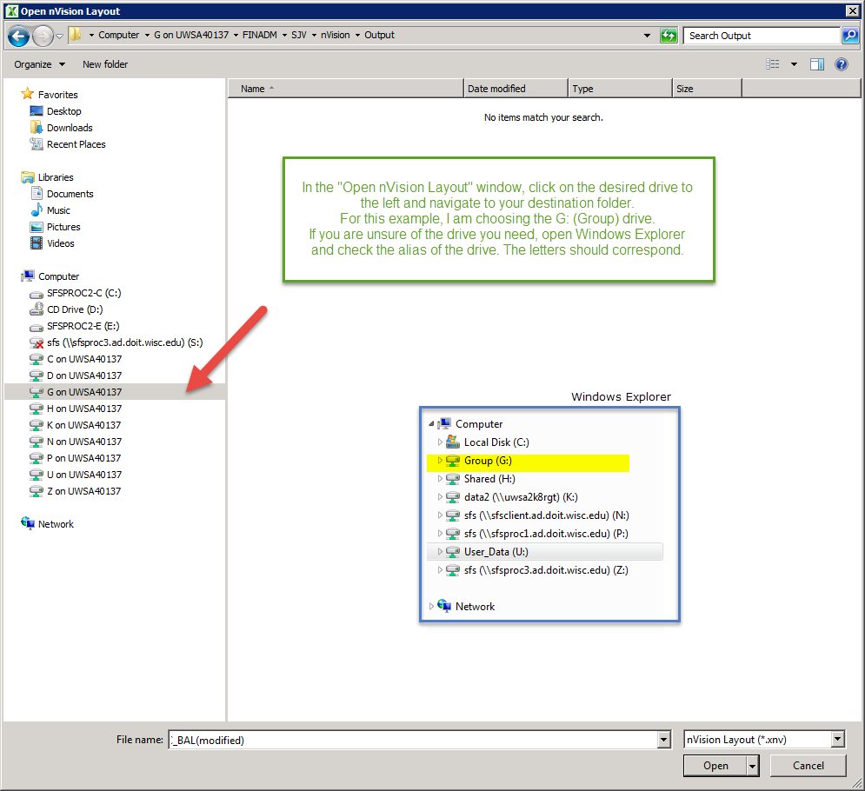

- Navigate to the location/folder in which you would like to store your report output. 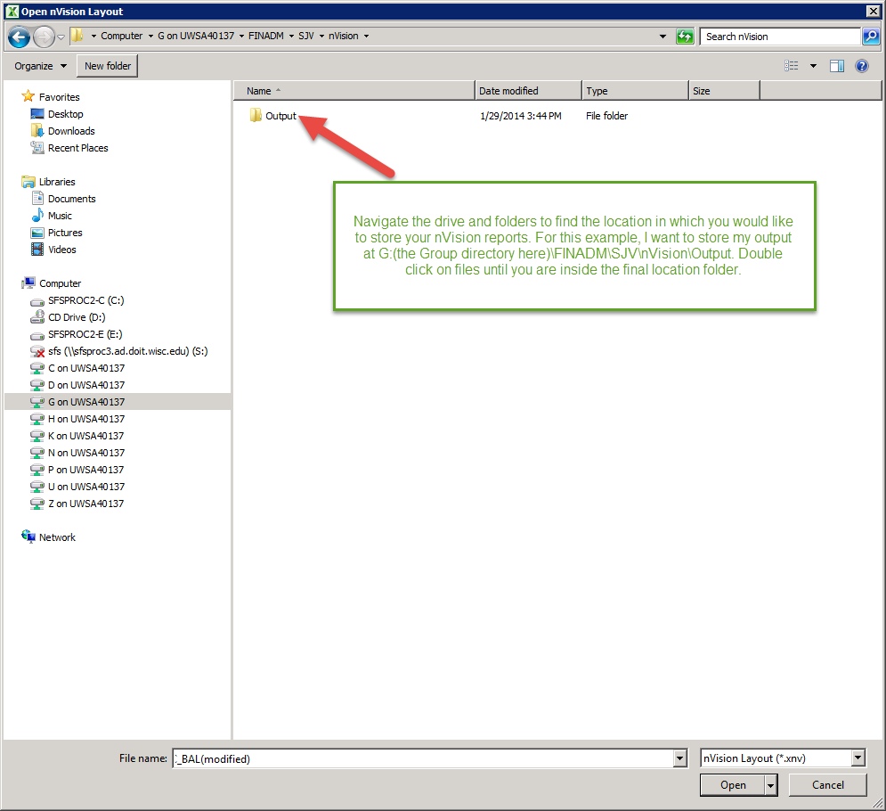

- In the address bar of the window, copy the address as text. 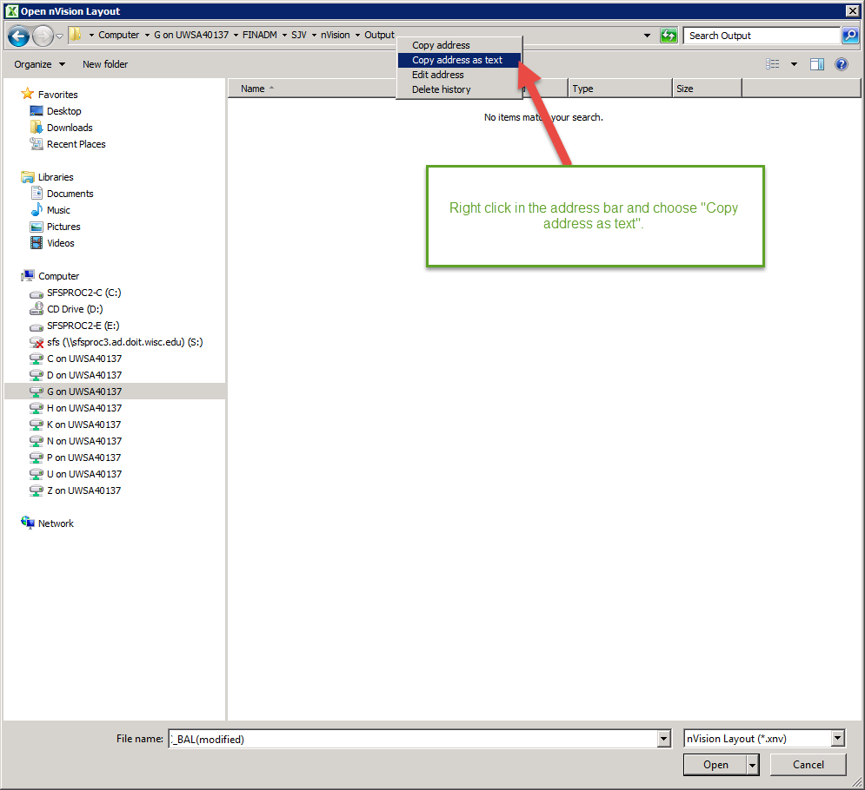

- Click “Cancel” to close the window.
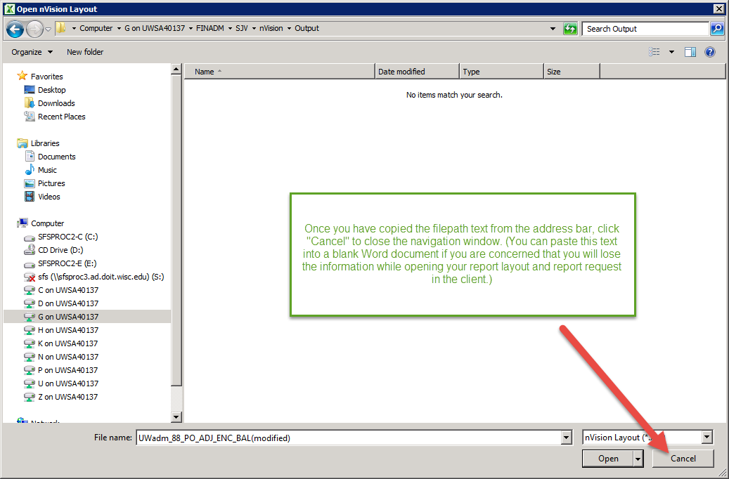

- Open the report request as you normally would. (You may need to open the layout first.)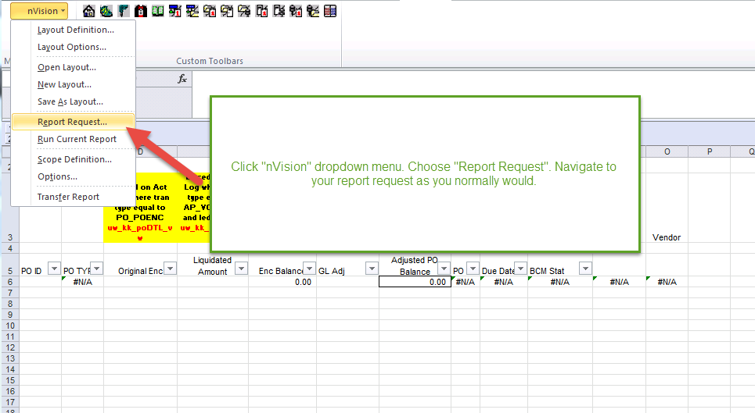

- Delete or overwrite any text in the “Directory Template” field of the nVision report request. Paste your new filepath in the field.
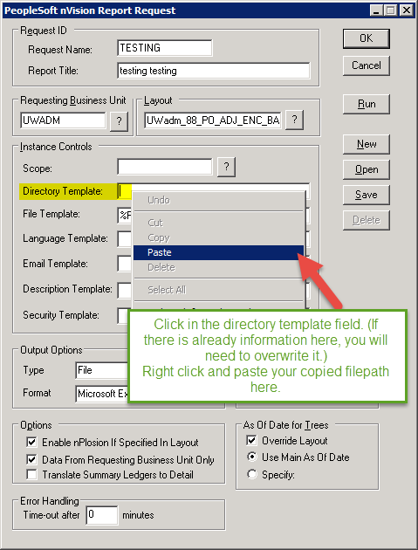

- You should see a new filepath that starts with ‘\\tsclient\.. ‘ instead of ‘G:\’, for example. 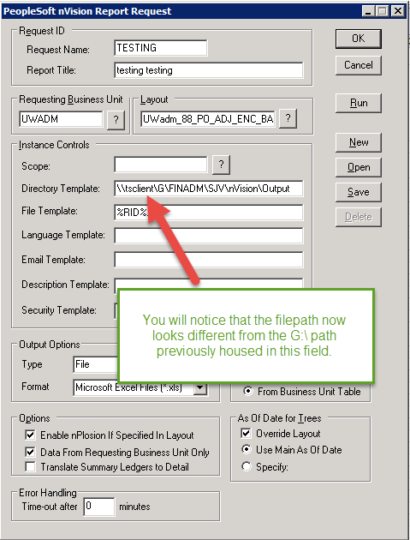

- Save your report request.

