How to Use the Receipt Split Function in the Expense Module

The Receipt Split function is used to:

• Indicate that a portion of an expense line is non-reimbursable (e.g. An employee imports a My Corporate Card expense for a meal from their wallet. The meal exceeds the maximum allowable by $10. The Receipt Split function is used to mark the $10 overage as non-reimbursable.)
• Divide a single expense line into multiple expense lines (e.g. A traveler has a lodging receipt that includes an internet fee and parking. The Traveler enters the total amount on one expense line and selects Lodging – Individual as the Expense Type. The Approver uses the Receipt Split function to divide the lodging expense line into three expense lines: Lodging – Individual, Internet Fee and Parking.)

The instructions below describe each process. Please note that the steps begin at the Details
page of the expense line you intend to split.

Note: Mileage expenses cannot be split.

How to Indicate that a Portion of an Expense Line is Non-Reimbursable

1) Click on the Receipt Split link located near the bottom of the page.
2) Perform the following actions on the Receipt Detail page that appears:

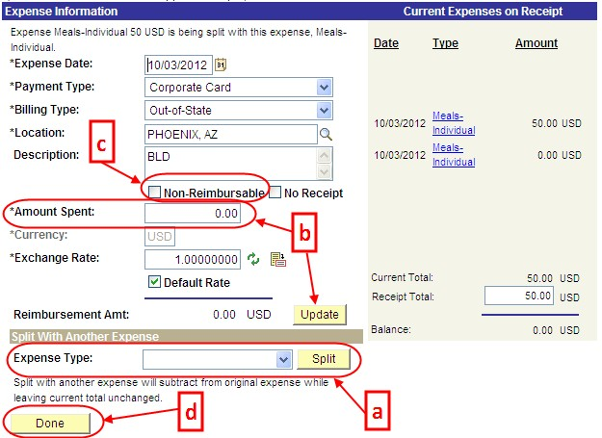

a. Click the Expense Type drop-down menu and select the appropriate expense type of the non-reimbursable portion of the expense line. In some cases, this might be the same expense type as the original expense line. Click the Split

button. A new zero-dollar expense line appears in the box to the right and the information on the left now pertains to this new expense line.
b. In the Amount Spent field, enter the non-reimbursable amount. Click the
Update button. The totals on the right will adjust.
c. Click the Non-Reimbursable checkbox. Update the Description field with details explaining why the expense line is non-reimbursable.
d. Click the Done button.
3) Click the Return to Expense Report link and note the new expense lines in the Expense
Line Items.

How to Divide a Single Expense Line into Multiple Expense Lines

1) Click on the Receipt Split link located near the bottom of the page.
2) Perform the following actions on the Receipt Detail page that appears:
a. Click the Expense Type drop-down menu and select the expense type of the new expense line that needs to be created. Click the Split button. A new zero-dollar expense line appears in the box to the right and the information on the left now pertains to this new expense line.
b. In the Amount Spent field, enter the amount of the new expense. Click the
Update button. The totals on the right will adjust.

c. Update the Description field as appropriate. d. Click the Done button.
3) Click the Return to Expense Report link and note the new
expense lines in the Expense Line Items.

Tip: You may split an expense line as many times as necessary. Complete steps a-c
for each additional required expense line.

