How to Sign in to the Expense Module

The Expense Module is a web-based system used to reimburse University of Wisconsin employees and non-employees for expenses incurred while traveling or conducting business for the university. To access the Expense Module, users must have a NetID and Password and be setup in HRS.

1) Log into http://sfs.doit.wisc.edu/support

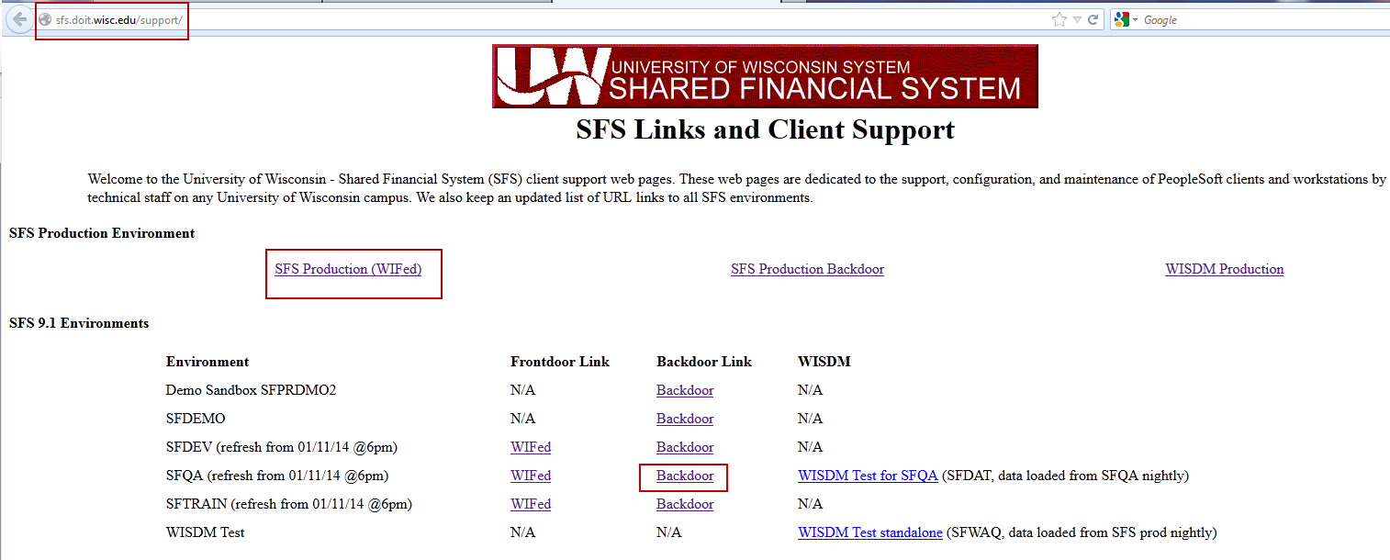

2) Click on the required environment. This will be SFQA for our testing purposes.
3) Enter your User ID and Password.

Note: When your work is done, be sure to click the Sign Out link in the upper right hand corner of the application and close the web browser.

