How to Reduce or Limit an Expense Reimbursement to a Fixed Budget Amount
University Policy 1200 - General Travel and Expense requires that University travel rates be uniformly and consistently applied for all who travel on University sponsored business, including non-employees and students.
Travelers, funding departments or institutions cannot limit or change individual expense reimbursement rates (i.e. M&IE per diem or mileage rates etc.) however due to budget limitations are able to reduce the overall University support (limiting overall travel expenses to a fixed budget) for a trip or related business activity.
Within E-Reimbursement there are two options to limit the overall expense reimbursement.
Note: Institutions may have a requirement on which option to use for this entry requirement. Consult with your institution’s travel office on any requirement for utilizing the options specified.
Option 1: Travel Reduction (Preferred)
- Utilizing this new expense type limits the overall expenses report reducing the reimbursement to a traveler’s budget limit
Option 2: Receipt Split Function
- Utilizing this function reduces an individual expense line making a portion of the expense non-reimbursable

How to use Travel Reduction Expense Type
A new Expense Type in E-Reimbursement has been created called: Travel Reduction
You cannot select the Payment Type of University Prepaid if the Expense Type is Travel Reduction. Also, the total amount for the overall report cannot be negative.
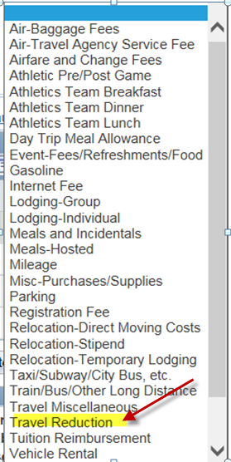
Once you enter a negative amount and submit the expense report or check for errors, a page called Credit Information will be displayed. A short description (60 characters or less) is required to be entered. Click OK.
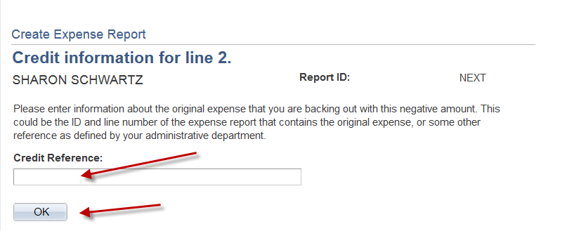

The screen/image shown below will be displayed when a negative amount is entered for an expense line. The message is to notify and confirm that the traveler acknowledges that their reimbursement will be reduced. After you have read, click Return.
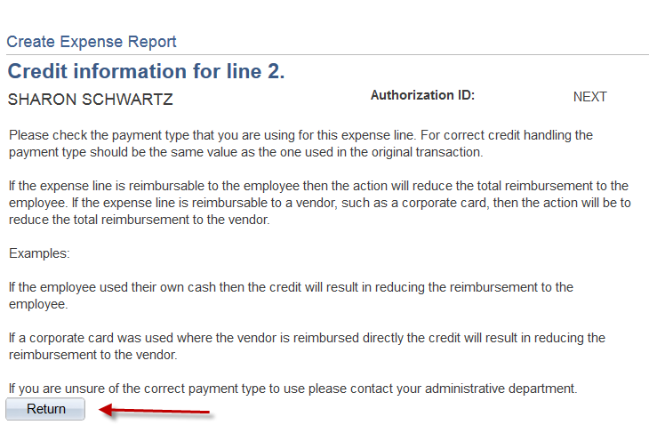

Description box is required to be completed for the Travel Reduction expense type.
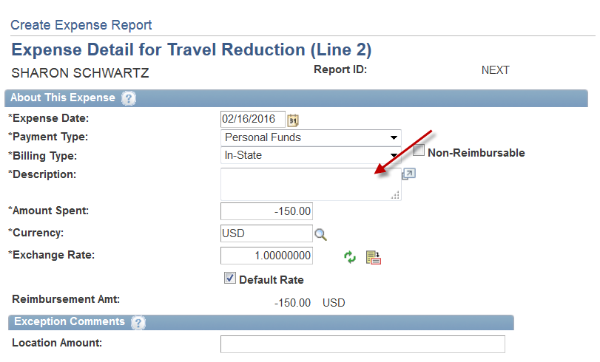
In the event that the traveler receives additional funding for the trip at a later date and the original expenses were filed within the required timeframe, additional reimbursement may be claimed by completing the following:
Reference the original Expense Report ID Number in the Expense/travel justification and supporting details box and submit a positive expense line amount with the Expense Type of Travel Reduction.
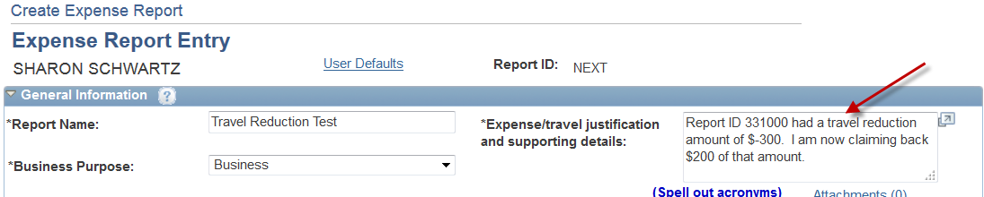

How to Use the Receipt Split Function in the Expense Module

Note: The expense type Mileage cannot be split for these purposes.

- Click on the Receipt Split link located near the bottom of the page. 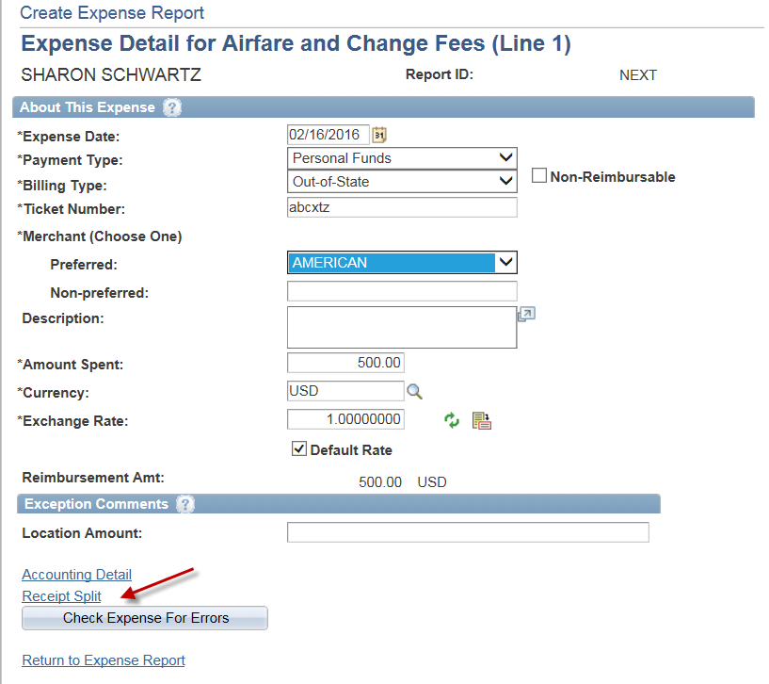
- Perform the following actions on the Receipt Detail page that appears:

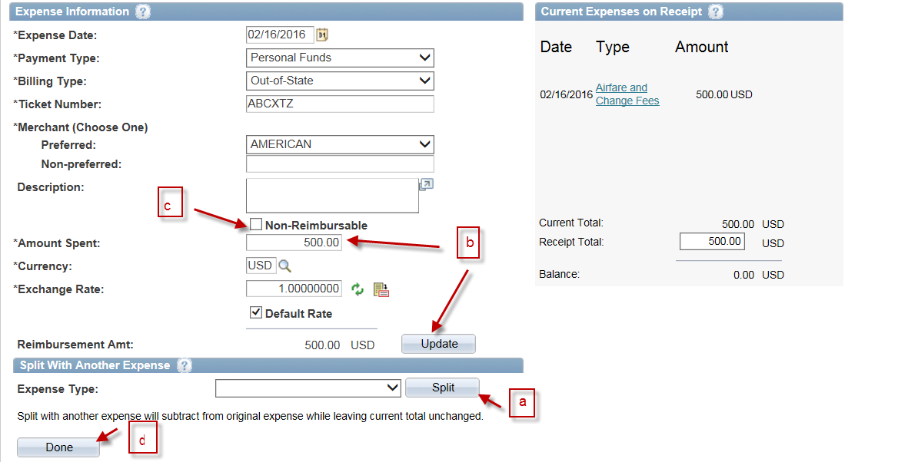Click the Expense Type drop-down menu and select the appropriate expense type of the non-reimbursable portion of the expense line. In some cases, this might be the same expense type as the original expense line. Click the Split
button. A new zero-dollar expense line appears in the box to the right and the information on the left now pertains to this new expense line.
b. In the Amount Spent field, enter the non-reimbursable amount. Click the
Update button. The totals on the right will adjust.
c. Click the Non-Reimbursable checkbox. Update the Description field with details explaining why the expense line is non-reimbursable.
d. Click the Done button.

- Click the Return to Expense Report link and note the new expense lines in the Expense
Line Items.

