How to Choose the Per Diem Deductions
Once you choose Meals and Incidentals as an Expense Type go to the Detail link
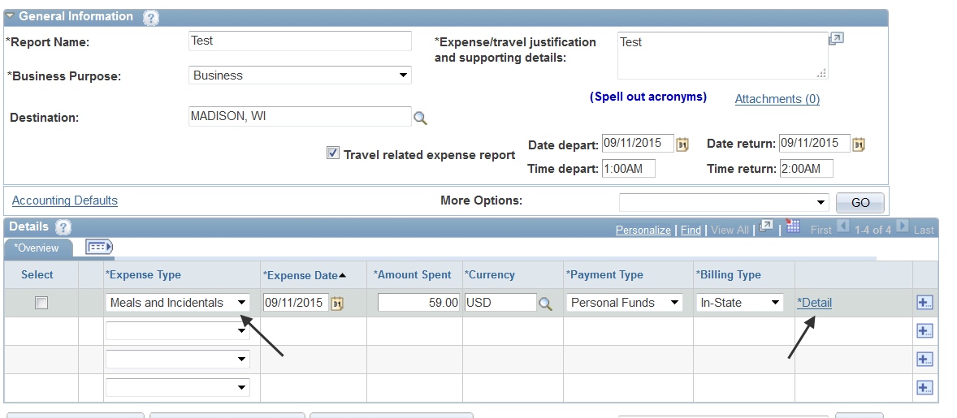
Once in the detail screen choose the Per Diem Deductions link
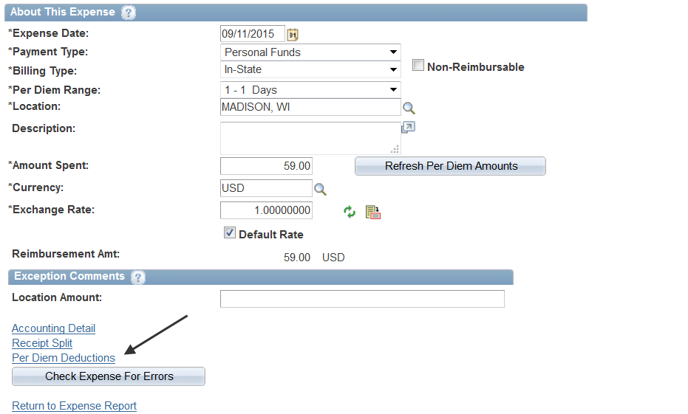
Choose the First/Last Day of Trip percentage if appropriate. This is actually a 25% reduction because you get 75% of the total per diem amount for the First and Last Day of trip. Also choose if any meals were sponsored for the appropriate deduction.
