How to Change Default Funding (Traveler Role)

Travelers can change their Default Funding in their Expense Module profile, which can significantly minimize expense entry time as this will be the new default funding in every Expense Report/Travel Authorization. Funding can still be changed on an individual report if required.

Below are the steps outlining this process.

- Sign into the Expense Module. Click on Travel and Expenses in the main menu on the left.
- Click on UW Travel and Expenses then My Default Profile

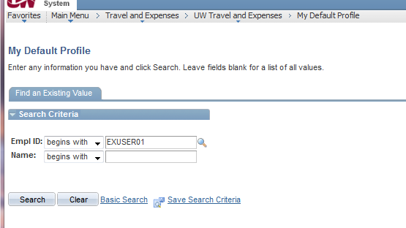
- Click View All in the upper right corner
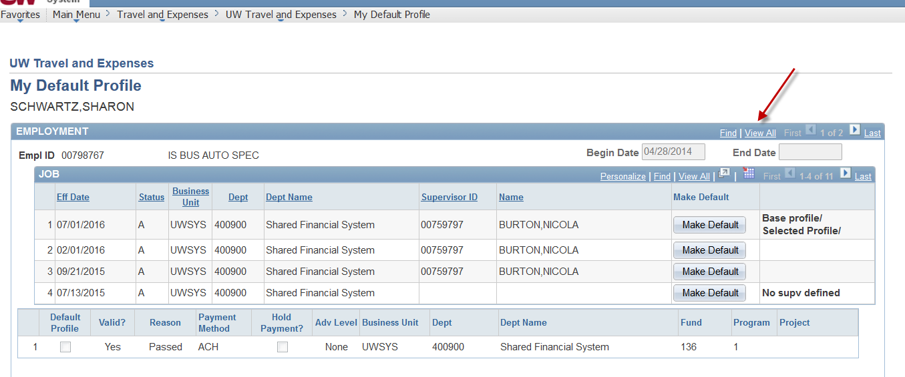
- Scroll down to the Default Travel Profile
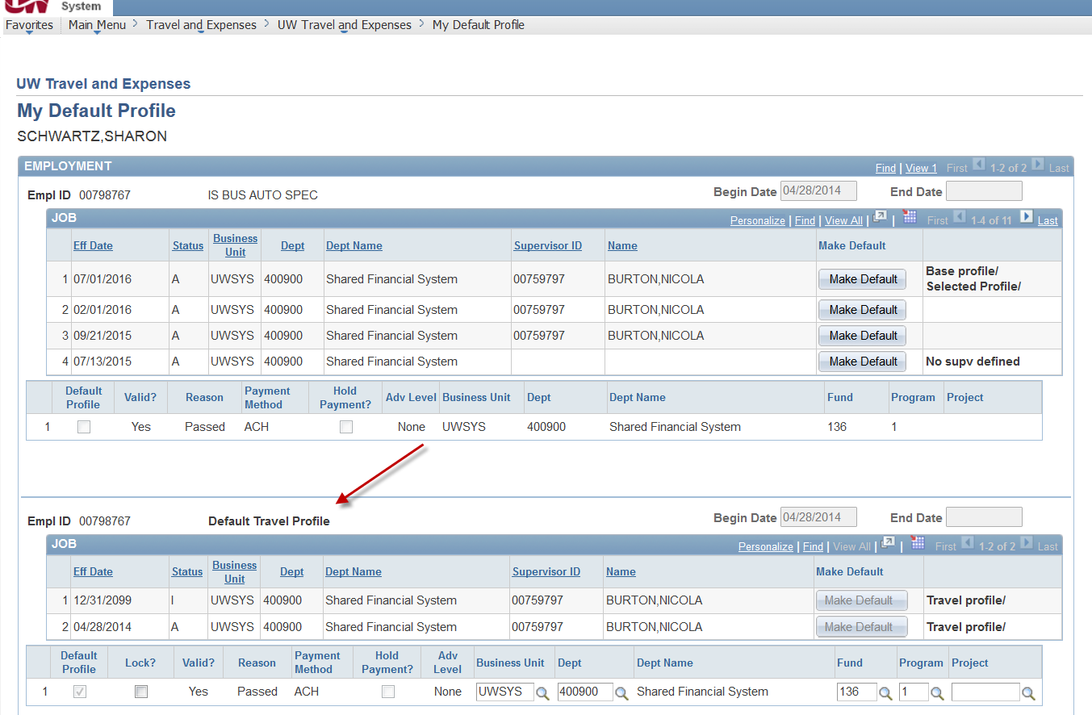
- Select the “Lock?” box and change to the funding you want to Lock Down.
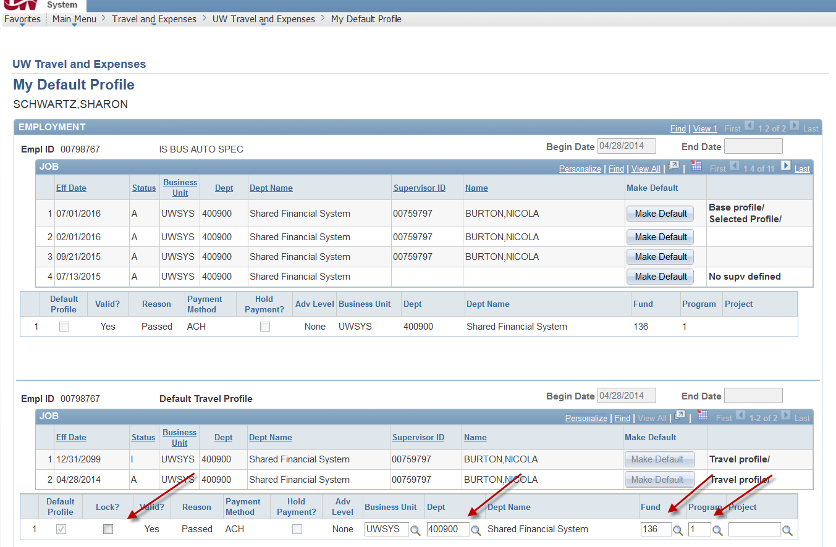
- Click Save

