How to Assign an Alternate in the Expense Module

Alternates are individuals assigned to employee or non-employee profiles to enter expenses in the Expense Module. Alternates working on behalf of non-employees can enter and submit reports for approval; however, employees must submit their own reports. Prior to entry, alternates must be assigned.

For non-employee profiles: Consult with your Expense Module Administrator.

For employee profiles: The following actions must be taken by the employee/traveler.

1) Sign into Expense Module (See How to Sign into the Expense Module). Click on Assign an
Alternate in the Expense Module - Expenses box.
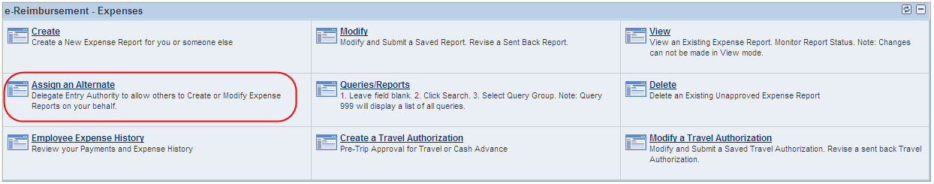
2) Click on the plus sign to add an additional row.
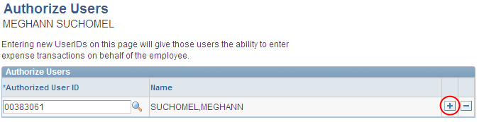
3) Enter the alternate’s Employee ID number in the Authorized User ID field. Click save.
Note: If you do not know the Employee ID, click on the magnifying glass next to the blank field. Change the “Search by” drop down to
“Description and enter the alternate’s last name. Click “Look Up”. Locate the alternate and click on their name. Click Save.
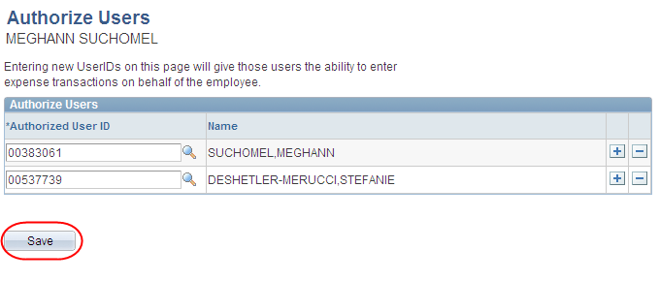
Note: To remove an alternate, click the minus sign next to his/her name, click OK and click Save.

