TER Payment Verification Process
Below is an nVision report that is run by UW System (Allen Hesselbacher) and other campuses to validate after you run expense processing, pay cycle and journal generate. Run this report to compare with the Trial Register to ensure that you can trace between the TER payments generated in the paycycle process and the approved TERs that generated journals during the expense processing.
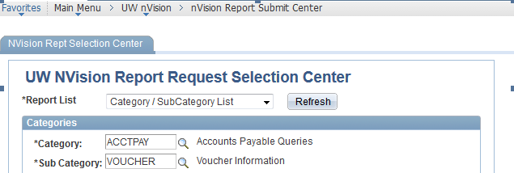
The report is third from the bottom, called ‘EXP_ADTR’. When you click on it, you will be asked for the business unit, journal date greater than, and auditor ID. We leave the auditor ID as %, we have one person who is supposed to handle auditing all TERs but that way we know we’ll catch all. We always enter yesterday’s date in the journal date greater than field.

