TER’s or TA’s Stuck at T00000 procedure:
Periodically (Daily, Weekly etc.) you need to watch for any TER’s or TA’s that could be stuck at T00000 and determine if you need to reassign them to another approver.
Here are the steps:
- Go to Main Screen and click on Reassign My Workflow 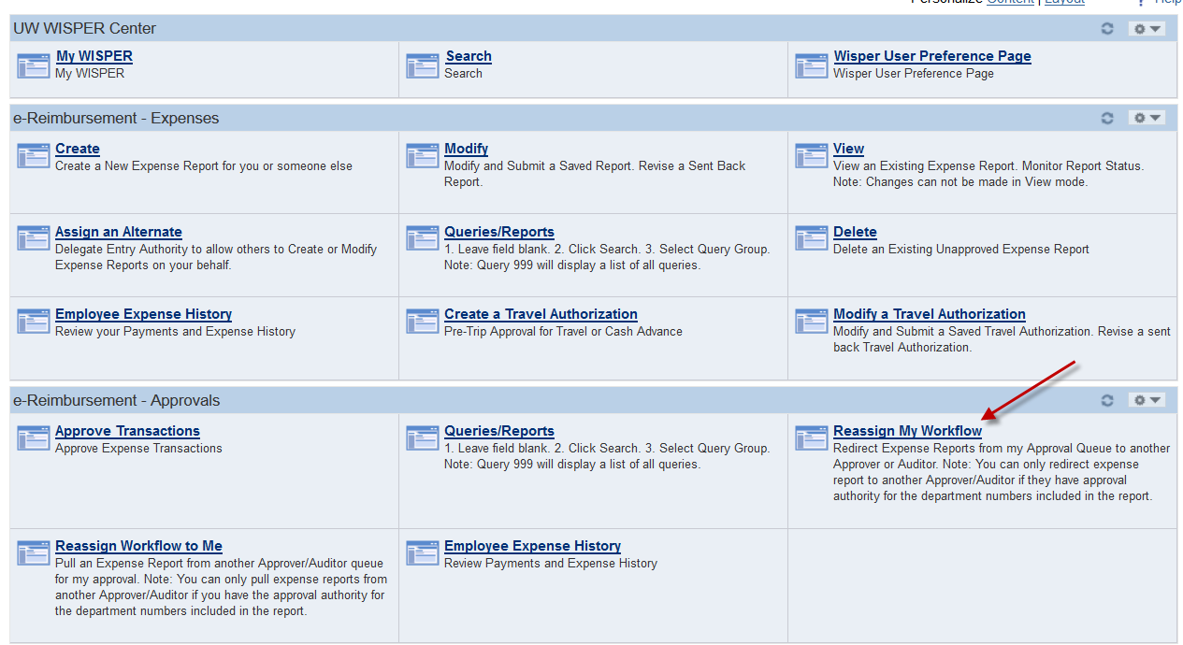
- Change the Emplid from your Emplid to T00000. 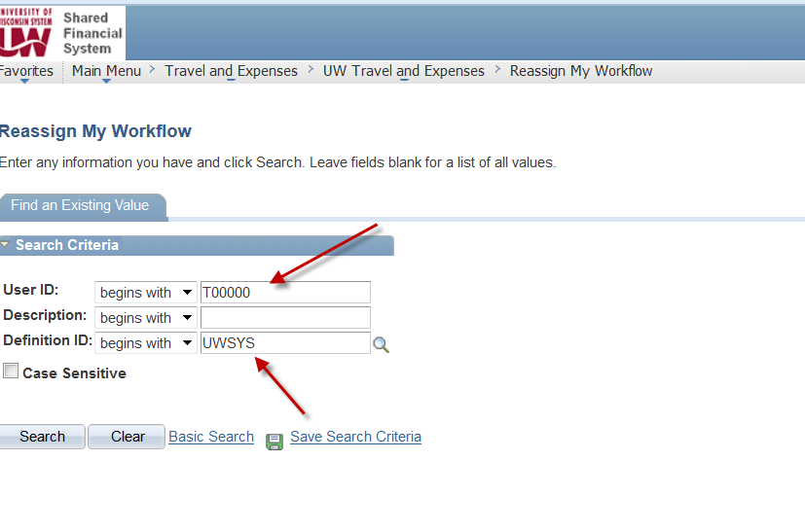
- If you hit search and it says “No Matching Values Were Found” you are finished. That means there are no stuck T00000 items for your campus.
- If when you hit search the following screen shows up, that means you have items stuck for your campus. 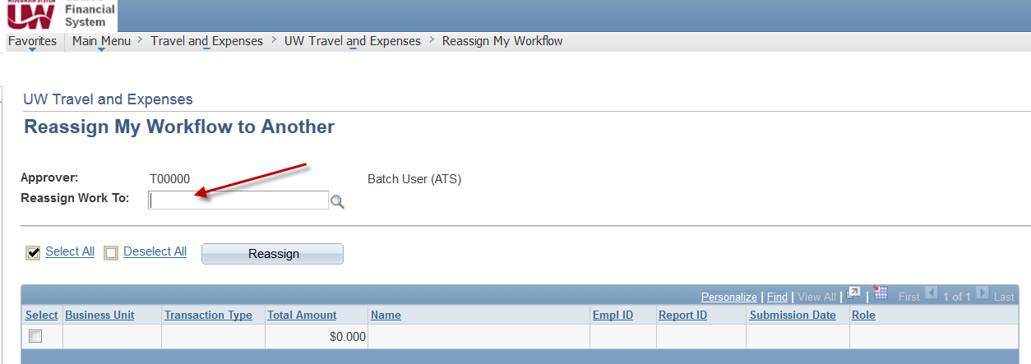
- In order to see what is stuck, you must be in an Emplid of any Approver in the Reassign Work To box to display the stuck items. 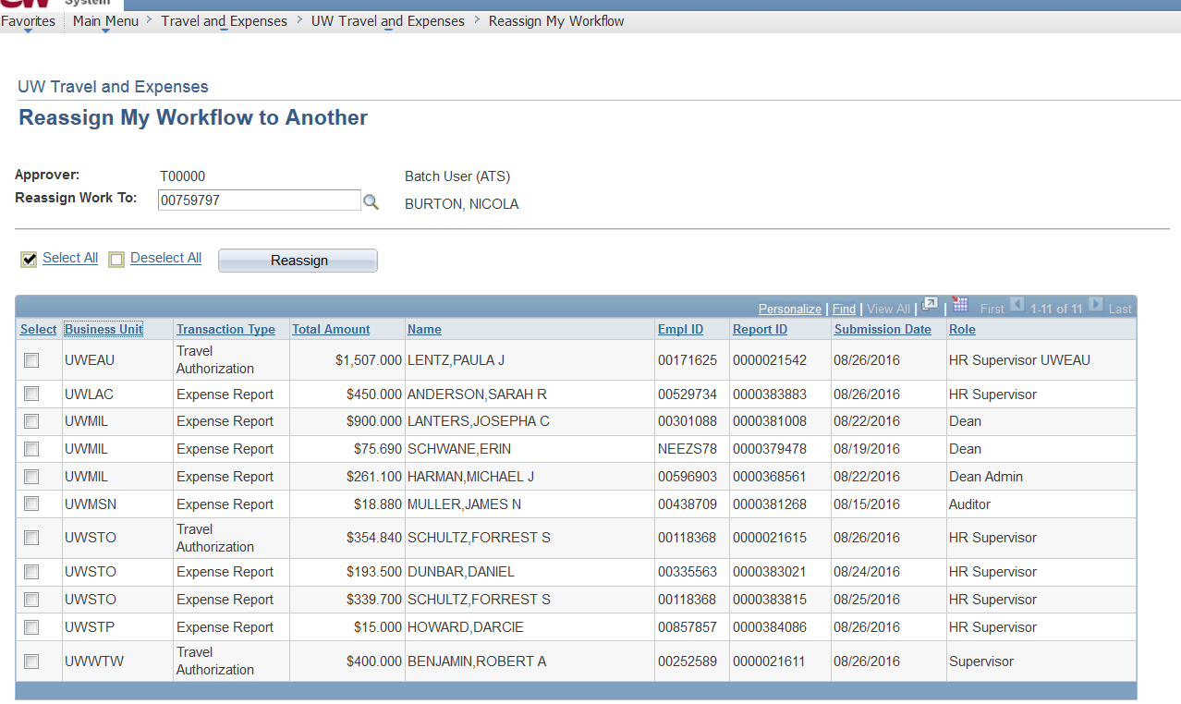
- It may show the list for all campuses. Click on Business Unit heading and it will sort by Business Unit.
- Anything in this list for your campus needs to be looked at. You will need to determine if it is only stuck with T00000 emplid. Any that say HR Supervisor or Supervisor in the last column (Role), those need to be reassign because you can only have one HR Supervisor assigned. You will also need to work with your HRS department to see if the Reports To Field is filled in on the most recent job. For any that don’t say HR Supervisor or Supervisor, you will want to see if it is also Pending with another approver. Best way is thru Information Central and look at the details of the TER or TA (group 25 or 27). If only with T00000 then you need to reassign to another approver. If with other approvers, you do not need to reassign.
- To reassign, find the emplid of the approver to assign to and put it in the Reassign Work To box. Validate it is the correct name of the approver and click the select box of the TER or TA that you want reassigned and click Reassign.

