How to allow cash advances for certain travelers:
If you want a traveler to be able to request a cash advance when they submit a travel authorization you must go into their Update Profile screen and set the cash advance level at the bottom on. You need to do this for each record on this screen. Example: You may have a record 0 and record 600. You can specify an amount or if you choose Business Unit the maximum amount is $100,000.00
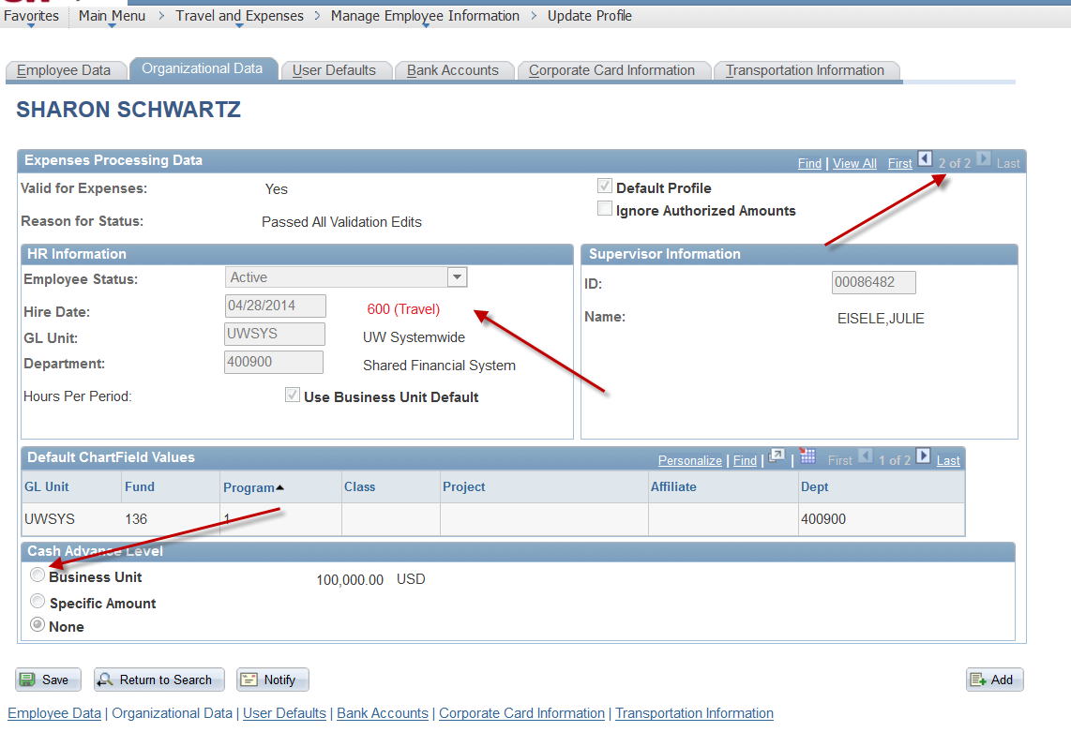
NOTE: IN ORDER TO RECEIVE THE PROMPT ASKING IF YOU WANT A CASH ADVANCE WHEN SUBMITTING THE TA, THE TA CANNOT BE ALL UNIVERSITY PREPAID AS THE PAYMENT TYPE.

