How to set-up Expense Templates in SFS:
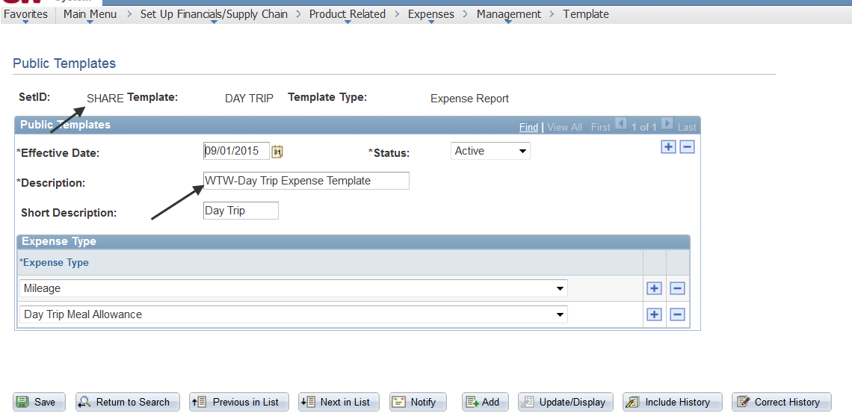
Create a template for a Travel Authorization:
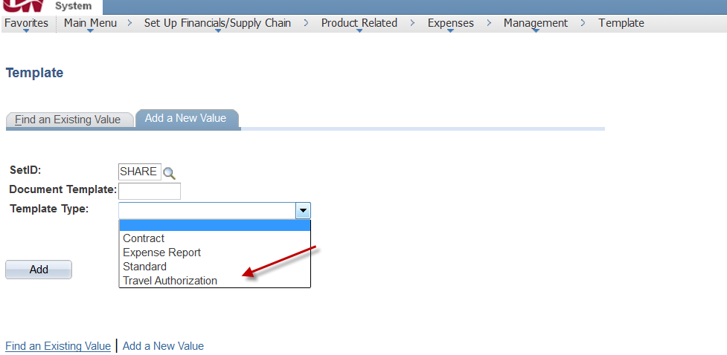
When you create a new Travel Authorization select A Template from the Quick Start and click Go:
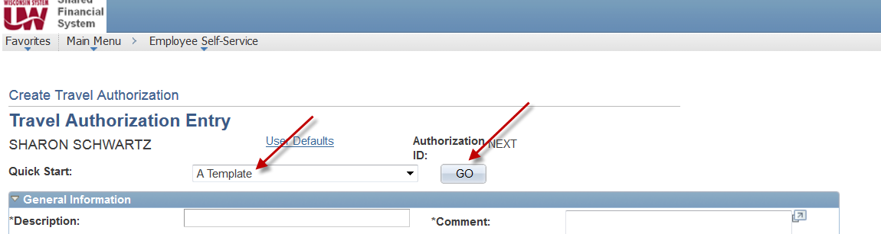
It brings up a list of available templates:
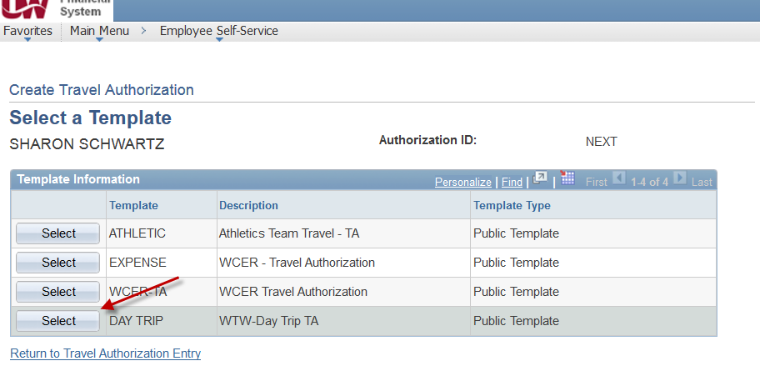
When you choose select a screen is displayed that you can decide which expense types you want to populate for which days on this TA.
