**How to assign an Alternate for someone else**

As a central processing person you may want to make yourself an alternate so you can look at an Expense Report or Travel Authorization that was saved but not submitted yet.

Here are the steps for doing that:

Go to Travel and Expenses/Manager Expenses Security/Authorize Expense Users.  Put in the traveler’s Emplid hit Search.

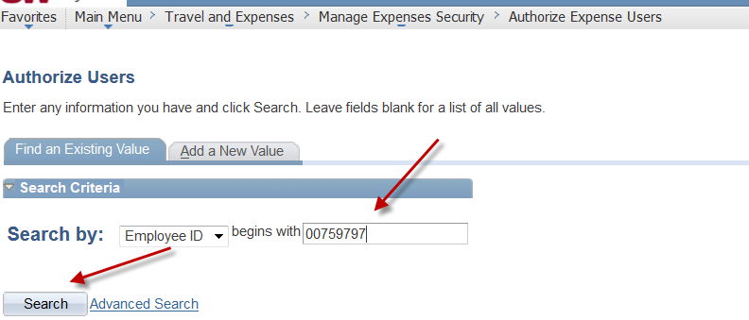

Hit the plus sign and put in your Emplid and hit Save

