How to Setup a Non-Employee Profile in e-Reimbursement
- Sign in to SFS:
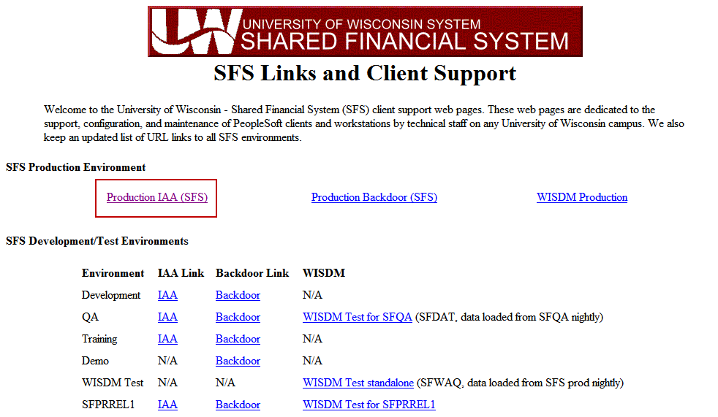

- Navigate to: Travel and Expenses > Manage Employee Information > Update Profile
Note: Save this as a “Favorite” (My Favorites > Add to Favorites).
- Determine what the new non-employee ID number will be by changing the “Search By” drop-down box to Employee ID. Enter “NE” plus the individual’s initials (First Middle Last). If no middle initial is provided on the form, we use the letter “Z”. Click search. A list of all non-employee IDs that start with the five letters entered displays. Choose the next 3-digit number in the list, making a new 8-digit non-employee ID number. Write this number down.
**NOTE: If the non-employee is actually an employee from another campus, please create the profile as NE followed by the last 6 digits of their Emplid number.
Example: In the example below, the next available non-employee ID would be NEMLS006.
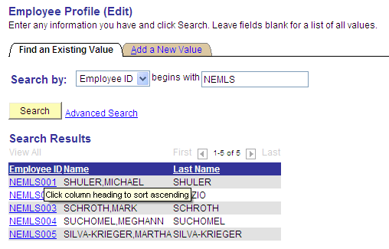
- Click on the “Add a New Value” tab. Enter the new number you just wrote down. Click “Add.”
- Complete the following fields.
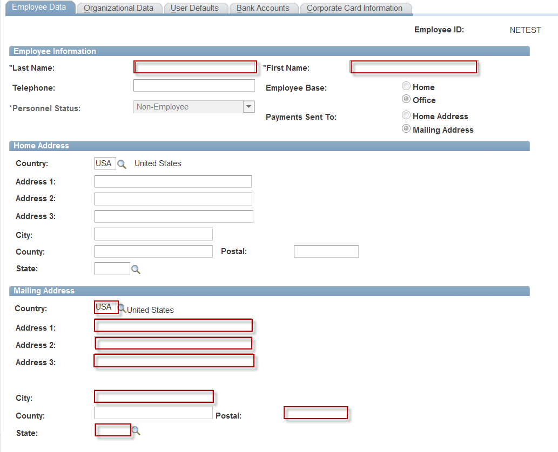
- Select the “Organizational Data” tab and complete the following:
  - Employee Status: Always select “Active”
  - Hire Date: Date of First Travel Expense (Indicated on setup form)
  - GL Unit: UWXXX
  - Department
Note: After entering the Department, hit “Enter.” This causes the GL Unit and Dept fields in the Default ChartField Values boxes to populate.
  - Fund/Program/Project
  - Fill in either the Supervisor ID or Designated Approver. If you do not use HR Supervisor for approval of non-employee expense reports please put in T00000 as the Supervisor ID.

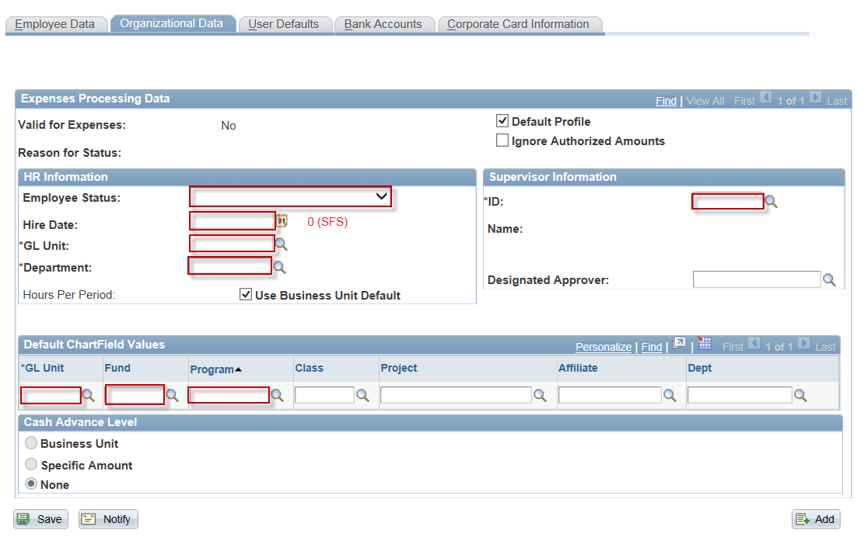

- Select the “User Defaults” tab and complete the following:
  - Entry Method: Occasional User
  - Payment Type: PER
  - Billing Type: Determined by individual’s address (e.g. If the address is in the state of Wisconsin, select “In-State.
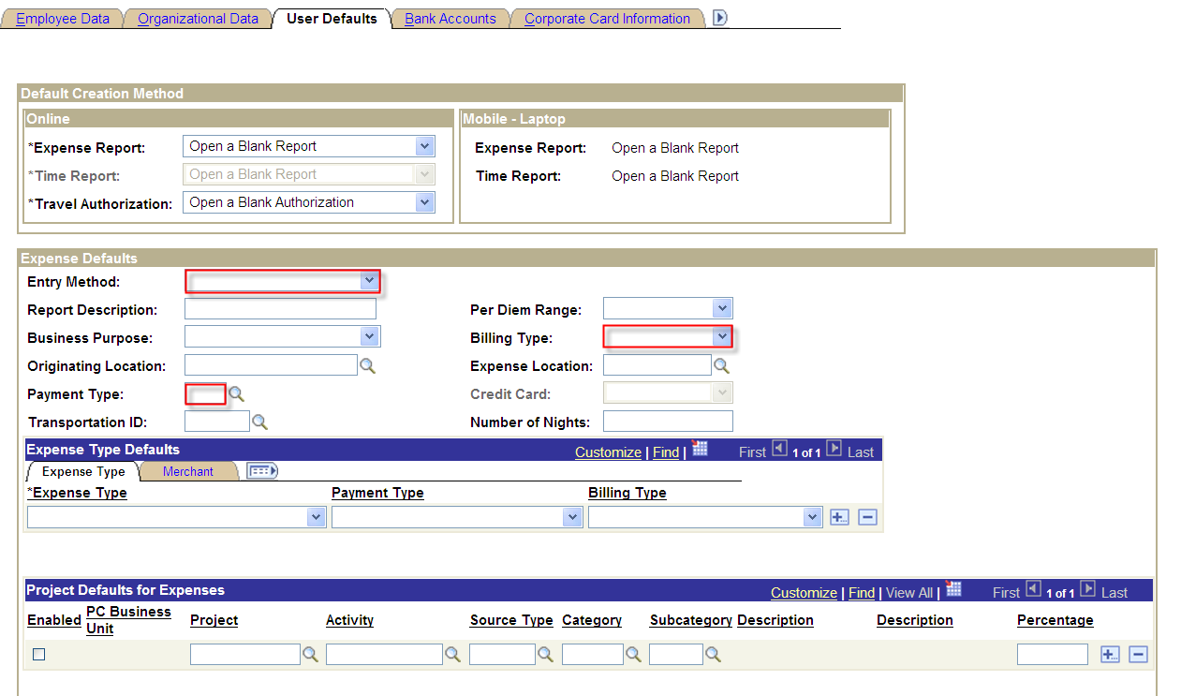
- Skip the Bank Accounts and Corporate Card Information tabs (since these are non-employees, they are not eligible for Corporate Cards and will not have banking information since they are paid via check).
- Hit the Save button at the bottom.
- Navigate to: Travel and Expenses > T and E Administration Center > Profiles and Preferences > Delegate Entry Authority (add this page to your favorites as well)
- Enter the new non-employee ID number. Click “Search.”
- Enter the UW Person Emplid of the alternate (person that is going to submit the expense report on behalf of the non-employee), hit enter and verify that the alternate’s name matches the form. If there is more than one alternate listed, click the “+” at the end of the row to create another line.
- Click “Save” and then “OK”.
IF THE ALTERNATE NEEDS TO PUT IN THE EXPENSE REPORT TODAY DO THE FOLLOWING STEPS, ELSE THEY WILL AUTOMATICALLY HAPPEN OVERNIGHT AND YOU CAN SKIP THE REST OF THESE STEPS.
- Navigate to: Travel and Expenses > Manage Employee Information > Update Profile
- Find the new Non Employee Emplid you just created. Now there should be a Transportation Information tab at the top.
- Select the “Transportation Information” tab and complete the following:
- If your campus uses TurnDown Rate you may also need to add that row if this non-employee would need to claim that rate or the Motorcycle rate.
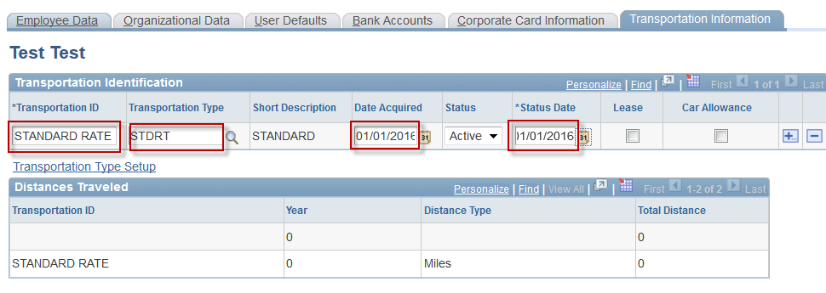

- Click “Save.”
- Select the “Organizational Data” tab and click the “Validate” button. When the system finishes processing, you will be taken to the “Employee Data” tab.
- Close the setup form document.

