How Traveler Can See Where Their Expense Report (TER) Is or TA and CA
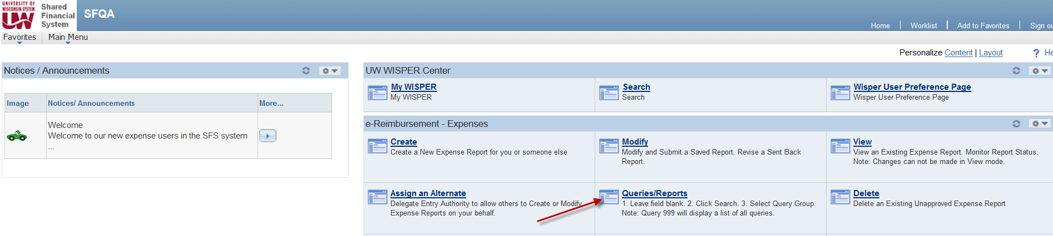
Choose 1 for Travel Authorizations and Cash Advances, 10 for Expense Reports and 20 as an alternate:
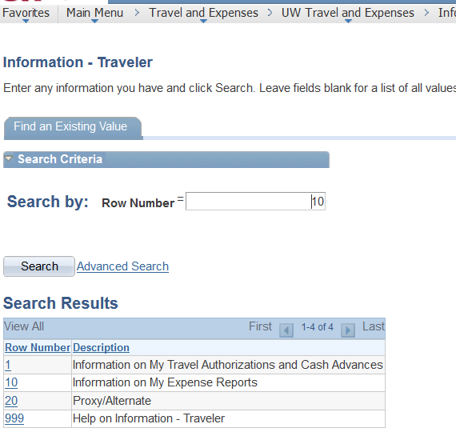
Once you choose from above, choose 1 Where are my ER’s (TA, CA etc)
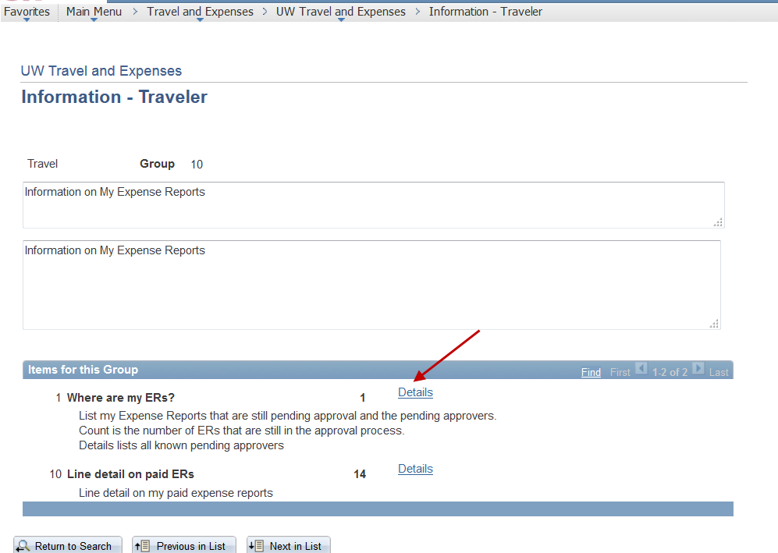
The screen below is displayed and you can see which approver your report is waiting for.
