Cancel a Payment and/or Reissue

Cancelling and reissuing a payment is very sensitive to other expense processing and should be run separately.

If you are voiding an ACH payment without reissue, please get reimbursement from the traveler first before going thru the steps below to Void the payment and not reissue.

- Identify the payment reference/check number.

- Navigate to Travel and Expenses > Process Expenses>Review Payments>Payment History.
- Enter Empl ID and SetID.
- Click and a list will be returned which includes the Payment Reference
- Write down payment reference number to be used in the next step

***NOTE: If there was a Corporate Card (Due Vendor) payment, please contact uwsaproblemsolvers@maillist.uwsa.edu for help with finding the payment reference number.

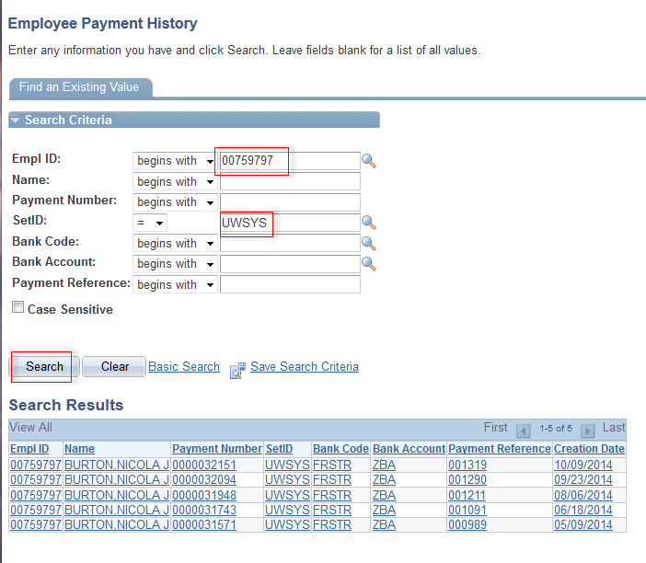

- Cancel/Void the Payment.

- Navigate to Accounts Payable>Payments>Cancel/Void Payments>Payment Cancellation
- Enter the required criteria. Criteria being the Bank SETID, Bank Code, Bank Account and Payment Reference (from the search above). Click After October 1st, 2017 there are more than one Bank Code so please look at Employee Payment History screen above to determine which Bank Code you need to search on.

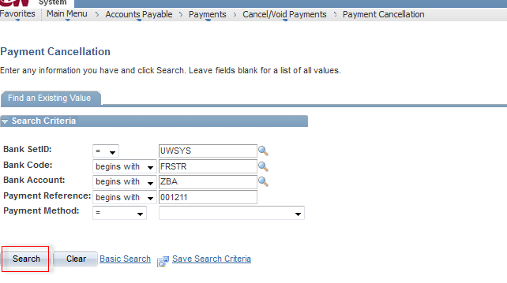

- Select the required action to Void /Reissue, or Void Do not Reissue/Close Liability, click Save ***NOTE***. If you are changing it from an ACH to Check or Check to ACH you must Void and Do Not Reissue and have the traveler submit a new report.
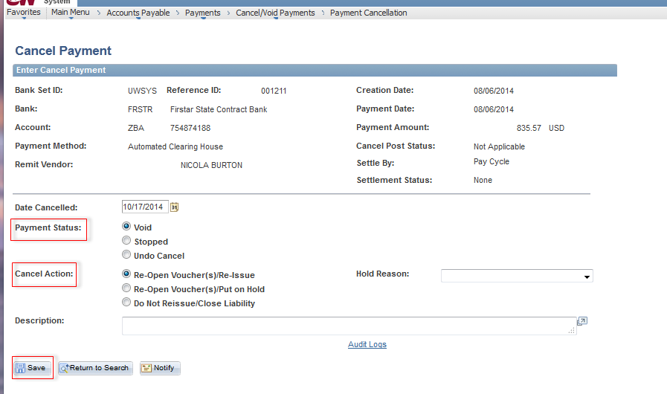

- Click OK on warning message.
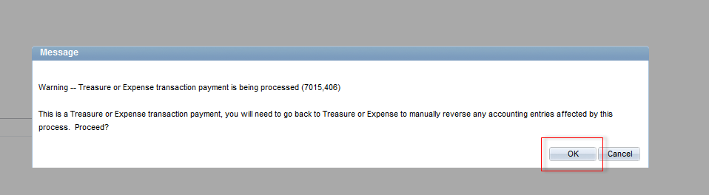

- Navigate to Travel and Expense>Process Expenses>Expense Processing
- Enter a run control. Select the Checkbox associated with "Cancel Payment" and run the process.

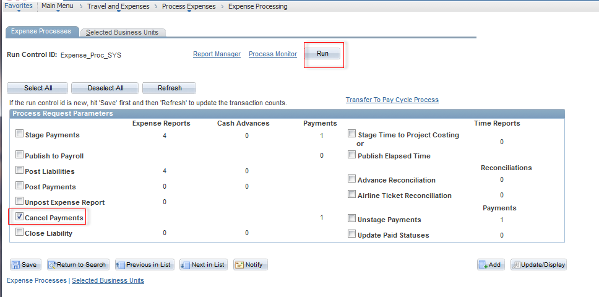

- Depending on whether one elected Void / Do not reissue or Void/Reissue determines the next step.
- If "Do Not Reissue", the application engine process will automatically invoke the Close Liability process as well.
- If “Reissue” then re-run the Accounts Payable pay cycle if it was already run for that day to reissue the payment. Pay cycle needs to be run before any further Expense processing is run which normally happens overnight. (Do not run Post Liabilities and Stage Payments)

