How To View Expense Module Payment Information (Approval Roles)

Individuals assigned to approval roles in the Expense Module have the capability to view payment information for employee and non-employee claimants, including payments made to the individual (Personal Funds) and payments made directly to US Bank (My Corporate Card). The steps below outline the navigation used to access payment dates, payment methods, address information for paper checks and direct links to the expense report.

1. Sign into e-Reimbursement. Click on Employee Expense History in the e-Reimbursement- Approvals box.
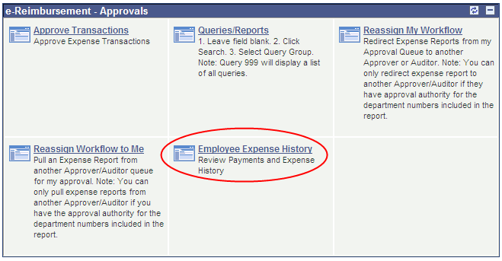
2. Select Employee ID or Name from the drop-down menu, enter the appropriate information in the
begins with field and click the Search button.
Note: The most efficient way to search is by entering the Employee ID. If searching by name, enter the following: last name,first name (no space). Click the Search button and select the desired individual from the list that displays.
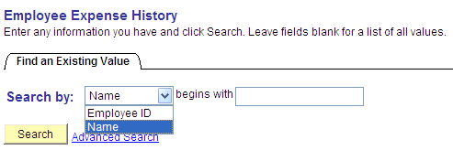
3. By default, the system will display a list of expense reports paid to the individual within the last year. If necessary, adjust the date range and click the Search button again.

Note: The system will not display a report until it has been processed for payment.
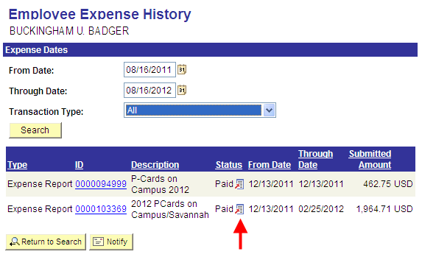
4. Click on the icon in the Status column for the desire expense report to display the following menu:
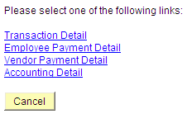
5. View expense report details and payment information in one of the following ways:
• To display the expense report, click the Transaction Detail link.

- To review information about payments made to the individual (expense lines indicated as
Personal Funds), click the Employee Payment Detail link.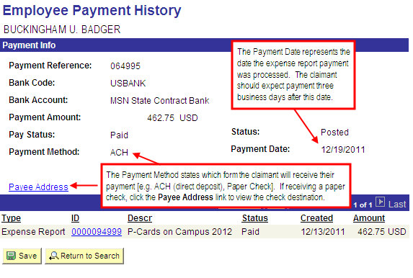
• To review information about My Corporate Card payments made directly to US Bank on behalf of the claimant, click on the Vendor Payment Detail link. If multiple expense reports are processed on the same day, a lump sum payment will be made to US Bank.

