How to Reassign Workflow in the Expense Module

Approvers/Auditors may need to reassign transactions from one approval queue to another in cases when the standard workflow path is not sufficient. Approvers/Auditors have the ability to either reassign a transaction in their approval queue to another Approver/Auditor or
to pull a transaction from someone else’s queue into their own. The instructions below
describe each process.

Reassign Transaction(s) to Another Approver/Auditor

- Sign into the Expense Module. Click on Reassign My Workflow in the Expense Module - Approvals box. On the following screen, click the Search button.

2) Enter the Employee ID of the individual

you would like to reassign the transaction
to in the Reassign Workflow To field. Hit the Enter key or click the Reassign button. Your approval queue will appear.
Tip: If you do not know the individual’s Employee ID,
change the Search By drop-down menu to Description and enter the individual’s last name in the begins with field. Click the Search button and select the individual from the list.

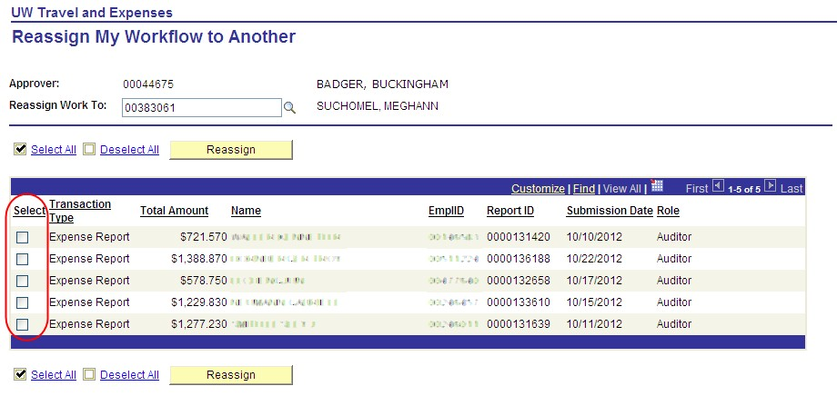
3) Click the box in the Select column next to the transaction you wish to reassign. Click the
Reassign button. The selected transaction will disappear from your Approval queue.

Note: If you are unable to select a transaction in your queue, the desired recipient is not an assigned Approver/Auditor for the Department ID within the transaction.

Reassign Transaction(s) from Another Approver/Auditor
1) Sign into Expense Module. Click on Reassign Workflow to Me in the Expense Module
- Approvals box.
2) Enter the Employee ID of the individual who holds the transaction you wish to receive.
Click the Search button. The selected individual’s approval queue will appear. Note that your Employee ID has automatically populated the Reassign Work To field.
3) Click the box in the Select column next to the transaction you wish to reassign. Click the
Reassign button. The selected transaction will disappear from the approval queue and can now be accessed by clicking the Approve Transactions link in the Expense Module - Approvals box.

