Where is an Expense Report or Travel Authorization for Approval?
If a traveler calls and wants to know where their TER or TA is in workflow you can direct them to the document called: How a Traveler Can See Their TER, else you can do the process below.
Navigate to: Main Menu/Travel and Expenses/UW Travel and Expenses/Information – Central

Choose 25 for TER’s and 27 for TA’s

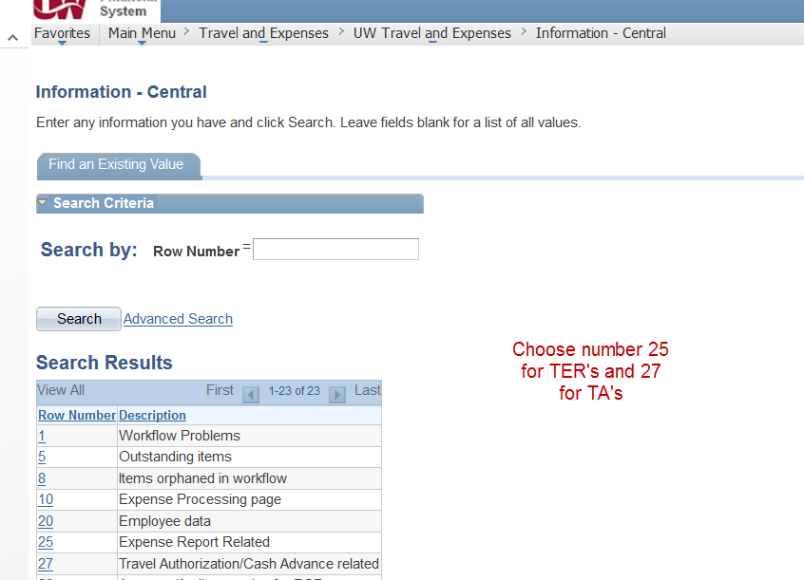

Next choose 3 (ER in workflow (details) for TER’s and 6 )TA in workflow (detail) for TA’s.
Put in the TER or TA number including the leading zeros. Search and look in the column labeled “Approver Status” (column 8) and under the Approver Status column look for Pending and see who the TER or TA is waiting for.

