- The SFS security approval process begins when a user submits their role request form. If the user is requesting access for themselves, an email will be sent to their supervisor, asking for approval. If they are requesting access for someone else, the approval request will first go to that individual and then to their supervisor.

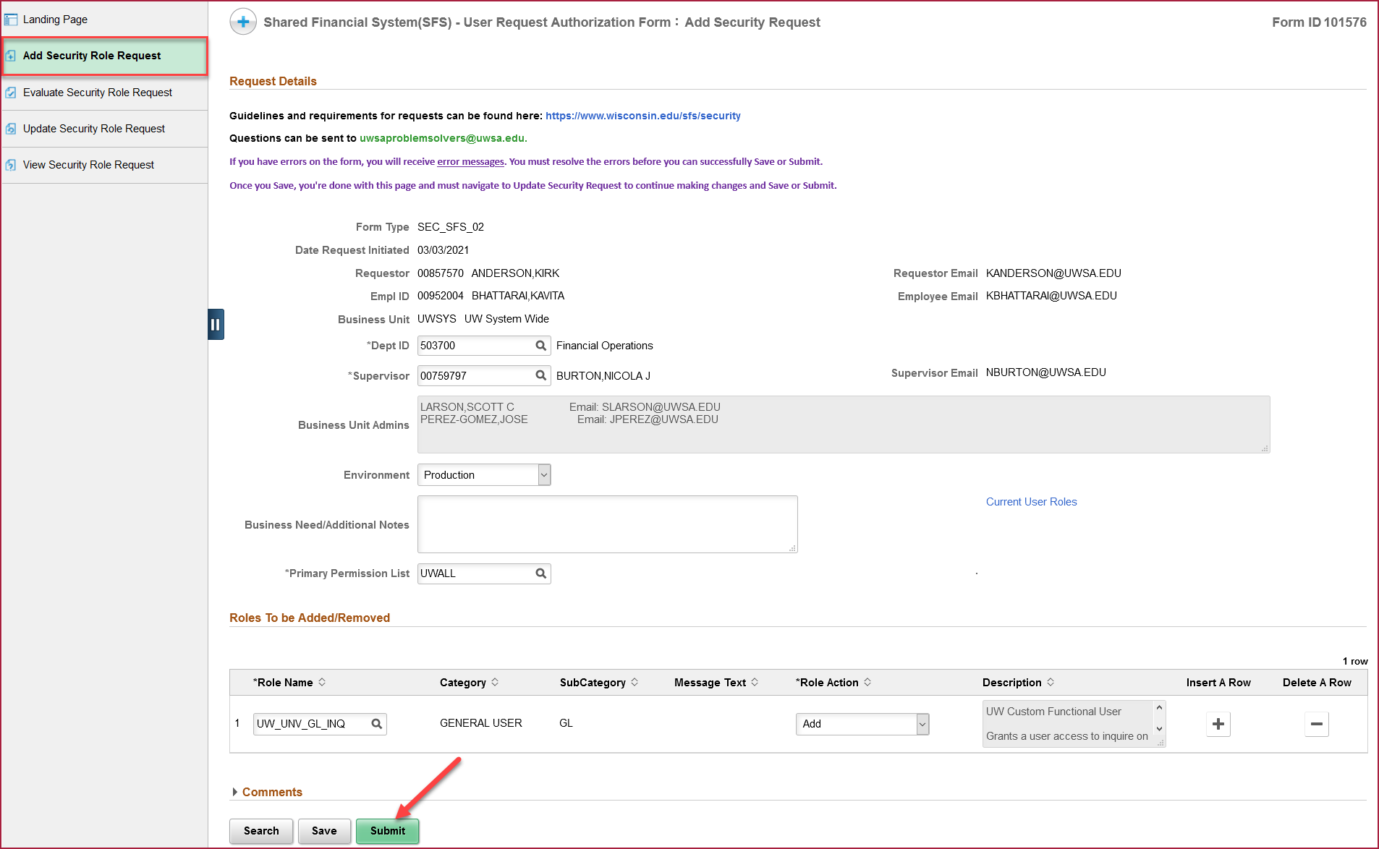

- Users will receive an email from do-not-reply@sfs.uwsa.edu, requesting them to take action on the form. Click on the Link to review the form hyperlink to be directed to SFS.

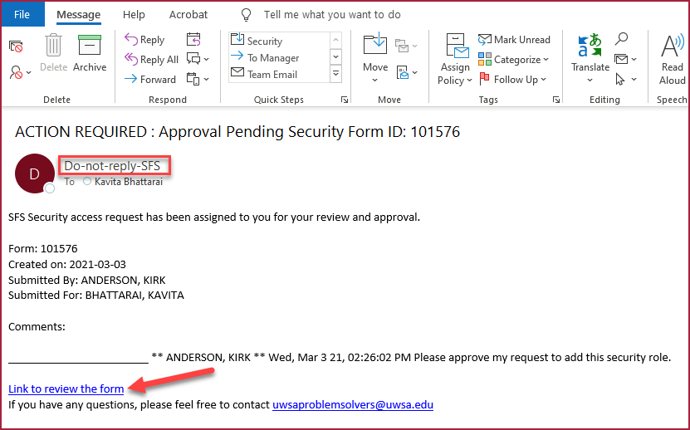
- Users will be brought to the Evaluate Security Role Request page, where they can Deny, Recycle or Approve the request*. Deny will reject the request and close the form. Recycle will send the form back to the requestor for changes.

Carefully review the requested access, confirming that the security roles are appropriate for the user. A warning message will show if the user has requested to change their Primary Permission List, as users rarely need to change this setting. Note that certain roles have been deemed high privilege and will require additional approval from either the financial director or technical manager.

After reviewing the form, change the acknowledgement button to Yes, agreeing to the terms of the form, and click the Approve button. The form will now be sent to the next approver in the workflow.

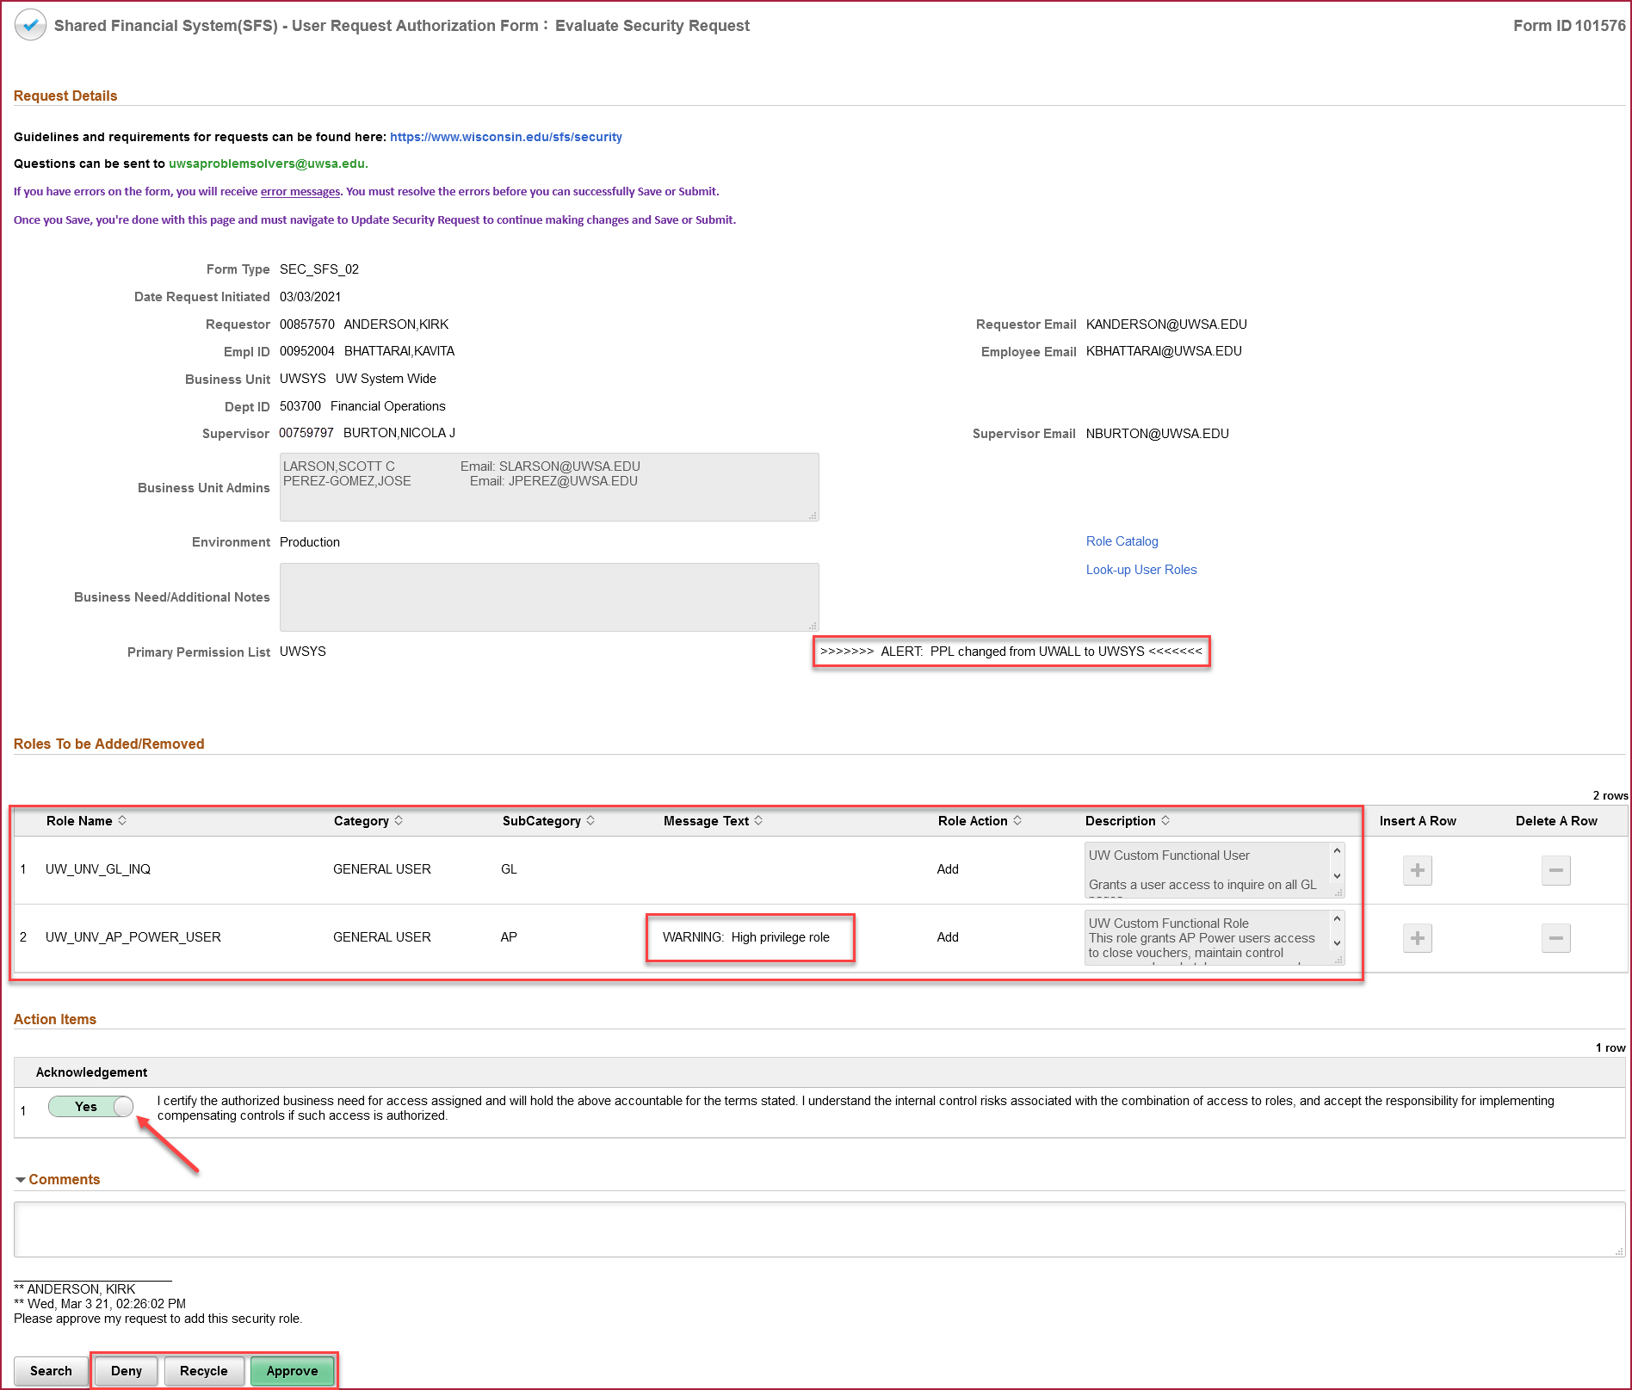

- After approving the form, a page will show confirming that it has been successfully approved. Click the View Approval Route button to see the remaining approvers.

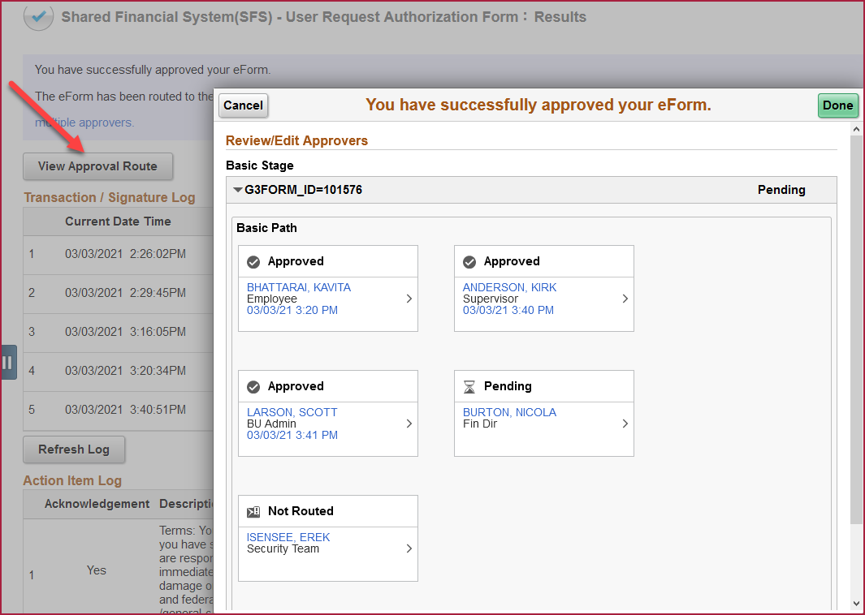

- Once all approvals have been completed, an email will be sent to the requestor and the individual receiving access, confirming that the access has been granted.
Alternate way to approve the form

* If the approval request had been sent to multiple approvers (e.g. multiple BU admins at a campus), only the first approver will be able to access this page. Subsequent approvers will see a search page that says, “Search returned no results”, when clicking on the email link. This means that another approver took action and there’s nothing they need to do.

