How to Disconnect Your Currently Mapped Drives (and see which drives you have mapped)

IMPORTANT NOTE: Do not disconnect ‘Local Disk (C:)’, ‘Group (G:)’, ‘Shared (H:)’ or ‘User_Data (U:)’ drives. The additional drives you have mapped should start with ‘\\sfs...’ and will list the full technical name.
- Open Windows Explorer. 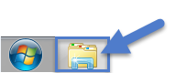
This is usually a folder icon in your taskbar or on your desktop as a shortcut. You can also find it by choosing the Start Menu and searching for “Windows Explorer”.
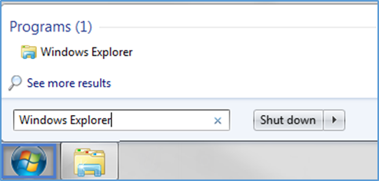
- In the Windows Explorer screen, find the “Computer” heading. You may need to click the small triangle to the immediate left of the heading to see the items beneath it. These items are your drive locations. The mapped drives start with “\\” and have the full technical name. Right click on the drive you wish to remove. On the pop up menu, click “Disconnect”. You should no longer see the drive available.
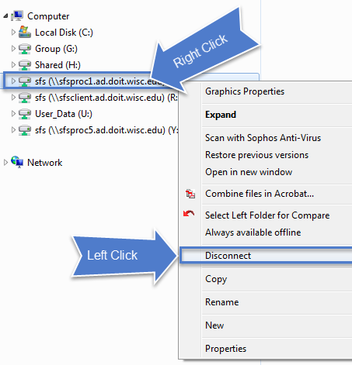

How to Map (Remap) a Drive
- Please close any open work. Open Windows Explorer.
This is usually a folder icon in your taskbar or on your desktop as a shortcut. You can also find it by choosing the Start Menu and searching for “Windows Explorer”.
- In the Windows Explorer screen, find the “Computer” heading. You may need to click the small triangle to the immediate left of the heading to see the items beneath it. These items are your drive locations. Right click on the “Computer” heading. In the menu that appears, click on “Map network drive…”.
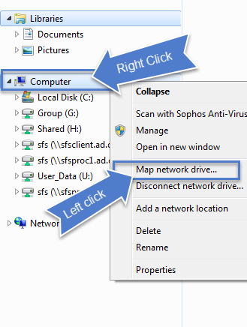
- The ‘Map Network Drive’ dialog box opens. 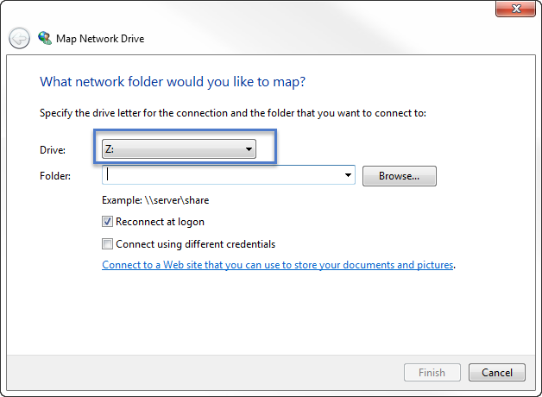
- Choose a drive alias (letter) slot from the drop down menu under the ‘Drive’ field. In the ‘Folder’ field, type in the name of the drive you would like to access. Or if it exists in the dropdown menu, select it. Examples:
sfsclient (typhoon)
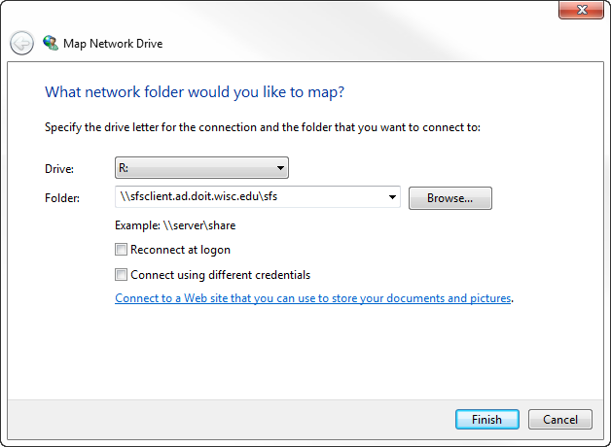
sfsproc1 (SFS production)
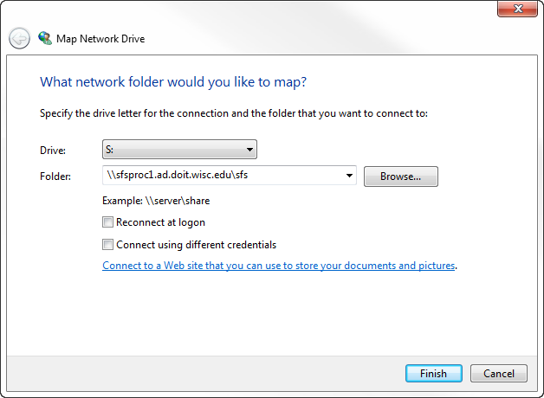
sfsproc5 (DEV and QA-stratus)
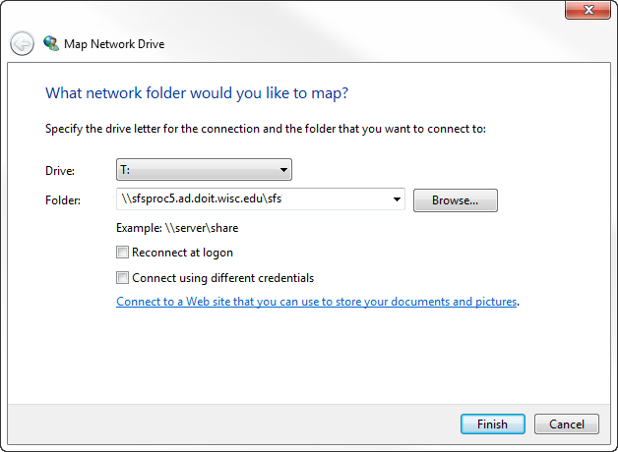
- Click “Finish”.
- You may see the following message while the drive is connecting: 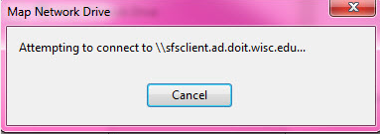
- If you have difficulties, please contact your local IT support staff for assistance.

