Cash Advances when Travel is Not Taken:
- Traveler needs to write a check back to the University. The deposit should be credited to the same funding string the Cash Advance was originally debited. You can look this up in WISDM or run query called: UW_CASH_ADVANCE_FUNDING. It will prompt you for the Business Unit and Cash Advance number. Make sure and put in the leading zeros in front of the Cash Advance number. Please code it to account 6100 as the debit and account 6241 as the credit. The Department, Fund, Program Code and Project will be used from the query.Do not go off the funding in the Travel Authorization because of the way Cash Advances works in E-Reimbursement. The Cash Advance follows the funding from the default profile and not the Travel Authorization.
- The Auditor must reconcile the cash advance thru: Travel and Expenses>Manager Accounting>Reconcile Cash Advance. Search for the appropriate cash advance number and put in the Check number (or cash) and the amount. The Expense Processing Advance Reconciliation process will run overnight.
- Close the Travel Authorization since the trip didn’t happen else it will remain active. Navigate to: Travel and Expenses>Process Expenses>Cancel Travel Authorizations. The first time create a new run control. Put in the Business Unit, Description and hit Search. This will bring up all Active Travel Authorizations for this Business Unit. PLEASE MAKE SURE AND CHOOSE THE CHANGE ACCOUNTING DATE LINK AND PICK TODAY’S DATE. Hit the Select box next to the Travel Authorization you want to close and Hit Run. Watch Process Monitor for the job to run to success.
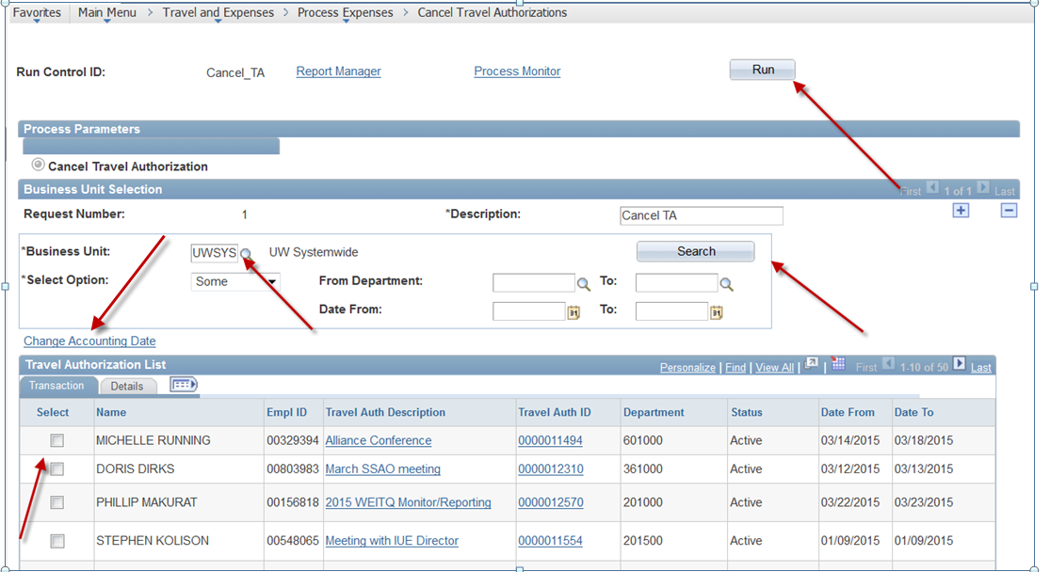

- You can now search for the Travel Authorization and make sure it has a Status of Closed.
