Follow these mail merge instructions step-by-step to create personalized reassignment forms for eligible University Staff employees at your institution.

- After running the SQL query, save the file as an Excel Spreadsheet. This will be your “data source”. The data source contains relevant information for each employee and the results will be populated on the personalized reassignment form.
  - Note: Format the “Hourly Rate” and “Annual Salary” columns as Number and make the Hourly Rate column reflect 3 decimals.
  - Save and close the file. Make note of where you saved the file.

- Open the Personalized Reassignment TEMPLATE Document.
  - You may receive this message:
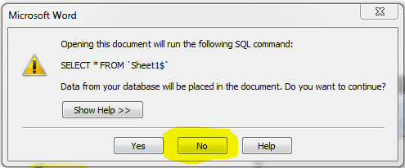
  - If you do, press NO to continue.

- Import data from the data source. By importing the data, you are “joining” the information from the data source with the personalized reassignment form. This begins the process of populating relevant information from the data source onto the personalized reassignment form. The mail merge process cannot be completed without this step.
  - Go to Mailings tab, press “Select Recipients”, then “Use Existing List” 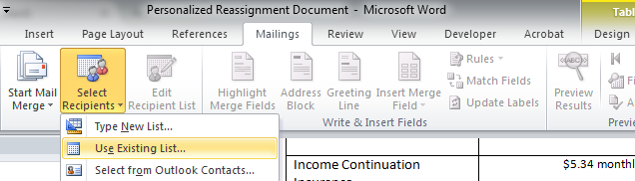
  - Locate where you saved the data source and press OPEN.

- You will be prompted to select which worksheet to use. 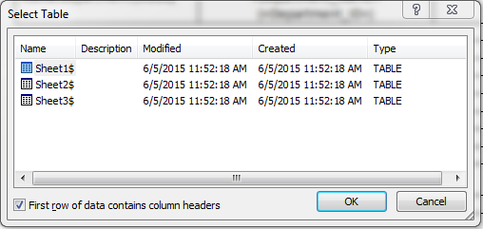

  - By default, the “master” data source information is saved in Sheet 1. **See Helpful Hints at the end**
  - Press OK to continue.

- Complete the mail merge.
  - Go to Mailings tab, press “Finish & Merge” , then “Edit Individual Documents” 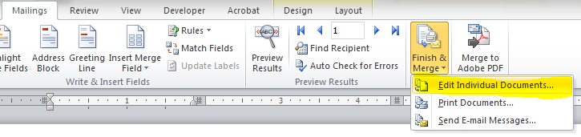
  - You will see this prompt:
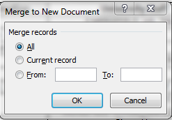
  - Press OK. This will complete the mail merge process and create a personalized reassignment form for each person on the data source spreadsheet. All of the letters will populate in a separate window as ONE merged document, called “Letters” followed by a number (ex: Letters1). You may save the file at this point. Keep the file open.

- Close the personalized reassignment TEMPLATE document. Do not save any changes.

- Clean up the merged letters. You will notice that on each employee’s personalized reassignment form, there may be blank rows in the Benefits section. The template document was created so it would only show values for benefit plans that the employee is enrolled in. Blank rows will appear where an employee is not enrolled in a specific benefit plan. Follow this step to remove the blank rows to clean up the document.
  - Make sure cursor is in the merged letters document.
  - Press ALT+ F11 (You will see new window pop up that looks like below)
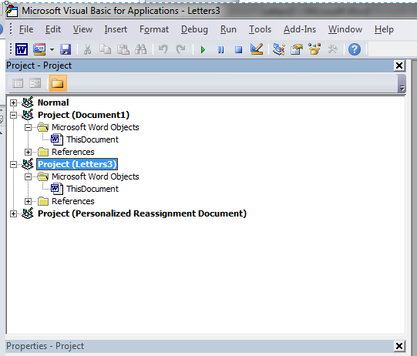

  - Highlight the “Project” that has the name of your saved document in the parentheses by clicking on it once.
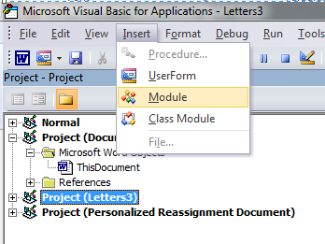

  - Once highlighted, click “Insert”, then “Module”. A screen will pop up to the right. It may say “Option Explicit”at the top.
  - Underneath “Option Explicit’” (or in the box if “Option Explicit” is not shown), copy and paste the following:
Sub DeleteEmptyTableRows()
Application.ScreenUpdating = False
Dim Tbl As Table, cel As Cell, i As Long, n As Long, fEmpty As Boolean
With ActiveDocument
For Each Tbl In .Tables
n = Tbl.Rows.Count
For i = n To 1 Step -1
fEmpty = True
For Each cel In Tbl.Rows(i).Cells
If Len(cel.Range.Text) > 2 Then
fEmpty = False
Exit For
End If
Next cel
If fEmpty = True Then Tbl.Rows(i).Delete
Next i
Next Tbl
End With
Set cel = Nothing: Set Tbl = Nothing
Application.ScreenUpdating = True
End Sub

  - Press F5 to run the macros. This will remove the blank rows from the personalized merge document to clean it up. It may take a few moments.
- Review the merged letters document. The letters should no longer have the blank rows. There may be a few blank rows remaining which you may manually delete if you wish.
- Save the merged letters document.
- Prior to doing one-on-one counseling with employee, you will want to make sure the personalized form is complete with information regarding their potential AS/L appointment in the right column. Once completed, make sure to save the document again.
- Print individual forms as needed for one-on-one counseling.
  - VERY IMPORTANT: Forms for all employees will be combined into one large file. See instructions below on how to print individual forms. It is not as easy as printing “page 5”.

HOW TO PRINT INVIDIDUAL LETTERS FROM MAIL MERGE FILE

Note: The personalized reassignment forms for all employees are saved together as one large merged file. It’s important to note that each employee is considered a “record”—all of the person’s information is on one row on the data source and this is all considered one “section”. One person= one record= one section. If you want to print a specific employee’s personalized reassignment form, you will need to know which “section” of the full document is the employee’s. Follow the instructions below to identify the employee’s section number and how to print the person’s form.

There are two ways to identify the employee’s section number: 1) Set Word to display “section” numbers or 2) Refer to your data source.

Identifying Section Number #1: Set Word to display “section” numbers.

- To display the section number, right click over the status bar at the bottom of the Word window (where it says ‘Page’, ‘Words’ etc) and select Section.
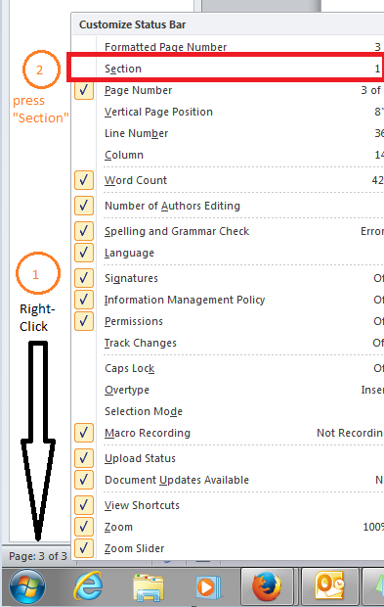

  - Once checked, the Section will now appear on the status bar:
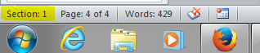

- Scroll to the first page of the employee (ex: Bucky Badger) whose personalized form you want to print.
- Look at the status bar to see what Section number it shows. Let’s pretend it says “Section: 41”. You have now identified that Bucky Badger’s section number is 41.

Identifying Section Number #2: Refer to data source

Keep in mind that each row is a “section”.

- Open up the data source spreadsheet.
- Locate the employee whose personalized form you want to print out.
- Identify which row number their record is showing up on.
  - Bucky Badger is showing up on row 42.
- Subtract 1 from this number to get the section number since the Column Headers take up one row.
  - You have now identified that Bucky Badger’s section number is 41 (Row 42 minus 1).

Printing Instructions (once you have identified Section Numbers)

- Press CTRL + P, or go to File> Print
  - Under “Settings” in the “Pages” field, you will want to type in “S” (for section) followed by the section number. For Bucky Badger’s personalized reassignment form, you would type in “S41”. It will print however many pages are in that section. The personalized reassignment form is 2 pages long, so it would print the full 2 pages for Bucky.
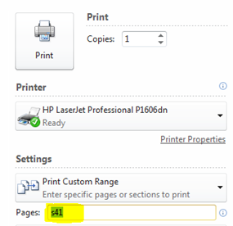
  - NOTE: You may print section ranges as well. For example, if you want to print personalized reassignment forms for Bucky, Jane and John and their section numbers are 41, 59 and 110, you may type in: “S41, S59, S110” and it will print their forms. Or, if their section numbers were 41, 42 and 43, you may type in: “S41- S43”.
  - REMEMBER to always include “S” before the section number when printing!

HELPFUL HINTS
- Sheet 1 of the data source should hold the “master” query results. The results will include information for all Classified Exempt employees at your institution. You may not need to create a personalized reassignment form for all employees, especially if they are not interested in voluntarily reassigning. You may limit the reassignment forms you create by filtering out the subset of employees into a separate sheet.
  - Once you become aware of an employee wanting a one-on-one counseling session, create a secondary list in “Sheet 2” of the data source file. Make sure to copy/paste the column headers into row 1 first. Save the file. You will now have data in both Sheets 1 and 2. Sheet 1 will contain ALL eligible employees and Sheet 2 will contain employees who want one-on-one counseling, for whom you’ll want to create personalized forms.
  - When you go to do the mail merge for this subset of employees, in step 4, you would select Sheet 2 to create personalized forms for just the subset of employees who want the one-on-one counseling session.
    - Since all of these employees will be receiving one-on-one counseling, you may want to print all of the personalized forms. You will not necessarily need to know section numbers since you will likely print them all out.
  - You can rename the sheets if you like.
- If the personalized reassignment TEMPLATE document is open, the data source is considered open as well. If you attempt to open the data source document separately in Excel while the TEMPLATE document is open, you will be able to open it in read-only format. If you need to make changes to the data source file, you will need to close the personalized reassignment TEMPLATE first.

