University of Wisconsin System
SFS Accounting Manual
Category: General Ledger |  | Effective Date: Updated Annually
Task or Process: Year-End Close  Guidelines – FY 2023 |  | Revision Date: Mar 2023  Issued Date: Apr 2023
Contact Information:  Name: Julia Lengyel | Email: jlengyel@uwsa.edu |  | Phone: 608-262-5850

Following are the guidelines for closing FY 2023, 13th month processing, and starting FY 2024. Updates will be issued if changes are needed.

1. When will year 2024 be opened for processing?

a) The FY 2024 Standard Budget Ledger will be opened May 1, 2023 to allow business units (BUs) to begin posting budget journals for the new fiscal year. An earlier date may be allowed if BUs request it.

b) UWSA staff open the FY 2024 Purchasing module on April 3, 2023 so that the SFS BUs may begin processing purchase orders for the new fiscal year. The PO data will post to the KK Ledger as they are created.

c) SFS ledgers for FY 2024 (Actuals and Accrual) won’t be open for regular posting until July 2.
Exception: Summer Session payrolls processed through HRS in May & June will generate salary and fringe journals that will be posted in SFS before July 2. The Actuals Ledger will be opened for period 1 of the new year to get those journals posted. The ledger will be closed again as soon as the posting is completed.

d) Please make certain all staff members are aware of the following guidelines for year 2023 or 2024 July transactions:

1. July 1 is the single date that represents the 13th month of FY 2023. July 2 is the first day of the FY 2024 July accounting period.
2. All BUs should use the date of July 2 as the first PO/journal date for year 2024 transactions that will post to the Actuals and KK Ledgers.
3. Extra care should be taken in the month of July to ensure that all SFS transactions are recorded in the correct fiscal year, regardless of where the transactions are initiated.

e) Any journal data that must be reported to DOA prior to July must be posted in FY 2023. All
BUs must comply with this restriction.

f) All BUs must not enter FY 2024 vouchers in AP until July 2.
g) All BUs must not run FY 2024 pay cycle until July 2.

2. Year 2024 Accounting Period Calendar (CC calendar)

Period 1 is the first Period of the fiscal year and runs from July 2nd thru July 31st.

Period 13 is available to record entries to be included prior to closing the fiscal year. All journals dated July 1st will post to period 13.

The remaining periods begin and end dates follow the Calendar month.

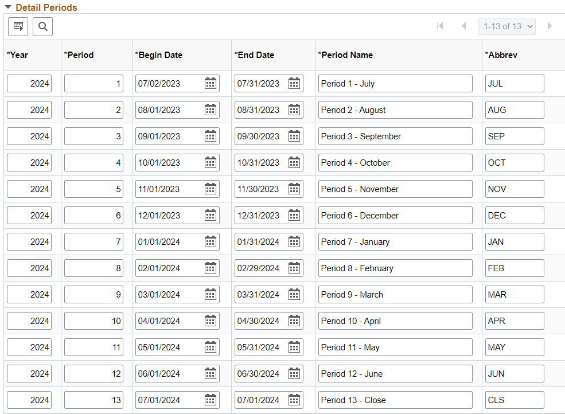

UWSA staff will close periods after the end of the 3rd business day of the month once all the related batch jobs have run. Typically, this will be the first thing in the morning of the 4th business day of the period. This allows Business Units time (at least 3 business days) to post end-of-month journals before the period is closed. More stringent deadlines will apply for the 13th period.

3. Processing at end of June

a) Daily deposit amounts recorded via GL journal entries to fund 990, account 9198 on the last business day of June must be the last that will be included in the June accounting period.

b) Any additional 990 deposit GL journal entries needed to record old fiscal year receipts received by June 30 must be posted in period 13 of FY 2023, along with related revenue distribution journals to clear 990.

c) For any receipts received after June 30, GL journal entries for 990 deposits related to old or new fiscal year receipts must be posted in period 1 of the new fiscal year (journal date must be July 2 or later).

d) BUs will be allowed to run Pay Cycle (as many as desired) until 3:30 pm on June 30, 2023.

The PY journal posting will be performed after 4:00 pm, same as any other day.

e) BUs must be able to reconcile their Accounts Payable balance to unpaid AP vouchers.

BUs Accounts Payable balances at end of the fiscal year must be able to be tracked and verified to ensure that offsetting Accounts Payable transactions are charged to the new fiscal year (in PY journals) and accurately bring the old fiscal year balances to zero.

f) The June period will be closed the first thing in the morning on July 7th.

4. Period 13 processing criteria

a) All SFS journals for 13th period general ledger posting must be assigned a journal date of July 1. Please ensure that all staff members are aware of this requirement. It is extremely important that these journals do not get posted to the new fiscal year by mistake (because the wrong journal date was assigned).

b) BUs must not run Pay Cycle on July 1. All Pay Cycle processes run in SFS after July 1 will create PY journals in the GL for the new fiscal year (even if the vouchers paid are recorded in the old fiscal year).

c) HIGH PRIORITY: For all BUs. You must not cancel, void, or put a stop on any payments on July 1! You must not cancel, void, or put a stop on any payments during the last six business days of June unless you have enough payments to cover the negative dollar effect of the cancels, voids, or stops. Failure to comply with these rules may result in creation of PY journals that have a negative balance. We cannot interface negative balance data to DOA.

d) Internal transfer journals for chargebacks, coding corrections, encumbrance adjustments, etc. can be processed in SFS in the 13th period up through July 14th. All journals must be posted in SFS by 3:30 pm on July 14. Same is true for within campus budget adjustments posted to the Standard Budget ledger.

e) All inter-unit transfer journals (IUJ, IUT, etc) can be entered into JET on July 14th, but must be posted by all BUs involved by 3:30 pm.

f) UWSA will close FY 2023 period 13 at 4:00 pm on July 14th. Period 13 will be re-opened periodically during the second half of July so that final adjusting transactions initiated at UWSA can be posted and interfaced to DOA.

5. Monitoring encumbrance balances for fiscal year close

a) The year-end open encumbrance balances for the Service/Supply, Capital, Financial aid and Special Purpose major lines (for all BUs) will be reported to DOA by UWSA. Those encumbrance balances must match the PY_ENC budget balances for FY 2023 (PY_ENC budgets are entered by each BU). Therefore, make certain those encumbrance balances are accurate at the end of the year. All standing orders for FY 2023 will be closed prior to the PO roll-over process. Owners of POs created as standing orders will be notified of their orders so that they can determine if new fiscal year standing orders need to be created.
CARRYOVER JUSTIFICATION: Each BU must submit written justification for carrying over any PO that is more than 1 year old (e.g., created in FY 2022 or earlier). Justification documentation must be submitted to the UW System Controller by May 31 annually.

b) If you determine (after the mid-July cutoff) that an encumbrance balance adjustment is needed, send a request (email) to the UW System Controller to provide justification for the change.

c) PO Year-End Processing - In order to fulfill reporting requirements and track outstanding purchase order encumbrances, institutions are required to close purchase orders that will no longer be used and roll those open purchase orders that will continue to be used in the future fiscal year.

Please review “Training and Documentation” files on the SFS website related to Purchasing – the PO clean-up, PO roll, and future fiscal year PO processes.

https://www.wisconsin.edu/sfs/sfs-9-2-training/

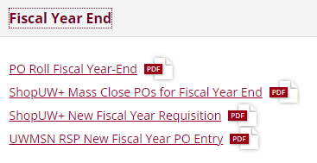

6. Processing guidelines for transfers that cross fiscal years

- Instructions for processing Advance Fees collected prior to July 1 are located on the SFS web site under “Accounting Procedures”: https://www.wisconsin.edu/financial-administration/accounting-and-budget-control/
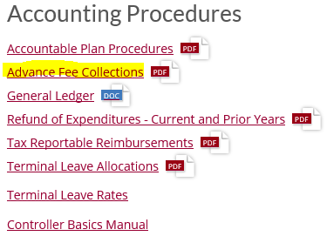

b) NOTE: Internal transfer journals processed in period 13 (or any other period) may only contain data for one fiscal year. You cannot perform a transfer between fiscal years in one journal. If there are any other situations where revenues or expenses will be moved between fiscal years, it is very important that the proper asset/liability offset accounts are used in each year so that the data for each fiscal year is properly balanced for reporting to DOA. If you will need to process cross-year transfers, send UWSA the information about what they involve and why they are needed. UWSA will work with you to determine the asset/liability entries that will be needed in each year.

7. Period 998 adjustments

- Instructions for processing period 998 journals are located on the SFS web site under “Fiscal Year End”: https://www.wisconsin.edu/financial-administration/accounting-and-budget-control/

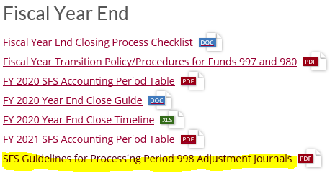

b) All period 998 adjustment should be completed by no later than August 15th.

c) UWSA staff will perform the final fiscal year closing process in SFS by August 15th for all BUs. Account balances are brought forward to period zero of the new year as part of this process.

