Direct Admit Common Issues as of October 2025

**GRAYED OUT UWS ON DIRECT ADMIT FORM**

As you work with students to accept their Direct Admit offers of admission to the Universities of Wisconsin Admission Pathway Portal, a grayed-out UW means they already have a traditional application either submitted or in-progress (see image below). If in-progress, they should delete it before submitting the Direct Admit Form. If already submitted, they are not going to be able to submit a Direct Admit Form; simply contact the UW to inform them of their Direct Admit status.

Example of a grayed-out UW in the Direct Admit Form:

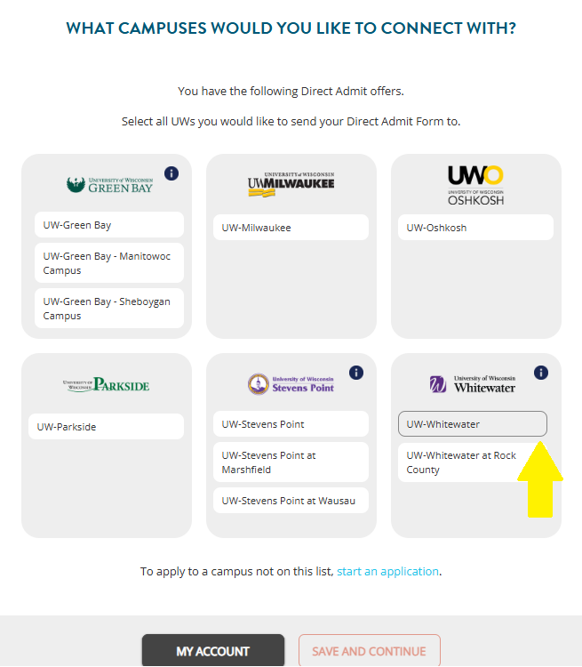

**ACCOUNT CREATION:**

Students who have received Direct Admit offers of admission must take the next step of submitting a Direct Admit Form. To do so, students must use the Universities of Wisconsin Admission Pathway Portal at apply.wisconsin.edu.

* Step-by-Step Direct Admit Form: <https://go.wisconsin.edu/wp-content/uploads/2025/10/Fall-2026-Direct-Admit-Form-Walkthrough.pdf>

**Creating a New Account**

If this is the first time a student is visiting the Universities of Wisconsin Admission Pathway Portal, they will need to create a new account.

***Steps to Create a New Account***

* Go to the Universities of Wisconsin Admission Pathway Portal at apply.wisconsin.edu/direct-admit
* Click on “CREATE ACCOUNT.” Enter in the high school email address in addition to the personal email address. Complete all other fields.
* Verify both the high school email address and personal email address.
* Once logged in, from the “DIRECT ADMIT” tab, it will display the list of the UWs the student has been directly admitted to.
* To start a Direct Admit Form, click on the button “DIRECT ADMIT FORM.” Follow the instructions to complete the form.

**LINKING AN EXISTING ACCOUNT:**

If students have used the Universities of Wisconsin Admission Pathway Portal account before and have an existing account, they will need to log into the account and link the high school record to the account. Students may already have an account if they previously applied for dual enrollment classes at a UW (for example: CAPP, PIE, ECCP, PACC, CCIHS courses).

***Steps to Use an Existing Account to Link a Direct Admit Record***

* Go to the Universities of Wisconsin Admission Pathway Portal at www.apply.wisconsin.edu/direct-admit
* Click on “SIGN IN.” Enter in the personal email address.
* Once logged in, click on the “Direct Admit” tab. Then, click on “LINK YOUR DIRECT ADMIT RECORD.” Enter in the high school email address.
* A verification code will be sent to the student’s high school email address. Verify the high school email address.
* Once the email is verified, from the “DIRECT ADMIT” tab, it will display the list of the UWs the student has been directly admitted to.
* To start a Direct Admit Form, click on the button “DIRECT ADMIT FORM.” Follow the instructions to complete the form.

**MAKING UPDATES TO STUDENT INFORMATION WITHIN ACCOUNT:**

***Updating a FIRST and LAST NAME:***

* The first and last name of a student cannot be updated within the Direct Admit Form itself.
* If the Direct Admit Form is displaying an incorrect first and/or last name, this information can be updated within the main account under “My Account: Account Information.”
* Updates to the “Account Information” will automatically update any in-progress Direct Admit Forms.

***Updating a HIGH SCHOOL:***

* Upon creating a Direct Admit Form, the high school of the student will automatically populate for the student. If the high school is incorrect, the student can make changes within the Form.
* In the “Academic Background: High School” section, a high school will automatically populate along with an “Anticipated graduation date.”

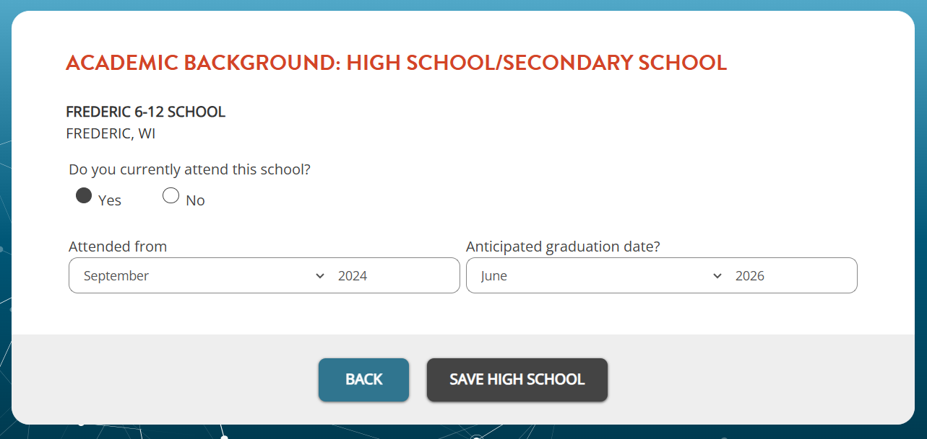

* Enter in an “Attended from” date (this can be any date). Click on “SAVE HIGH SCHOOL.”
* Once the high school is saved, it will show up in the “Academic Background: High School” page.

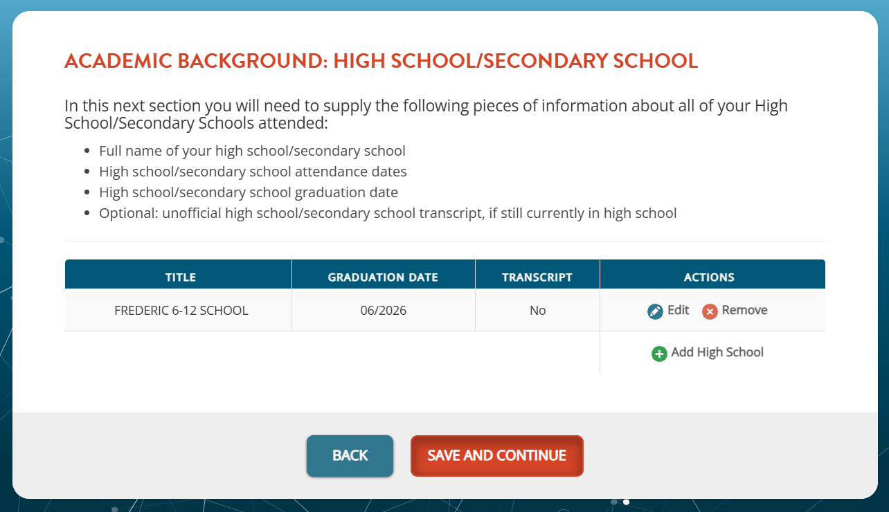

* From the “Actions” column, click on “Remove” to remove the incorrect school.
* Then, click on “Add High School” to add the correct school.