KB - Under Min/Over Max Report

Table of Contents
Table of Contents 1
Purpose and Overview 1
Process Inputs 1
Process Outputs 1
Procedure Steps 2
Tables 8

Purpose and Overview
This report displays employee records where an individual's (or a vacant’s) updated budget salary (updated salary including adjustments entered into the CAT) is above or below the rate for that title in HRS. Title min/maxes will be pulled from HRS as of the beginning of the next fiscal year. Employee records that have an over max/under min error will continue to appear on this report unless their updated Comprates are changed in the CAT to be within the salary range (even if they are approved to be over max/under min).
For Madison employees, the ESR (Extraordinary Salary Range) min/maxes will appear on this report as separate columns from the HRS min/maxes. If a Madison employee record has an ESR, the logic of this report will compare their updated CAT salary to the ESR range, and ignore the HRS range.

Process Inputs
- Fiscal Year
- Business Unit
- Division (optional)
- Department (optional)
- Empl Class
- Include Vacants Checkbox

Process Outputs
- Excel document with all employee records (or vacant positions) that meet the run control criteria and have an under min/over max error.

Procedure Steps
- Navigate to Workforce Administration > UW External HR Systems > Compensation Admin Tool > CAT Reports > Under Min/Over Max Report.
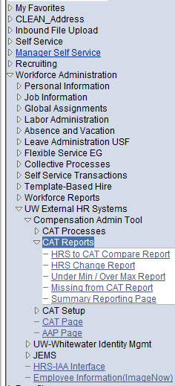
- Click Search under the Find an Existing Value tab to select a previously created Run Control ID, or create a new Run Control ID by selecting Add a New Value. To create a new Run Control ID, assign a unique identifier as the Run Control ID (eg. initials_date_etc.) into the Run Control ID box and select Add.
- Note: Run Control ID sets the report parameters. Users can create one ID, and use it to process multiple reports/processes, or create a new ID for each report/process.
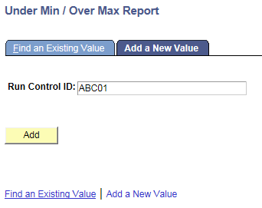
- Enter parameters to define criteria for the Under Min/Over Max Report.
  - Select the upcoming Fiscal Year used for CAT budgeting planning purposes. This field will default to the latest fiscal year setup in the CAT.
  - Select a Business Unit.
  - If desired, select a Division.
  - If desired, select a Department.
    - If available, the Department field will become editable when the user selects a Division from the search tool or enters one manually and presses the tab button out of the field.
  - Check or Uncheck the “Include Vacants” Checkbox.
    - Leaving the checkbox checked will pull Vacant positions from the AAP whose Full Time Rate is under the min or over the max for the Job Code entered in the AAP.
    - Unchecking the checkbox will ensure that only CAT positions that are under the min or over the max will appear on the report.
  - Click Select Values in the employee class box if you wish to exclude certain employee classes from the report. The default is for all employee classes to be included. Employee classes that are not included in the CAT will not pull onto CAT reports.
  - Click Save in the bottom left to save the parameters for the report.
  - Click Run in the top right to run the report.
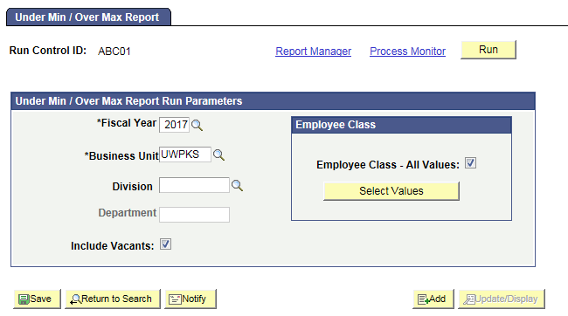
- User will be automatically directed to the Process Scheduler Request page. From this page, select OK.
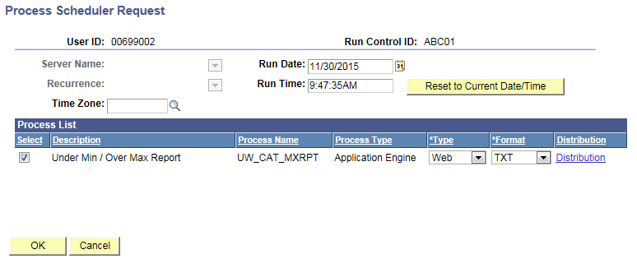
- User will be directed back to Under Min/Over Max Report Page. Select “Process Monitor” to view Process list.
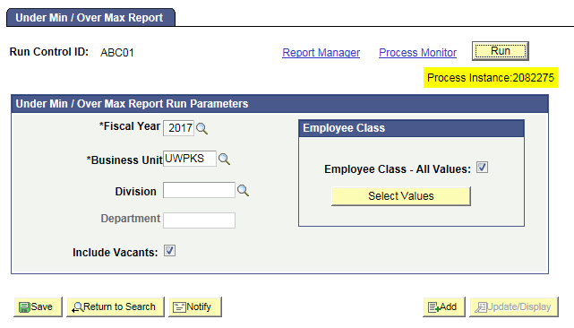
- Click Process Monitor at the top right of the window.
- Search for your process instance number under Process List, which will indicate the status of the report generation. When the report is complete, Run Status will be “Success” and Distribution Status will be “Posted”.
  - If Run Status is “Queued,” it indicates that the report generation is waiting to start.
  - If Run Status is “Processing,” it indicates that the report generation is processing.
  - Click Refresh at the top right of the window to refresh the status of the document.
- Once the Run Status hits “Success” and the Distribution Status hits “Posted,” download the output.
  - Click Details.
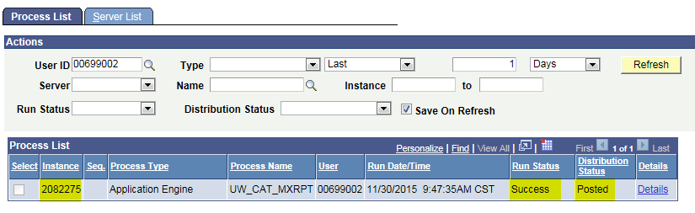
  - Click View Log/Trace at the bottom right of the window.
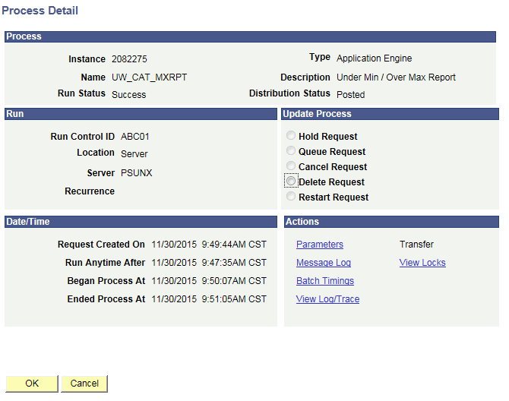
  - Under File List, click the file with the .xls extension to download the output. Note: you may have two .xls outputs if you have any additional splits.
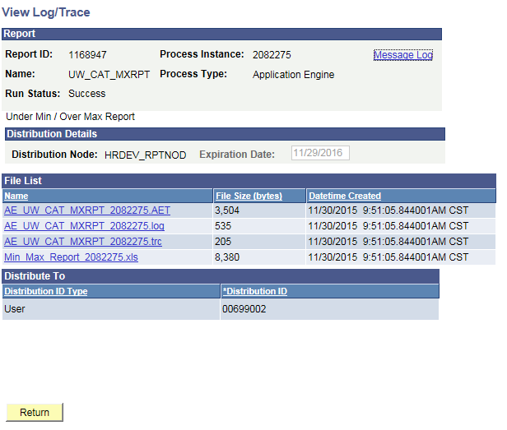
  - When opening the file in Excel, if an error message appears indicating that “The file you are trying to open…is in a different format than specified by the file extension,” click Yes.
  - Note that different internet browsers may have different opening processes.
- Review the output file.
  - Open the downloaded Excel file.
    - A description of the different header and column fields found in the output is below.
    - The output file will look like the screenshot below.
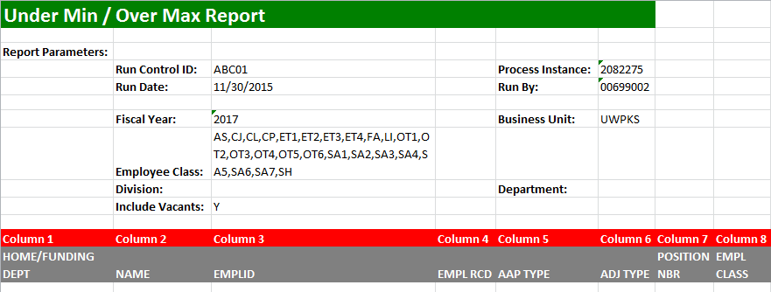
- Review all employee records (and Vacant positions) on this report, and lower their CAT adjustments so that their salary falls within the HRS Min/Max (or ESR min/max) range.
- If an employee record has been approved for over max, the Approved for Over Max column will be populated with a Y. In these cases, their updated CAT Salary may be above the HRS Max.

Tables
Report Parameters
Field Name |  | Description
Run Control ID |  | The run control identification entered when report was created.
Run Date |  | The date the report was created.
Fiscal Year |  | The Fiscal Year selected in the run control
Employee Class |  | The employee classes included on the report’s run control.
Division |  | The Division (if any) selected in the run control.
Include Vacants |  | Include Vacants as selected on the run control
Process Instance |  | The number assigned by PeopleSoft for each process.
Run By |  | The User ID of the user who ran the report.
Business Unit |  | The Business Unit selected in the run control.
Department |  | The Department (if any) selected in the run control.
Report Columns
Column | Description
HOME DEPT/ FUNDING DEPT FOR VACANTS | The Home Department of the employee record from the CAT. The Funding Department of the Vacant Position from HRS.
NAME | The Name of the employee record from HRS. This field will appear blank for Vacant positions.
EMPLOYEE ID | The Employee ID of the employee record from HRS. The field will appear blank for Vacant positions.
EMPLOYEE RECORD | The Employee Record Number from the CAT. The field will appear blank for Vacant positions.
POSITION TYPE (AAP LABEL) | The Position Type from the AAP for vacant positions. This field will appear blank for CAT jobs.
ADJUSTMENT TYPE (AAP LABEL) | The Adjustment Type field from AAP for Vacant Positions. This field will appear blank for CAT jobs.
POSITION NUMBER | The Position Number of the employee record from CAT, or the vacant position from the AAP.
EMPL CLASS | The Employee Class of the employee record from CAT. The field will appear blank for Vacant positions.
PAY BASIS | The Pay Basis of the employee record from CAT. The field will appear blank for Vacant positions.
PLANNED FTE | The Home Department of the employee record from CAT, or the vacant position from the AAP.
JOB CODE | The Job Code of the employee record from CAT, or the vacant position from the AAP.
TITLE | The Title of the employee record from CAT, or vacant position from the AAP.
SALARY PLAN | The Salary Plan of the employee record from HRS, or vacant position from the AAP.
SALARY GRADE | The Salary Grade of the employee record from HRS, or vacant position from the AAP.
FULL TIME RATE | The Full Time Rate of the employee record from HRS, or vacant position from the AAP.
HOURLY MINIMUM | The minimum of the salary grade associated with the job code/employee record from HRS, or associated with the job code/vacant position from the AAP.
HOURLY MAXIMUM | The maximum of the salary grade associated with the job code/employee record from HRS, or associated with the job code/vacant position from the AAP.
ANNUAL MINIMUM | The minimum of the salary grade associated with the job code/employee record from HRS, or associated with the job code/vacant position from the AAP.
ANNUAL MAXIMUM | The maximum of the salary grade associated with the job code/employee record from HRS, or associated with the job code/vacant position from the AAP.
OVER MAX FLAG | Yes/No based on the checkbox from HRS
ESR MINIMUM | Extraordinary salary range minimum (if available) for a job code/ position number in the UWMSN Business Unit. This field will appear blank for vacant positions.
ESR MAXIMUM | Extraordinary salary range maximum (if available) for a job code/ position number in the UWMSN Business Unit. This field will appear blank for vacant positions.
ERROR MESSGE | Type of error associated

