KB – Record Errors Report
Table of Contents
Purpose and Overview 1
Process Inputs 2
Process Outputs 2
Procedure Steps 2
Tables 10

Purpose and Overview
The Record Errors Report displays all records in the budget that have generated any sort of (employee-level) error based on the edits that have been set up in the CAT. This report contains all Job Level Errors, Compensation Change Errors, Funding edit errors (SFS, budget errors) and Funding Section Errors (math-type errors). The run control will allow for the user to include all errors, or separate them out by type (funding edit, funding section, job level or compensation).
Job Errors: Certain error statuses will be stored at the job level (parent CAT record). Users will need to be able to save the CAT page, even with some of these errors existing (i.e., planned FTE errors).
Funding Edit Errors: Users of the CAT will need to be able to save the CAT page with invalid funding strings (those that don’t pass SFS edits if ok to load is checked, and those that don’t pass budget edits if ok to load is unchecked).
Funding Section Errors: Users of the CAT will need to be able to save the CAT page even if certain funding errors exist (math errors related to different funding splits). This will allow them to do things such as work with other CAT users to finalize the funding data for shared employees.
Compensation Section Errors: Additionally, users of the CAT will need to be able to upload empl records to the CAT via the IPS to CAT process using the append option. In this process, compensation increases for an empl record in the spreadsheet will add to existing compensation increases in the CAT. Thus, a user (or two different users) could load the same action reason increase with different percentages for the same empl record. A report is needed to capture this duplication, and edit so there is only one row for each action reason in the CAT.
Users of the CAT will need to be able to quickly identify any empl record with an error on a single consolidated report. Throughout the budgeting cycle, this report will be run error by error to clean up multiple action reasons, invalid funding strings, and a variety of math errors in the funding section. Towards the end of the budgeting cycle, users will run this entire report to clean up the final record errors.

This report will serve as an update notification of all these errors. Users will need to then review the records on this report, and correct the error in the CAT before the CAT is locked. Once corrected the error row for that employee will fall off the report.

Process Inputs
- Fiscal Year
- Effective Dates
- Business Unit
- Division (Optional)
- Department (Optional)
- Employee Class

Process Outputs
- Excel document with a population that meets the run control criteria and has an error in the CAT.

Procedure Steps
- Navigate to Workforce Administration > UW External HR Systems > Compensation Admin Tool > CAT Reports > Record Errors Report.
- Click Search under the Find an Existing Value tab to select a previously created Run Control ID, or create a new Run Control ID by selecting Add a New Value. To create a new Run Control ID, assign a unique identifier as the Run Control ID (eg. initials_date_etc.) into the Run Control ID box and select Add.
- Note: Run Control ID sets the report parameters. Users can create one ID, and use it to process multiple reports/processes, or create a new ID for each report/process.
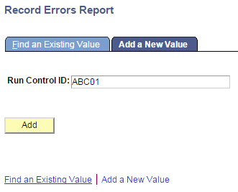
- Enter parameters to define criteria for the Record Errors Report.
  - Select the upcoming Fiscal Year used for CAT budgeting planning purposes. This field will default to the latest fiscal year setup in the CAT.
  - Select a Business Unit.
  - If desired, select a Division.
  - If desired, select a Department.
    - If available, the Department field will become editable when the user selects a Division from the search tool or enters one manually and presses the tab button out of the field.
  - Click Select Values in the employee class box if you wish to exclude certain employee classes from the report. The default is for all employee classes to be included. Employee classes that are not included in the CAT will not pull onto CAT reports.
  - Select the types of errors you wish you view in the output by checking the associated boxes
    - If compensation errors are included in the run control, an effective date range must be chosen by pressing the Effective Dates buttons next to the From Date and To Date.
  - Click Save in the bottom left to save the parameters for the report.
  - Click Run in the top right to run the report.
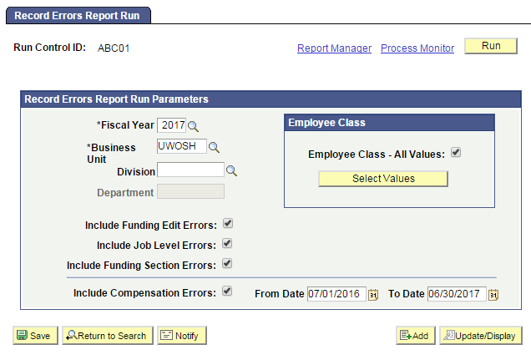
- User will be automatically directed to the Process Scheduler Request page. From this page, select OK.
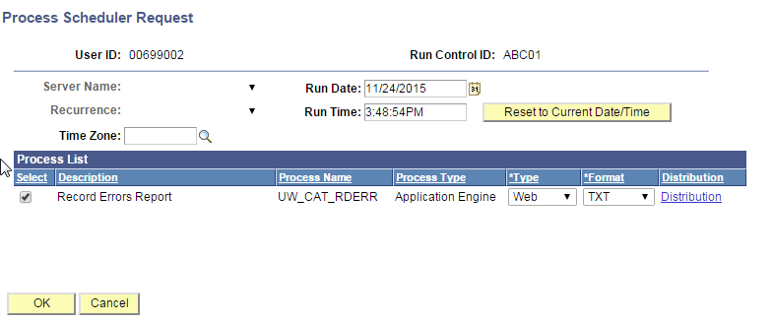
- Note the Process Instance number under the Process Monitor link. This designates the specific instance of the report run.
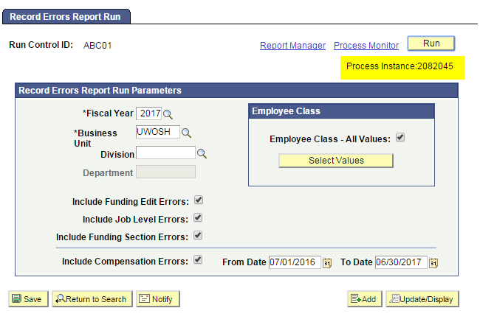
- Click Process Monitor at the top right of the window.
- Search for your process instance number under Process List, which will indicate the status of the report generation. When the report is complete, Run Status will be “Success” and Distribution Status will be “Posted”.
  - If Run Status is “Queued,” it indicates that the report generation is waiting to start.
  - If Run Status is “Processing,” it indicates that the report generation is processing.
  - Click Refresh at the top right of the window to refresh the status of the document.
- Once the Run Status hits “Success” and the Distribution Status hits “Posted,” download the output.
  - Click Details.
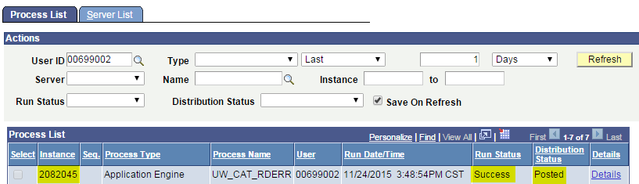
  - Click View Log/Trace at the bottom right of the window.
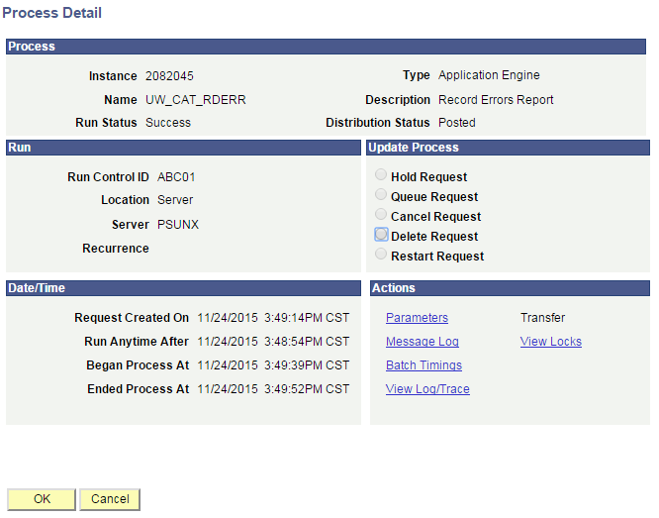
  - Under File List, click the file with the .xls extension to download the output. Note: you may have two .xls outputs if you have any additional splits.
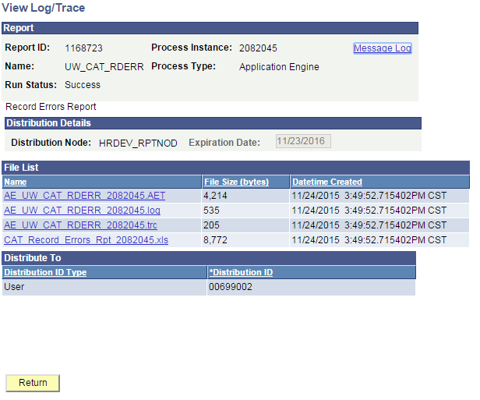
  - When opening the file, if an error message appears indicating that “The file you are trying to open…is in a different format than specified by the file extension,” click Yes.
- Review the report.
  - The excel output file will look like the screenshot below:

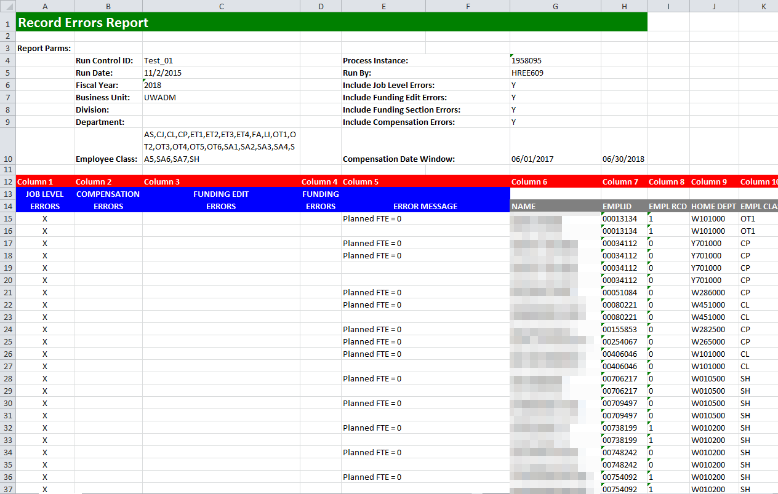

  - The report is displays four different types of errors, demarcated for each string by an X under the specific record type.
  - Emplrcds may appear in multiple sections of the report
  - Emplrcds will likely appear as multiple rows within each section because:
    - Emplrcds with more than one error will appear as multiple rows on the report
    - Compensation increases and funding splits are added as horizontal rows under each employee such as follows:
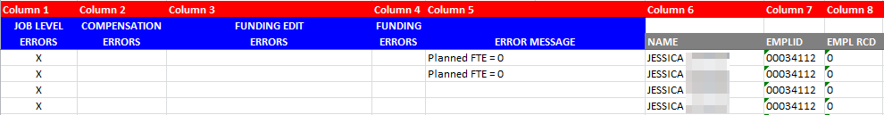
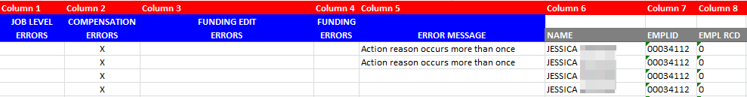
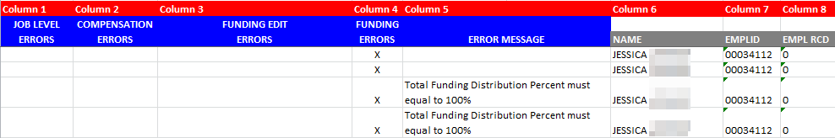
  - A description of the different header fields is displayed in Table 1 below.
  - A description of error messages, grouped by error type is displayed in Table 2 below.
  - A description of column headers past the error columns is displayed in Table 3 below.

Tables
Table 1: Output Header Fields
Report Parameters
Field Name | Description
Run Control ID | The run control identification entered when report was created.
Run Date | The date the report was created.
Fiscal Year | The Fiscal Year for which the report is pulling data.
Business Unit | The Business Unit selected in the run control.
Division | The Division (if any) selected in the run control.
Department | The Department (if any) selected in the run control.
Employee Class | The Employee Class as selected in the run control
Process Instance | The number assigned by PeopleSoft for each process.
Run By | The user ID of the user who ran the report.
Include Job Level Errors | Y/N dependent on whether Job Level Errors were selected in the run control.
Include Funding Edit Errors | Y/N dependent on whether Funding Edit Errors were selected in the run control
Funding Section Errors | Y/N dependent on whether Funding Edit Errors were selected in the run control.
Include Compensation Errors | Y/N dependent on whether Compensation errors were selected in the run control.
Compensation Date Window | The effective dates for the compensation errors section.

Table 2: Error Messages
Job Level Errors
Error | Error Message in Column 5
Planned FTE is 0 for an employee | Planned FTE = 0
Planned FTE is greater than one across multiple empl records | Planned Fte > 1 on multiple empl records
Compensation Errors
Error | Error Message in Column 5
Multiple CAT increases, same action reason | Action reason occurs more than once
Identical Action Reason exists in the CAT and in HRS (as of the effective date window you assign on the run control) | Identical action reason exists in the CAT and in HRS
$0 comp change amount entered | $0 amount entered in comprate change field
Funding Edit Errors
Error | Error Message in Column 5
The funding string combination for Fund Code and Scenario is not valid | Combo error for fields FUND_CODE/ SCENARIO in group SCENARIO.
The funding string combination for Department, Fund Code, and Program Code is not valid | Combo error for fields DEPTID/ FUND_CODE/ PROGRAM_CODE in group ORGEDIT.
The funding string combination for Fund Code and Program Code is not valid | Combo error for fields FUND_CODE/ PROJECT_ID in group FNDPRJ.
The funding string combination for Project ID and Fund Code is not valid | Combo error for fields PROJECT_ID/ FUND_CODE in group PRJ_FUND.
Funding Errors
Error | Error Message in Column 5
No funding has entered, salary will not add to summary totals | No Funding Information Entered in the CAT
Funding distribution is greater or less than 100% | Total Funding Distribution Percent must equal to 100%
On an individual funding split, Distribution Percentage, Budgeted FTE, or Budgeted Amount = 0 | Funding split distribution percent is 0
Funding Edit
Error | Error Message in Column 5
The funding string combination for Fund Code and Scenario is not valid | Combo error for fields FUND_CODE/ SCENARIO in group SCENARIO.
The funding string combination for Department, Fund Code, and Program Code is not valid | Combo error for fields DEPTID/ FUND_CODE/ PROGRAM_CODE in group ORGEDIT.
The funding string combination for Fund Code and Program Code is not valid | Combo error for fields FUND_CODE/ PROJECT_ID in group FNDPRJ.
The funding string combination for Project ID and Fund Code is not valid | Combo error for fields PROJECT_ID/ FUND_CODE in group PRJ_FUND.

Table 3: Report Columns
Column | Description
NAME | First and Last name pulled from HRS
EMPLOYEE ID | EmplID pulled from the CAT
EMPLOYEE RECORD NUMBER | Empl Record pulled from the CAT
HOME DEPT | Home Department from the CAT
EMPLOYEE CLASS | Employee Class pulled from the CAT
PAY BASIS | Pay Basis pulled from the CAT
POSITION NUMBER | Position number pulled from the CAT
JOBCODE | JobCode pulled from the CAT
TITLE | Job Title pulled from the CAT
PLANNED TITLE | Planned Title pulled from the CAT
PLANNED FTE (FROM CAT) | Planned FTE pulled from the CAT
HRS ACTION REASON | For Compensation Errors, pull the action reason from HRS, that falls within the defined effective dated window, for which an identical action reason has been entered in the CAT.  If multiple identical action reasons exist between the CAT and HRS, pull only the max effective dated/seq one from HRS.  Note: If the error is not an HRS/CAT duplicate action reason error the field will appear blank
HRS CHANGE AMOUNT | For Compensation Errors, pull comprate change amount associated with the duplicate action reason from HRS (max effective dated/seq that falls within the defined effective dated window).  If the error is not an HRS/CAT duplicate action reason error, this field will appear blank.
CAT ACTION REASON | For Compensation Errors, pull the action reason from the CAT for which a duplicate action reason exists either in HRS, or in the CAT (has been loaded via a spreadsheet upload process)  For non-Compensation Errors, pull the first action reason from the CAT.
CAT CHANGE AMOUT | For Compensation Errors, pull the comprate change amount from the CAT associated with Increase 1 Action Reason (for which a duplicate action reason exists either in HRS, or in the CAT (has been loaded via a spreadsheet upload process)).  For non-Compensation Errors, pull the comprate change amount associated with the first action reason from the CAT.
TOTAL COMPRATE | Updated Compensation Rate pulled from the CAT
GL BUSINESS UNIT | Pull the GLBU from the account code in the CAT – funding string 1
FUND | Pull the Fund Code of this empl record from the account code in the CAT - funding string 1
DEPARTMENT ID | Pull the DeptID of this empl record from the account code in the CAT - funding string 1
PROGRAM | Pull the Program of this empl record from the account code in the CAT - funding string 1
PROJECT ID | Pull the ProjectID of this empl record from the account code in the CAT - funding string 1
DISTRIBUTION PERCENT | Pull distribution percentage of first funding split of empl record with error from the CAT- funding string 1
BUDGETED FTE | Pull budgeted FTE of first funding split of empl record with error from the CAT- funding string 1
FUNDING OK TO LOAD | OK to load to CAT

