KB – Missing from CAT Report
Table of Contents
Purpose and Overview 1
Process Inputs 1
Process Outputs 1
Procedure Steps 1
Tables 8

Purpose and Overview
The Missing from CAT report displays employees who exist in HRS, but do not exist in the CAT. This report is intended to identify employees that may have been hired after the Initialization Report (IR) was run, or before the first of the next fiscal year, and employee records excluded while working in the IR or Institutional Planning Spreadsheet (IPS).
This report should be run regularly, after the IPS is loaded into the CAT.

Process Inputs
- Fiscal Year
- Business Unit
- Division (Optional)
- Department (Optional)
- Employee Class

Process Outputs
- Excel document with all employee records that meet the run control criteria and have a missing from CAT error.

Procedure Steps
- Navigate to Workforce Administration > UW External HR Systems > Compensation Admin Tool > CAT Reports > Missing from CAT Report.
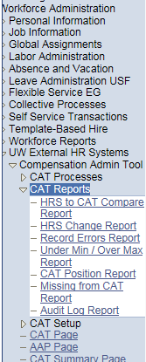
- Click Search under the Find an Existing Value tab to select a previously created Run Control ID, or create a new Run Control ID by selecting Add a New Value. To create a new Run Control ID, assign a unique identifier as the Run Control ID (eg. initials_date_etc.) into the Run Control ID box and select Add.
- Note: Run Control ID sets the report parameters. Users can create one ID, and use it to process multiple reports/processes, or create a new ID for each report/process.
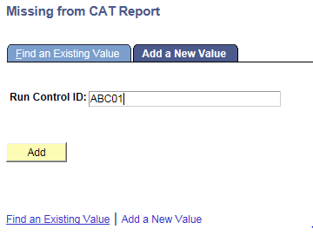
- Enter parameters to define criteria for the Missing from CAT Report.
  - Select the upcoming Fiscal Year used for CAT budgeting planning purposes. This field will default to the latest fiscal year setup in the CAT.
  - Select a Business Unit.
  - If desired, select a Division.
  - If desired, select a Department.
    - If available, the Department field will become editable when the user selects a Division from the search tool or enters one manually and presses the tab button out of the field.
  - Click Select Values in the employee class box if you wish to exclude certain employee classes from the report. The default is for all employee classes to be included. Employee classes that are not included in the CAT will not pull onto CAT reports.
  - Click Save in the bottom left to save the parameters for the report.
  - Click Run in the top right to run the report.
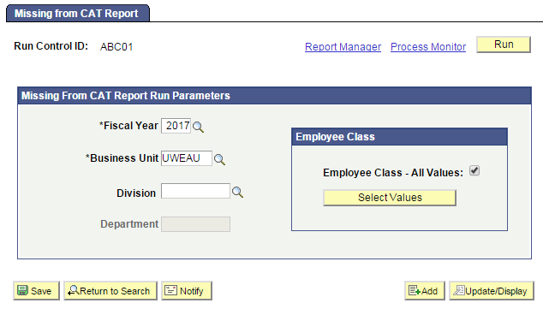
- User will be automatically directed to the Process Scheduler Request page. From this page, select OK.
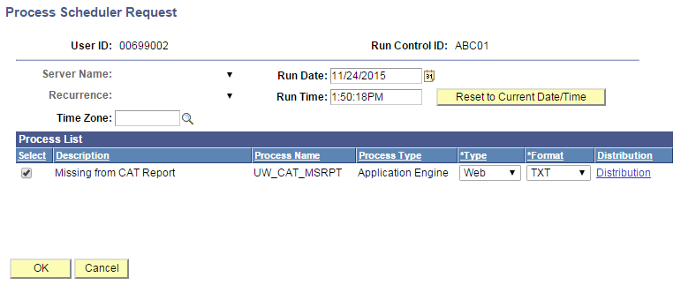
- Note the Process Instance number under the Process Monitor link. This designates the specific instance of the report run.
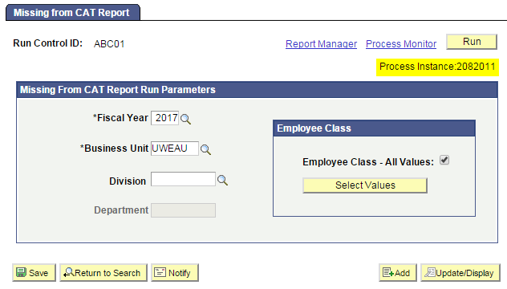
- Click Process Monitor at the top right of the window.
- Search for your process instance number under Process List, which will indicate the status of the report generation. When the report is complete, Run Status will be “Success” and Distribution Status will be “Posted”.
  - If Run Status is “Queued,” it indicates that the report generation is waiting to start.
  - If Run Status is “Processing,” it indicates that the report generation is processing.
  - Click Refresh at the top right of the window to refresh the status of the document.
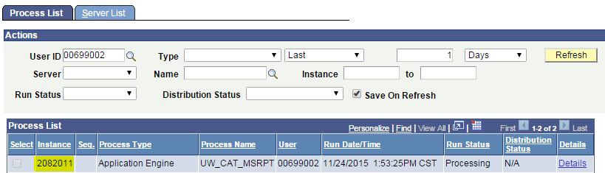
- Once the Run Status hits “Success” and the Distribution Status hits “Posted,” download the output.
  - Click Details.
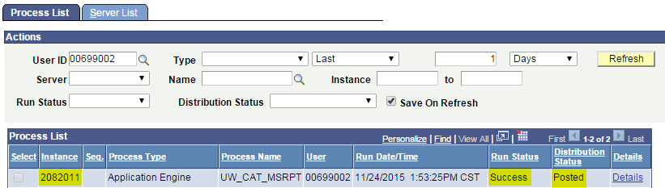
  - Click View Log/Trace at the bottom right of the window.
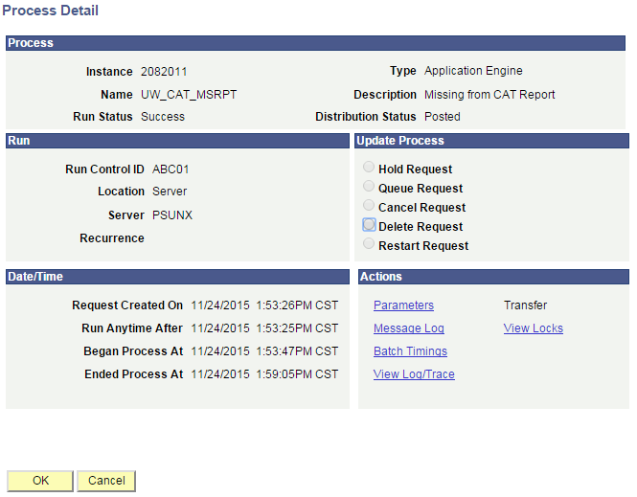
  - Under File List, click the file with the .xls extension to download the output. Note: you may have two .xls outputs if you have any additional splits.
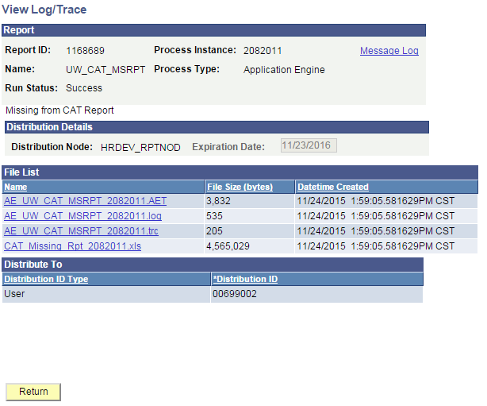
  - When opening the file in Excel, if an error message appears indicating that “The file you are trying to open…is in a different format than specified by the file extension,” click Yes.
  - Note that different internet browsers may have different opening processes.
- Review the report.
  - Open the downloaded Excel file.
    - A description of the different header fields of the output is below.
    - Review each record, and determine if that employee is eligible for Merit or should be added to the CAT.
    - If a particular employee record should be added, navigate to Workforce Administration > Compensation Administration Tool > CAT Page > Add a Value
    - Enter the empl id and empl rcd
    - A blank CAT page will appear for the user to enter rate increases and funding information.

Tables
Report Parameters
Field Name | Description
Run Control ID | The run control identification entered when report was created.
Run Date | The date the report was created.
Fiscal Year | The fiscal year selected in the run control.
Business Unit | The Business Unit selected in the run control.
Division | The Division (if any) selected in the run control.
Process Instance | The number assigned by PeopleSoft for each process.
Run By | The user ID of the user who ran the report.
Employee Class | The employee classes included on the report’s run control.
Department | The Department (if any) selected in the run control.
Report Columns
Column | Description
FISCAL YEAR | The upcoming fiscal year that is active in the CAT.
BUSINESS UNIT | The Business Unit of the employee record from HRS.
HOME DEPT (DEPT ID) | The Home Department of the employee record from HRS.
EMPLOYEE ID | The Employee ID of the employee record from HRS.
EMPLOYEE RECORD NUMBER | The Employee Record Number of the employee record from HRS.
NAME DISPLAY | The Employee Name of the employee record from HRS.
EMPLOYEE CLASS | The Employee Class of the employee record from HRS.
POSITION NUMBER | The Employee Position Number of the employee record from HRS.
JOBCODE | The Jobcode of the employee record from HRS.
TITLE (JOBCODE DESCRIPTION) | The Title of the employee record from HRS.
CONTINUITY CODE | The Continuity Code of the employee record from HRS.
FTE | The FTE of the employee record from HRS.
PAY BASIS | The Pay Basis of the employee record from HRS.
COMPRATE | The Comprate of the employee record from HRS.
ANNUALIZED FULL TIME RATE (1 FTE) | The Annualized Full Time Rate (annual salary as if 1FTE) from HRS.
EXPECTED END DATE | The Expected Job End Date of the employee record from HRS if they have one.
FUND CODE (1,2,3,4,5) | The Fund of the funding string(s) of the employee record from HRS.
DEPARTMENT (1,2,3,4,5) | The DeptID of the funding string(s) of the employee record from HRS.
PROGRAM (1,2,3,4,5) | The Program of the funding string(s) of the employee record from HRS.
PROJECT ID (1,2,3,4,5) | The ProjectID of the funding string(s) of the employee record from HRS.

