HR - Initialization Report
Table of Contents
Purpose and Overview 1
Process Inputs 1
Process Outputs 1
Procedure Steps 1
Output Header Fields 7

This procedure outlines the process for running the Initialization Report as a part of the Compensation Administration Tool Business Process.

Purpose and Overview

The Initialization Report is the first step of the Compensation Administration Tool process. It exports current job compensation and funding data out of HRS for next Fiscal Year’s budgeted population into an .xls file. The outputs of the Initialization Report are used to populate the Institutional Planning Spreadsheet.

Process Inputs
- Effective Date
- Business Unit
- Division (optional)
- Employee Class

Process Outputs
- An excel document that lists all employees that meet the Run Control criteria and have 5 or less funding splits.
- An excel document that lists all employees that meet the Run Control criteria and have 6 or more funding splits.

Procedure Steps
- Navigate to Workforce Administration > UW External HR System > Compensation Administration Tool > CAT Processes > Initialization Report Process.

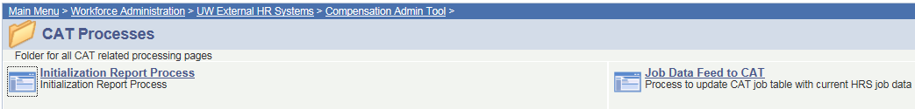

- Create a Run Control ID by selecting the “Add a New Value” tab. Enter desired name for Run Control ID into the Run Control ID box and select add.
  - The Run Control ID can be any unique identifier that does not include spaces (ex. your initials and the date).
  - To use an existing Run Control ID select “Find an Existing Value”, then enter the Run Control ID into the Run Control ID box.

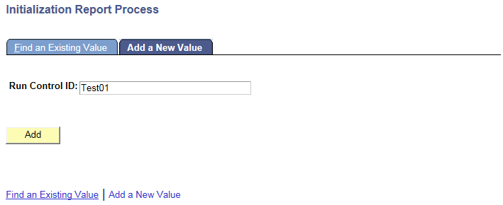

- Enter “Fiscal Year”, “Effective Date”, and “Business Unit” to define criteria for the Initialization Report on the Initialization Report Process page.
  - Select the upcoming “Fiscal Year”, as recognized for budgeting purposes. This field will default to the latest fiscal year that is set up in the CAT. Example: if it is January of 2017 and you are planning for the next Fiscal Year, this value should default to 2017.
  - Select the “Effective date” from HRS. All employees that are active as of this date in HRS (and meet the Business Unit, Division, and Empl Class run control criteria) will appear on the IR.
    - It is up to each institution to decide which date to utilize for the IR Effective Date. It can be run for ‘today’ or for a future effective date (such as the first of the upcoming fiscal year, like 7/01/2017).
      - Keep in mind that running the IR for a future effective date will capture future dated hires. However, running the IR for a future effective date will not take future dated terminations into account. For example, if you run the IR as of 7/1, an employee with an Expected Job End Date of 6/30 will still appear on the IR.
      - No matter what date the IR is run for, it is important to review the EJED column and remove employees who will be terminating.
  - Select the “Business Unit” for which you are running the IR.
  - If desired, select the “Division” for which you are running the IR. This is the 3 digit alpha numeric code (example: A01).
  - “Division” is an optional field, but can be used to narrow the results returned.
  - If desired, select “Employee Class”. The default for this run control is to have all employee classes included in the IR output. If you wish to exclude certain employee classes, click the “Select Values” button. This will open a window in which you can either uncheck the boxes next to the empl class code you don’t want (ex: SH), or “Clear” all empl classes and check the ones you do want. Click “OK” to proceed.

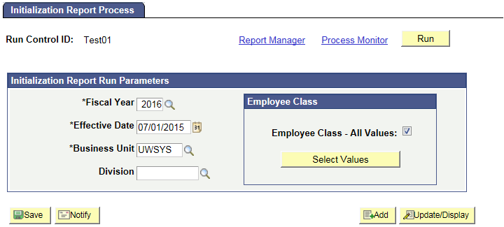

- After entering Run Control Criteria select “Run” to begin Initialization Report processing.

- User will be automatically directed to the Process Scheduler Request page. From this page, select “Ok”.
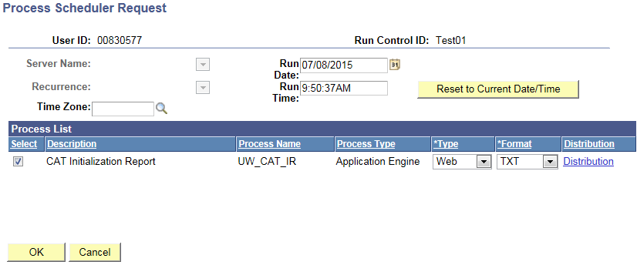

- User will be directed back to Initialization Report Process Page. Note your Process Instance Number. Select “Process Monitor” to view the Process list.

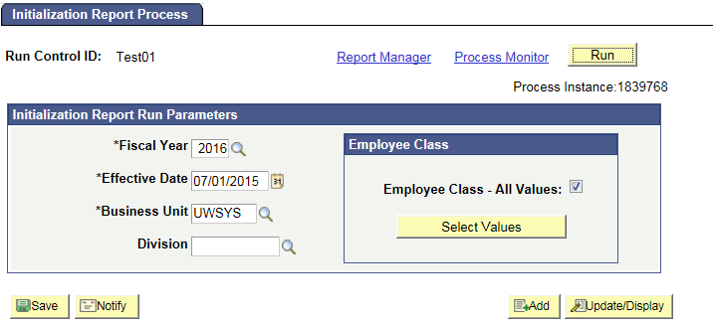

- Refresh page until “Run Status” is “Success”. Depending on the data load queued in the Process Monitor, this may take several minutes.
- Once Run Status is “Success” select “Details” to route to Process Detail page.
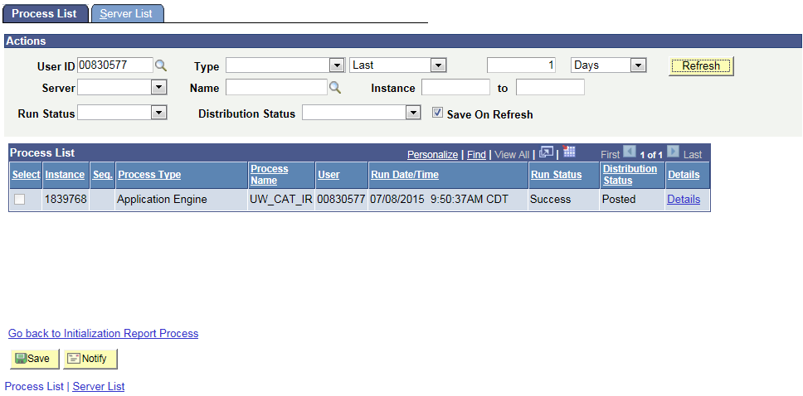

- Select “View Log/Trace” from the Process detail page.

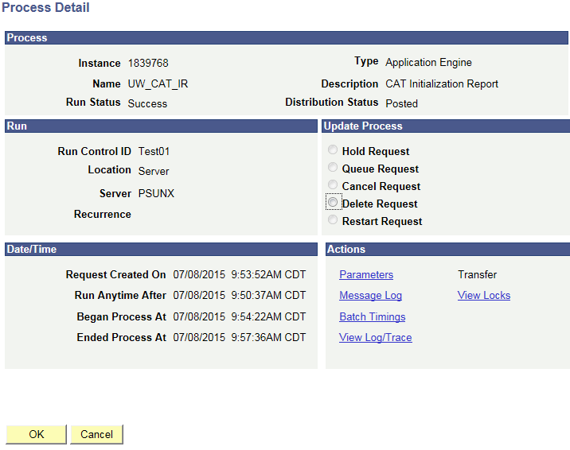

- Select “init_report_Process Instance Number.xls” Report and “init_report_addl_splits_Process instance number.xls” outputs to view the Initialization Report based on Run Control criteria.
  - The “init_report_Process Instance Number.xls” Report contains all employee records that meets Run Control Criteria and have 5 or less funding splits.
  - The “init_report_addl_splits_Process instance number.xls” contains all employee records that meets Run Control Criteria and have 6 or more funding splits.
  - It’s possible that there will only be init_report_Process Instance Number.xls, as the criteria entered on the run control may not return employees with 6 or more results.

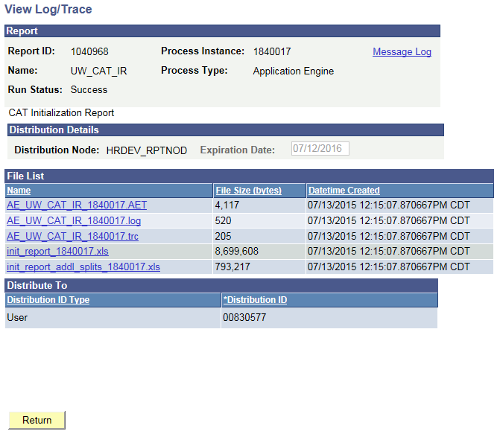

- Excel will prompt you to open the file and select “Yes”. Note that different browsers may have different processes to open the file. Ensure that your pop-up blockers are turned off to open this file. The output files will look like the screenshot below.
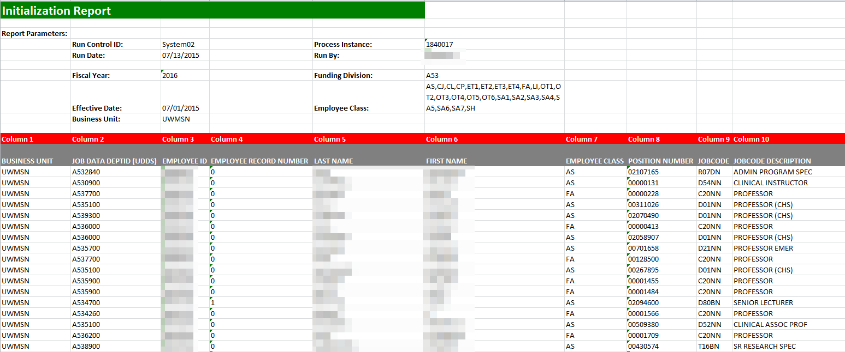

- Review the output file.
  - Verify the header information matches what was entered on the run control. Save the Initialization Report as an .xls file.
  - You can verify that the compensation information is correct based on HRS Job Data by comparing an employee on the IR output to one in HRS.
  - A description of the different header fields of the output is below.

Output Header Fields
Report Parameters
Field Name | Description
Run Control ID | The run control used to create the report.
Run Date | The date the report was created.
Process Instance | The number assigned by PeopleSoft for each process.
Ran By | The user ID of the user who ran the report.
Fiscal Year | As entered on the run control.
Effective Date | As entered on the run control.
Business Unit | As entered on the run control.
Funding Division | As entered on the run control.
Employee Class | As selected on the run control.

- Follow the steps in the IPS KB to copy and paste this data into the IPS to be loaded into the CAT.

