KB – IPS Upload to CAT (Append)
Table of Contents
Purpose and Overview 1
Procedure Steps 1
Output Header Fields 8

Purpose and Overview
The IPS Load to CAT and AAP (Append) process uploads data from the IPS to the CAT and AAP for analysis, reporting, editing. The IPS Load to CAT/AAP process appends existing data in the CAT/APP by only adding new, unique employee records or rows to existing employees. Therefore, all data in the IPS file will be added to the CAT and AAP, with the exception of data this is identical on all fields that make a unique record.

A row is considered ‘unique’ if any of the following fields are different when comparing one row to another row within the file and/or CAT: Effective Date, Employee ID, Employee Rcd, Action, Action Reason, and Change Amount.

Procedure Steps
The IPS should be loaded to the CAT after all mass changes have been made in the IPS. For information on how to use the IPS, please see KB 05.
- Save the “IPS -> CAT” tab of the IPS as a .CSV.
  - Scroll down the Comp Admin Planning tab to identify the number of data rows populated.
  - Open the “IPSCAT” tab
  - The text string formula that begins in cell A4 only copies down for 100 rows. If the number of rows counted in step (a) is greater than 100, drag the formula in A4 down for ten more rows than that number.
  - Any extra rows copied will appear in this format: IPS;;;;000000;00000000;00;;;;0.000000. Delete any null rows like this.
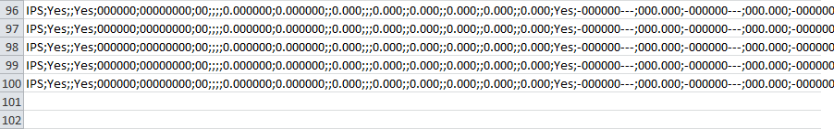
  - Scroll back up to the top of the page and press the “Click Here to Export File for CAT Page Upload” button.
    - Note that if this button does not appear, you can do it manually by clicking the View tab, selecting the Macros option on the right, and running the “ThisWorkbook.ExportRangetoFileCAT” option listed.

  - Save the output file “Name.CSV” under the file menu
    - Note that Excel 2013 may call this a “Comma Separated Text” file. It will still have the same .CVS extension.
  - The following box will appear in Excel. Select Okay.

  - The “Name.CSV” file will appear on your screen. You may close it out.
- Navigate to the CAT.
  - Log in to HRS and navigate to Workforce Administration > UW External HR Systems > Compensation Admin Tool > CAT Processes> Upload to CAT and AAP Process (shown in the images below).
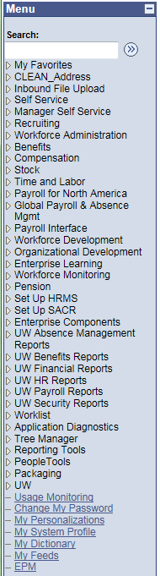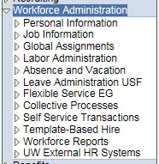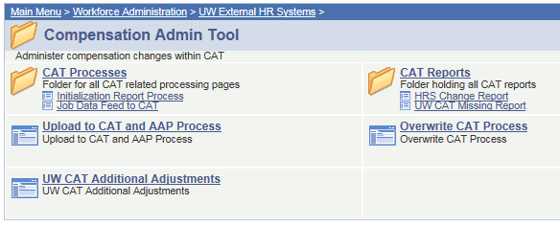
- Create a new run control or use existing saved run control.
  - The Run Control ID is a unique identifier that saves different values for the run control criteria.
  - While there is no set format for the Run Control ID, a potential suggested format is Initials + next available number (e.g. “ABC01”).
    - Note: you cannot use spaces in your Run Control ID.
  - Click either the “Find and Existing Value” or “Add a New Value” tab depending on what you would like to do.
  - Enter the run control.
  - Click either “Search” or “Add.”
  - If you are searching for a run control and it does not exist, you will have the option to create a new run control.
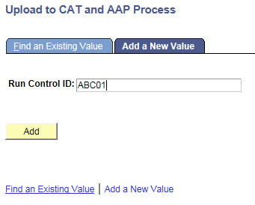
- The following screen will appear:

- Under “Process Options,” choose between “Report” and “Process and Report.”
  - The report mode should be run first.
    - This mode allows the data to be processed without committing data to the CAT. It generates an output .xls file that allows the data and any possible errors to be reviewed.
  - The process mode should be run after.
    - Once the data has been reviewed and any errors in the data have been corrected, the process mode can be run. This commits the data to the CAT and generates an output .xls file.
- The Fiscal Year should be automatically populated.
- Select the appropriate “Inbound File Upload Criteria”
  - For File Type, select “Compensation Adjustment”
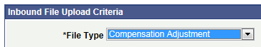
  - For Business Unit, click the magnifying glass to search for the appropriate business unit. Click the blue link for the business unit to select it.
  - For file description, there is no set format. A potential suggested format is “CAT_IPS_date” (e.g. “CAT_IPS_080615”).
  - Click the “Upload File” link next to Attached File to browse for, select, and upload the .CSV file from Step 1.

  - Once the .CSV file has uploaded, press the “Save” button at the bottom of the window.
    - The screen will appear the same, and your Run Control will be saved
- Upload the IPS to the CAT.
  - Press “Run” at the top right of the window.

  - Press “OK” at the bottom of the new window.
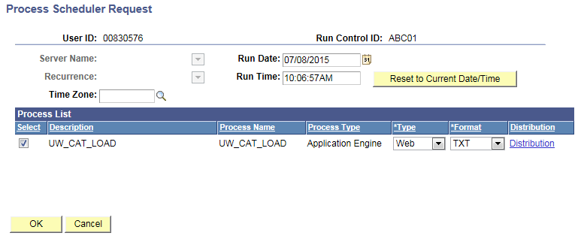

  - You will have returned to your previous window. Note your Process Instance Number. Press “Process Monitor” at the top right of the window.

  - The new window will indicate the status of your file upload. When the file is finished uploading, Run Status will be “Success.”
    - If Run Status is “queued,” it indicates that the file is waiting to be uploaded.
    - Click Refresh at the top right of the window to refresh the status of the document.
    - Note that this process may take several minutes, depending upon the data load in the Process Monitor.

- Once the Run Status is “Success,” download the output.
  - Click “Details.”

  - Press “View Log/Trace” at the bottom right of the window.

  - Under File List, click the file with the .xls extension to download the output.

  - When opening the file, if an error message appears indicating that “The file you are trying to open…is in a different format than specified by the file extension,” click “Yes.”

- Review the output file.
  - Open the downloaded Excel file.
    - An example output file is displayed below
    - A description of the different header fields is displayed in the “Output Header Fields” table below
  - The file will contain Error, Warning, and Successful sections.
    - Review the Error and Warning section of the output. Use the ERRORMSG column to diagnose the errors and correct if necessary.
    - A description of the different types of error messages is displayed in the “Error, Warning, and Successful Messages” table below.
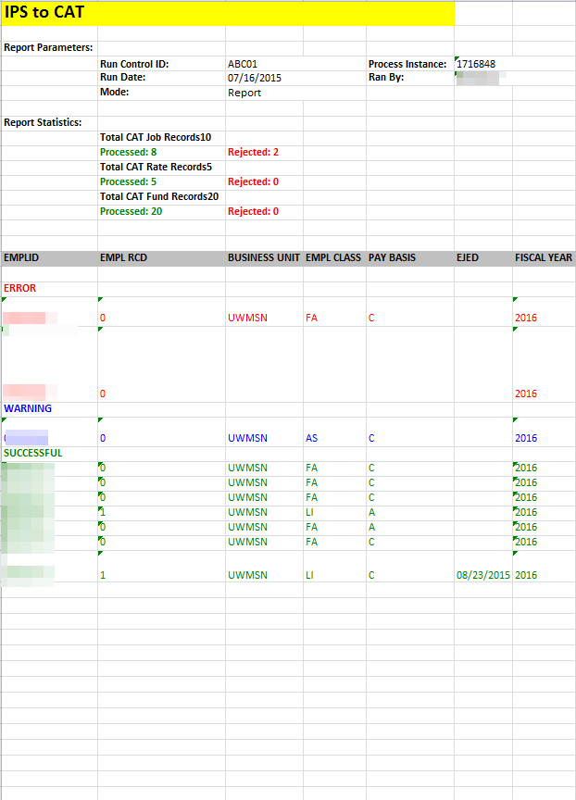

  - Correct the IPS based on the errors in the output. Once all errors have been corrected, the upload can be run in Process and Report mode using the same steps.
    - If the output file contains errors after the upload is run in Process mode, failed rows can also be manually added or edited directly within the CAT.
  - If saving the output file, ensure that it is saved as a file type Excel Workbook (.xlsx).

Output Header Fields
Report Parameters
Field Name | Description
Run Control ID | The run control used to create the report.
Run Date | The date the report was created.
Mode | The mode used for the upload. Either report or process.
Process Instance | The number assigned by PeopleSoft for each process.
Ran By | The user ID of the user who ran the report.
Report Statistics
Field Name | Description
Total CAT Job Records | The total number of CAT job records evaluated.
Processed | The total number of CAT job records processed successfully.
Rejected | The total number of CAT job records rejected because of errors.

Error, Warning and Successful Messages
# | Row Type | Description | Comments | IPS Upload Error Message
1 | Error | Empl Id/Empl Rcd Not Active in HRS | Entire row errors out | Emplid/Empl_Rcd not in Active HR STATUS
2 | Error | Position Number does not match emplid/empl rcd |  | Position_Nbr does not match emplid/empl_rcd
3 | Error | Invalid Effective Date, Fiscal Year, Emplid, emplrcd, position number, business unit, deptid, action reason, comprate, funding string, planned FTE | Field errors. Does this need to include all fields in the funding string? | INVALID_Field Name
3.1 | Error | Invalid Account Code |  | Account Code is invalid
3.2 | Error | Negative Distribution % |  | Negative Distribution % is invalid
3.3 | Error | Business Unit did not match Run Control |  | Business Unit: XXXXX did not match Run Control;
3.4 | Error | Invalid CSB Flag | CSB Flag is not 'Y' or 'N' | CSB Flag value is invalid;
3.5 | Error | Planned FTE < 0 |  | Planned FTE cannot be negative
4.1 | Warning | Business unit did not match between loaded row and HRS |  | Business Unit: XXXXX mismatch between loaded row and HRS;
4.2 | Warning | Deptid did not match between loaded row and HRS |  | Deptid: XXXX mismatch between loaded row and HRS
4.3 | Warning | FTE did not match between loaded row and HRS | For L basis employees HRS FTE .000250 = File FTE 0 | FTE: XXX mismatch between loaded row and HRS
4.4 | Warning | Pay Basis did not match between loaded row and HRS |  | Pay Basis: X mismatch between loaded row and HRS;
4.5 | Warning | Comprate did not match between loaded row and HRS | Comprate pulled from PS_COMPENSATION | Comprate: XXXX mismatch between loaded row and HRS;
4.6 | Warning | EJED did not match between loaded row and HRS |  | EJED mismatch between loaded row and HRS;
5 | Warning | Identical emplid/empl rcd/action reason/change amount exists | Funding section still loads | Identical emplid/empl_rcd/action reason/change amount exists in the file
5.1 | Warning | Invalid Action Reason for PAY | Rate row will error out but all other rate/fund row still loads | Action Reason is not valid for PAY;
6 | Warning | Identical funding string/distribution % exists | Compensation section still loads | Identical emplid/empl_rcd/acct_cd/uw_cat_dist_pct exists in the file
6.1 | Warning | Invalid Fund Code | Errors out fund row but all other rate/fund row still loads | Account Code: Fund Code is not valid;
6.2 | Warning | Invalid DeptId | Errors out fund row but all other rate/fund row still loads | Account Code: DeptId is not valid;
6.3 | Warning | Invalid Program Code | Errors out fund row but all other rate/fund row still loads | Account Code: Program Code is not valid;
6.4 | Warning | Invalid Project Id | Errors out fund row but all other rate/fund row still loads | Account Code: Project Id is not valid;
6.5 | Warning | Invalid Business Unit | Errors out fund row but all other rate/fund row still loads | Account Code: Business Unit is not valid;
7 | Successful | New Emplid/empl rcd combos | Create New CAT record | N/A
8 | Successful | Existing record, but unique emplid/empl rcd/actionreason/change amount exists | Add to existing CAT record | N/A
9 | Successful | Existing record, but unique funding string/distribution% exists | Add to existing CAT record | N/A

