KB – HRS to CAT Compare Report
Table of Contents
Purpose and Overview 1
Process Inputs 2
Process Outputs 2
Procedure Steps 2
Tables 8

Purpose and Overview
The HRS to CAT Comparison Report will serve to supplement the comp admin and funding planning process handled by the Compensation Administration Tool. It identifies employee records where key fields differ between the CAT and HRS and is intended to catch things like: Business Unit/Department change, Position Number change, Compensation Rate change, Empl Class Change, Title Change, Job Code Change, and an FTE change. This report will also capture terminations. Finally, it will also include empl records for which a title has been entered in the planned title field that does not match the HRS title on that CAT record (though often these are intentional).
For each record that appears on this report with a discrepancy, the user should review that employee record in the CAT and determine if the rate increases need to be altered based on the new job data information that was entered in HRS.
When the HRS to CAT Job Data Feed is ON
There is an automatic nightly process that pushes the values for all key fields on each CAT record from HRS to the CAT. This same process is run when you open up an existing CAT record. Thus, whenever a user accesses a CAT record, they will see the most recent values for all key fields, from HRS. This also means that the majority of the changes listed above (with the exception of Position Number changes and Terminations) will not appear on this report while the feed is on.
Based on the cycle of the process that updates the CAT fields with HRS values, it is best practice to run this report in the morning, when all job changes in HRS have been pushed to the CAT. If the report is run later in the day, and job data changes have been made in HRS earlier that day, records will appear on this report as if they have discrepant fields, because the auto update process has not been run yet. To remove these fields from the report, simply visit that employee record in the CAT.
Thus, for each record that appears on this report with a discrepancy that is NOT a position number discrepancy or termination, the user should simply visit that employee record in the CAT to update the discrepant fields and remove the employee record from the report.
When the HRS to CAT Job Data Feed is OFF
When the automatic nightly process that pushes the values for key fields from HRS to the CAT is turned off, more employee records will appear on this report with discrepant fields. For each record that appears on this report with a discrepancy, the user should review that employee record in the CAT and determine if the rate increases need to be altered based on the new job data information that was entered in HRS.

Process Inputs
- Effective Date
- Business Unit
- Division (Optional)
- Department (Optional)
- Employee Class

Process Outputs
- Excel document with a population that meet the run control criteria and have discrepancies between key fields in HRS and the CAT.

Procedure Steps
- Navigate to Workforce Administration > UW External HR Systems > Compensation Admin Tool > CAT Reports > HRS to CAT Compare Report.
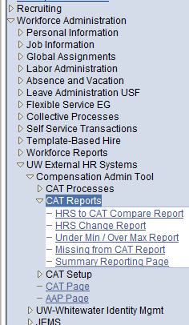
- Click Search under the Find an Existing Value tab to select a previously created Run Control ID, or create a new Run Control ID by selecting Add a New Value. To create a new Run Control ID, assign a unique identifier as the Run Control ID (eg. initials_date_etc.) into the Run Control ID box and select Add.
- Note: Run Control ID sets the report parameters. Users can create one ID, and use it to process multiple reports/processes, or create a new ID for each report/process.
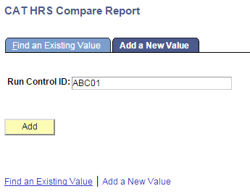
- Enter parameters to define criteria for the HRS to CAT Compare Report.
  - Select the upcoming Fiscal Year used for CAT budgeting planning purposes. This field will default to the latest fiscal year setup in the CAT.
  - Select the Effective Date of the CAT you wish to compare against in HRS. This field will default to the current date. In order to accurately check for discrepancies, users should enter the first date of the upcoming fiscal year (ex: 7/1, 8/28).
  - Select a Business Unit.
  - If desired, select a Division.
  - If desired, select a Department.
    - If available, the Department field will become editable when the user selects a Division from the search tool or enters one manually and presses the tab button out of the field.
  - Click Select Values in the employee class box if you wish to exclude certain employee classes from the report. The default is for all employee classes to be included. Employee classes that are not included in the CAT will not pull onto CAT reports.
  - Click Save in the bottom left to save the parameters for the report.
  - Click Run in the top right to run the report.
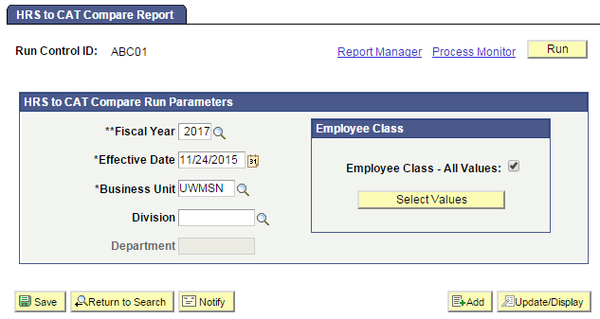
- User will be automatically directed to the Process Scheduler Request page. From this page, select OK.
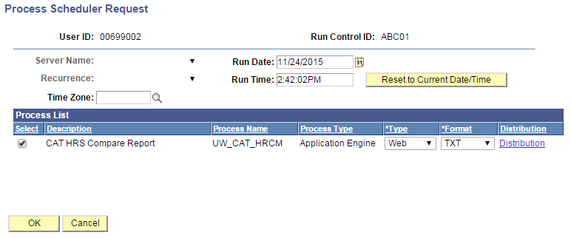
- Note the Process Instance number under the Process Monitor link. This designates the specific instance of the report run.
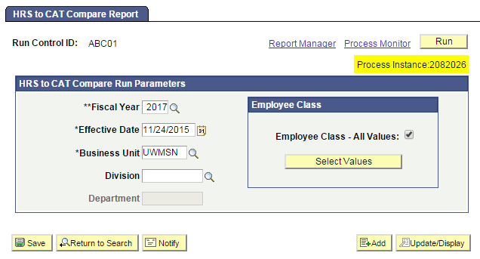
- Click Process Monitor at the top right of the window.
- Search for your process instance number under Process List, which will indicate the status of the report generation. When the report is complete, Run Status will be “Success” and Distribution Status will be “Posted”.
  - If Run Status is “Queued,” it indicates that the report generation is waiting to start.
  - If Run Status is “Processing,” it indicates that the report generation is processing.
  - Click Refresh at the top right of the window to refresh the status of the document.
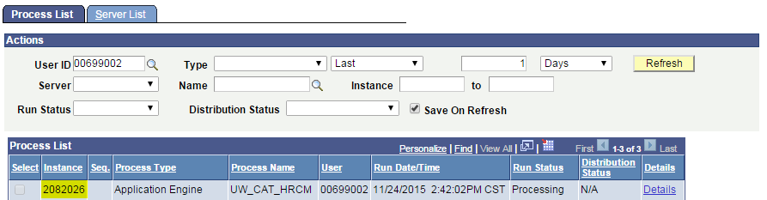
- Once the Run Status hits “Success” and the Distribution Status hits “Posted,” download the output.
  - Click Details.
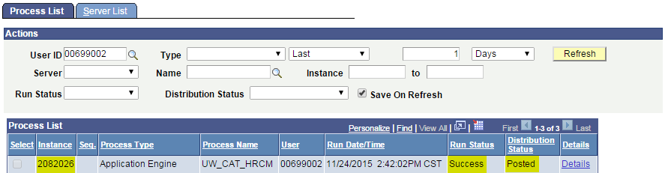
  - Click View Log/Trace at the bottom right of the window.
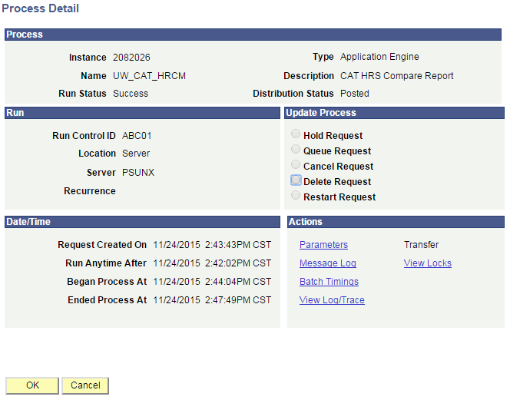
  - Under File List, click the file with the .xls extension to download the output. Note: you may have two .xls outputs if you have any additional splits.
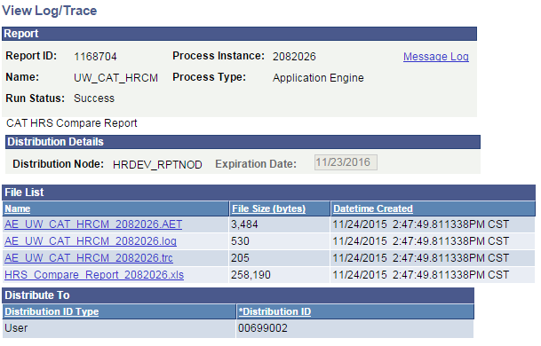
  - When opening the file, if an error message appears indicating that “The file you are trying to open…is in a different format than specified by the file extension,” click Yes.

  - Note that different internet browsers may have different opening processes.
- Review the report.
  - The report will appear as follows:
    - One row per emplid/emplrcd combination is displayed.
    - If the two fields are the same between HRs and the CAT, they will appear blank.
    - If a change is due to a termination, only CAT columns will populate.
    - If a change is due to a hire, only HRS columns will populate.

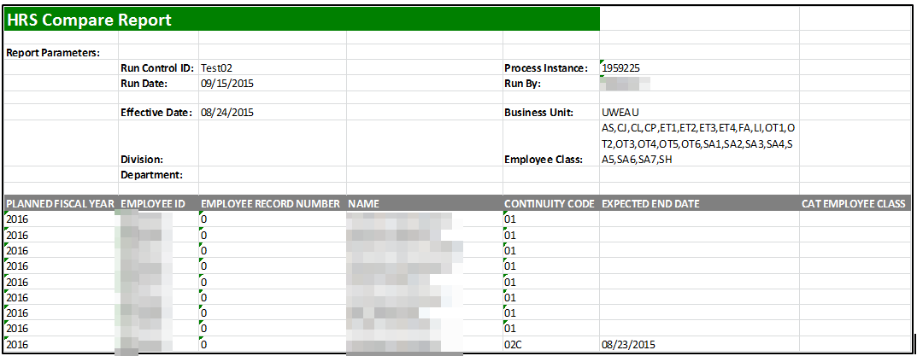
  - A description of the different header fields of the output is displayed in Table 1 below.
  - Action items based on the report output are presented in Table 2.

Tables
Table 1: Output Header Fields
Report Parameters
Field Name | Description
Run Control ID | The run control identification entered when report was created.
Run Date | The date the report was created.
Fiscal Year | The fiscal year of the CAT you wish to compare against in HRS.
Effective Date | The effective date of the CAT you wish to compare against in HRS.
Division | The Division (if any) selected in the run control.
Department | The Department (if any) selected in the run control.
Process Instance | The number assigned by PeopleSoft for each process.
Run By | The user ID of the user who ran the report.
Business Unit | The Business Unit selected in the run control.
Employee Class | The employee classes included on the report’s run control.
Report Columns
Column | Description
PLANNED FISCAL YEAR | The upcoming fiscal year that is active in the CAT.
EMPLOYEE ID | The Employee ID of the employee record from HRS.
EMPLOYEE RECORD NUMBER | The Employee Record Number of the employee record from HRS.
NAME | The Name of the employee record from HRS.
CONTINUITY CODE | The Continuity Code of the employee record from HRS.
EXPECTED END DATE | The Expected Job End Date of the employee record from HRS if they have one.
CAT EMPLOYEE CLASS | The Employee Class of the employee record from CAT.
HRS EMPLOYEE CLASS | The Employee Class of the employee record from HRS.
CAT BUSINESS UNIT | The Business Unit of the employee record from CAT.
HRS BUSINESS UNIT | The Business Unit of the employee record from HRS.
CAT HOME DEPT | The Home Department of the employee record from CAT.
HRS HOME DEPT | The Home Department of the employee record from CAT.
CAT POSITION # | The Position Number of the employee record from CAT.
HRS POSITION # | The Position Number of the employee record from HRS.
CAT JOBCODE | The Job Code of the employee record from CAT.
HRS JOBCODE | The Job Code of the employee record from HRS.
CAT JOB TITLE | The Job Title of the employee record from CAT.
HRS JOB TITLE | The Job Title of the employee record from HRS.
CAT PAY BASIS | The Pay Basis of the employee record from CAT
HRS PAY BASIS | The Pay Basis of the employee record from HRS
CAT FTE | The FTE of the employee record from CAT
HRS FTE | The FTE of the employee record from HRS
CAT COMPRATE | The Comprate of the employee record from CAT
HRS COMPRATE | The Comprate of the employee record from HRS
EMPLOYEE TERMINATED? | Yes if the employee has been terminated ( appears in CAT and not HRS)  No if the employee has not been terminated ( appears both in the CAT and HRS)

Table 2: Action Items based on HRS Feed Status
HRS Feed Status | Job Changes in HRS that Occurred | Action Item
OFF | Employee Terminated | Delete from CAT
 | Transfer/ Position # Change | Delete and Re-Add to CAT
 | Title Change | Review and Potentially Edit Comp Increases
 | Comprate Change | Review and Potentially Edit Comp Increases
 | New Hire | Potentially Add to CAT
 | FTE, EJED Change | Potentially Edit Planned FTE or Remove from CAT
ON | Employee Terminated | Delete from CAT
 | Transfer/Position # Change | Delete and Re-Add to CAT

